Statistical Process Control, Quality Assurance, Data Analysis, and Artificial Intelligence in Production

Khaled Alabsi

Inhaltsverzeichnis

[1. Linear Algebra 2](#_Toc169871780)

[1.1. Eigenvector and Eigenvalue 2](#_Toc169871781)

[1.2. Inner Product and Outer Product: Definitions, Differences, and Geometric Interpretations 5](#_Toc169871782)

[2. Tools For (Measurement,…) 9](#_Toc169871783)

[2.1. Mahalanobis 9](#_Toc169871784)

[2.1.1. Relationship between the likelihood ratio and the Mahalanobis distance in the context of multivariate normal distributions. Let's explore this relationship step by step. 16](#_Toc169871785)

[2.2. The L1-Norm 18](#_Toc169871786)

[2.3. The L2-norm 19](#_Toc169871787)

[2.4. L∞ Norm (Max Norm) 20](#_Toc169871788)

[2.5. Lp Norm (General p Norm) 20](#_Toc169871789)

[2.6. L0 Norm 21](#_Toc169871790)

[2.7. Frobenius Norm 21](#_Toc169871791)

[2.8. Lasso 22](#_Toc169871792)

[2.8.1. What is LASSO? 22](#_Toc169871793)

[2.8.2. Why Use LASSO? 22](#_Toc169871794)

[2.8.3. How Does LASSO Work? 22](#_Toc169871795)

[2.8.4. Mathematical Formulation 23](#_Toc169871796)

[2.8.5. Conclusion 23](#_Toc169871797)

[3. Statics Tests 24](#_Toc169871798)

[3.1. T-test vs. Hotelling's T² Test 24](#_Toc169871799)

[3.1.1. Relationship with Euclidean and Mahalanobis Distances 25](#_Toc169871800)

[3.1.2. F-distribution 25](#_Toc169871801)

[3.1.3. Example Use Case: ANOVA 26](#_Toc169871802)

[3.1.4. Example of a T-test 26](#_Toc169871803)

[3.1.5. Example of Hotelling’s T² Test 27](#_Toc169871804)

[3.1.6. Conclusion: 28](#_Toc169871805)

[3.2. Chi – distribution 30](#_Toc169871806)

[3.2.1. Key Characteristics of the Chi Distribution: 30](#_Toc169871807)

[3.2.2. Applications: 31](#_Toc169871808)

[4. MCMC 33](#_Toc169871809)

[4.1. Basic Concept 33](#_Toc169871810)

[4.2. How MCMC Works 33](#_Toc169871811)

[4.3. Metropolis-Hastings Algorithm 34](#_Toc169871812)

[4.4. Analogy 34](#_Toc169871813)

[4.5. Example 35](#_Toc169871814)

[4.6. Parameters of the Distribution vs Distribution of the Parameters 35](#_Toc169871815)

[4.7. Calculating π (pi) using Markov Chain Monte Carlo (MCMC) 36](#_Toc169871816)

[4.8. MCMC in context of control charts 37](#_Toc169871817)

[5. What is data depth 40](#_Toc169871818)

[5.1. Tukey Depth (Halfspace Depth) 41](#_Toc169871819)

[5.2. How is the transformation to F distribution works 42](#_Toc169871820)

[6. Control Charts 44](#_Toc169871821)

[6.1. Q&A 44](#_Toc169871822)

[6.1.1. Why control chart assumption for Normal distribution and independent random variables 44](#_Toc169871823)

[6.1.2. How to work with dependencies in control charts 47](#_Toc169871824)

[6.1.3. What is residual monitoring? 50](#_Toc169871825)

[6.1.4. What is the difference between phase 1 and phase 2 55](#_Toc169871826)

[6.1.5. Which technique are used in phase one 55](#_Toc169871827)

[7. Distributions 58](#_Toc169871828)

[7.1. Overview 58](#_Toc169871829)

[7.2. Elliptical distributions 65](#_Toc169871830)

[7.2.1. A list of some elliptical distributions 65](#_Toc169871831)

[7.2.2. General Form of Elliptical Distributions 66](#_Toc169871832)

[7.2.3. A Python code snippet that lets you experiment with the general form of elliptical distributions. 72](#_Toc169871833)

[7.2.4. Importance of Mahalanobis Distance 74](#_Toc169871834)

[7.3. PDF 78](#_Toc169871835)

[8. Papers 83](#_Toc169871836)

[8.1. Distribution under elliptical symmetry of a distance-based multivariate coefficient of variation" 83](#_Toc169871837)

[8.1.1. Preparation: 83](#_Toc169871838)

[8.1.2. Paper Summary: 92](#_Toc169871839)

[8.1.3. key takeaways 96](#_Toc169871840)

[8.2. A review of dispersion control charts for multivariate individual observations 107](#_Toc169871841)

[8.2.1. Preparation: 107](#_Toc169871842)

[8.2.2. Paper Summary 131](#_Toc169871843)

[8.2.3. CUSUM-type Dispersion Charts 138](#_Toc169871844)

[8.2.4. MEWMA Type charts 165](#_Toc169871845)

[8.2.5. Shewhart-Type Dispersion Charts 185](#_Toc169871846)

[8.2.6. Non-Parametric Dispersion Charts 243](#_Toc169871847)

[8.2.7. Multivariate Charts for High-Dimensional Data 264](#_Toc169871848)

[8.2.8. More info 283](#_Toc169871849)

# Linear Algebra

## Eigenvector and Eigenvalue

**Definitions**

- **Eigenvalue**: A scalar that satisfies the for a given square matrixand a nonzero vector

- **Eigenvector**: The nonzero vector that satisfies the equation

**Mathematical Background**

For a matrix to have an eigenvalue and an eigenvector , the following condition must be met:

where is the identity matrix of the same dimension as . This equation is crucial because it leads to a polynomial known as the characteristic polynomial of , whose roots are the eigenvalues of .

**Example**

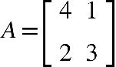

1. **Finding the Eigenvalues**:

We solve

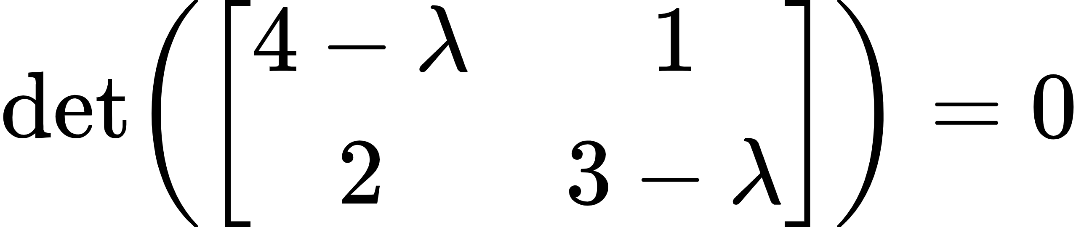

Expanding the determinant:

Solving this quadratic equation:

2. Finding the **Eigenvectors**:

- For :

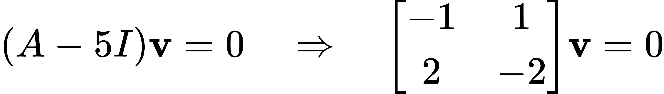

A possible eigenvector is

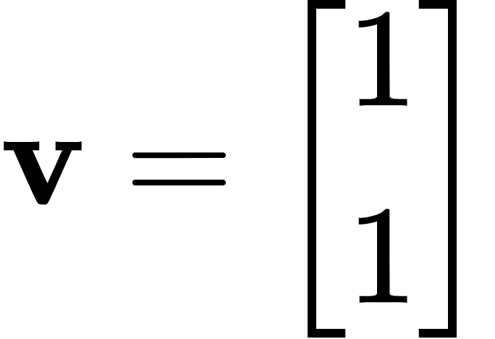

For

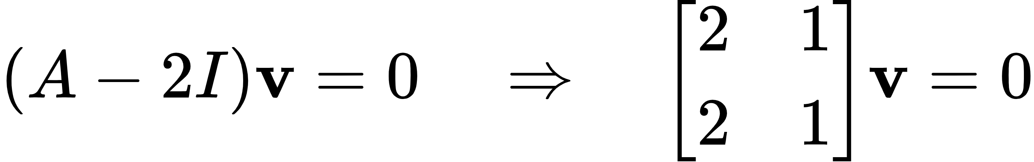

A possible eigenvector is

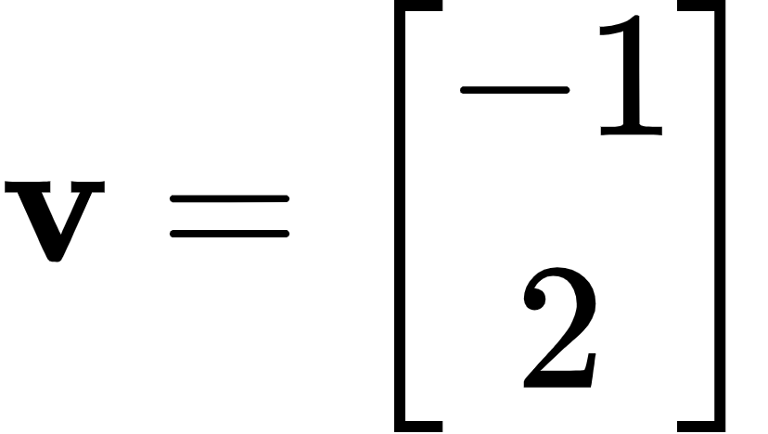

**Here's a breakdown of why this equation holds and what it signifies:**

The transformation matrix affects the eigenvector by scaling it, and that's precisely what the equation encapsulates.

1. Transformation Nature: When you apply a matrix to any vector , it typically transforms by rotating and scaling it within its space. However, for certain special vectors (the eigenvectors), this transformation simplifies to mere scaling.

2. Scaling Effect: In the equation , is a scalar known as the eigenvalue associated with the eigenvector This means that when is applied to \(\mathbf{v}\), the only effect is to stretch or compress by a factor of without any rotation. The direction remains unchanged, although the vector may point in the opposite direction if is negative.

3. Geometric Interpretation: Geometrically, you can think of this operation as if the matrix "sees" the eigenvector as being so aligned with its inherent transformation properties that all it can do is scale it along its direction. This is unlike most other vectors, which would generally be both rotated and scaled.

4. Matrix Decomposition Insight: Understanding eigenvectors and eigenvalues is also crucial in more advanced concepts, like decomposing the matrix into simpler, more interpretable parts (eigen decomposition). This decomposition highlights that the entire action of on its space can be understood fully just by knowing its effects on its eigenvectors.

This special property of eigenvectors being scaled by their corresponding eigenvalues under matrix transformation is what makes them extremely useful in simplifying complex matrix operations and solving systems of linear equations more efficiently. They also play a crucial role in many applications like principal component analysis in statistics, quantum mechanics in physics, and stability analysis in systems engineering.

## Inner Product and Outer Product: Definitions, Differences, and Geometric Interpretations

**Inner Product**

Definition:

The inner product (also called the dot product) of two vectors is a scalar value that measures the cosine of the angle between the two vectors scaled by their magnitudes. For two vectors and in :

Geometric Interpretation:

The inner product can be interpreted geometrically as the projection of one vector onto another. If is the angle between and , then:

Where:

- and are the magnitudes (lengths) of vectors and .

- is the cosine of the angle between the two vectors.

If the inner product is zero, the vectors are orthogonal (perpendicular).

Example:

For vectors

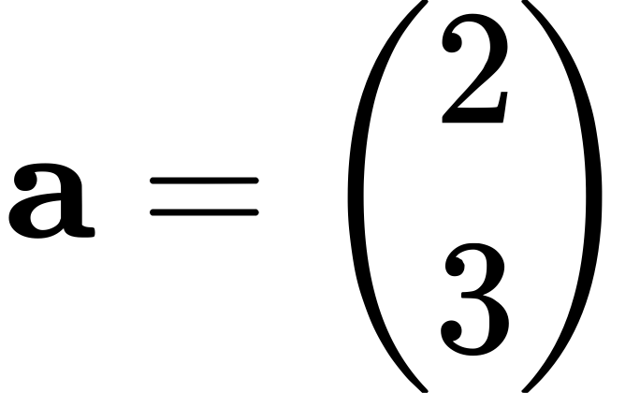

And

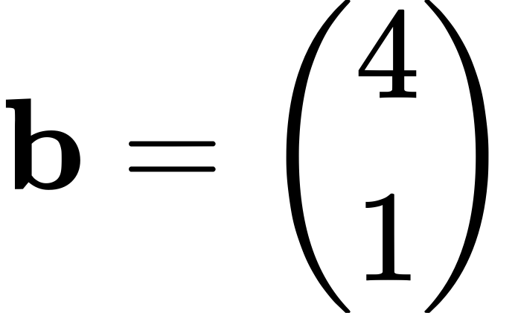

**Outer Product**

Definition:

The outer product of two vectors results in a matrix. For vectors and , the outer product is given by:

Where is a matrix.

Geometric Interpretation:

The outer product creates a matrix where each element is the product of the component of and the component of . This matrix represents the linear combinations of and in a way that spans the space they define.

Example:

For vectors



And





Differences Between Inner and Outer Products

1. Result Type:

- Inner Product: Produces a scalar.

- Outer Product: Produces a matrix.

2. Geometric Meaning:

- Inner Product: Measures the projection of one vector onto another, indicating how much one vector extends in the direction of another.

- Outer Product: Constructs a matrix that represents the linear combinations of two vectors, which can be used to span a higher-dimensional space.

3. Applications:

- Inner Product: Used in calculating angles between vectors, lengths, orthogonality, and in various projections in vector spaces.

- Outer Product: Used in forming matrices in linear algebra, tensor products in physics, and in covariance matrices in statistics.

Geometric Interpretation

1. Inner Product:

- Projection: The inner product can be viewed as the length of the projection of onto scaled by the length of .

- Orthogonality: If the inner product is zero, the vectors are orthogonal (perpendicular).

2. Outer Product:

- Span: The outer product creates a matrix that spans a space defined by the linear combinations of and .

- Basis Expansion: It can be used to expand vectors in terms of a basis in higher-dimensional spaces.

Summary

- Inner Product:

- Produces a scalar.

- Measures projection and orthogonality.

- Example: .

- Outer Product:

- Produces a matrix.

- Constructs a spanning matrix for linear combinations.

- Example:

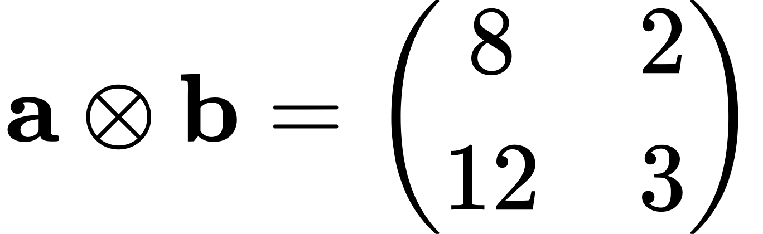

These products are fundamental in various fields such as physics, computer science, and statistics, providing different insights and tools for manipulating and understanding vectors and spaces.

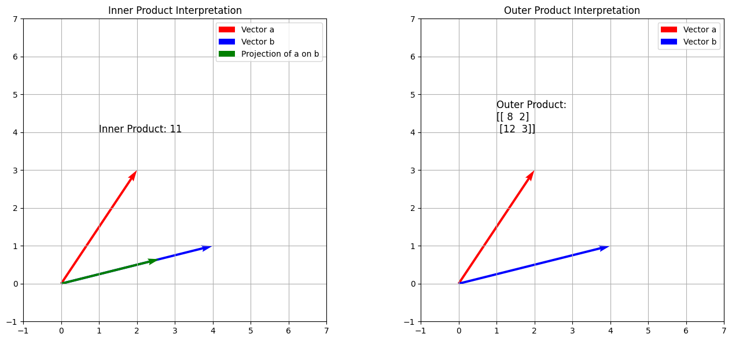

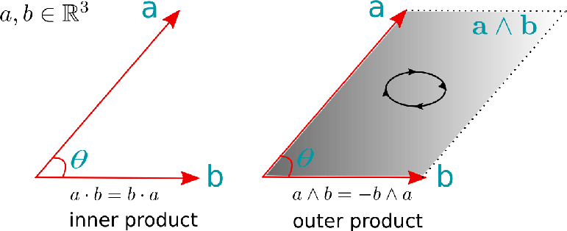

## Matrix:

To make one of the variables (columns) equal to 0 for all samples, you need to multiply the data in such a way that one column becomes zero. Here's the method to achieve this:

### Steps:

1. \*\*Choose the Column to Zero Out\*\*: Decide which variable (column) you want to set to zero.

2. \*\*Multiply the Data with a Transformation Matrix\*\*: Use a transformation matrix that zeroes out the chosen column while keeping the other columns unchanged.

For example, if you want to set the \*\*second variable (second column)\*\* to zero while keeping the others unchanged, you can use the following transformation matrix:

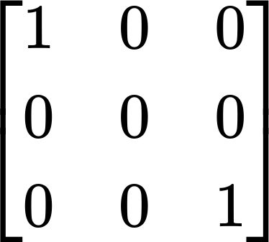

### Explanation:

- The diagonal elements are \*\*1\*\* for the columns you want to keep unchanged.

- The \*\*0\*\* in the second diagonal entry effectively sets all elements in the second column to \*\*0\*\* after multiplication.

Let me implement this transformation for an example dataset.

The transformed data has the second variable (second column) set to zero for all samples:

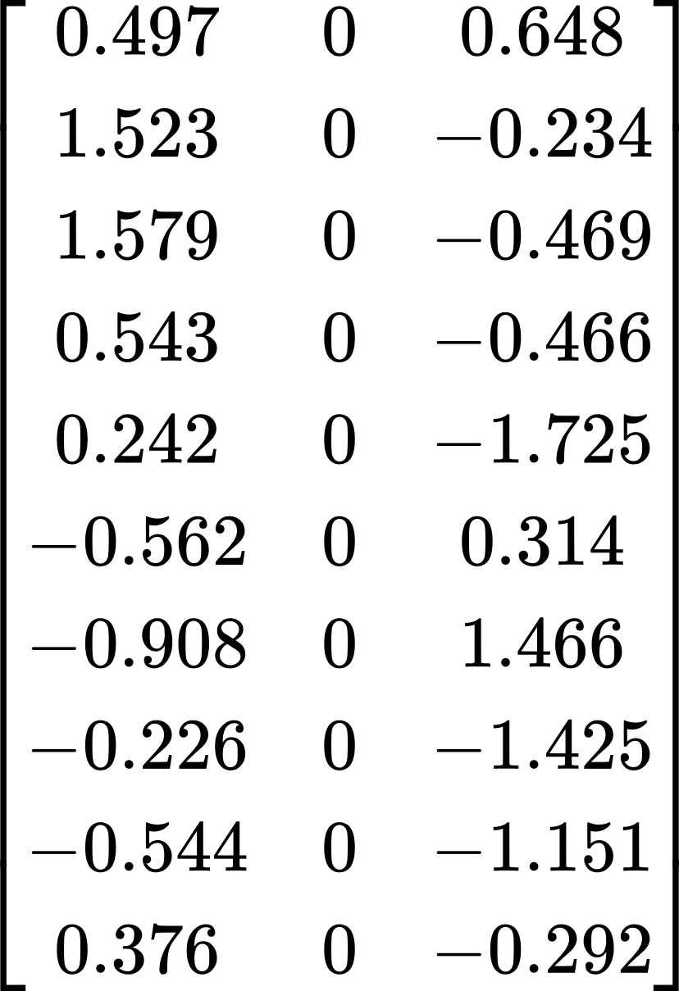

### Explanation:

- The \*\*second column\*\* is completely zeroed out, while the \*\*first and third columns\*\* remain unchanged. This was achieved by multiplying the original data with a transformation matrix that sets the second column to zero.

Yes, you're correct in observing that the diagonal elements of a transformation matrix directly affect the scaling or preserving of the corresponding variables (columns) of the original data matrix. However, the \*\*off-diagonal elements\*\* introduce interactions between the different variables. Let's break down their effects:

### Transformation Matrix Elements and Their Effects

1. \*\*Diagonal Elements\*\*:

- Each diagonal element corresponds to a specific variable in the data matrix.

- A value of \*\*1\*\* keeps the variable unchanged.

- A value of \*\*0\*\* zeroes out that variable.

- Other values \*\*scale\*\* the variable up or down (e.g., a diagonal element of 2 doubles the variable, and 0.5 halves it).

2. \*\*Off-Diagonal Elements\*\*:

- The elements not on the diagonal (i.e., where introduce \*\*mixing or transformation\*\* between different variables.

- An off-diagonal element affects how much the \*\*j-th variable\*\* contributes to the \*\*i-th variable\*\* in the transformed data.

- Essentially, the off-diagonal elements perform a \*\*linear combination\*\* of the columns, introducing a dependency between variables.

### Example to Illustrate Effects

Let's take an example transformation matrix:

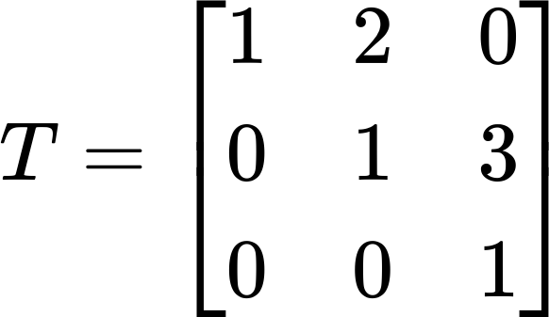

Here's how this transformation matrix affects a data matrix \( D \):

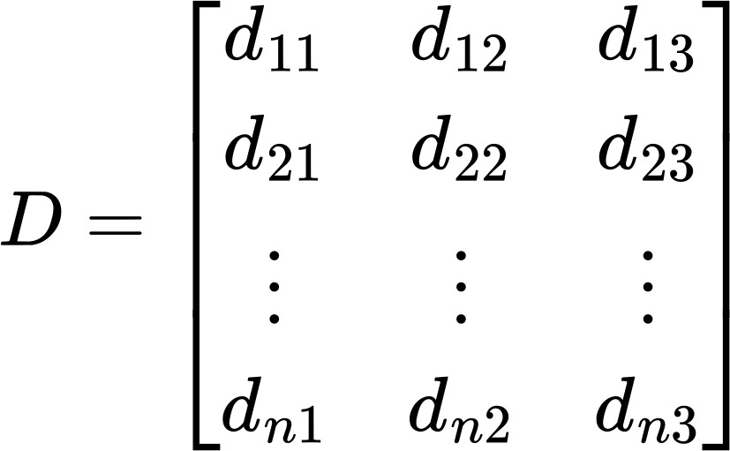

#### Resulting Transformed Data

The resulting data matrix after applying will be:

1. \*\*First Variable (Column 1)\*\*:

- Transformed by combining itself with twice the second variable.

- Each element in the first column of becomes:

2. \*\*Second Variable (Column 2)\*\*:

- Transformed by combining itself with three times the third variable.

- Each element in the second column of becomes:

3. \*\*Third Variable (Column 3)\*\*:

- Remains unchanged because there is no contribution from any other variable.

- Each element in the third column of becomes:

So, the off-diagonal elements introduce \*\*linear dependencies\*\* between variables, which can create correlations or interactions that weren't present in the original data. If you'd like, I can apply this transformation to a data matrix and show you the results.

# Tools

## Mahalanobis

The Mahalanobis distance is a measure of distance that accounts for the correlation between variables in a dataset, making it a powerful tool especially when dealing with multivariate data where the scales of the variables differ, or the variables are not independent.

How Mahalanobis Distance Works Mathematically

Mathematically, the Mahalanobis distance between a point and a distribution with covariance matrix is defined as:

Here's a step-by-step breakdown of this formula:

1. calculates the difference between the point and the mean of the distribution. This difference vector represents how far and in what direction the point deviates from the mean.

2. is the inverse of the covariance matrix This matrix plays a crucial role as it accounts for the variability and correlation of the dataset dimensions. Applying to the difference vector adjusts this vector according to these correlations and variabilities.

3. The product computes a scalar that quantifies the squared distance of the point from the mean, adjusted for the scale and correlation of the data.

4. Taking the square root of this scalar gives the Mahalanobis distance, a measure of how many standard deviations is away from the mean of the distribution.

The main strengths of Mahalanobis distance include:

- Scale-invariance: It is not affected by the scale of the variables, unlike Euclidean distance, which can be heavily influenced by units.

- Correction for correlation: By considering the covariance matrix, it naturally adjusts for any correlations between variables.

- Identifying outliers: It is highly effective for identifying outliers in multivariate data because an outlier will have a larger Mahalanobis distance compared to other points.

**Limitations of Mahalanobis Distance**

The Mahalanobis distance, while a robust metric for measuring the similarity between observations in a multivariate context, does have several limitations that can impact its effectiveness in certain situations. Here are some detailed limitations along with examples and potential solutions:

1. Dependence on Accurate Covariance Estimation

Limitation: Mahalanobis distance relies heavily on the accurate estimation of the covariance matrix. If the covariance matrix is not accurately estimated, perhaps due to the presence of outliers or a small sample size relative to the number of variables, the Mahalanobis distance can become distorted.

Example: Consider a dataset with 100 variables but only 50 observations. The covariance matrix in this case might not be invertible (singular) because there aren't enough data points to estimate the covariance between each pair of variables accurately.

Solution: Regularization techniques such as adding a small constant to the diagonal elements of the covariance matrix (a technique known as "ridge regularization") can help make the covariance matrix invertible. Alternatively, principal component analysis (PCA) can be used to reduce the dimensionality of the data before calculating the Mahalanobis distance, focusing on the most significant directions and avoiding overfitting.

2. Computationally Intensive

Limitation: Calculating Mahalanobis distance involves inverting the covariance matrix, which can be computationally expensive and time-consuming, particularly with large datasets or high-dimensional data.

Example: In real-time systems or applications where speed is crucial, such as in certain types of machine learning algorithms running on large datasets, the computational cost of inverting a large covariance matrix may be prohibitive.

Solution: Approximate methods such as using the pseudo-inverse instead of the full inverse, or employing numerical optimization techniques that approximate the inverse, can reduce computational load. Additionally, dimensionality reduction prior to applying Mahalanobis distance can simplify the calculations.

3. Sensitivity to Outliers

Limitation: The covariance matrix can be unduly influenced by outliers in the data, as these can skew the covariance calculations, leading to an inaccurate measure of distance.

Example: In a dataset representing human heights and weights, a few data points of extremely high values can skew the overall data distribution, leading to a covariance matrix that does not represent the majority of the data points accurately.

Solution: Robust statistics methods, such as using a robust covariance matrix estimator that mitigates the influence of outliers (like the Minimum Covariance Determinant estimator), can help address this issue. Alternatively, preprocessing data to remove or mitigate outliers before calculating Mahalanobis distance can be beneficial.

4. Assumption of Multivariate Normality

Limitation: The effectiveness of the Mahalanobis distance is optimal when the underlying data distribution is multivariate normal. For distributions that deviate significantly from normality, the metric might not accurately reflect true similarities.

Example: In a dataset where the data are heavily skewed or have heavy tails, the Mahalanobis distance might not effectively identify outliers or calculate distances accurately because the scale and shape of the distribution are not captured well by the mean and covariance alone.

Solution: Transforming the data to more closely approximate a normal distribution, or using distance metrics that do not assume normality, can be an alternative. Non-parametric methods that do not rely on assumptions about the data distribution can also be considered.

These limitations highlight the importance of understanding the data characteristics and the context in which Mahalanobis distance is being used. While there are no one-size-fits-all solutions, these approaches can help mitigate the limitations where appropriate.

**Comparison to Euclidean Distance**

The Mahalanobis distance reduces to the Euclidean distance when the covariance matrix is the identity matrix In this case, the formula simplifies to:

This happens when all variables are uncorrelated and have the same variance (i.e., the variance of each variable is 1). Under these conditions, the Mahalanobis distance is equivalent to measuring the standard Euclidean distance in rescaled coordinates where each variable is independent and identically scaled.

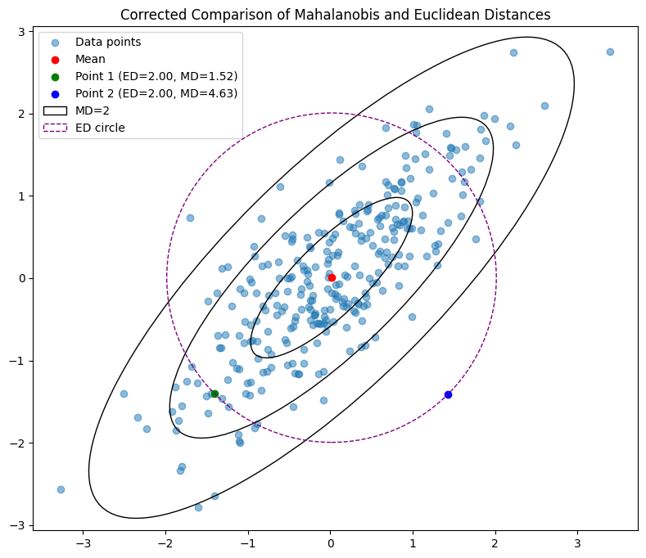

Here’s a detailed look at what the term , does and its connection to the concept of eigenvalues and eigenvectors.

**Function of in Mahalanobis Distance**

The covariance matrix captures the variance of each variable along its diagonal and the covariance between variables in the off-diagonal elements. When is applied to a vector, it scales each element of the vector according to the variance of the corresponding variable and shifts elements to account for covariances between variables. Therefore, encodes how variables are spread and how they are linearly related.

In contrast, the inverse of the covariance matrix, effectively "undoes" this scaling and shifting. Specifically:

1. Scaling: Each variable is rescaled inversely to its variance. If a variable has a high variance, reduces its influence by scaling it down, ensuring that no single variable with large variance dominates the distance measurement.

2. De-correlating: The off-diagonal elements that represent covariance are adjusted to minimize the influence of linear relationships between different variables. This adjustment means that effectively rotates the coordinate system to align with the principal axes of the data (which are defined by the eigenvectors of where the influence of covariances is neutralized.

Relationship with Eigenvalues and Eigenvectors

The eigenvectors and eigenvalues of the covariance matrix have a fundamental relationship with the Mahalanobis distance. The eigenvectors of define the directions of the principal axes of the data distribution, and the eigenvalues indicate the variance explained by each of these directions.

When you apply to the vector what you are effectively doing is transforming this vector into a new coordinate system aligned along these principal axes. Each component of the transformed vector is then scaled by the inverse of the corresponding eigenvalue. This means that:

- Large eigenvalues (which correspond to directions of high variance) have a smaller effect in the transformed space because their inverse is smaller.

- Small eigenvalues (which correspond to directions of low variance) have a greater effect in the transformed space because their inverse is larger.

This process ensures that each dimension contributes equally to the distance calculation, free from the influence of differing variances and the linear relationships among the variables. In simpler terms, Mahalanobis distance considers not just how far points are but also the structure of the data set itself, providing a more nuanced measure of distance.

Thus, Mahalanobis distance can be understood as a way of measuring distance that is invariant to the scale of the data and sensitive to the shape of the data distribution as defined by its covariance structure. The use of ensures that this distance reflects how data are distributed in every direction, not just in terms of simple Euclidean space.

**Applications of the Mahalanobis**

The Mahalanobis distance is a versatile statistical measure that has a wide range of applications in various fields. Its ability to take into account the correlations between variables and scale the distances appropriately makes it particularly useful in contexts where standard Euclidean distance would fall short. Here are some detailed applications of the Mahalanobis distance with examples:

**1. Outlier Detection**

Application: Mahalanobis distance is extensively used to identify outliers in multivariate data. Since it measures distances incorporating the covariance among variables, it can effectively spot outliers that deviate in more subtle ways than just having extreme values.

Example: In finance, an investment firm might analyze portfolios containing various assets. The Mahalanobis distance can help identify portfolios that deviate from typical asset allocations. If a particular portfolio's asset distribution significantly deviates from the mean distribution of the majority, flagged by a large Mahalanobis distance, it could indicate risky investments or potential data entry errors.

**2. Cluster Analysis**

Application: In clustering tasks, Mahalanobis distance can be used to form clusters of similar data points, particularly useful in the presence of correlated variables. It helps in defining more natural clusters that account for the inherent structure of the data.

Example: In marketing, customer segmentation can be performed based on purchasing behavior, age, income, etc. By using Mahalanobis distance, clusters of customers with similar profiles can be created, considering the relationships between different spending habits and demographics. This approach can lead to more meaningful segments for targeted marketing campaigns.

**3. Multivariate Anomaly Detection**

Application: Mahalanobis distance is used in multivariate anomaly detection, where monitoring systems track multiple indicators simultaneously. It is particularly effective when the indicators are expected to exhibit some degree of correlation.

Example: In a manufacturing process, sensors might collect data on various aspects of a machine's operation like temperature, pressure, and vibration levels. The Mahalanobis distance can help detect anomalies by spotting when the current state of the machine deviates from typical operating conditions, suggesting a potential failure or the need for maintenance.

**4. Classification Problems**

Application: In statistical classification, Mahalanobis distance can be used to classify observations into predefined groups. This is particularly effective in discriminant analysis, where groups are defined by their means and covariance matrices.

Example: In medical diagnostics, patient data with multiple health indicators can be classified into risk categories for diseases. Mahalanobis distance can differentiate between patient groups with differing health profiles, helping to diagnose based on how statistically unusual their health indicators are relative to known affected and unaffected groups.

**5. Image Recognition**

Application: Mahalanobis distance is useful in image recognition tasks to measure the similarity between features of images. It can compare the distribution of features in an image against known classifications, making it robust against variations in lighting, orientation, or scale.

Example: In facial recognition technology, features extracted from images of faces can be compared using Mahalanobis distance to a database of known faces. This method can more accurately identify individuals by accounting for variations in the images due to angle and lighting, as these features are often correlated.

**6. Quality Control**

Application: In quality control processes, Mahalanobis distance can be used to ensure that products meet multivariate specifications. It provides a comprehensive measure that can take into account multiple correlated dimensions of quality.

Example: In food production, characteristics like weight, size, color, and texture are important. The Mahalanobis distance can help determine whether a batch of products falls within acceptable quality ranges defined by these correlated characteristics, identifying batches that are outliers and may not meet the required standards.

These applications demonstrate how Mahalanobis distance is a powerful tool in areas requiring consideration of correlations and scaling in multivariate spaces. Its ability to provide a nuanced view of distances between observations makes it invaluable in these contexts.

### Relationship between the likelihood ratio and the Mahalanobis distance in the context of multivariate normal distributions. Let's explore this relationship step by step.

**Multivariate Normal Distribution**

For a multivariate normal distribution with mean vector and covariance matrix , the probability density function is given by:

**Likelihood Ratio**

The likelihood ratio compares the likelihoods of the data under two different hypotheses: the in-control process (with parameters and and the out-of-control process (with parameters and ).

For the in-control process:

For the out-of-control process:

The likelihood ratio is:

Simplifying the Likelihood Ratio

First, note the determinant relationship:

Then, the likelihood ratio becomes:

**Mahalanobis Distance**

The Mahalanobis distance is defined as:

Relationship Between Likelihood Ratio and Mahalanobis Distance

From the simplified likelihood ratio:

This shows that the likelihood ratio includes the Mahalanobis distance as a key component. Specifically, the term in the likelihood ratio is exactly the Mahalanobis distance, which measures how far is from the mean in the context of the covariance matrix .

**Interpretation**

- The likelihood ratio quantifies the change in likelihood between the in-control and out-of-control processes.

- The Mahalanobis distance measures the "distance" of a point from the mean, normalized by the covariance matrix, indicating how unusual the point is.

- In control charts like CUSUM, the Mahalanobis distance helps to detect shifts in the mean or variance by providing a normalized measure of deviation.

Thus, the Mahalanobis distance is embedded in the likelihood ratio, serving as a core measure of deviation from the expected process behavior.

## The L1-Norm

The L1-norm, often referred to as the Manhattan norm or taxicab norm, is another way to measure the magnitude of vectors. Unlike the L2-norm, which calculates the straight-line distance (as in Euclidean distance), the L1-norm sums the absolute values of the vector's components. This gives the total distance traveled along each axis to get from the origin to the point represented by the vector.

**Definition**

For a vector is defined as:

This formula effectively calculates the total distance traveled in a grid-like path (akin to moving along city blocks) from the origin to the point defined by the vector coordinates.

**Properties of the L1-Norm**

- Positive definiteness: if and only if all components of are zero.

- Triangle inequality: , which states that the norm of the sum of two vectors is at most the sum of the norms of these vectors.

- Homogeneity: for any scalar meaning that scaling a vector by a constant scale the L1-norm by the absolute value of that constant.

**Applications**

- Compressed Sensing: The L1-norm is crucial in compressed sensing, where it is used to promote sparsity in solutions to underdetermined systems. This application exploits the property of the L1-norm being more likely to yield sparse solutions than the L2-norm.

- Optimization Problems: Many optimization problems, particularly those involving linear programming, use the L1-norm to formulate constraints or objectives that are robust to outliers.

- Machine Learning: In machine learning, particularly in regression models like Lasso (Least Absolute Shrinkage and Selection Operator), the L1-norm is used as a regularization term to encourage simpler models that may perform better on new data.

- Robust Statistics: The L1-norm is often used in statistics to develop robust statistical methods that are less sensitive to outliers in the data.

**Example Calculation**

Consider a vector is calculated as follows:

This result represents the total distance one would travel, moving along axes, from the origin to the point (-3, 4, -1) in a three-dimensional grid.

The L1-norm provides a useful alternative to the L2-norm when the goal is to emphasize each component's contribution equally without squaring their values, which amplifies larger differences and dampens smaller ones found in the L2-norm.

## The L2-norm

The L2-norm, also known as the Euclidean norm, is a measure of the magnitude of a vector. It's calculated from the square root of the sum of the squares of the vector's components. This norm is widely used in mathematics, physics, engineering, and statistics for determining the length of a vector in Euclidean space.

**Definition**

For a vector , the L2-norm is defined as:

This formula effectively calculates the Euclidean distance of the vector from the origin of the vector space.

**Properties of the L2-Norm**

- Positive definiteness: if and only if

- Triangle inequality: .

- Homogeneity:

**Applications**

- Distance Measurement: The L2-norm is used to calculate the straight-line distance between points in Euclidean space, which is important for many applications in physics and engineering.

- Machine Learning: In machine learning and statistics, the L2-norm is used in various algorithms, including as a regularization term in linear regression (Ridge regression) to prevent overfitting by penalizing large coefficients.

- Signal Processing: In signal processing, the L2-norm of a signal can represent its energy or power when the signal is represented as a vector of amplitude values.

**Example Calculation**

Consider a vector is calculated as follows:

This computation shows that the length or magnitude of the vector from the origin to the point (3, 4) in a 2D Cartesian plane is 5 units.

The L2-norm is an essential tool for quantifying the size of vectors in many areas of science and technology, providing a fundamental measure that extends to various applications beyond just the length of a vector.

## L∞ Norm (Max Norm)

- Description: This norm measures the maximum absolute value among the elements of a vector. It is often referred to as the infinity norm or max norm.

- Mathematical Formula:

- Example:

- Vector:

- Calculation: The L∞ norm of this vector is the maximum absolute value of its elements. Here, it is because the absolute value of is the highest.

## Lp Norm (General p Norm)

- Description: The Lp norm is a general form of vector norms defined for any positive real number . It becomes the Euclidean norm when and the Manhattan norm when \.

- Mathematical Formula:

- Example:

- Vector:

- p-value:

- Calculation:

## L0 Norm

- Description: The L0 "norm" counts the number of non-zero elements in the vector. It is not a true mathematical norm because it does not satisfy all norm properties, such as homogeneity.

- Mathematical Formula:

- Example:

- Vector:

- Calculation: The L0 norm is the count of non-zero elements, which are 2, 4, and 5. Thus,

## Frobenius Norm

- Description: This norm is used for matrices and is analogous to the L2 norm for vectors. It measures the "size" of a matrix using the square root of the sum of the absolute squares of its elements.

- Mathematical Formula:

- Example:

- Matrix:

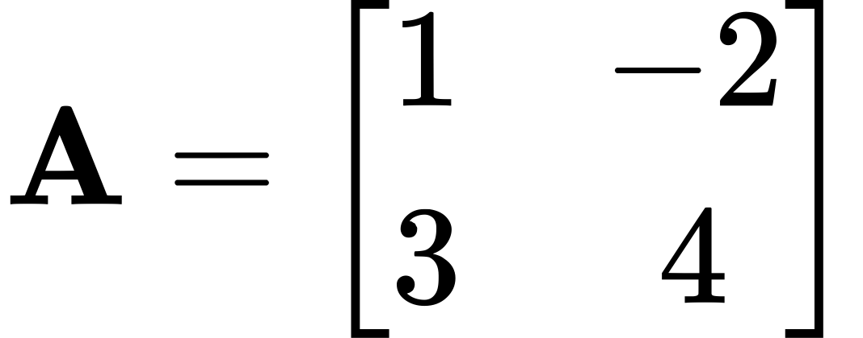

- Calculation:

## Lasso

### What is LASSO?

LASSO stands for Least Absolute Shrinkage and Selection Operator. It's a statistical method used primarily for two things:

1. Regression analysis: This means LASSO helps in finding the relationship between a set of predictor variables and a target variable.

2. Feature selection: This means LASSO helps identify which variables are important in predicting the target variable.

### Why Use LASSO?

In many real-world problems, especially those with many variables, not all variables contribute equally to understanding the problem. Some variables might be irrelevant or redundant. LASSO helps by not only building a model but also by automatically selecting which variables should be included in the model.

### How Does LASSO Work?

LASSO works by adding a penalty to the traditional least squares method used in regression. Here's a simple way to understand the process:

1. Traditional Least Squares: Imagine you have data on house prices and features like size, location, number of rooms, age of the house, etc. You want to predict house prices based on these features. The traditional least squares approach tries to find a line (or hyperplane in multiple dimensions) that best fits the data by minimizing the sum of the squared differences between the observed values and the values predicted by the line.

2. Adding a LASSO Penalty: LASSO modifies this by adding a penalty for the size of the coefficients in the regression model. The penalty is proportional to the absolute values of the coefficients. This penalty forces some of the coefficient estimates to be exactly zero. That means LASSO is not only trying to fit the data well but also trying to do so with as few variables as possible.

### Mathematical Formulation

If you have a set of observations (e.g., house prices) and predictors (e.g., house features), LASSO solves the following optimization problem:

Where:

- are the coefficients for each predictor.

- is the value of predictor for observation .

- is a tuning parameter that controls the strength of the penalty. As increases, more coefficients are set to zero.

Choosing the Right

The choice of is crucial in LASSO:

- A very small makes LASSO similar to traditional least squares, potentially leading to a model with many predictors.

- A very largecan make too many coefficients zero, possibly ignoring important predictors.

Typically, is chosen through a process called cross-validation, where different values of are tested to see which produces the best model for predicting data not used to fit the model.

### Conclusion

LASSO is particularly useful when you suspect that only a subset of your variables are truly important, or when you have more variables than observations (a common scenario in modern datasets). By combining prediction accuracy with model simplicity, LASSO helps create more interpretable models, making it a popular choice in both statistics and machine learning.

# Statics Tests

## **T-test vs. Hotelling's T² Test**

**T-test**

The T-test is used to compare the means of two groups or to compare a group mean against a hypothetical mean. It assesses whether the means of two groups are statistically different from each other.

Mathematical formula for a two-sample T-test:

where:

**The pooled standard deviation**

The pooled standard deviation is a weighted average of the standard deviations from two independent groups, and it's used in t-tests (specifically the independent two-sample t-test) to estimate a common variance when the variances of the two groups are assumed to be equal.

It provides a single estimate of the standard deviation that combines the variability from both groups, which is especially useful when the sample sizes of the groups differ.

Formula for Pooled Standard Deviation

S\_p = \sqrt{\frac{(n\_1 - 1) s\_1^2 + (n\_2 - 1) s\_2^2}{n\_1 + n\_2 - 2}}

\]

Where:

- \( S\_p \) is the pooled standard deviation.

- \( n\_1, n\_2 \) are the sample sizes of the two groups.

- \( s\_1, s\_2 \) are the standard deviations of the two groups.

- \( n\_1 - 1 \) and \( n\_2 - 1 \) are the degrees of freedom for each group.

- The denominator \( n\_1 + n\_2 - 2 \) is the total degrees of freedom for the pooled variance estimate.

Steps to Calculate the Pooled Standard Deviation:

1. Compute the variances for each group: \( s\_1^2 \) and \( s\_2^2 \).

2. Weight the variances by their degrees of freedom, which is \( n\_1 - 1 \) for the first group and \( n\_2 - 1 \) for the second group.

3. Sum the weighted variances and divide by the total degrees of freedom (\( n\_1 + n\_2 - 2 \)).

4. Take the square root of the result to get the pooled standard deviation.

Example:

Suppose you are comparing the heights of men and women in two different samples:

- Sample 1 (Men): \( n\_1 = 10 \), \( s\_1 = 5 \) cm.

- Sample 2 (Women): \( n\_2 = 12 \), \( s\_2 = 4 \) cm.

The pooled standard deviation would be:

1. Calculate the squared standard deviations (variances):

s\_1^2 = 5^2 = 25, \quad s\_2^2 = 4^2 = 16

2. Plug into the formula:

S\_p = \sqrt{\frac{(10 - 1) \times 25 + (12 - 1) \times 16}{10 + 12 - 2}}

S\_p = \sqrt{\frac{9 \times 25 + 11 \times 16}{20}}

S\_p = \sqrt{\frac{225 + 176}{20}} = \sqrt{\frac{401}{20}} = \sqrt{20.05} \approx 4.48

The pooled standard deviation is approximately 4.48 cm.

When to Use Pooled Standard Deviation:

- Equal Variance Assumption: You use the pooled standard deviation when you assume the two groups have equal variances. This is a common assumption in the independent t-test.

- T-Test: In the formula for the independent two-sample t-test, the pooled standard deviation is used to calculate the standard error of the difference between two means.

Why Use Pooled Standard Deviation?

The pooled standard deviation combines the information from both groups to give a better overall estimate of the variability when the sample sizes or variances are not too different. It assumes that the true variance in both groups is the same, which allows for more precise estimates in hypothesis testing (e.g., the t-test).

If the assumption of equal variances doesn't hold, you'd use a Welch’s t-test, which doesn't rely on the pooled standard deviation and adjusts for unequal variances.

**More:**

A t-test is a statistical test used to determine whether there is a significant difference between the means of two groups. It is often used when the sample size is small and the population standard deviation is unknown. The t-test helps to determine if the observed difference between two sample means is likely to have occurred by random chance, or if it reflects a true difference in the populations from which the samples were drawn.

Types of t-tests:

1. One-Sample t-test:

- Tests whether the mean of a single group differs significantly from a known or hypothesized population mean.

- Example: Checking if the average weight of a sample of apples differs from a known average weight of apples (e.g., 150 grams).

2. Independent (Two-Sample) t-test:

- Compares the means of two independent groups to see if they are significantly different from each other.

- Example: Testing if the average height of men is different from the average height of women in a population.

3. Paired t-test:

- Compares the means of the same group at different times (or under different conditions) to see if there is a significant change.

- Example: Testing whether a training program affects test scores by comparing the scores of the same group of students before and after the program.

Formula for t-test:

The t-statistic is calculated as:

t = \frac{\bar{x}\_1 - \bar{x}\_2}{\sqrt{\frac{s\_1^2}{n\_1} + \frac{s\_2^2}{n\_2}}}

\]

Where:

- \( \bar{x}\_1, \bar{x}\_2 \) are the sample means.

- \( s\_1^2, s\_2^2 \) are the sample variances.

- \( n\_1, n\_2 \) are the sample sizes.

For a one-sample t-test, the formula is simpler:

t = \frac{\bar{x} - \mu\_0}{s/\sqrt{n}}

\]

Where:

- \( \bar{x} \) is the sample mean.

- \( \mu\_0 \) is the hypothesized population mean.

- \( s \) is the sample standard deviation.

- \( n \) is the sample size.

Key Assumptions:

- The data should be approximately normally distributed (especially important for small sample sizes).

- The variances of the two groups should be approximately equal for the independent t-test (though this assumption can be relaxed with a Welch’s t-test).

- The observations should be independent of each other.

Steps in a t-test:

1. State the null hypothesis (H₀): Typically, the null hypothesis states that there is no difference between the means of the two groups (e.g., \( \mu\_1 = \mu\_2 \)).

2. State the alternative hypothesis (H₁): This suggests that there is a significant difference between the means (e.g., \( \mu\_1 \neq \mu\_2 \)).

3. Compute the t-statistic: Using the formula based on your data, calculate the t-statistic.

4. Determine the degrees of freedom (df):

- For an independent t-test: \( df = n\_1 + n\_2 - 2 \).

- For a one-sample t-test: \( df = n - 1 \).

5. Compare with the critical value: Use a t-distribution table to find the critical t-value based on your significance level (e.g., \( \alpha = 0.05 \)) and degrees of freedom.

6. Make a decision: If the calculated t-value is greater than the critical value, you reject the null hypothesis, indicating a significant difference. If not, you fail to reject the null hypothesis.

Example:

Imagine you want to test if the average score on a math test is significantly different from 75. You have a sample of 10 students, and their average score is 80 with a standard deviation of 10.

- Null hypothesis: \( H\_0: \mu = 75 \)

- Alternative hypothesis: \( H\_1: \mu \neq 75 \)

- Sample mean (\( \bar{x} \)) = 80, hypothesized mean (\( \mu\_0 \)) = 75, sample size (\( n \)) = 10, standard deviation (\( s \)) = 10.

Calculate the t-statistic:

t = \frac{80 - 75}{10/\sqrt{10}} = \frac{5}{3.16} \approx 1.58

\]

Compare this value with the critical value from the t-distribution table at 9 degrees of freedom and a chosen significance level (e.g., 0.05).

If the calculated t-value exceeds the critical value, you reject the null hypothesis, indicating the average score is significantly different from 75.

Let me know if you want to see this with real data!

**Hotelling’s T² test:**

Hotelling's T² test is the multivariate equivalent of the T-test, used when dealing with multiple continuous variables. It compares the mean vectors of two groups.

Mathematical formula for Hotelling’s T² test:

where:

### Relationship with Euclidean and Mahalanobis Distances

Euclidean Distance:

Used in the T-test when considering the difference between two scalar means. It is the ordinary straight-line distance between two points.

Mahalanobis Distance:

Used in the context of Hotelling’s T² test. It is a measure of distance between a point and a distribution.

Connection:

where the Mahalanobis distance between the mean vectors. This shows how Hotelling’s T² statistic is a scaled square of the Mahalanobis distance, reflecting how the variables interrelate.

### F-distribution

**Definition:**

The F-distribution is used to determine the statistical significance in tests that compare variances, such as ANOVA, regression analysis, and comparing two sample variances.

Mathematical Context:

Use in Hotelling's T² Test:

When converting the T² statistic to an F-statistic:

This transformation allows the use of F-distribution tables to find critical values or p-values, making the Hotelling’s T² test results interpretable and comparable to those of other statistical tests.

### Example Use Case: ANOVA

In an ANOVA test comparing the effect of different treatments (e.g., fertilizers on plant growth), you calculate the F-statistic by comparing the variance between treatment means to the variance within treatments, helping decide if different treatments have significantly different effects.

This detailed recap provides a structured summary of the statistical tests and concepts discussed, along with their mathematical underpinnings. You can copy this for your reference and further study.

Let's provide numerical examples with detailed solutions for the T-test, Hotelling’s T² test, and use of the F-distribution in ANOVA, enhancing your understanding with concrete data.

### Example of a T-test

Scenario:

Comparing the scores of two groups of students to determine if a new teaching method (Method B) significantly outperforms the traditional one (Method A).

Data:

- Method A: [84, 76, 89, 91, 87]

- Method B: [92, 88, 83, 85, 90]

Hypotheses:

Alternative Hypothesis (difference in means)

Calculations:

1. Mean:

2. Standard Deviation:

3. Pooled Standard Deviation:

4. T-statistic:

5. Conclusion:

- With a t-statistic of -0.81 and degrees of freedom \(df = 8\), if we look up a t-table for a 95% confidence level (critical t-value \(\approx \pm2.306\)), since \(-0.81\) is not greater than \(2.306\), we fail to reject \(H\_0\).

### Example of Hotelling’s T² Test

Scenario:

Comparing the performance of students in two subjects, Math and Science, to see if teaching Method A differs from Method B.

Data:

- Method A: Math: [82, 77, 93], Science: [78, 72, 88]

- Method B: Math: [75, 80, 85], Science: [70, 75, 80]

Calculations:

1. Mean Vectors:

2. Covariance Matrices:

- Sample covariance matrices calculated for each group; pooled covariance \( S \) calculated as average of these matrices.

3. Hotelling’s T² Statistic:

- Using pooled covariance and the formula:

- Assume a computed value.

4. Convert to F-statistic and Conclusion:

- Conversion to F-statistic using degrees of freedom (df1=2, df2=4) and testing against critical F-values.

Example of ANOVA Using F-distribution

Scenario:

Testing the effect of three different fertilizers on plant growth.

Data:

- Fertilizer A: [20, 30, 25]

- Fertilizer B: [35, 45, 40]

- Fertilizer C: [25, 20, 30]

Calculations:

1.Calculate Overall Mean and Between Group Variance.

2. Within Group Variance Calculation.

3. F-statistic:

-

- Compute and compare to critical F-value.

### Conclusion:

- If F-statistic is significant, conclude that different fertilizers have significantly different effects on plant growth.

These examples offer detailed calculations and outcomes for the T-test, Hotelling’s T² test, and the use of the F-distribution in ANOVA, providing a solid numerical foundation for understanding these statistical tests.

### Why we need t test? Why not just compare means which each other’s?

A \*\*t-test\*\* is necessary to determine whether the difference between means of two groups is statistically significant, rather than just due to random variation. Simply comparing means without statistical testing can be misleading because differences in means might occur by chance, especially when dealing with small samples.

Here are key reasons why a \*\*t-test\*\* is needed instead of just comparing means:

### 1. \*\*Random Variation and Noise\*\*:

- \*\*Raw comparison of means\*\* doesn't account for variability in the data (the spread or standard deviation). A small difference in means could just be due to random chance, especially in small samples.

- A \*\*t-test\*\* incorporates the variability in the data and helps you determine whether the observed difference is large enough to be considered statistically significant (i.e., unlikely to have occurred by chance).

### 2. \*\*Sample Size\*\*:

- \*\*Means alone\*\* don’t take into account the size of the sample. A small difference in means can be more meaningful if you have a large sample size, but the same difference in a small sample may not be enough to draw conclusions.

- The \*\*t-test\*\* adjusts for sample size by factoring in the number of observations. Larger sample sizes provide more reliable estimates of the population mean, and the t-test helps ensure that you only consider differences that would likely hold in the population.

### 3. \*\*Statistical Significance\*\*:

- \*\*Means\*\* by themselves don’t tell you whether the difference is statistically significant (i.e., whether the difference is likely to exist in the population from which the samples were drawn).

- A \*\*t-test\*\* gives a \*\*p-value\*\*, which tells you the probability that the observed difference occurred by chance. If this probability (p-value) is lower than a certain threshold (typically 0.05), the difference is considered significant.

### 4. \*\*Incorporating Variance\*\*:

- \*\*Means alone\*\* ignore the spread or variability of the data within each group. If one group has much higher variability than the other, even a small difference in means could be due to this spread rather than a true difference.

- The \*\*t-test\*\* incorporates the \*\*standard deviation\*\* (or variance) of both groups to ensure that we’re not mistaking variability for a real difference in means.

### 5. \*\*Hypothesis Testing\*\*:

- The \*\*t-test\*\* is a formal tool in \*\*hypothesis testing\*\*. When performing a t-test, you establish a \*\*null hypothesis\*\* (typically that the means of two groups are equal) and an \*\*alternative hypothesis\*\* (that the means are different). The test provides a structured way to reject or fail to reject the null hypothesis based on the data.

- Without a t-test, you lack a statistical framework to assess whether the observed difference in means provides enough evidence to conclude that a real difference exists.

### Example:

Suppose you want to compare the test scores of two different classes:

- Class A has an average score of 75, and Class B has an average score of 78.

If you simply compare the means, you might conclude that Class B performed better. However, what if:

- Class A had a standard deviation of 10, and Class B had a standard deviation of 25?

- Class A had 100 students, and Class B had 5 students?

Without a t-test, it would be difficult to know if this difference in means is statistically significant or just due to random variation. The t-test considers both the \*\*spread of the scores\*\* and the \*\*sample sizes\*\*, giving you a p-value to determine if the difference in means is likely to be real.

### Summary of Why You Need a t-Test:

- \*\*Means alone don't account for variability\*\*: The t-test incorporates standard deviation, providing a fuller picture.

- \*\*Means don’t show significance\*\*: The t-test tells you if the difference is statistically significant, beyond random chance.

- \*\*Sample size matters\*\*: The t-test adjusts for how many data points you have, making the results more reliable.

- \*\*Structured hypothesis testing\*\*: The t-test gives you a formal statistical framework to test your hypothesis.

So, in short, while comparing means might give you a quick idea of differences between groups, the \*\*t-test\*\* ensures that these differences are meaningful and not due to random variation.

Let’s break down how the \*\*t-test\*\* mathematically incorporates the aspects we discussed (variance, sample size, and statistical significance) using the \*\*example\*\* of Class A and Class B.

### Example Data:

- \*\*Class A\*\*:

- Sample size \( n\_1 = 100 \)

- Mean \( \bar{x}\_1 = 75 \)

- Standard deviation \( s\_1 = 10 \)

- \*\*Class B\*\*:

- Sample size \( n\_2 = 5 \)

- Mean \( \bar{x}\_2 = 78 \)

- Standard deviation \( s\_2 = 25 \)

### Step-by-Step Calculation:

#### 1. \*\*State the Hypotheses\*\*:

- \*\*Null hypothesis (H₀)\*\*: The means of the two classes are the same.

H\_0: \mu\_1 = \mu\_2

- \*\*Alternative hypothesis (H₁)\*\*: The means of the two classes are different.

H\_1: \mu\_1 \neq \mu\_2

#### 2. \*\*Calculate the Pooled Standard Deviation ( \( S\_p \) )\*\*:

The \*\*pooled standard deviation\*\* is calculated because we assume that both classes have the same underlying variance. The formula for \( S\_p \) is:

S\_p = \sqrt{\frac{(n\_1 - 1) s\_1^2 + (n\_2 - 1) s\_2^2}{n\_1 + n\_2 - 2}}

\]

Plugging in the values:

S\_p = \sqrt{\frac{(100 - 1) \times 10^2 + (5 - 1) \times 25^2}{100 + 5 - 2}}

\]

S\_p = \sqrt{\frac{99 \times 100 + 4 \times 625}{103}}

\]

S\_p = \sqrt{\frac{9900 + 2500}{103}} = \sqrt{\frac{12400}{103}} \approx \sqrt{120.39} \approx 10.97

\]

#### 3. \*\*Calculate the Standard Error (SE)\*\*:

The \*\*standard error\*\* of the difference between the two sample means is calculated as:

SE = S\_p \times \sqrt{\frac{1}{n\_1} + \frac{1}{n\_2}}

\]

Substituting the values:

SE = 10.97 \times \sqrt{\frac{1}{100} + \frac{1}{5}}

\]

SE = 10.97 \times \sqrt{0.01 + 0.2}

\]

SE = 10.97 \times \sqrt{0.21} \approx 10.97 \times 0.458 \approx 5.03

\]

#### 4. \*\*Calculate the t-statistic\*\*:

The \*\*t-statistic\*\* measures how many standard errors the observed difference in means is from zero (no difference). The formula for the t-statistic is:

t = \frac{\bar{x}\_1 - \bar{x}\_2}{SE}

\]

Substitute the values:

t = \frac{75 - 78}{5.03} = \frac{-3}{5.03} \approx -0.596

\]

#### 5. \*\*Degrees of Freedom (df)\*\*:

The \*\*degrees of freedom\*\* for the t-test is \( n\_1 + n\_2 - 2 \):

df = 100 + 5 - 2 = 103

\]

#### 6. \*\*Find the Critical Value and p-value\*\*:

Using a \*\*t-distribution table\*\* (or a calculator) for a two-tailed test with \( df = 103 \) and a significance level of 0.05, the \*\*critical value\*\* of t is approximately ±1.984.

Now compare the calculated t-statistic (-0.596) to the critical value (±1.984).

- Since \( -0.596 \) is between -1.984 and 1.984, we \*\*fail to reject the null hypothesis\*\*. This means the difference between the means is \*\*not statistically significant\*\*.

#### 7. \*\*Conclusion\*\*:

- Even though the \*\*mean difference\*\* between Class A and Class B is 3 points (75 vs. 78), the \*\*t-test\*\* shows that this difference is \*\*not statistically significant\*\* because it could easily occur due to the variability in the data and the small sample size of Class B.

- The t-test also shows that \*\*sample size\*\* matters. Class B has a much smaller sample size, leading to a larger standard error, which makes it harder to detect significant differences.

### Why Did the t-Test Consider Variance and Sample Size?

- \*\*Pooled Standard Deviation\*\*: The calculation of \( S\_p \) takes into account the variability within both groups. The standard deviation of Class B is much larger (25 vs. 10), which increases the pooled standard deviation. This results in a larger standard error, making the difference between the means less significant.

- \*\*Standard Error\*\*: The \*\*standard error\*\* also accounts for the difference in sample sizes. Since Class B has only 5 students, the term \( \frac{1}{n\_2} \) in the formula is larger, making the standard error larger and reducing the likelihood of detecting a significant difference.

Thus, the t-test combines both \*\*variance\*\* and \*\*sample size\*\* to provide a robust measure of whether the difference between means is statistically significant.

### how SE is calculated focusing on the intuition of it

The \*\*Standard Error (SE)\*\* measures the accuracy with which a sample represents a population. It quantifies the uncertainty or variability of a sample statistic, like the mean. In simple terms, the SE tells us how much the sample mean is expected to vary from the true population mean if we were to take multiple samples from the same population.

Let’s break down the \*\*intuition\*\* behind the SE, focusing on how it reflects \*\*sample size\*\* and \*\*variability\*\*:

### 1. \*\*Why Do We Need the Standard Error?\*\*

Imagine you take multiple samples from a population. Each time, the mean of the sample (\( \bar{x} \)) might be slightly different due to random sampling variation. The \*\*Standard Error\*\* tells you, on average, how much these sample means would differ from the true population mean (\( \mu \)).

#### Key Intuition:

- If your sample size is large, each sample is more likely to closely represent the population, and thus the SE will be \*\*smaller\*\*.

- If your sample size is small, there’s more uncertainty, so the SE will be \*\*larger\*\*.

- If the data in your sample are very spread out (i.e., high variance or standard deviation), your sample mean is more likely to differ from the population mean, making the SE \*\*larger\*\*.

### 2. \*\*Formula for Standard Error of the Mean:\*\*

For a single sample, the \*\*Standard Error of the Mean (SE)\*\* is given by:

SE = \frac{s}{\sqrt{n}}

\]

Where:

- \( s \) is the sample standard deviation (a measure of the variability in the data).

- \( n \) is the sample size.

For two samples, as in a t-test comparing two groups, the SE incorporates both sample sizes and their standard deviations. The formula for the \*\*combined SE\*\* (as in an independent t-test) is:

SE = S\_p \times \sqrt{\frac{1}{n\_1} + \frac{1}{n\_2}}

\]

Where:

- \( S\_p \) is the pooled standard deviation (which combines the variability of both groups).

- \( n\_1 \) and \( n\_2 \) are the sample sizes of the two groups.

### 3. \*\*Breaking Down the Intuition Behind the SE Formula\*\*

#### a. \*\*Sample Size (\( n \)) and SE:\*\*

- The formula involves dividing by the square root of the sample size, \( \sqrt{n} \).

- \*\*Larger sample sizes\*\* reduce the SE. Intuitively, a larger sample gives a more precise estimate of the population mean, so the SE decreases.

\*\*Example\*\*: If you sample 100 people from a population, your estimate of the population mean is more reliable than if you only sample 5 people. This is why \( n \) appears in the denominator: a larger sample size reduces the uncertainty of the sample mean.

- Conversely, \*\*smaller samples\*\* increase the SE because smaller samples are less likely to represent the population accurately. This increases the potential difference between the sample mean and the true population mean.

#### b. \*\*Variability (\( s \)) and SE:\*\*

- The SE also depends on the \*\*standard deviation\*\* \( s \) of the sample.

- \*\*Higher variability\*\* (i.e., more spread out data) means the sample mean could be further from the population mean, so the SE increases.

\*\*Example\*\*: Imagine two classrooms where you are measuring test scores:

- In Classroom A, all students score between 75 and 85 (low variability).

- In Classroom B, students score between 50 and 100 (high variability).

If you take a sample from Classroom A, you’re more likely to get a sample mean close to the population mean because the scores are clustered. In Classroom B, the high variability makes it more likely that your sample mean could be far from the true mean.

- Lower variability decreases the SE, meaning your sample mean is more likely to be close to the population mean.

#### c. \*\*How SE Combines Variability and Sample Size:\*\*

The SE is a balance between how \*\*spread out\*\* the data are (standard deviation) and how much \*\*data\*\* you have (sample size).

- \*\*Small samples with high variability\*\* result in a \*\*large SE\*\*, meaning your sample mean is not very reliable.

- \*\*Large samples with low variability\*\* result in a \*\*small SE\*\*, meaning your sample mean is a good estimate of the population mean.

### 4. \*\*Why Do We Use SE in a t-test?\*\*

The SE is crucial in a \*\*t-test\*\* because it helps standardize the difference between two means by taking into account:

- The \*\*variability\*\* of the data (how spread out the data is in each group).

- The \*\*sample size\*\* (how much data we have from each group).

A t-test compares the difference between the means of two groups relative to the combined SE. Without SE, we’d only look at the raw difference in means, ignoring the uncertainty due to small sample sizes or high variability.

### 5. \*\*Example of How SE Changes:\*\*

Let’s return to the example of Class A and Class B from earlier:

- \*\*Class A\*\* has 100 students, and their scores have a standard deviation of 10.

- \*\*Class B\*\* has 5 students, and their scores have a standard deviation of 25.

\*\*SE Calculation\*\*:

- For Class A, the \( \sqrt{\frac{1}{n\_1}} \) term is small (since \( n\_1 = 100 \)), so the contribution of Class A’s data to the overall SE is small.

- For Class B, the \( \sqrt{\frac{1}{n\_2}} \) term is large (since \( n\_2 = 5 \)), and combined with the higher standard deviation, Class B’s data greatly increases the overall SE.

Even though the difference in means between the two classes is 3 points, the \*\*large SE\*\* means we can’t confidently say that this difference is statistically significant. The t-test adjusts for these factors by incorporating the SE.

### Summary of SE Intuition:

- \*\*Small SE\*\*: When the sample size is large and/or variability is low, the SE is small, meaning the sample mean is likely to be close to the population mean.

- \*\*Large SE\*\*: When the sample size is small and/or variability is high, the SE is large, meaning the sample mean could be far from the population mean.

In a t-test, SE is essential because it ensures we account for both the sample size and variability when determining whether the difference in means is meaningful or just due to random chance.

## Chi – distribution

The chi distribution, or more commonly referred to as the chi distribution, is a family of continuous probability distributions that arise in statistics as the distribution of the square root of a variable distributed according to a chi-squared distribution. It is closely related to the chi-squared distribution and is a special case of the gamma distribution.

### Key Characteristics of the Chi Distribution:

1. Definition and Formula:

- The chi distribution is defined as the distribution of the square root of a sum of the squares of independent standard normal random variables. If are independent standard normal (Gaussian) variables, then the random variable , defined as , follows a chi distribution with degrees of freedom.

2. Degrees of Freedom:

- The degrees of freedom, ( k ), are a critical parameter and correspond to the number of squared normal variables summed to form the chi-squared variable whose square root is taken to obtain the chi distribution.

3. Probability Density Function (PDF):

- The PDF of a chi-distributed random variable with degrees of freedom is given by:

is the gamma function.

4. Relationship to Other Distributions:

- When the chi distribution becomes the absolute value of a standard normal distribution.

- When the square of a chi-distributed variable is taken, the result is a chi-squared distribution. This relationship makes the chi distribution critical in generating chi-squared distributed variables.

- It is a special case of the gamma distribution and a particular instance of the Weibull distribution when the shape parameter matches the degrees of freedom.

### Applications:

- Hypothesis Testing: The chi distribution is used in hypothesis testing when dealing with variables that are hypothesized to follow a normal distribution, particularly in goodness-of-fit tests.

- Confidence Intervals: In statistical inference, particularly in constructing confidence intervals for variance components in normally distributed data.

- Engineering and Quality Control: The distribution is used to model the magnitude of a vector of normally distributed measurements, making it useful in quality control and reliability engineering.

Understanding the chi distribution provides essential insights into statistical methods that involve normal distributions and their variances, especially in contexts where the underlying distribution's normality needs to be assessed or utilized.

Using the normal distribution directly for all types of statistical tests might seem like a straightforward approach, but there are several reasons why other distributions, such as the chi, chi-squared, and t-distributions, are often more appropriate, especially in hypothesis testing. Here’s why these other distributions are used instead of just using the normal distribution:

1. Handling Sample Variance and Sample Size

The normal distribution is well-suited for modeling the behavior of continuous data with known means and variances. However, when dealing with sample data:

- Estimates of Variance: The sample variance of a normally distributed population does not follow a normal distribution; it follows a chi-squared distribution. This is crucial when you want to test hypotheses about population variance or construct confidence intervals around the variance estimate.

- Small Sample Sizes: When sample sizes are small, the distribution of sample means can be more accurately modeled by t-distributions, which are derived from the normal distribution but have heavier tails. This provides more accurate confidence intervals and hypothesis tests.

2. Dealing with the Square Roots of Sums of Squares

The chi distribution is specifically useful when the test statistic involves the square root of the sum of squared standard normal variables. This situation often arises in:

- Magnitude and Distance Calculations: In multivariate statistics, when the interest is in the magnitude of a vector from a multivariate normal distribution, the chi distribution naturally arises as the distribution of this magnitude.

3. Independence and Goodness-of-Fit Tests

- Normal Distribution Limitations: The normal distribution assumes independent and identically distributed variables with known variance, which is not always the case, especially in tests involving multiple variables or categories, where the independence of variables must be assessed, or where multiple samples are compared.

- Chi-Squared Tests: For categorical data, tests of independence and goodness-of-fit are typically conducted using the chi-squared distribution. This is because these tests are based on comparing observed frequencies with expected frequencies under the null hypothesis, which naturally leads to a chi-squared distribution of the test statistic.

4. Robustness to Model Assumptions

- Less Sensitivity to Non-Normality: Tests based on the t-distribution or chi-squared distribution are less sensitive to deviations from normality, particularly with larger sample sizes, due to the Central Limit Theorem. This makes these tests more robust in practical applications where perfect normality cannot be assured.

5. Multivariate Applications

- Need for Specific Distributions: In multivariate statistics, analyzing the relationship between multiple variables often requires specific distributions that account for the complexity and interdependencies among variables. The chi and chi-squared distributions are particularly suited to these applications.

In summary, while the normal distribution is fundamental in statistics and serves as the basis for deriving other distributions, its direct application is limited to scenarios where the data strictly meet its assumptions. Other distributions like the chi, chi-squared, and t-distributions extend the applicability of statistical methods to a broader range of practical scenarios, especially those involving estimates of variances, small sample sizes, or non-normal data.

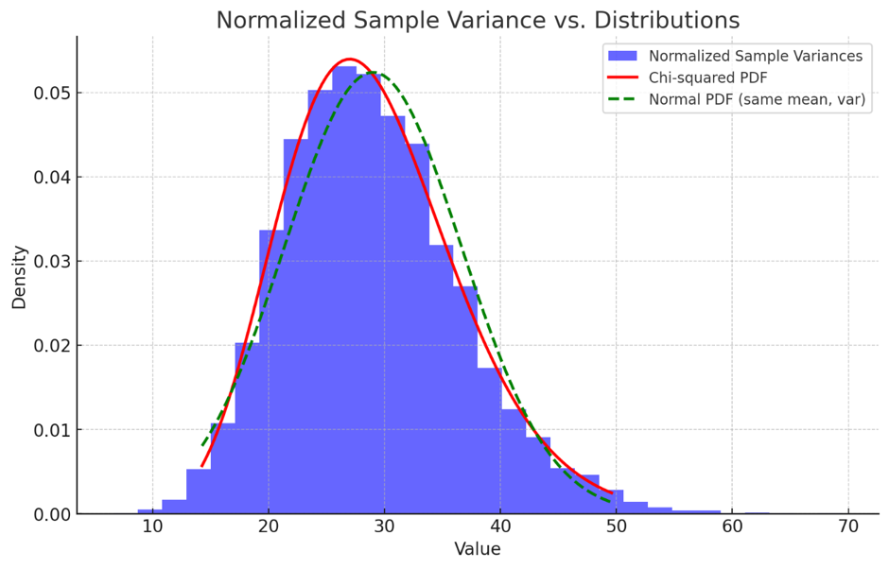

## Hotelling’s T² test vs Mahalanobis distance

The Hotelling’s T² test and the Mahalanobis distance are closely related, but they serve slightly different purposes. Let me walk you through the main differences between the two:

1. Purpose

- Hotelling’s T² Test:

- It is primarily used in the context of multivariate statistical process control or hypothesis testing.

- The T² test is designed to monitor the stability of the mean vector of multiple variables over time (in control charts) or to test if the mean vector of a multivariate sample differs from a target mean (e.g., testing if a process is in control or not).

- It is a statistical test used to assess whether the sample mean vector significantly deviates from the in-control or hypothesized mean vector, accounting for the correlations between variables.

- Mahalanobis Distance:

- It is a distance measure that quantifies how far a point (observation) is from the mean of a multivariate distribution.

- It accounts for the covariance structure of the data (i.e., the correlations between variables), so it is more sophisticated than Euclidean distance.

- Mahalanobis distance is used in various applications such as anomaly detection, outlier detection, classification, and clustering.

2. Formula

Both the Hotelling’s T² statistic and Mahalanobis distance use a similar underlying formula but are used in different contexts.

- Hotelling’s T² Formula:

T^2 = n (\mathbf{\bar{x}} - \mathbf{\mu\_0})' S^{-1} (\mathbf{\bar{x}} - \mathbf{\mu\_0})

Where:

- \( \mathbf{\bar{x}} \) is the sample mean vector.

- \( \mathbf{\mu\_0} \) is the hypothesized mean vector (often the in-control mean).

- \( S \) is the sample covariance matrix.

- \( n \) is the sample size.

- \( T^2 \) is used to test if the sample mean vector differs from the target mean vector.

- Mahalanobis Distance Formula:

D\_M^2 = (\mathbf{x} - \mathbf{\mu})' S^{-1} (\mathbf{x} - \mathbf{\mu})

Where:

- \( \mathbf{x} \) is an observation (or point) in the multivariate space.

- \( \mathbf{\mu} \) is the mean vector of the distribution.

- \( S \) is the covariance matrix of the distribution.

- \( D\_M^2 \) is a distance metric that measures how far the point \( \mathbf{x} \) is from the mean, considering the variance and correlations of the data.

3. Key Differences

- Hypothesis Testing vs. Distance Measurement:

- Hotelling’s T² is primarily a test statistic used in hypothesis testing. It tests whether the observed sample mean significantly deviates from a target or hypothesized mean. It's designed for monitoring processes or performing multivariate hypothesis tests.

- Mahalanobis distance, on the other hand, is a measure of distance. It quantifies how far a single observation is from the mean of a distribution and is not inherently used for hypothesis testing (although it can be adapted for outlier detection).

- Sample Mean vs. Individual Observations:

- Hotelling’s T² uses the mean vector of a sample to assess the difference between the sample and the target mean.

- Mahalanobis distance is computed for individual observations, measuring how far each point is from the mean, considering the covariance structure of the variables.

- Degrees of Freedom and Control Limits:

- Hotelling’s T² involves degrees of freedom and uses control limits (like an F-distribution or chi-squared distribution) to assess whether the process is in control.

- Mahalanobis distance does not rely on degrees of freedom or control limits—it simply gives a scalar distance.

4. Use Cases

- Hotelling’s T²:

- Used in multivariate control charts to monitor a process over time.

- Used in hypothesis testing to check whether the sample mean deviates from a target mean.

- Used in multivariate analysis of variance (MANOVA).

- Mahalanobis Distance:

- Used in anomaly detection and outlier detection, particularly when data is multivariate.

- Used in classification algorithms where distance to a centroid or class mean is important.

- Common in clustering analysis and discriminant analysis.

Summary

- Hotelling’s T²: Primarily used for hypothesis testing in multivariate analysis, particularly for checking if the mean of a multivariate sample differs from a reference mean.

- Mahalanobis Distance: A distance metric that tells you how far an individual observation is from the mean of a multivariate distribution, accounting for correlations between variables.

Both methods involve the covariance matrix and account for relationships between variables, but they are applied in different contexts—one for testing and one for distance measurement.

## The F-distribution and the chi-squared distribution

The F-distribution and the chi-squared distribution are used in multivariate control charts, like Hotelling’s T², because they provide the basis for setting control limits that account for the variability and degrees of freedom in multivariate data. These distributions are particularly useful for setting thresholds in hypothesis testing to determine whether a process is in control or out of control.

Here’s why they are used:

1. F-distribution in Hotelling’s T² Test

The F-distribution is used when calculating the Upper Control Limit (UCL) for Hotelling’s T² statistic in Phase I or when the sample size is small. This is because Hotelling’s T² statistic is related to the F-distribution when testing whether the sample mean vector deviates significantly from the hypothesized mean vector.

# Why use the F-distribution?

- Multivariate Setting: In multivariate settings with small sample sizes, the distribution of Hotelling’s T² is approximately an F-distribution. The F-distribution accounts for the ratio of variance between different groups and provides control limits that adapt based on the number of variables and samples.

- Degrees of Freedom: The F-distribution is appropriate because it incorporates both degrees of freedom related to the number of variables (\(p\)) and the number of samples (\(n\)). In the formula for Hotelling’s T², these degrees of freedom are important for adjusting the control limits to account for the sample size.

The control limit based on the F-distribution is:

UCL = \frac{p(m+1)(n-1)}{mn - m - p + 1}F\_{\alpha; p; mn - m - p + 1}

\]

Where:

- \( F\_{\alpha; p; mn - m - p + 1} \) is the critical value from the F-distribution.

- \( p \) is the number of variables.

- \( n \) is the number of observations per sample.

The F-distribution is used here because it adjusts the control limits based on the size of the dataset and the number of variables being monitored, providing a robust way to control for false alarms in small samples.

2. Chi-Squared Distribution in Hotelling’s T² Test

The chi-squared distribution is used when dealing with larger sample sizes or when the covariance structure of the data is well known. It is the limiting distribution of Hotelling’s T² statistic as the sample size increases.

# Why use the chi-squared distribution?

- Large Sample Approximation: As the sample size \( n \) becomes large, Hotelling’s T² statistic approaches a chi-squared distribution with \( p \) degrees of freedom (where \( p \) is the number of variables).

- Simplicity: The chi-squared distribution is simpler to compute and is used in Phase II when you monitor future observations and the Phase I estimates for mean and covariance are well established.

For a large sample, the control limit is:

UCL = \chi^2\_{\alpha, p}

\]

Where \( \chi^2\_{\alpha, p} \) is the critical value from the chi-squared distribution with \( p \) degrees of freedom.

Key Differences Between F-Distribution and Chi-Squared Distribution in Hotelling’s T²:

- F-Distribution:

- Used when sample sizes are small and you need to account for the variability in the data more accurately.

- Provides more flexible control limits based on the sample size and number of variables.

- More appropriate in Phase I (when parameters are estimated and variability needs to be managed).

- Chi-Squared Distribution:

- Used when sample sizes are large and the sample covariance matrix is stable.

- Provides simpler control limits and is often used in Phase II.

- As \( n \to \infty \), the T² statistic converges to a chi-squared distribution, making it easier to set control limits.

Summary:

- F-distribution: Used in small sample settings or when estimating parameters in Phase I because it accounts for variability in the data and degrees of freedom.

- Chi-squared distribution: Used in large sample settings or in Phase II, when the distribution of T² is approximately chi-squared and simpler control limits can be used.

Both distributions help set control limits that determine when the process is out of control, ensuring that we account for the multivariate nature of the data and the sample size.

1. F-distribution for Hotelling’s T²:

- The F-distribution is plotted for the degrees of freedom calculated for the Hotelling’s T² statistic.

- The plot shows the probability density function (PDF), which highlights how the values of Hotelling’s T² are distributed when the process is in control.

- The shape of the F-distribution depends on the number of variables (p) and sample size (n). The control limits for a small sample size will be higher compared to large samples.

2. Chi-Squared Distribution for Hotelling’s T²:

- The chi-squared distribution is plotted for degrees of freedom equal to the number of variables (p).

- This distribution is typically used in Phase II for larger sample sizes where the T² statistic follows a chi-squared distribution.

- The chi-squared distribution has a long right tail, which represents the rare, large values of T² that signal the process is out of control.

These plots show how the probability distribution helps to set control limits for detecting when a process moves out of control. If you'd like, I can try generating the plots again or share further insights on specific values from these distributions.

# MCMC

Markov Chain Monte Carlo (MCMC) sampling is a statistical method used to approximate the distribution of parameters in complex mathematical models, particularly when the models are too intricate for analytical solutions or straightforward sampling techniques. MCMC helps in estimating distributions by constructing a Markov chain that has the desired distribution as its equilibrium distribution.

Here's a step-by-step explanation, along with an analogy and examples to illustrate how MCMC works:

## Basic Concept

1. Markov Chain: A Markov chain is a stochastic model describing a sequence of possible events in which the probability of each event depends only on the state attained in the previous event.

2. Monte Carlo Sampling: This refers to techniques that rely on repeated random sampling to obtain numerical results. The aim is to simulate large numbers of trials to approximate a solution.

## How MCMC Works

MCMC begins with a random value for the parameters being estimated. It proceeds by generating a sequence of samples where each subsequent sample depends only on the current sample, adhering to the Markov property:

1. Choose a starting point: Start the process at some random point in the parameter space.

2. Iteration: For each step, generate a new sample based on the current position.

3. Transition rule: Use a probabilistic rule to decide whether to move to this new position (accept) or stay in the current position (reject). This rule ensures that over time, the frequency of visiting a particular state is proportional to its probability under the desired distribution. This rule often involves calculating a quantity known as the Metropolis ratio.

4. Convergence: After many iterations, the distribution of the samples converges to the target distribution. The initial samples (burn-in period) are often discarded to allow for this convergence.

## Metropolis-Hastings Algorithm

One popular MCMC method is the Metropolis-Hastings algorithm. Here’s how it operates:

- Start with an initial parameter value.

- Propose moving to a new parameter value based on a proposal distribution.

- Calculate the acceptance probability (Metropolis ratio), which usually depends on how likely the new parameter value is (from the target distribution) compared to the current parameter value and the likelihood of moving from the new value back to the old value.

- Accept or reject the proposed move based on the acceptance probability. If rejected, the next sample is the same as the current one.

## Analogy

Imagine you're exploring a mountainous region blindfolded and your goal is to find the highest peak. You start from a random position and take steps in various directions. Whether you decide to move to a new position or stay in the current one depends on whether the new position feels higher (more probable) than where you currently are. Over time, you tend to move towards and stay around the highest peaks (high probability regions).

## Example

Consider estimating the mean (μ) and standard deviation (σ) of a normal distribution given some data points. MCMC could be used to sample from the posterior distribution of μ and σ, using data likelihood and prior beliefs about μ and σ (perhaps that both are positive). Each iteration proposes new values for μ and σ, evaluates their probability, and either moves to them or stays based on the Metropolis ratio.

## Parameters of the Distribution vs Distribution of the Parameters

Parameter: This is a specific characteristic or measure, like the defect rate in our factory example, which is the proportion 𝑝 of defective widgets. It is a single value that we are trying to estimate.

Distribution of a Parameter: This refers to our beliefs about what values this parameter could take, expressed in the form of a probability distribution. It encompasses all possible values of the parameter along with their associated probabilities, reflecting our uncertainty about the true value.

Parameters of the Distribution

These are specific characteristics that define a probability distribution. For example, in a normal distribution, the parameters are the mean (average) and the standard deviation (which measures the spread around the mean). These parameters describe the behavior of the distribution—where its center is and how much data points vary around that center.

Distribution of the Parameters

When we talk about the "distribution of the parameters" in the context of Bayesian statistics, we are referring to how our beliefs about these parameters are expressed in probability terms. Before collecting any data, these beliefs are described by the "prior distribution." After data is collected, these beliefs are updated, and we obtain the "posterior distribution."

To tie it back to the fish example, you begin with a prior belief about the average weight of the fish, described by a normal distribution (say, mean = 2 kg, standard deviation = 0.5 kg). This prior belief represents your initial guess about the average weight before any actual data from the fish is collected.

Sampling from the Posterior Distribution

Once you collect data (i.e., you weigh a sample of fish from the lake), you use this data to update your prior beliefs about the average weight. This updating process gives you a new distribution called the posterior distribution. The posterior distribution incorporates both your prior beliefs and the new evidence from the data, providing a new set of probable values for the average weight of the fish.

Prior Distribution: What you believed about the fish's average weight before collecting any data.

Data Collection: Weighing a number of fish.

Posterior Distribution: Updated beliefs about the average weight after considering the data.

Sampling from this posterior distribution means generating random samples from this updated distribution. Each sample represents a possible value of the average weight, considering both the prior information and the data you've collected. Sampling is useful because it helps you understand the range of plausible values for the average weight and how confident you might be about these values.

In practice, sampling from the posterior distribution is often done using computational methods like MCMC, especially when the math involved in calculating the posterior directly is too complex.

## Calculating π (pi) using Markov Chain Monte Carlo (MCMC)

Calculating π (pi) using Markov Chain Monte Carlo (MCMC) is an interesting application of statistical methods to solve problems that at first might not seem directly related to statistics. A common approach to estimate π using MCMC involves a technique similar to Monte Carlo integration, particularly using random sampling within a geometric framework. Here's how you can use MCMC to calculate π through an example involving a circle inscribed in a square.

**Geometric Setup**

1. Square and Circle: Imagine a square with side length 2 units. Inside this square, a circle is inscribed with a radius of 1 unit. The center of the circle and the center of the square coincide.

2. Area Relationship: The area of the square is \(4\) square units (since the side is 2), and the area of the circle is The ratio of the area of the circle to the area of the square is \(\frac{π}{4}\).

Using MCMC to Estimate π

To estimate π using MCMC:

1. Random Sampling: Start by randomly selecting points within the square. The points have coordinates

2. Determine Inside Circle: For each sampled point, determine if it lies inside the circle. This is true if

3. MCMC Sampling: Although typically MCMC involves a "chain", for estimating π, we can simplify by using straightforward Monte Carlo sampling to illustrate the concept. Here, the random sampling of points can be thought of as a naive form of MCMC where each point is sampled independently from a uniform distribution over the square.

4. Estimate π: Count the number of points that fall inside the circle and divide by the total number of points sampled. This ratio estimates π/4. Multiply the result by 4 to estimate π.

**Python Example**

import random

def estimate\_pi(num\_samples):

points\_inside\_circle = 0

for \_ in range(num\_samples):

x, y = random.uniform(-1, 1), random.uniform(-1, 1)

if x2 + y2 <= 1:

points\_inside\_circle += 1

return 4 \* points\_inside\_circle / num\_samples

# Using 100,000 samples for a better approximation

pi\_estimate = estimate\_pi(100000)

print(f"Estimated π: {pi\_estimate}")

**Note on MCMC vs. Monte Carlo**

The example provided uses a Monte Carlo method. To make it a true MCMC method, one would implement a dependency between successive samples where each new point depends on the previous one, perhaps using a random walk or another method to propose movements within the square. MCMC techniques like Metropolis-Hastings could be used, but for the problem of estimating π, simple Monte Carlo is usually more straightforward and sufficient.

The MCMC approach is more relevant in scenarios where samples are dependent on each other, and exploring the space more efficiently is crucial, especially in high-dimensional problems or where the probability distribution is complex and not uniform.

## MCMC in context of control charts

Markov Chain Monte Carlo (MCMC) methods can be beneficial in the context of control charts and anomaly detection. These applications typically involve statistical modeling, where MCMC can be used to estimate the parameters of the models or to make probabilistic inferences about the process being monitored. Here’s how MCMC can be applied in these areas:

**Control Charts**

Control charts are used in quality control to monitor whether a process is functioning within expected bounds. Here's how MCMC can be utilized:

1. Parameter Estimation: Control charts often rely on estimates of parameters such as the mean and variance of a process. MCMC can be used to obtain distributions of these parameters, especially when the data does not neatly follow normal distributions or when the parameters are not independent.

2. Handling Complex Models: In some cases, the assumptions of traditional control charts (e.g., independence of samples, normal distribution of data) do not hold. MCMC allows for the use of more complex models that can account for autocorrelation between samples, non-normal distributions, and other complexities.

3. Bayesian Control Charts: These control charts use Bayesian methods to continuously update beliefs about process parameters as new data comes in. MCMC methods are often used to sample from the posterior distributions of these parameters, allowing for dynamic updating of control limits based on the most recent data.

**Anomaly Detection**

Anomaly detection involves identifying rare events or observations which raise suspicions by differing significantly from the majority of the data. MCMC can be particularly useful in the following ways:

1. Probabilistic Modeling: Anomaly detection often requires the modeling of complex data behaviors, where anomalies are defined as deviations from a modeled normal behavior. MCMC can be used to estimate the parameters of these models, particularly in situations where the model involves latent variables or hierarchical structures.

2. Dynamic Systems: For systems that evolve over time, MCMC can help model the time-dependent behavior of the system, allowing for the detection of anomalies in a dynamic context. This is particularly relevant in fields like cybersecurity, finance, and network traffic, where data patterns evolve continuously.

3. High Dimensionality: MCMC is useful in high-dimensional data spaces often encountered in anomaly detection scenarios. It helps in estimating complex dependencies between variables and in exploring high-dimensional parameter spaces.

**Practical Example**

Imagine you are monitoring a manufacturing process with a control chart and you suspect the underlying process dynamics have changed due to new machinery. Traditional control chart methods might not immediately adapt to such change. An MCMC-based Bayesian approach can be used to continuously update the process parameters' estimates, allowing the control limits to be dynamically adjusted. This approach would not only detect whether the process is out of control but also adapt to new "normal" levels established by the upgraded machinery.

Similarly, in anomaly detection, if you are monitoring network traffic for unusual patterns, an MCMC approach can help model complex dependencies and interactions between various aspects of the traffic. This model can then be used to probabilistically assess whether new observations fit the expected pattern or constitute anomalies.

**Conclusion**

MCMC's flexibility in handling complex models and its ability to provide a comprehensive probabilistic interpretation of model parameters make it a powerful tool in both control charts and anomaly detection. It provides a robust framework for dealing with uncertainty, dynamic systems, and complex dependencies, which are common challenges in these fields.

# What is data depth

Data depth is a statistical concept that measures the "centrality" or "depth" of a point relative to a data distribution. It is used in nonparametric statistics to define and analyze the structure of multivariate data. Here are some key points about data depth:

1. Definition and Purpose: Data depth assigns a number to each point in a data set, indicating how deep or central the point is relative to the rest of the data. The deeper a point, the more central it is considered. This measure can help identify central points, outliers, and the overall shape of the data distribution.

2. Types of Data Depth:

- Tukey Depth (Halfspace Depth): Measures the smallest number of data points in any closed half-plane that includes the point of interest. A higher value indicates a more central position.

- Simplicial Depth: Defines the depth of a point as the number of simplices (triangles in two dimensions, tetrahedrons in three dimensions, etc.) formed by data points that contain the point.

- Mahalanobis Depth: Based on the Mahalanobis distance from the point to the mean of the distribution, normalized so that the maximum depth is at the mean.

3. Applications: Data depth is used in various statistical methods, including robust statistics, data visualization, and the development of depth-based descriptive statistics like medians and trimmed means.

4. Advantages: One of the main advantages of data depth is that it provides a way to understand the structure of data without assuming any particular distributional form, making it useful for analyzing complex or multidimensional data.

Data depth can be particularly useful for identifying central tendencies and outliers in data, providing a more nuanced understanding of data distributions compared to traditional measures like the arithmetic mean or median.

## Tukey Depth (Halfspace Depth)

**Definition:**

Tukey Depth, introduced by John Tukey in 1975, measures the centrality of a point relative to a data set. It is defined for a point in the data set as the smallest number of points in any closed half-space containing . Essentially, it asks the question: What is the minimum number of data points you must include if you split the data with a line (or hyperplane in higher dimensions) such that the point is on one side of the line?

**Computation:**

- In two dimensions, imagine drawing a line through the point . This line divides the plane into two half-planes.

- The Tukey Depth of s then the minimum number of data points that fall into one of these half-planes, across all possible lines through

- This means if has a high Tukey Depth, it would be closer to the "center" of the data because every line through will always have a substantial number of points on either side.

**Visual Example:**

Think of it as trying to balance a seesaw on the point where data points are weights. A point with a high Tukey Depth will allow the seesaw to be balanced in many orientations because there are plenty of weights (data points) on both sides no matter how you tilt it.

**Properties:**

- Robustness: Tukey Depth is very robust to outliers because its calculation is based on the arrangement of a large number of data points. An outlier will not significantly change the minimum count of points in a half-space.

- Range: The depth ranges from 0 to the floor of is the number of data points. The maximum depth is achieved by the median in one-dimensional cases.

**Applications:**

- Tukey Depth is particularly useful in creating non-parametric measures like the median or other quantiles.

- It can also help in identifying outliers and for robust regression and classification in statistics.

## How is the transformation to F distribution works

The transformation to an F-distribution often arises in the context of statistical hypothesis testing, particularly in scenarios involving variance analysis, such as ANOVA (Analysis of Variance). Here’s a simplified explanation of how this transformation generally works, focusing on why and how it results in an F-distribution:

**Basis of F-Distribution Transformation**

The F-distribution is fundamentally linked to comparing variances and is derived from the ratio of two scaled chi-squared distributions. Here's a step-by-step breakdown:

1. Chi-Squared Distributions:

- Suppose you have two independent chi-squared variables, with degrees of freedom respectively. These might represent the variability (squared deviations) of two independent samples or two variance estimates.

2. Scaling:

- To form variables that can be compared directly, each chi-squared variable is scaled by its degrees of freedom. This gives us scaled variables These scaled variables have an expected value of 1 if the underlying normal populations have the same variance.

3. Formation of the F-statistic:

- The F-statistic is formed by taking the ratio of these scaled chi-squared distributions:

- Here, follows an F-distribution with numerator degrees of freedom and denominator degrees of freedom.

**Contextual Example: ANOVA**

In ANOVA, the F-distribution is used to determine whether the means of several groups are all equal. This involves comparing the variance between groups (between-group variability) to the variance within groups (within-group variability):

- Between-Group Variance (Numerator):

- This measures the variance among the group means weighted by the number of observations in each group. It captures how much the group means diverge from the overall mean.

- Within-Group Variance (Denominator):

- This measures the average of the variances within each group, representing typical deviations around the group means.

- F-Statistic in ANOVA:

- The F-statistic in ANOVA is:

- If the null hypothesis (all group means are equal) is true, MSB and MSW should be approximately equal, leading to an F-statistic near 1. Larger values of suggest significant differences between group means, indicating that at least one group mean is different.

**Why Use the F-Distribution?**

The use of the F-distribution is appropriate when comparing variances because it is designed to handle the ratio of two variances (scaled chi-squared values), taking into account the degrees of freedom of the estimates, which adjusts for sample size effects. This makes it an ideal tool for tests like ANOVA where such comparisons are central.

This transformation to an F-distribution provides a probabilistic framework to judge whether observed differences in variances (or variances of means) could be due to random variation or represent actual differences, guiding decisions in hypothesis testing.

# Principal Component Analysis (PCA) Overview

## Introduction to PCA

- PCA is a dimensionality reduction technique that transforms a dataset with possibly correlated features into a set of linearly uncorrelated variables called principal components.

- The primary objective of PCA is to find the direction (principal component) that captures the maximum variance in the data.

## Steps Involved in PCA

1. Standardization:

- Before applying PCA, the data is standardized so that each feature has a mean of 0 and a standard deviation of 1. This is crucial because PCA is sensitive to the scale of the data.

2. Covariance Matrix Calculation:

- The covariance matrix represents the relationships between features. For a standardized dataset \(X\), the covariance matrix \(\Sigma\) is calculated as:

where \(X^T\) is the transpose of the data matrix \(X\).

3. Eigenvalue and Eigenvector Calculation:

- PCA finds the eigenvalues and eigenvectors of the covariance matrix. The eigenvector corresponding to the largest eigenvalue is the direction of the first principal component, which captures the maximum variance in the data.

- The eigenvalue equation is:

where \(\lambda\) is the eigenvalue (variance explained by the principal component) and \(\mathbf{v}\) is the eigenvector (direction of the principal component).

4. Maximization Problem:

- The maximization problem in PCA can be expressed as:

Subject to the constraint:

This ensures that the vector \(\mathbf{v}\) is a unit vector. The Lagrange multiplier method is used to solve this problem, leading to the eigenvalue equation.

5. Principal Component Transformation:

- Once the eigenvectors are found, the data is projected onto the principal components. The first principal component captures the maximum variance, followed by the second, and so on.

## Example with Numerical Data

Given a dataset with 4 features, PCA was applied, and the following results were obtained:

1. Covariance Matrix:

\Sigma = \begin{bmatrix} 1.0526 & -0.0497 \\ -0.0497 & 1.0526 \end{bmatrix}

2. Eigenvalues and Eigenvectors:

- Eigenvalue

- Eigenvalue

The first eigenvalue \(\lambda\_1\) and its corresponding eigenvector \(\mathbf{v}\_1\) represent the direction that maximizes the variance.

## Comparison of PCA and Linear Regression

- Principal Component (PC1):

- The first principal component maximizes the variance in the data. It minimizes the orthogonal (perpendicular) distances from the data points to the line, making it the best fit for capturing the spread of the data.

- Linear Regression:

- Linear regression minimizes the vertical distances between the observed data points and the line. It is focused on predicting one variable from another, making it the best fit for prediction purposes.

Key Differences:

1. Variance Maximization vs. Error Minimization:

- PCA focuses on maximizing variance, while regression minimizes prediction error.

2. Symmetry vs. Asymmetry:

- PCA treats all variables equally, while regression treats one variable as dependent and the other as independent.

3. Data Orientation:

- PCA finds directions of maximum variance, often resulting in a line that might not match the regression line.

### Mathematical Explanation of PCA Maximization

PCA maximizes the variance by solving the following optimization problem using Lagrange multipliers:

Taking the derivative of this function and setting it to zero leads to the eigenvalue equation:

The eigenvector corresponding to the largest eigenvalue is the direction of the first principal component, which captures the maximum variance in the data.

## Introduction to Lagrange Multipliers

Lagrange multipliers are a technique used in optimization to find the local maxima and minima of a function subject to equality constraints. This method introduces additional variables (Lagrange multipliers) to transform a constrained problem into an unconstrained one.

Steps Involved in Lagrange Multipliers

1. Writing the Lagrangian:

- Combine the objective function and the constraint(s) into a single function called the Lagrangian:

- Here, \( f(x, y) \) is the objective function, \( g(x, y) \) is the constraint, and \( \lambda \) is the Lagrange multiplier.

Benefit:

- The Lagrangian integrates the objective function and constraints, making the problem easier to manage by converting it into an unconstrained optimization problem.

2. Taking the Partial Derivatives:

- To find the critical points, take the partial derivatives of the Lagrangian with respect to each variable, including the Lagrange multiplier, and set them equal to zero:

Benefit:

- This step systematically identifies the critical points where the function might achieve a maximum or minimum, ensuring that both the objective function and constraints are satisfied.

3. Solving the System of Equations:

- Solve the resulting system of equations to find the values of \( x \), \( y \), and \( \lambda \) that optimize the objective function while satisfying the constraint.

Benefit:

- This step provides the optimal solutions by ensuring that the solutions meet the constraint and identify whether the solutions correspond to a maximum or minimum of the objective function.

## Example Using Lagrange Multipliers

##Problem:

Maximize \( f(x, y) = x + y \) subject to the constraint \( g(x, y) = x^2 + y^2 - 1 = 0 \).

Step 1: Write the Lagrangian:

Step 2: Take the Partial Derivatives:

Step 3: Solve the System of Equations:

The critical points are \( (x, y) = \left(\frac{1}{\sqrt{2}}, \frac{1}{\sqrt{2}}\right) \) and \( (x, y) = \left(-\frac{1}{\sqrt{2}}, -\frac{1}{\sqrt{2}}\right) \).

##Conclusion:

- The maximum value is \( \sqrt{2} \) at \( \left(\frac{1}{\sqrt{2}}, \frac{1}{\sqrt{2}}\right) \).

- The minimum value is \( -\sqrt{2} \) at \( \left(-\frac{1}{\sqrt{2}}, -\frac{1}{\sqrt{2}}\right) \).

Key Points About Lagrange Multipliers

- Why Use Derivatives?

- Derivatives are used in the Lagrange multiplier method to identify critical points where the function \( f(x, y) \) might achieve its maximum or minimum under the constraint \( g(x, y) = 0 \).

- By setting the derivatives of the Lagrangian equal to zero, we find points where the gradient of the objective function is aligned with the gradient of the constraint, ensuring that the constraint is satisfied while optimizing the function.

- This method systematically incorporates both the objective function and the constraint into a single framework, making it a powerful tool for solving constrained optimization problems.

Summary of Lagrange Multipliers

1. Step 1 (Lagrangian): Combines the objective function and constraints into one function, simplifying the problem by handling constraints systematically.

2. Step 2 (Partial Derivatives): Identifies the critical points where the optimal solution might occur, offering insights into how the objective function and constraints interact.

3. Step 3 (Solving Equations): Finds the specific values of the variables that maximize or minimize the objective function while ensuring the constraints are met, ultimately leading to feasible and optimal solutions.

These steps together provide a robust method for solving optimization problems with constraints, enabling a systematic approach to finding the best possible solutions.

# Control Charts

## Q&A

### Why control chart assumption for Normal distribution and independent random variables

In control charts, the assumption that the observed random variables follow a normal distribution and are independent is crucial for several reasons:

**Normal Distribution**

1. Central Limit Theorem (CLT): Many control charts, especially those that monitor the mean, rely on the CLT. The theorem states that regardless of the distribution of the individual data points, the distribution of the sample means will approximate a normal distribution as the sample size becomes large. This property allows for simpler statistical analysis since the normal distribution has well-defined properties (mean and variance).

**Limitations and Exceptions of CLT:**

Distributions Without Finite Variance: The CLT does not apply to distributions that do not have a finite variance. For example, distributions with heavy tails like the Cauchy distribution do not satisfy the requirements of the CLT because they lack a finite variance. In such cases, the mean itself may not be well-defined, or the variance may be infinite.

Significant Dependence: The CLT assumes that the variables are independent. If there is significant dependence among the variables, the theorem may not hold.

Small Sample Sizes: While the CLT states that the distribution of the sample mean will approach normality as the number of samples increases, the speed of convergence can vary based on the underlying distribution. For distributions that are significantly non-normal or have extreme skewness or kurtosis, larger samples may be required for the CLT to effectively approximate a normal distribution.

2. Standardization: Control charts often use the mean and standard deviation to determine control limits. The properties of the normal distribution allow for straightforward calculation of these limits. For a normal distribution, approximately 99.73% of the values lie within three standard deviations from the mean. This makes it easy to detect outliers or shifts in the process mean or variability.

3. Simplicity in Interpretation: The normal distribution provides a basis for making probabilistic statements about the points plotted on the chart. This helps in deciding whether variations in process outputs are due to common causes (natural variations within the system) or special causes (external factors that need correction).

**Independence**

1. No Auto-correlation: Independence of observations ensures that the data points on a control chart are not influenced by previous data points. This is important because the presence of auto-correlation can distort the control limits, leading to incorrect conclusions about process stability or variability.

2. Accurate Control Limits: When observations are independent, the statistical calculations (e.g., means, variances) used to set the control limits are valid. If observations are dependent, these estimates may be biased, affecting the sensitivity of the control chart in detecting real changes in the process.

3. Validity of Statistical Tests: Many of the tests used in control charts (like runs tests) assume that the data points are independent. These tests are used to detect trends, cycles, or shifts in the process that might indicate a problem. Dependence among observations can lead to either overestimating or underestimating the presence of control in the process.

**Practical Application**

In practice, while the assumption of normality is useful, it is not always strictly necessary depending on the type of control chart and the nature of the data. Some modern control chart methods can handle data that does not follow a normal distribution. However, the assumption of independence is generally crucial, and violation of this assumption can seriously impact the effectiveness of a control chart.

In summary, assuming that the observed variables are normally distributed and independent simplifies the creation and use of control charts, making them powerful tools for quality control and process management. **When these assumptions are not met, alternative methods or transformations might be necessary to correctly apply statistical process control techniques.**

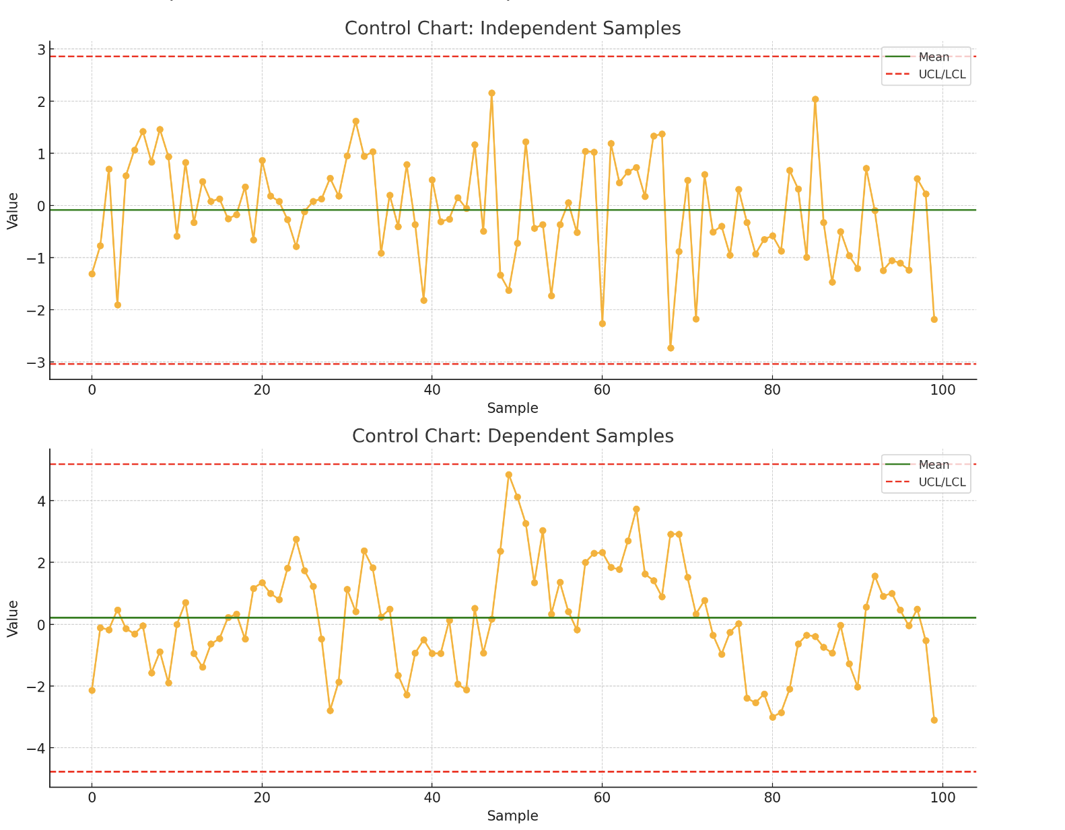

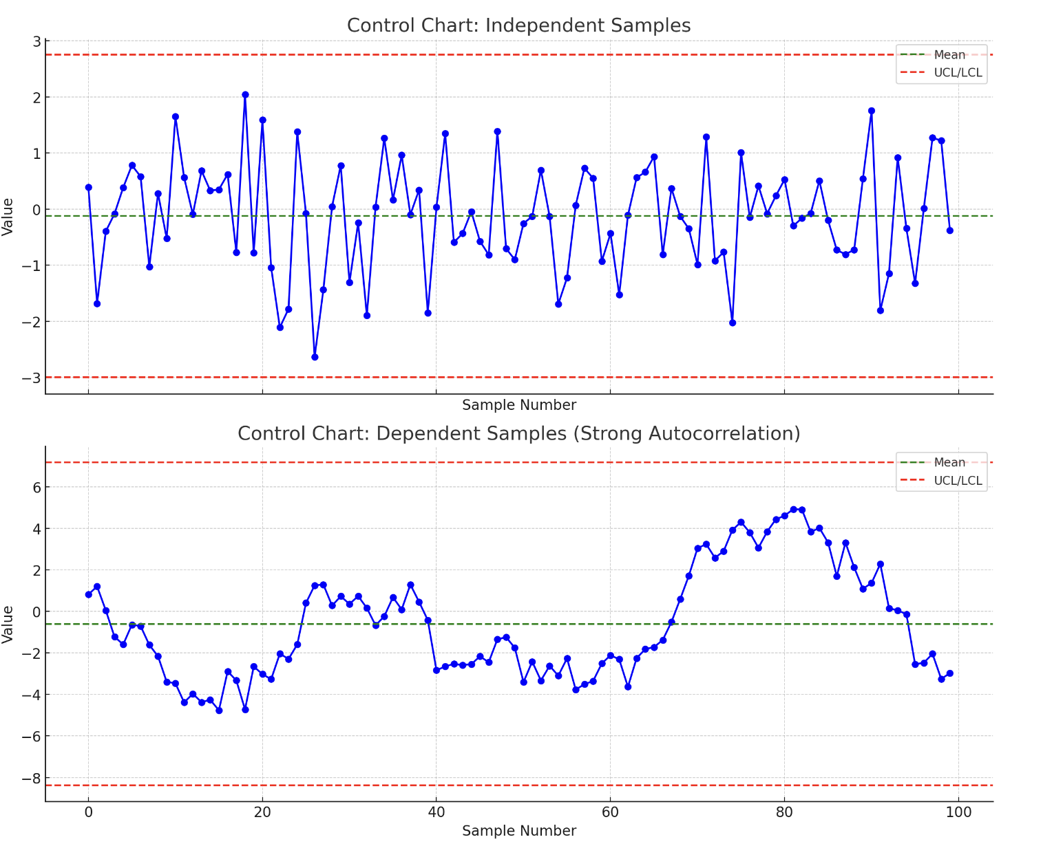

**Control Chart: Independent Samples**

The chart shows random variation around the mean, which is typical for independent samples from a normal distribution. The process appears stable with no patterns or trends, and all points are within the control limits (UCL and LCL).

Control Chart: Dependent Samples

This chart displays a clear autocorrelation effect where consecutive samples influence each other, resulting in a pattern that deviates from what you would expect in a stable process. This can mislead the control chart's assessment of process control, as patterns due to dependence might be misinterpreted as shifts in the process or special causes.

### How to work with dependencies in control charts

When dealing with dependencies in control chart data, it's important to adjust the approach or choose control chart types that can handle autocorrelation and other forms of dependency. Traditional control charts assume independence between data points, but this assumption isn't always valid, especially in processes with inherent serial correlation (like many chemical processes, or processes under automatic control systems).

**Strategies to Handle Dependencies in Control Charts:**

1. Use Time-Series Analysis Techniques:

- ARIMA Models: Fit an autoregressive integrated moving average (ARIMA) model to the data to remove autocorrelation before applying control charts.

- Residuals Monitoring: After fitting a time-series model, monitor the residuals with a control chart. The residuals, if the model is adequate, should be independent and identically distributed with a mean of zero.

2. Special Control Charts:

- CUSUM (Cumulative Sum Control Chart): This type of chart is particularly effective for detecting small shifts in the mean and is less sensitive to autocorrelation than traditional Shewhart charts.

- EWMA (Exponentially Weighted Moving Average): EWMA charts place more weight on recent observations and are better suited for detecting small shifts in processes where data points are correlated.

3. Adjust Control Limits:

- Calculate control limits by accounting for the autocorrelation. For instance, if the data are positively autocorrelated, the true variability of the process mean estimates will be higher than that calculated under the assumption of independence, which should be reflected in wider control limits.

4. Remove or Reduce Dependence:

- Differencing: Applying a differencing operation to the data series can sometimes help to remove trends and reduce autocorrelation.

- Transformation: Use transformations such as logarithmic or square root to stabilize the variance and potentially reduce dependencies.

5. Use Process Adjustment Techniques:

- If the dependency is due to process design, consider adjusting the process to reduce dependency. For example, introduce buffers or delays if feasible, or change the frequency of sampling to reduce the effects of autocorrelation.

Example Implementation: EWMA Control Chart

Let's implement an EWMA control chart as an example. This chart is effective in handling data with autocorrelation and is often used in cases where data exhibit trends or gradual shifts.

We'll simulate a data set with autocorrelation, fit an EWMA chart, and visualize the results.

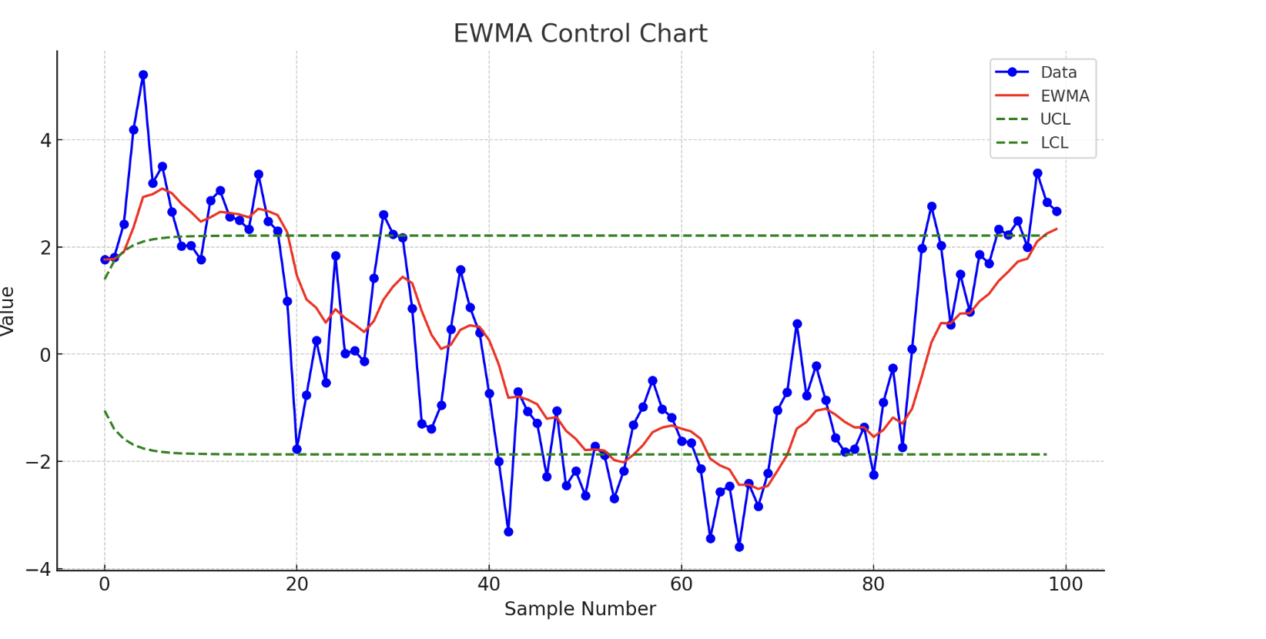

The EWMA (Exponentially Weighted Moving Average) control chart shown above is designed to handle data with autocorrelation effectively:

- Data Points (Blue): Represent the autocorrelated data generated from an AR(1) model. The influence of previous data points is evident in the trends and patterns.

- EWMA Line (Red): Shows the exponentially weighted moving averages of the data. The EWMA line is smoother than the raw data, indicating its capability to dampen the effects of autocorrelation by emphasizing more recent observations.

- Control Limits (Green, Dashed Lines): The Upper Control Limit (UCL) and Lower Control Limit (LCL) are calculated to adapt to the smoothing effect of the EWMA. These limits are not fixed but adapt dynamically based on the properties of the EWMA, including the variance influenced by the chosen lambda (smoothing parameter).

Key Points:

- Responsiveness: The EWMA chart's responsiveness to process changes can be adjusted by the smoothing parameter (λ). A smaller λ gives more weight to recent data, making the chart more sensitive to shifts.

- Control Limits: The limits account for the fact that the smoothed data have a reduced variance compared to the original data, which helps in maintaining appropriate sensitivity to shifts or trends despite the autocorrelation.

- Autocorrelation Handling: By smoothing the data, the EWMA chart reduces the noise and misleading patterns caused by autocorrelation, providing a clearer picture of the actual process behavior.

This chart is particularly useful in continuous process industries where data are inherently autocorrelated and traditional Shewhart control charts may not perform effectively.

### What is residual monitoring?

Residual monitoring is a statistical technique used to check the appropriateness of a model that has been fitted to a dataset, particularly in the context of regression analysis, time series forecasting, and other predictive modeling techniques. The main goal of residual monitoring is to ensure that the residuals — the differences between the observed values and the values predicted by the model — behave in a manner consistent with the statistical assumptions of the model.

**Key Aspects of Residual Monitoring:**

1. Residuals: Residuals are defined as the discrepancies between the observed data points and the values predicted by a model. Mathematically, if is the observed value and is the predicted value, then the residual is given by:

2. Assumptions: The basic assumptions regarding residuals in most statistical modeling contexts include:

- Independence: Residuals should not show autocorrelation; each residual should be independent of the others.

- Homoscedasticity: The variance of the residuals should remain constant across all levels of the independent variables.

- Normality: Residuals should be normally distributed (particularly important in linear regression for hypothesis testing).

3. Techniques for Monitoring:

- Plotting Residuals: Visual inspections such as plotting residuals against predicted values or against independent variables can help identify patterns indicating assumption violations, like changing variance or trends.

- Statistical Tests: Tests like the Durbin-Watson test for autocorrelation, Breusch-Pagan test for heteroscedasticity, and Shapiro-Wilk test for normality can provide formal checks on the residuals.

- Control Charts: Applying control charts to the residuals can help detect out-of-control conditions, indicating that the model may not be capturing some aspect of the process variability.

**Application in Control Charts:**

In the context of control charts, particularly in processes where a model of expected behavior is used (such as in statistical process control for complex or correlated data), residual monitoring involves using control charts to track the residuals from the model. If the model is adequate and the process is under control, the residuals should appear as random noise within control limits.

This approach is useful because it allows the use of simple control chart techniques, like Shewhart charts or EWMA charts, to monitor complex processes where the direct application of traditional control charts might not be appropriate due to model or data complexity.

**Example Scenario:**

If a production process can be modeled by a time series prediction model, residuals from this model can be plotted on a control chart. If the control chart of these residuals shows points outside the control limits, or systematic patterns, this suggests that the model is not capturing all the process dynamics, and there might be special causes of variation that need to be investigated.

Overall, residual monitoring serves as a critical diagnostic tool to ensure that predictive models accurately represent the system being studied and to maintain quality control in various industrial and business applications.

To demonstrate the benefit of using a residual control chart against a traditional Shewhart control chart in cases of autocorrelation, I'll create a scenario where the time series data exhibit autocorrelation and undergo a slight process shift that will be evident in the residuals but may not be as clear in the direct application of a Shewhart chart on the raw data.

Steps:

1. Generate Simulated Data: Create time series data using an AR(1) model and introduce a subtle shift partway through the series.

2. Fit Model and Calculate Residuals: Fit an AR(1) model to the data (ignoring the shift during fitting), then calculate the residuals.

3. Apply Shewhart Control Chart:

- Directly to the raw data.

- To the residuals.

This approach will help illustrate how a residual control chart can detect subtle shifts that might be missed by a Shewhart control chart due to the presence of autocorrelation in the data.

Let's start by generating the data and setting up the models.

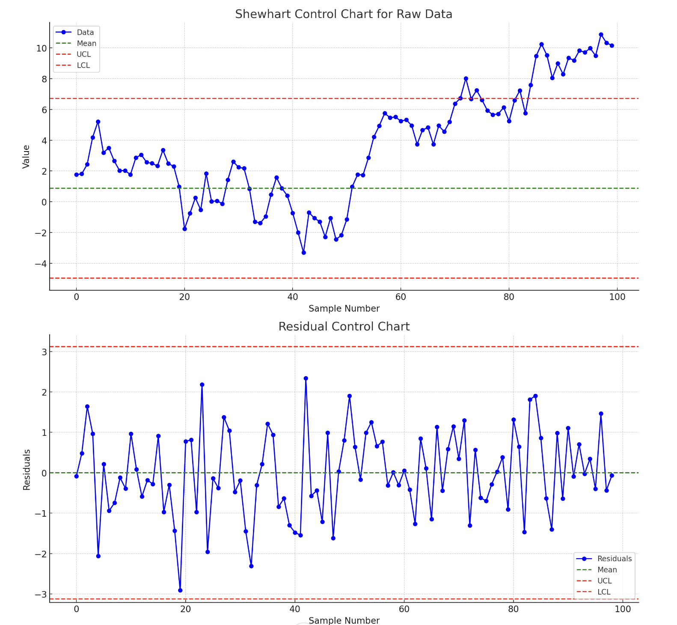

The plots above demonstrate the use of a Shewhart control chart applied directly to raw data and to the residuals from an AR(1) model:

1. Shewhart Control Chart for Raw Data:

- This chart shows the time series data with a mean line and control limits calculated from the data before the shift. The control limits appear wide due to the autocorrelation in the data, which inflates the observed variability. Notice that despite a noticeable upward shift in the mean around sample number 50 (introduced shift), the Shewhart chart fails to flag this shift clearly as out of control. The inflated control limits diminish the chart's sensitivity to shifts.

2. Residual Control Chart:

- The residuals are derived from the AR(1) model fitted to the entire dataset. The mean and control limits are narrower here, reflecting the reduced variability in the residuals compared to the raw data. The control chart for residuals clearly shows multiple points beyond the upper control limit shortly after the shift point. This indicates a process shift that the residuals detect but the raw data chart does not, highlighting a significant benefit of using residual control charts in the presence of autocorrelation.

Key Insights:

- Autocorrelation Impact: In the raw data chart, autocorrelation masks the shift's effect by artificially increasing the data variability, leading to wider control limits and reduced sensitivity.

- Residuals Reveal Shift: By modeling the autocorrelation and examining the residuals, we effectively filter out the dependency, revealing deviations caused by the shift more clearly.

Conclusion:

The residual control chart is more effective for detecting subtle changes in processes characterized by dependent data. It highlights the importance of model-based approaches in process monitoring, especially in scenarios where traditional methods might fail to detect shifts due to underlying data dependencies. This approach ensures that quality control processes remain robust, especially in complex industrial settings where autocorrelation is common.

Code

import numpy as np

import matplotlib.pyplot as plt

from statsmodels.tsa.arima\_process import ArmaProcess

from statsmodels.tsa.ar\_model import AutoReg

# Seed for reproducibility

np.random.seed(0)

# Parameters

n = 100

phi = 0.8

shift\_point = 50

shift\_magnitude = 1.5

# Generate AR(1) data with a shift in the mean at a specific point

. noise = np.random.normal(0, 1, n)

data = [noise[0]]

for i in range(1, n):

current\_shift = shift\_magnitude if i >= shift\_point else 0

data.append(phi \* data[-1] + noise[i] + current\_shift)

# Fit AR(1) model to the entire dataset (ignoring the shift)

model = AutoReg(data, lags=1)

model\_fitted = model.fit()

# Calculate residuals

residuals = model\_fitted.resid

# Shewhart control chart limits for raw data and residuals

data\_mean = np.mean(data[:shift\_point]) # Mean before the shift

data\_std = np.std(data[:shift\_point])

residual\_mean = np.mean(residuals)

residual\_std = np.std(residuals)

data\_UCL = data\_mean + 3 \* data\_std

data\_LCL = data\_mean - 3 \* data\_std

residual\_UCL = residual\_mean + 3 \* residual\_std

residual\_LCL = residual\_mean - 3 \* residual\_std

# Plotting Shewhart control chart for raw data

fig, axes = plt.subplots(2, 1, figsize=(12, 12))

axes[0].plot(data, marker='o', linestyle='-', color='blue', label='Data')

axes[0].axhline(data\_mean, color='green', linestyle='--', label='Mean')

axes[0].axhline(data\_UCL, color='red', linestyle='--', label='UCL')

axes[0].axhline(data\_LCL, color='red', linestyle='--', label='LCL')

axes[0].set\_title('Shewhart Control Chart for Raw Data')

axes[0].set\_xlabel('Sample Number')

axes[0].set\_ylabel('Value')

axes[0].legend()

# Plotting control chart for residuals

axes[1].plot(residuals, marker='o', linestyle='-', color='blue', label='Residuals')

axes[1].axhline(residual\_mean, color='green', linestyle='--', label='Mean')

axes[1].axhline(residual\_UCL, color='red', linestyle='--', label='UCL')

axes[1].axhline(residual\_LCL, color='red', linestyle='--', label='LCL')

axes[1].set\_title('Residual Control Chart')

axes[1].set\_xlabel('Sample Number')

axes[1].set\_ylabel('Residuals')

axes[1].legend()

plt.tight\_layout()

plt.show()

### What is the difference between phase 1 and phase 2

In the context of statistical process control (SPC), which includes nonparametric control charts as discussed in "Chakraborti\_Nonparametric\_2019.pdf," the distinction between Phase I and Phase II control charting is foundational to understanding how control charts are implemented and used for quality control. Here's a breakdown of the differences between these two phases:

**Phase I - Initial Process Study**

- Objective: The main goal of Phase I is to establish and verify the stability of a process. This phase involves collecting data from a process that is presumed to be operating under stable conditions.

- Use: It's used to detect any out-of-control conditions that may have been present in the process historically. This includes identifying any special cause variations that need to be eliminated to ensure the process is stable.

- Outcome: The outcome of Phase I is the establishment of control limits based on historical data. If the process is found to be stable, these control limits are then used in Phase II for monitoring the process. Phase I may also involve adjusting the process to improve its stability or capability.

**Phase II - Process Monitoring**

- Objective: Phase II focuses on the ongoing monitoring of the process to detect any signals or evidence of special cause variation that occurs after the initial study period. This phase is about maintaining control and signaling when the process may have changed.

- Use: It uses the control limits established in Phase I to monitor the process in real-time (or near real-time). Any points that fall outside of the control limits or patterns that suggest a non-random distribution within the limits may indicate a change in the process that needs investigation.

- Outcome: The key outcome of Phase II is the detection of process shifts or trends early enough to take corrective actions before producing off-specification products or services. This helps in maintaining the quality of the output and ensuring that the process remains in a state of statistical control.

In summary, Phase I is about establishing control limits based on a retrospective analysis of process data to ensure the process is stable, while Phase II is about using those control limits for real-time monitoring to maintain process stability and quality.

### Which technique are used in phase one

In Phase I of the statistical process control (SPC) process, the main technique used is the analysis of historical data to assess the stability of the process and to establish control limits. This involves several specific techniques and approaches, depending on the nature of the data and the process. Here’s a brief overview of some common techniques used in Phase I:

1. Descriptive Statistics and Visualization

- Techniques Used: Calculation of means, variances, ranges, and the use of histograms, box plots, and run charts.

- Purpose: To get an initial understanding of the process data, its variability, and to identify any obvious patterns or anomalies.

2. Capability Analysis

- Techniques Used: Calculation of capability indices such as Cp, Cpk, Pp, and Ppk.

- Purpose: To assess whether a process is capable of meeting specification limits or customer requirements, assuming the process is stable.

3. Control Chart Selection and Implementation

- Techniques Used: Selection of appropriate control chart types (e.g., \(X\overline{}\)-R, \(X\overline{}\)-S, Individual-Moving Range (I-MR), p-chart, np-chart, c-chart, u-chart) based on the type of data (attribute or variable) and distribution.

- Purpose: To monitor and evaluate process stability and variability over time. This includes identifying any special cause variations.

4. Statistical Tests for Stability

- Techniques Used: Application of statistical tests (e.g., runs test) to check for non-random patterns that would indicate instability.

- Purpose: To formally test for the presence of special or assignable causes of variation in the process data.

5. Process Adjustment (if necessary)

- Techniques Used: Analysis of variance (ANOVA), regression analysis, or other statistical models to understand relationships between variables and to adjust process parameters.

- Purpose: To improve process stability or capability based on the analysis of historical data.

6. Nonparametric Techniques

- Given the reference to nonparametric control charts, for processes where the data does not meet the assumptions required for parametric tests (e.g., normality), nonparametric methods such as the Mann-Whitney test, Kruskal-Wallis test, or nonparametric control charts might be utilized.

- Purpose: These techniques are useful when you cannot assume a specific data distribution, ensuring that the control limits and stability analysis are robust to violations of these assumptions.

In summary, Phase I involves a comprehensive approach that combines descriptive statistics, capability analysis, the selection and application of control charts, statistical testing, and potentially process adjustment, to establish a stable process baseline. The selection of specific techniques depends on the nature of the process data, the goals of the control charting effort, and any specific industry or regulatory standards that apply.

In Phase I of statistical process control (SPC), especially within the context of nonparametric methods as indicated in "Chakraborti\_Nonparametric\_2019.pdf," the focus is on approaches that do not assume a specific distribution of data. Nonparametric methods are particularly useful when the data does not conform to the normal distribution or when the distribution is unknown, making them a versatile tool in SPC. Here's a deeper dive into some nonparametric techniques used in Phase I:

**Nonparametric Control Charts**

- Types and Techniques: Nonparametric control charts leverage ranks or other distribution-free measures. Examples include the CUSUM (Cumulative Sum) and EWMA (Exponentially Weighted Moving Average) charts based on medians or other nonparametric statistics. These charts are designed to monitor the process median or variability without assuming a specific data distribution.

- Purpose: They provide a mechanism for detecting shifts or changes in the process distribution, focusing on changes in central tendency or dispersion, without the need for data to follow a particular distribution.

**Mann-Whitney and Kruskal-Wallis Tests**

- Techniques Used: These are rank-based tests used to compare two or more samples. The Mann-Whitney U test compares differences between two groups, while the Kruskal-Wallis test is an extension that can compare three or more groups.

- Purpose: In Phase I, these tests can help in comparing historical data sets or batches to assess stability or identify significant changes in the process that may not be evident through parametric methods.

**Sign Test and Wilcoxon Signed-Rank Test**

- Techniques Used: The sign test looks at the direction of differences between paired observations, ignoring the magnitude, whereas the Wilcoxon signed-rank test takes into account both the direction and magnitude of differences but still does not require the assumption of a normal distribution.

- Purpose: These tests can be useful for analyzing the changes in a process over time or comparing before-and-after scenarios when implementing process improvements.

Run Tests

- Techniques Used: Run tests (e.g., Wald-Wolfowitz runs test) evaluate the randomness of a sequence of data points by analyzing the occurrence of runs, which are sequences of similar points (either above or below the median).

- Purpose: Useful for detecting non-random patterns in the data that may indicate process instability or special cause variations not accounted for by the normal process variability.

Nonparametric Estimation of Control Limits

- Techniques Used: Control limits can be estimated using nonparametric methods such as bootstrapping, which involves resampling the historical data (with replacement) to create a distribution of a statistic without making assumptions about the form of the original population distribution.

- Purpose: To establish control limits that are robust to the underlying distribution of the process data, ensuring that the Phase I analysis accurately reflects the process's natural variability.

Implementing these nonparametric techniques in Phase I allows for a more flexible analysis of process stability and capability, accommodating a wide range of data types and distributions. By not relying on specific distributional assumptions, these methods can provide a more accurate reflection of the process behavior and are particularly advantageous in industries where process data do not follow the normal distribution or where the distribution is unknown.

# Distributions

## Overview

1. Normal Distribution (Gaussian distribution):

- Parameters: μ (mean of the distribution), σ (standard deviation of the distribution)

- Mean (μ)

- Standard Deviation (σ)

- PDF:

- CDF:

2. Exponential Distribution:

- Parameter: λ (rate parameter, inverse of the mean)

- Mean:

- Standard Deviation:

- PDF:

- CDF:

3. Poisson Distribution:

- Parameter: λ (average number of events in an interval)

- Mean (λ)

- Standard Deviation:

- PDF:

- CDF:

4. Uniform Distribution:

- Parameters: a (minimum value), b (maximum value)

- Mean:

- Standard Deviation:

- PDF:

- CDF:

5. Binomial Distribution:

- Parameters: n (number of trials), p (probability of success in each trial)

- Mean:

- Standard Deviation:

- PDF:

- CDF:

6. Gamma Distribution:

- Parameters: α (shape parameter), β (rate parameter)

- Mean:

- Standard Deviation:

- PDF:

- CDF: No simple closed form, typically computed numerically

Additional Distributions:

7. Beta Distribution:

- Parameters: α (shape parameter), β (shape parameter)

- Mean:

- Standard Deviation:

- PDF:

- CDF: No simple closed form, typically computed using special functions

8. Chi-square Distribution:

- Parameter: k (degrees of freedom)

- Mean:

- Standard Deviation:

- PDF:

- CDF: Computed numerically

9. Geometric Distribution:

- Parameter: p (probability of success)

- Mean:

- Standard Deviation:

- PDF:

- CDF:

10. Negative Binomial Distribution:

- Parameters: r (number of successes), p (probability of success)

- Mean:

- Standard Deviation:

- PDF:

- CDF: Computed numerically

11. Log-Normal Distribution:

- Parameters: μ (mean of the logarithm of the variable), σ (standard deviation of the logarithm of the variable)

- Mean:

- Standard Deviation:

- PDF:

- CDF: Computed using the normal CDF

12. Weibull Distribution:

- Parameters: k (shape parameter), λ (scale parameter)

- Mean:

- Standard Deviation:

- PDF:

- CDF:

13. F-distribution:

- Parameters: d1 (degrees of freedom in numerator), d2 (degrees of freedom in denominator)

- Mean:

- Standard Deviation:

- PDF:

- CDF: Computed numerically

14. Logistic Distribution:

- Parameters: μ (mean), s (scale parameter)

- Mean (μ)

- Standard Deviation:

- PDF:

- CDF:

15. Hypergeometric Distribution:

- Parameters: N (population size), K (number of success states in the population), n (number of draws)

- Mean:

- Standard Deviation:

- PDF for appropriate k values

- CDF: Computed numerically

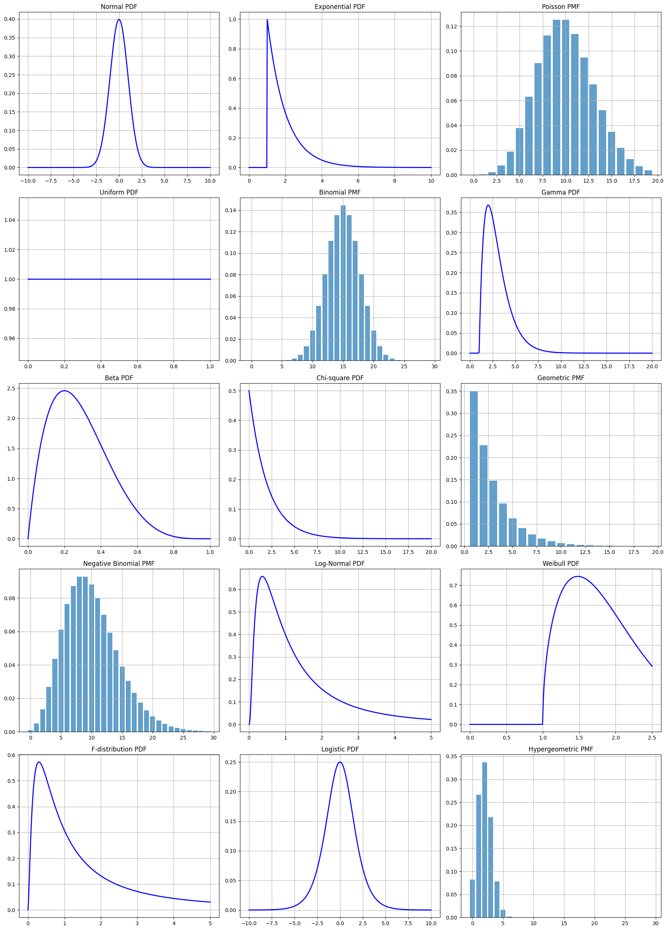

Code

1. import numpy as np

2. import matplotlib.pyplot as plt

3. from scipy.stats import norm, expon, poisson, uniform, binom, gamma, beta, chi2, geom, nbinom, lognorm, weibull\_min, f, logistic, hypergeom

4.

5. # Set up figure and axes

6. fig, axes = plt.subplots(5, 3, figsize=(18, 25))

7. axes = axes.flatten()

8.

9. # Data for distributions

10. x\_values = {

11. 'Normal': np.linspace(-10, 10, 400),

12. 'Exponential': np.linspace(0, 10, 400),

13. 'Poisson': np.arange(20),

14. 'Uniform': np.linspace(0, 1, 100),

15. 'Binomial': np.arange(30),

16. 'Gamma': np.linspace(0, 20, 400),

17. 'Beta': np.linspace(0, 1, 400),

18. 'Chi-square': np.linspace(0, 20, 400),

19. 'Geometric': np.arange(1, 20),

20. 'Negative Binomial': np.arange(0, 30),

21. 'Log-Normal': np.linspace(0.001, 5, 400),

22. 'Weibull': np.linspace(0, 2.5, 400),

23. 'F-distribution': np.linspace(0, 5, 400),

24. 'Logistic': np.linspace(-10, 10, 400),

25. 'Hypergeometric': np.arange(0, 30) # specific values needed

26. }

27.

28. # Parameters for distributions

29. params = {

30. 'Normal': (0, 1),

31. 'Exponential': (1,),

32. 'Poisson': (10,),

33. 'Uniform': (0, 1),

34. 'Binomial': (30, 0.5),

35. 'Gamma': (2, 1),

36. 'Beta': (2, 5),

37. 'Chi-square': (2,),

38. 'Geometric': (0.35,),

39. 'Negative Binomial': (10, 0.5),

40. 'Log-Normal': (1,), # Parameters for log-normal

41. 'Weibull': (1.5, 1),

42. 'F-distribution': (5, 2),

43. 'Logistic': (0, 1),

44. 'Hypergeometric': (50, 10, 10) # N, K, n

45. }

46.

47. # Distributions from scipy.stats

48. distributions = {

49. 'Normal': norm,

50. 'Exponential': expon,

51. 'Poisson': poisson,

52. 'Uniform': uniform,

53. 'Binomial': binom,

54. 'Gamma': gamma,

55. 'Beta': beta,

56. 'Chi-square': chi2,

57. 'Geometric': geom,

58. 'Negative Binomial': nbinom,

59. 'Log-Normal': lognorm,

60. 'Weibull': weibull\_min,

61. 'F-distribution': f,

62. 'Logistic': logistic,

63. 'Hypergeometric': hypergeom

64. }

65.

66. # Plot each distribution

67. for ax, (key, dist) in zip(axes, distributions.items()):

68. x = x\_values[key]

69. param = params[key]

70. if key in ['Poisson', 'Binomial', 'Geometric', 'Negative Binomial', 'Hypergeometric']:

71. pmf = distributions[key].pmf(x, \*param)

72. ax.bar(x, pmf, alpha=0.7)

73. ax.set\_title(f'{key} PMF')

74. else:

75. pdf = distributions[key].pdf(x, \*param)

76. ax.plot(x, pdf, 'b-', lw=2)

77. ax.set\_title(f'{key} PDF')

78.

79. ax.grid(True)

80.

81. plt.tight\_layout()

82. plt.show()

83.

## Elliptical distributions

### A list of some elliptical distributions

1. Multivariate Normal Distribution:

- Formula:

- Applications: Widely used in statistics for modeling correlations between variables, in finance for portfolio optimization, and in machine learning algorithms.

2. Multivariate t-Distribution:

- Formula:

- Applications: Used for data with outliers, in robust statistics, and in finance to model heavy-tailed returns.

3. Multivariate Cauchy Distribution:

- Formula:

- Applications: Suitable for situations with extremely heavy tails and undefined moments, used in physics for resonance behaviors.

4. Multivariate Logistic Distribution:

- Formula:

- Applications: Modeling growth processes and in situations where a distribution is needed that has a sharper peak and heavier tails than the normal but more moderate than the t-distribution.

5. Multivariate Laplace Distribution:

- Formula:

- Applications: Useful in signal processing and image analysis for modeling noise that is more impulsive than Gaussian noise.

6. Pearson Type II and Type VII Distributions:

- Formula (Type VII): Similar to the multivariate t-distribution but with additional shape parameters.

- Applications: Flexibly model data distributions in scientific research where the data may exhibit skewness or excess kurtosis.

7. Kotz Type Distribution:

- Formula: Complicated and based on a form involving the radius raised to a power that depends on additional shape parameters.

- Applications: Used in modeling phenomena where the distributions are not only heavy-tailed but may have other complex characteristics not captured by simpler elliptical distributions.

These distributions share the general form where is a function defining the specific distribution, is the dispersion matrix, is the mean vector, and is a normalizing constant. This general structure highlights the flexibility of elliptical distributions in adapting to different data characteristics while maintaining a form that facilitates analysis and application across a variety of fields.

Yes, the formulas provided in the previous message are probability density functions (PDFs) for each respective multivariate elliptical distribution. Let's delve deeper into the general form of the elliptical distributions and explore how these formulas fit within that framework.

### General Form of Elliptical Distributions

The general formula for the PDF of an elliptical distribution is based on a functional form that represents the density as a function of the squared Mahalanobis distance, which measures how far each point is from the mean, standardized by the covariance matrix. The general PDF for an elliptical distribution can be expressed as:

Where:

- is the vector of variables.

- is the mean vector.

- is the covariance matrix, which describes the scale and correlation of the distribution.

- is a function that shapes the density and controls how the probability mass is distributed (typically depending on how far a point is from the mean).

- is a normalizing constant that ensures the integral over the PDF equals 1, dependent on and the dimensions of .

**Explanation of**

1. The Function

- This function determines the characteristics of the distribution, especially how probabilities decline with distance from the mean. For the normal distribution, is an exponential function reflecting the rapid decrease in probability as distance increases. For distributions like the t-distribution,allows probabilities to decrease more slowly, giving heavier tails.

2. The Normalizing Constant

- The value of \( C \) depends on the specific form of \( g \) and ensures the total area under the PDF equals one. Calculating \( C \) typically involves integrating the effect of \( g \) across the entire space where the distribution is defined, often using properties of gamma functions and determinants of the covariance matrix.

Applications of \( g \) in Specific Distributions

- Normal Distribution: Here, , which leads to a rapid decline in probability with distance (quadratic).

- t-Distribution: For this, , where is the degrees of freedom, moderating the decline and allowing for heavier tails.

- Cauchy Distribution: A specific case of the t-distribution with , emphasizing very heavy tails.

**Example:**

Let's work through some examples to show how the general form of elliptical distributions is used in practice with actual numbers. We will consider examples for the multivariate normal distribution and the multivariate t-distribution, using specific values for mean, covariance, and other parameters.

Example 1: Multivariate Normal Distribution

Parameters:

- Mean vector

- Covariance matrix

- The function

Point to Evaluate:

- Point

Calculation:

1. Mahalanobis Distance:



2. Function

3. Normalizing Constant

4. Density Function Value:

Example 2: Multivariate t-Distribution

Parameters:

- Degrees of freedom

- Same mean and covariance as in the normal example

Point to Evaluate:

- Same point as before:

Calculation:

1. Using the same Mahalanobis Distance calculated previously.

2. Function \( g(t) \) with \(\nu = 3\):

3. Normalizing Constant \( C \):

4. Density Function Value:

These examples illustrate how different parameters and functional forms influence the density calculations in elliptical distributions. The calculations highlight the adaptability of these distributions to model real-world data with varying characteristics, especially in terms of tail behavior and robustness to outliers.

Yes, if you directly use the probability density function (PDF) formulas specific to the multivariate normal distribution and the multivariate t-distribution rather than applying the general elliptical form, you should obtain the same results. The general form is essentially a framework that encompasses these specific cases, so using the specific formulas is just a direct application of that framework with parameters tailored to each distribution.

To clarify this with the examples given:

Specific PDF Formula Application

1. Multivariate Normal Distribution

- Specific Formula:

- Given:

- Mean vector

- Covariance matrix

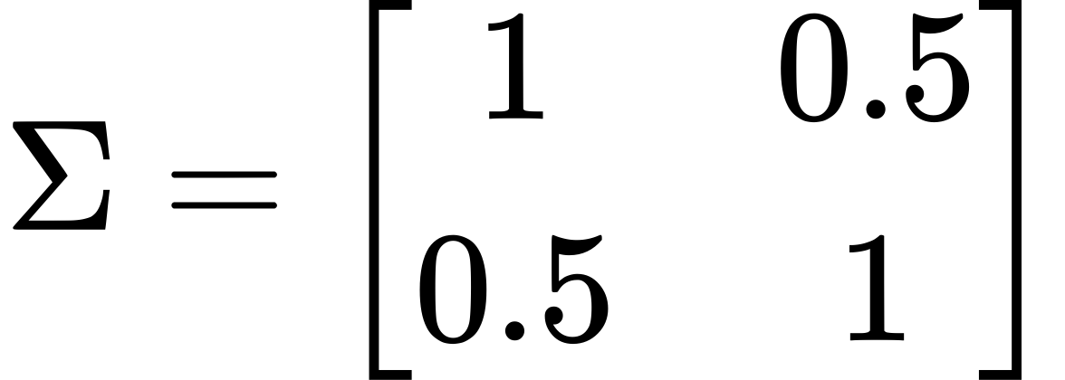

- Point

- Density Calculation:

- Compute the Mahalanobis distance exactly as done before, yielding

- Directly applying the formula, substituting \( t \) and the determinant of \( \Sigma \), gives:

This matches the result calculated using the general form.

2. Multivariate t-Distribution

- Specific Formula:

- Given:

- Degrees of freedom (\(\nu\)): 3

- Density Calculation:

- Use the same Mahalanobis distance \( t = 1.5 \).

- Plugging into the formula:

This again matches the result obtained using the general form.

Conclusion

Whether using the general form of elliptical distributions or the specific formulas for each distribution, the resulting PDF values should be the same, provided all computations are correctly performed. This equivalence underscores how the general form is a unifying framework that encompasses these specific distributions, each with their parameters tailored to describe different characteristics of multivariate data.

### A Python code snippet that lets you experiment with the general form of elliptical distributions.

The code provides a flexible setup where you can define the function and compute the normalization constant for different configurations. This will enable you to see how changes to these components affect the shape of the distribution.

In this script, we'll implement a class for the general elliptical distribution, allowing you to modify the function and the covariance matrix. We'll also include a plotting function to visualize the effects of these changes.

Python Code for Customizable Elliptical Distributions

1. import numpy as np

2. import matplotlib.pyplot as plt

3. from scipy.stats import multivariate\_normal

4. from scipy.integrate import quad

5.

6. class EllipticalDistribution:

7. def \_\_init\_\_(self, mu, sigma, g\_func, c\_calc):

8. self.mu = np.array(mu)

9. self.sigma = np.array(sigma)

10. self.g = g\_func

11. self.c = c\_calc(sigma, g\_func)

12.

13. def pdf(self, x):

14. x\_minus\_mu = x - self.mu

15. mahalanobis\_sq = x\_minus\_mu.T @ np.linalg.inv(self.sigma) @ x\_minus\_mu

16. return self.c \* self.g(mahalanobis\_sq)

17.

18. def g\_example(t):

19. # Example of a 'g' function; change this as needed

20. return np.exp(-t / 2)

21.

22. def calculate\_c(sigma, g\_func):

23. # Calculate normalization constant 'C'

24. # This is an example; adjust based on the chosen 'g'

25. def integrand(t):

26. return g\_func(t) \* np.exp(-t / 2)

27. result, \_ = quad(integrand, 0, np.inf)

28. return 1 / (2 \* np.pi \* np.sqrt(np.linalg.det(sigma)) \* result)

29.

30. def plot\_elliptical\_distribution(dist, num\_points=100):

31. # Create a grid of points for plotting

32. x, y = np.linspace(-5, 5, num\_points), np.linspace(-5, 5, num\_points)

33. X, Y = np.meshgrid(x, y)

34. pdf\_values = np.zeros(X.shape)

35.

36. # Calculate PDF over the grid

37. for i in range(num\_points):

38. for j in range(num\_points):

39. point = np.array([X[i, j], Y[i, j]])

40. pdf\_values[i, j] = dist.pdf(point)

41.

42. # Plotting

43. plt.figure(figsize=(8, 8))

44. plt.contourf(X, Y, pdf\_values, levels=15, cmap='viridis')

45. plt.colorbar()

46. plt.title('Elliptical Distribution PDF')

47. plt.xlabel('X')

48. plt.ylabel('Y')

49. plt.axis('equal')

50. plt.show()

51.

52. # Configuration parameters

53. mean = [0, 0]

54. covariance = [[1, 0.5], [0.5, 1]]

55.

56. # Create an instance of the distribution

57. elliptical\_dist = EllipticalDistribution(mean, covariance, g\_example, calculate\_c)

58.

59. # Plot the distribution

60. plot\_elliptical\_distribution(elliptical\_dist)

61.

**Key Components of the Code**

1. EllipticalDistribution Class: This class takes mean, covariance, a \( g \) function, and a function to calculate \( C \). It can compute the PDF for any given point.

2. g\_function and C Calculation: You can define different \( g \) functions and corresponding methods to calculate the normalization constant \( C \). In this example, a basic form of \( g(t) = e^{-t/2} \) is used, which resembles the normal distribution. You should adjust the integral in `calculate\_c` based on your \( g \) function to ensure proper normalization.

3. Plotting: The `plot\_elliptical\_distribution` function visualizes the PDF over a grid of points, showing the contours of the distribution.

**How to Use and Modify**

- Modify the \( g \) Function: Change the definition of `g\_example` to explore how different tail behaviors and shapes are represented.

- Adjust the Covariance Matrix: Change `covariance` to see how different correlations and variances impact the shape of the distribution.

This setup provides a flexible framework to explore and understand the properties and behaviors of elliptical distributions by manipulating their core components.

### Importance of Mahalanobis Distance

The squared Mahalanobis distance is central to these distributions. It adjusts the Euclidean distance by the scale and correlation of the variables, allowing the elliptical distributions to account for the structure in multivariate data more effectively than isotropic distributions like the univariate normal.

Understanding these components helps in comprehending how elliptical distributions can be adapted to model various data types beyond the assumption of normality, providing tools for robust statistical analysis in the presence of outliers, skewed data, and other complex data structures.

The Mahalanobis distance plays a crucial role in the theory of elliptical distributions by measuring how far a point is from the mean of a distribution, taking into account the covariance of the distribution. This distance measure is essential because it scales the Euclidean distance by the variability of each dimension, providing a normalized distance that is invariant to scales and correlations in the data.

Mathematical Explanation of Mahalanobis Distance

The Mahalanobis distance for a point from a group with mean and covariance matrix is given by:

Key Points:

- Scaling and Correlation: The inverse of the covariance matrix, , scales the distance calculation according to the variance of each component and the correlation between components. This scaling ensures that the distance reflects how "unusual" or "extreme" a data point is, not just in terms of absolute distance but relative to the distribution's spread and shape.

- Unitless Distance: The distance is unitless and scale-invariant, which is critical when dealing with variables that have different units or scales.

Importance in Elliptical Distributions

1. Shape of Density Contours: In elliptical distributions, contours of equal probability density are ellipsoids centered at the mean . The Mahalanobis distance is constant on these ellipsoids, making it a natural measure to define the shape of these contours.

2. Outlier Detection: It is widely used in outlier detection because it effectively discerns points that are far from the norm, considering the overall data structure. A large Mahalanobis distance indicates a potential outlier.

3. Classification and Clustering: In statistical classification and clustering, the Mahalanobis distance is used to assign classifications based on the shortest distance to class centroids, improving accuracy over Euclidean distance in cases where classes have different covariances.

**Visualization and Example**

Let's visualize the importance of Mahalanobis distance using a bivariate normal distribution, comparing it with the Euclidean distance to highlight why it is more appropriate in the context of elliptical distributions.

We will:

- Generate a bivariate normal distribution with a specified mean and covariance.

- Plot the ellipsoids of equal density (constant Mahalanobis distance).

- Show points with the same Euclidean and Mahalanobis distances to compare how they differ.

Let's proceed with the code to generate this visualization.

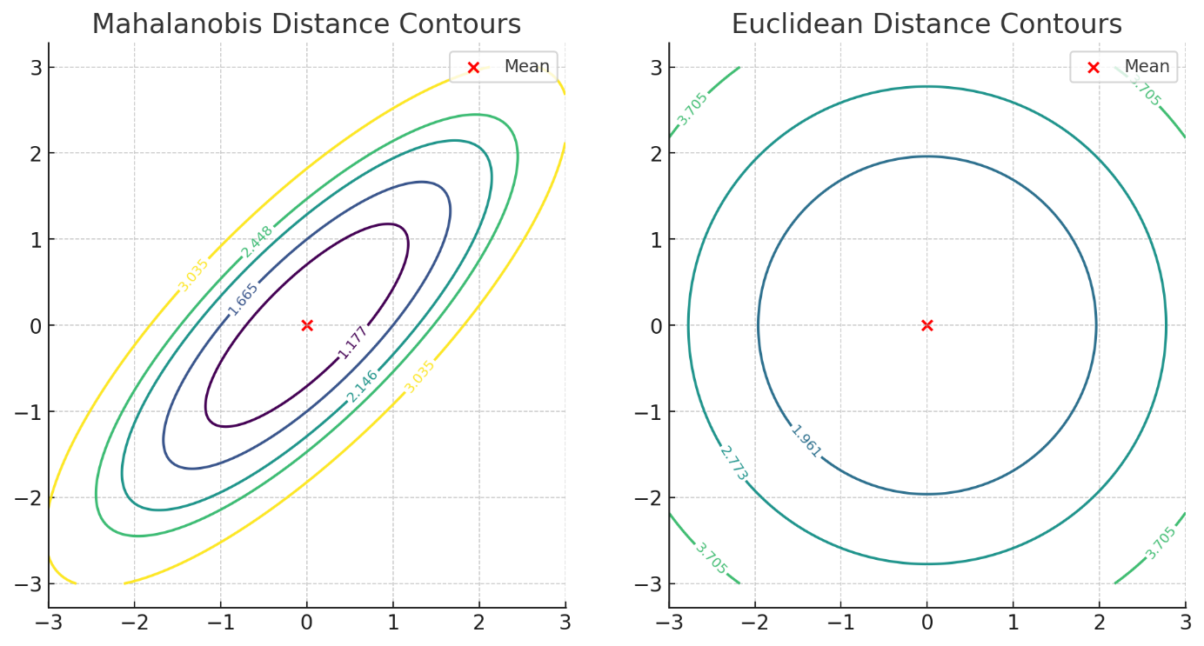

The plots above illustrate the differences between Mahalanobis distance and Euclidean distance for a bivariate normal distribution with a strong correlation between variables.

**Mahalanobis Distance Contours (Left Plot):**

- The contours are ellipses centered at the mean

- These ellipses reflect the covariance structure of the distribution, stretching along the axis of higher variance and correlation.

- The distances are scaled such that points equidistant according to the Mahalanobis distance have the same probability density, which is crucial for accurate statistical modeling and outlier detection in data with correlations.

**Euclidean Distance Contours (Right Plot):**

- The contours are circles, which do not account for the correlation or different variances along different axes.

- This metric treats distance uniformly in all directions, which can misrepresent the "true" distance of points in terms of likelihood under the given distribution.

Key Takeaways

- Mahalanobis Distance: Properly accounts for the shape and orientation of the data distribution, providing a more accurate representation of distances in the context of the underlying statistical properties.

- Euclidean Distance: Fails to incorporate the covariance structure, potentially leading to misleading interpretations in multivariate analyses.

These visualizations and explanations underscore why Mahalanobis distance is essential for applications involving elliptical distributions, particularly when dealing with correlated multivariate data. It ensures that the statistical methods applied, such as clustering, classification, and anomaly detection, are sensitive to the actual structure of the data, leading to more reliable and meaningful results.

Code:

1. import numpy as np

2. import matplotlib.pyplot as plt

3. from scipy.stats import chi2

4.

5. # Parameters

6. mean = np.array([0, 0])

7. covariance = np.array([[1, 0.8], [0.8, 1]]) # High correlation

8.

9. # Create a grid of points

10. x, y = np.meshgrid(np.linspace(-3, 3, 300), np.linspace(-3, 3, 300))

11. xy = np.column\_stack([x.flat, y.flat])

12.

13. # Calculate Mahalanobis distance from the mean

14. mahalanobis\_distance = np.array([

15. np.sqrt((point - mean).T @ np.linalg.inv(covariance) @ (point - mean))

16. for point in xy

17. ]).reshape(x.shape)

18.

19. # Calculate Euclidean distance from the mean for comparison

20. euclidean\_distance = np.sqrt((x - mean[0])2 + (y - mean[1])2)

21.

22. # Plotting

23. fig, ax = plt.subplots(1, 2, figsize=(12, 6))

24.

25. # Plot for Mahalanobis distance

26. cs1 = ax[0].contour(x, y, mahalanobis\_distance, levels=np.sqrt(chi2.ppf([0.5, 0.75, 0.9, 0.95, 0.99], df=2)), cmap='viridis')

27. ax[0].scatter(mean[0], mean[1], c='red', label='Mean')

28. ax[0].set\_title('Mahalanobis Distance Contours')

29. ax[0].axis('equal')

30. ax[0].legend()

31. ax[0].clabel(cs1, inline=True, fontsize=8)

32.

33. # Plot for Euclidean distance

34. cs2 = ax[1].contour(x, y, euclidean\_distance, levels=np.sort(mahalanobis\_distance.flat)[::len(mahalanobis\_distance.flat)//5], cmap='viridis')

35. ax[1].scatter(mean[0], mean[1], c='red', label='Mean')

36. ax[1].set\_title('Euclidean Distance Contours')

37. ax[1].axis('equal')

38. ax[1].legend()

39. ax[1].clabel(cs2, inline=True, fontsize=8)

40.

41. plt.show()

42.

## PDF

The probability density function (PDF) is a fundamental concept in statistics and probability theory, essential for describing the distribution of continuous random variables. Let's dive into how PDFs work, their purpose, and provide a concrete example using a normal distribution.

**How the PDF Generally Works**

1. Definition: The PDF of a continuous random variable is a function that describes the relative likelihood for this random variable to take on a given value. Essentially, it gives us the "density" of the probability at each point in its range.

2. Properties:

- The PDF is always non-negative: for all .

- The integral of the PDF over the entire range of is 1, symbolizing the total probability:

3. Purpose: The PDF helps in calculating probabilities for intervals of values. For example, to find the probability that falls within a range \([a, b]\), you would integrate the PDF over that range:

**Inputs and Outputs**

- Input: The input to a PDF is a value or range of values for which you want to evaluate the probability density.

- Output: The output is the probability density associated with the input value(s). This is not a probability itself but a density from which probabilities can be calculated as described above.

**Example with the Normal Distribution**

Let's consider the normal distribution, which is one of the most important probability distributions in statistics, defined by two parameters: mean () and standard deviation ().

- Normal Distribution PDF:

Parameters:

- Mean (): 0

- Standard deviation (): 1 (This makes it a standard normal distribution.)

**Question: What is the density at**

Calculation:

This value represents the probability density at \(x = 1\), indicating how "dense" the probability is around this point. It is not a probability itself, but it shows that \(x = 1\) is a relatively likely value for a standard normal distribution, though not the most likely, which would be at \(x = 0\) (the mean).

**Why the PDF is Needed**

The PDF is crucial because it provides a complete description of the distribution of a random variable. It allows us to:

- Calculate probabilities for specific ranges of values.

- Analyze the properties of the distribution (like where it concentrates, variability, tail behavior).

- Perform statistical tasks such as hypothesis testing, confidence intervals, and regression analysis based on the underlying distribution of data.

Understanding and using the PDF enables statisticians and data scientists to make informed decisions and predictions based on the statistical characteristics of data.

When you see a plot of a probability density function (PDF) for a normal distribution, it's important to clarify that the plot is based on the theoretical properties of the distribution defined by its parameters (mean and standard deviation), not directly from discrete data points like However, if you want to generate a PDF plot from a sample like this, you typically estimate the parameters (mean and standard deviation) from the sample and then use these estimated values to plot the theoretical distribution. Here's how you can do it:

Steps to Create a PDF Plot from Sample Data

1. Estimate Parameters:

- Mean () is estimated as the sample mean.

- Standard Deviation () is estimated as the sample standard deviation.

2. Define the PDF:

- For a normal distribution, the PDF is given by:

f

- With and replaced by their estimates.

3. Generate Values for :

- Choose a range of values typically extending a few standard deviations around the

4. Compute the PDF Values:

- Calculate for each \(x\) in the chosen range.

5. Plot the PDF:

- Use a line plot to show how the density of the probability distribution varies across different values of \(x\).

Example: Creating a PDF Plot from

Let's go through the process with Python to illustrate how you can plot a PDF for a normal distribution estimated from the given sample.

Code:

1. import numpy as np

2. import matplotlib.pyplot as plt

3. from scipy.stats import norm

4.

5. # Sample data

6. data = np.array([1, 2, 3, 2, 2])

7.

8. # Estimate parameters

9. mu = np.mean(data)

10. sigma = np.std(data, ddof=1) # Using Bessel's correction with ddof=1

11.

12. # Generate x values for the PDF plot

13. x\_values = np.linspace(mu - 3\*sigma, mu + 3\*sigma, 100)

14.

15. # Calculate PDF values

16. pdf\_values = norm.pdf(x\_values, mu, sigma)

17.

18. # Plotting the PDF

19. plt.figure(figsize=(8, 4))

20. plt.plot(x\_values, pdf\_values, label='Estimated Normal PDF')

21. plt.scatter(data, np.zeros(len(data)), color='red', label='Data Points')

22. plt.title('Normal Distribution PDF Estimated from Sample Data')

23. plt.xlabel('x')

24. plt.ylabel('Density')

25. plt.legend()

26. plt.grid(True)

27. plt.show()

28.

**Explanation**

- Data Points: The red dots on the plot (at \(x = 1, 2, 3\)) represent the actual data points, showing their positions relative to the estimated distribution.

- PDF Curve: The curve shows the estimated normal distribution based on the calculated mean and standard deviation from the sample. It gives a visual understanding of where most data points are likely to fall within the distribution.

This process effectively uses sample data to estimate and visualize the underlying distribution, helping in understanding the distribution's characteristics and checking how well the sample represents a normal distribution.

Derivation of the Normal Distribution PDF

1. Central Idea:

- The formula is derived with the aim that the distribution of errors or deviations from the mean follows a bell-shaped curve, which is symmetric and where the occurrence of values decreases exponentially as they deviate from the mean.

2. Exponential Function:

- The use of the exponential function \( e^{-x^2} \) in statistics for the normal distribution is crucial because it ensures that the curve is bell-shaped. This is due to the rapid decay of \( e^{-x^2} \) as \( x \) moves away from zero, providing a strong mathematical tool to model decay in real-world phenomena.

3. Scaling and Normalizing:

- The component \( \frac{(x - \mu)^2}{2\sigma^2} \) in the exponent adjusts the exponential decay to accommodate any mean \( \mu \) and any variance \( \sigma^2 \). By scaling \( x-\mu \) by \( \sigma \), we standardize the deviation around the mean, ensuring that the spread of the distribution correctly represents the variance of the data.

- The factor \( \frac{1}{\sigma \sqrt{2\pi}} \) serves as a normalization factor to ensure that the total area under the curve (i.e., the total probability) is 1. The \( \sqrt{2\pi} \) in the denominator is particularly chosen to mathematically cancel out the integration over \( e^{-x^2} \) when integrated from \( -\infty \) to \( \infty \), a result derived from the Gaussian integral.

Gaussian Integral

The choice of \( \sqrt{2\pi} \) is justified through the Gaussian integral, which computes the integral of the exponential of a squared variable:

\int\_{-\infty}^{\infty} e^{-x^2} \, dx = \sqrt{\pi}

For the normal distribution, we use:

\int\_{-\infty}^{\infty} e^{-\frac{(x-\mu)^2}{2\sigma^2}} \, dx = \sigma \sqrt{2\pi}

This adjustment ensures the integral across the PDF equals 1.

Simplification

To simplify, imagine setting \( \mu = 0 \) and \( \sigma = 1 \) (a standard normal distribution):

f(x) = \frac{1}{\sqrt{2\pi}} e^{-\frac{x^2}{2}}

This formula shows that as \( x \) moves away from 0, the value of \( f(x) \) (or the probability density) decreases exponentially, peaking at \( x = 0 \) where the mean of the distribution lies.

# Papers

## Distribution under elliptical symmetry of a distance-based multivariate coefficient of variation"

### Preparation:

#### What are Asymptotic Properties?

The discussion of asymptotic properties in the paper primarily focuses on the behavior of the MCV estimators as the sample size increases, particularly under the assumption that the underlying data distribution exhibits elliptical symmetry.

In statistics, "asymptotic" refers to the behavior of estimators when the sample size approaches infinity. Key asymptotic properties include:

- Consistency: An estimator is consistent if it converges in probability to the true parameter value as the sample size increases. This is a fundamental property that ensures the reliability of the estimator in large samples.

- Asymptotic Normality: An estimator is asymptotically normal if, when appropriately normalized, its distribution converges to a normal distribution as the sample size becomes large. This property is crucial for constructing confidence intervals and hypothesis tests.

# Mathematical Formulation in the Paper

The paper specifically explores the asymptotic distribution of MCV estimators constructed using affine-equivariant estimators for the mean and covariance matrix. Here’s a more detailed look at the formulations and results:

1. Estimator Definition:

- The MCV, is estimated by \), where is the sample mean vector, and is the sample covariance matrix.

2. Asymptotic Analysis:

- The paper proves that if the sample mean and the sample covariance are affine-equivariant estimators, then the distribution of depends

#### Bias Correction

A significant methodological focus is on addressing the bias in the classical estimator of the MCV. The classical estimator is direct but can be biased, especially in small samples or under specific distributional conditions. The paper presents both parametric and non-parametric methods to correct this bias, enhancing the accuracy of the MCV estimates.

**Parametric methods** involve adjustments based on the assumed model of the data distribution.

**Non-parametric methods** (such as bootstrapping and jackknifing) do not rely on distributional assumptions and are used to estimate and adjust the bias empirically.

A- Parametric methods

**To illustrate parametric methods for bias correction** in statistical estimation, let's consider an example where we adjust the bias in the estimation of the multivariate coefficient of variation (MCV) **under the assumption that the data follow a specific distribution**, such as the multivariate normal distribution. This is a common scenario in the statistical analysis of financial or scientific data where the underlying assumptions about the distribution can significantly influence the accuracy and reliability of the estimates.

Example: Bias Correction in Estimating MCV under Multivariate Normality

# Context and Setup

Suppose we have a dataset comprising returns of a portfolio of assets. We assume that the returns are jointly normally distributed, which is a typical assumption in portfolio risk management. This assumption allows us to use the properties of the multivariate normal distribution to correct biases in our estimator.

# Estimation of MCV

The MCV is given by:

where is the mean vector of asset returns, and is the covariance matrix of the returns.

# Classical Estimator

Initially, we compute the classical estimator for the MCV using the sample mean and sample covariance matrix derived directly from the data:

where s the sample mean vector and is the sample covariance matrix.

# Bias Recognition

In the classical estimator, there is an inherent bias, especially pronounced in small samples or when the dimensionality of the data (number of assets) is high relative to the sample size. This bias stems from the underestimation of the denominator due to the inversion of the sample covariance matrix, which might not be an efficient estimator of the true inverse covariance matrix.

# Parametric Bias Correction

To correct this bias, we use the properties of the multivariate normal distribution:

- Adjustment Formula: Knowing that the sample covariance matrix is biased, we can apply a correction factor based on the degrees of freedom. A common adjustment is to scale the covariance matrix by a factor related to the sample size and the dimension

- Corrected MCV Estimator:

# Example Calculation

Let's say we have a portfolio of 5 assets, and the sample size is 30 (This could be monthly returns data over 30 months, for example, from January 2020 to June 2022.). After computing the sample mean vector and covariance matrix, the corrected covariance matrix would be scaled by assuming the above correction factor is appropriate given the degrees of freedom.

# Effectiveness and Implementation

This corrected estimator is expected to be closer to the true MCV, reducing the bias introduced by the direct inversion of the sample covariance matrix in the classical method. The effectiveness of this correction would typically be validated through simulation studies or bootstrap methods to ensure that it performs better across different sample sizes and under various market conditions.

B - Non-parametric methods:

1- Bootstrap Sampling Explained

1. Random Selection with Replacement:

- When creating a bootstrap sample, you randomly select observations from the original dataset. Importantly, each selection is made with replacement, which means after an observation is selected, it's put back into the original dataset, making it eligible to be selected again.

2. Sample Composition:

- Each bootstrap sample is the same size as the original dataset but the contents of each sample vary. Because of the replacement:

- Duplicates: Some observations from the original dataset may appear multiple times in a bootstrap sample.

- Omissions: Other observations might not be included in a particular bootstrap sample at all.

3. Not Just Duplication:

- This process is different from just duplicating the dataset. Duplication would imply making an exact copy of the entire dataset without any variation, which would not add any new information or provide any insights into the variability of statistics calculated from the data.

- Bootstrap samples are unique in that each one is like a new realization of the dataset, simulating what might happen if you were to collect new data under the same conditions that produced the original dataset.

Example for Clarity

Suppose you have a small dataset: A, B, C, D, E

- Bootstrap Sample 1 might look like: A, A, B, C, E

- Bootstrap Sample 2 might look like: B, D, D, E, E

- Bootstrap Sample 3 might look like: C, A, C, D, B

In each sample:

- Some original data points (like "A" in Sample 1) may appear more than once.

- Some data points might not appear in a particular sample at all (like "D" in Sample 1 and "A" in Sample 2).

Why This Matters

The variability among these bootstrap samples allows statisticians to:

- Estimate the Sampling Distribution: By calculating the desired statistic (mean, variance, etc.) for each bootstrap sample, you can estimate the sampling distribution of that statistic.

- Assess Robustness and Reliability: This process helps in understanding how sensitive your statistical estimates are to variations in the sample data, thereby providing insights into their robustness and reliability.

In summary, bootstrap resampling is a powerful tool that leverages the original data to simulate the sampling process, enabling the assessment of statistical estimates without needing new data collection. This method enriches the statistical analysis by providing a practical way to gauge the accuracy and variability of estimates derived from sample data.

2- The jackknife method

The jackknife method is a resampling technique used in statistics to estimate the bias and variance of a statistical estimator, improve its accuracy, and provide error estimates for the estimates. This method involves systematically recalculating the statistic by leaving out one or more observations at a time from the sample set.

How the Jackknife Method Works

1. Subsamples Creation: From an original dataset of size create new subsamples, each of which is formed by excluding one observation from the dataset. For example, if the original dataset is , the first subsample would be , the second , and so on.

2. Estimate Calculation: Calculate the estimate of interest for each subsample. This could be a mean, median, variance, or any other statistical measure.

3. Bias Correction: Estimate the bias of the original estimator by comparing the estimates from the full dataset to the average of the estimates from the jackknife samples.

4. Error Estimation: Estimate the variance and standard error of the estimator using the variability among the jackknife estimates.

Example of Using the Jackknife Method

# Scenario:

Consider a small dataset representing the weights of ten newborn puppies: kg. We want to estimate the average weight but also understand the reliability (variance) of our estimate.

# Steps Using Jackknife

1. Original Estimate: Calculate the mean weight of the puppies.

- Original mean kg.

2. Create Subsamples: Exclude one observation at a time to create nine new datasets. For instance:

- Subsample 1 (exclude the first observation): .

- Calculate the mean for each subsample.

3. Estimates from Subsamples:

- Mean of Subsample 1:kg.

- Continue this for all subsamples.

4. Bias and Variance Calculation:

- Average of all subsample means: .

- Bias estimation:

- Variance estimation: where is the number of observations.

5. Result Interpretation:

- Use the bias to adjust the original mean if necessary.

- Report the standard error as to provide an uncertainty measure for the mean weight estimate.

Conclusion

The jackknife is a valuable method for estimating the accuracy and reliability of statistical estimates, particularly useful when the sample size is small, and other resampling methods like the bootstrap might be computationally intensive or impractical. This method not only helps in adjusting the bias but also in providing robust error estimates, making it a versatile tool in statistical analysis.

#### Multivariate CoV in Financial Markets:

When dealing with portfolios, we encounter multiple assets whose returns can exhibit interconnected variability. The multivariate CoV becomes useful here, as it accounts for the covariance between different asset returns, offering a more holistic view of the portfolio’s volatility relative to its mean performance.

Mathematical Formulation:

The multivariate coefficient of variation for a portfolio can be represented in a way that incorporates the correlation structure among the assets. If we denoteas a random vector representing the returns of different assets in the portfolio, then the multivariate CoV is defined using a distance measure that considers the covariance matrix

Example Calculation:

Suppose we have a portfolio with two assets. Over a certain period, asset A has an expected return of 8% with a standard deviation of 5%, and asset B has an expected return of 12% with a standard deviation of 8%. The correlation coefficient between the assets' returns is 0.6.

Step 1: Calculate the covariance matrix .

- The variance of A is , and the variance of B is

- The covariance between A and B, given the correlation of 0.6, is

Covariance matrix:

\Sigma = \begin{bmatrix}

0.0025 & 0.0024 \\

0.0024 & 0.0064

\end{bmatrix}

Step 2: Define the mean vector and compute

- \( \mu = \begin{bmatrix} 0.08 \\ 0.12 \end{bmatrix} \)

-

Step 3: Calculate \( \text{MCoV}(X) \).

Assuming \( \mu\_0 = \begin{bmatrix} 0 \\ 0 \end{bmatrix} \) (zero vector for simplicity),

\text{MCoV}(X) = \frac{\sqrt{\begin{bmatrix} 0.08 & 0.12 \end{bmatrix} \begin{bmatrix} 400 & -150 \\ -150 & 625 \end{bmatrix} \begin{bmatrix} 0.08 \\ 0.12 \end{bmatrix}}}{0.10}

Let's calculate this using Python to find the exact value.

The calculated multivariate coefficient of variation (MCoV) for the portfolio is approximately 17.37. This value indicates the level of risk per unit of return, taking into account the correlation between the assets in the portfolio. A higher MCoV suggests a higher level of risk relative to the expected return, which is essential for making informed investment decisions.

This example provides a practical application of the multivariate CoV in financial markets, helping portfolio managers and analysts to better understand the risk-return profile of their investments considering the interconnected variability of asset returns.

Certainly! Let's revise the previous calculation by setting the reference mean vector to a more realistic scenario where we don't use it as a zero vector, and we'll also delve into a real-world interpretation of the results.

Revised Calculation

In financial terms, might typically represent a target return that the portfolio manager aims to achieve. Let's consider a scenario where the target returns for the portfolio are aligned with a benchmark or a desired minimum threshold. For simplicity, let's assume \( \mu\_0 \) represents a conservative target return of 5% for both assets.

Step 1: Define the new

- \( \mu\_0 = \begin{bmatrix} 0.05 \\ 0.05 \end{bmatrix} \)

Step 2: Recalculate with the new

- We already have and its inverse, from the previous example.

- We recalculate the Mahalanobis distance and the multivariate CoV.

Let's calculate this using the new

The recalculated multivariate coefficient of variation (MCoV) for the portfolio, using a realistic target return of 5% for both assets, is approximately 8.80. This value is lower than the previous calculation, indicating a relative decrease in risk when considering the specified target returns.

Real-World Interpretation:

The MCoV of 8.80 can be interpreted as follows:

- Risk-Return Profile: This value quantifies the dispersion of the asset returns in the portfolio relative to the average return, factoring in the covariance between assets. A lower MCoV, as recalculated with the new indicates that the portfolio returns are more tightly clustered around the mean when benchmarked against a conservative target. This suggests less relative volatility and potentially lower risk from the perspective of meeting the target returns.

- Decision-Making Utility: For a portfolio manager, this metric is useful for comparing the risk associated with different investment strategies or portfolios. If the goal is to minimize risk relative to a set benchmark, portfolios with a lower MCoV would be preferable.

- Benchmarking: Setting at a specific target or benchmark return allows investors to assess how much additional risk is incurred to achieve returns above this benchmark. It's particularly useful for adjusting expectations in portfolio performance evaluation, especially in volatile markets or for portfolios with diverse asset types.

Interpretation Without 𝜇\_0​

Risk Assessment: The MCoV quantifies the relative variability of the returns within the portfolio itself, without comparison to any external benchmark or target. A higher MCoV indicates greater dispersion relative to the mean, suggesting higher risk from an internal consistency perspective.

Portfolio Diversification: Since the measure takes into account the covariance (i.e., how returns on different assets move in relation to each other), a lower MCoV could also indicate better diversification within the portfolio. Assets whose returns are less correlated with each other will tend to have a lower overall MCoV, signaling that the portfolio might be less vulnerable to systematic risks.

Investment Strategy: For investment managers, understanding the MCoV in the absence of a target can still provide valuable insights into the volatility and risk profile of the portfolio. This can guide decisions about rebalancing strategies, risk management, and whether current investment holdings are aligned with the risk appetite of the stakeholders.

The Mahalanobis distance in the context of the Multivariate Coefficient of Variation (MCoV) calculation serves a specific role by quantifying how far the mean vector of the data, denoted as , is from a reference or target mean vector considering the covariance structure of the data. When is not explicitly defined or is assumed to be the zero vector, the Mahalanobis distance measures the deviation of from the origin (zero vector) adjusted for the scale and correlation of the data variables.

Understanding Mahalanobis Distance

1. Definition: The Mahalanobis distance is defined for a vector \( x \) from a mean \( \mu \) given a covariance matrix \( \Sigma \) as:

This distance measure takes into account the correlations of the data set due to the use of the inverse of the covariance matrix. It scales the components of the vector difference by the variability of each component in correlation with others.

2. Role in MCoV: In the MCoV formula:

Here, the Mahalanobis distance measures how much the mean vector \( \mu \) deviates from zero or another target mean \( \mu\_0 \) in a standardized way. It reflects the "distance" of the average returns measured in units of standard deviation, adjusted for the correlation between the variables (assets).

Practical Implications

- **Without**  is not considered (i.e., if it is set to zero), the Mahalanobis distance measures the "spread" or "scatter" of the mean vector \( \mu \) from the origin, considering the underlying covariance structure. This tells us how variable the portfolio is in a multivariate sense, where each dimension corresponds to the return of an asset, and these dimensions are not independent but correlated.

- If a target or benchmark is defined, then the Mahalanobis distance provides a measure of how far the portfolio's actual performance (mean returns) is from this target performance, again considering the correlation between returns.

Summary

The Mahalanobis distance in the MCoV formula without a specific \( \mu\_0 \) essentially provides a way to measure the inherent risk and variability of a portfolio from the geometric center of the return space (assuming the center is zero if no \( \mu\_0 \) is specified). It offers a nuanced view of portfolio risk by accounting for the internal structure of return correlations, providing a deeper insight into the stability and consistency of returns relative to their average. This insight can be crucial for portfolio management, particularly in assessing the effectiveness of diversification and the inherent stability of investment returns.

### Paper Summary:

In statistics, "asymptotic" refers to the behavior of estimators when the sample size approaches infinity. Key asymptotic properties include:

by S. Aerts, G. Haesbroeck, and C. Ruwet:

The paper explores a multivariate extension of the univariate coefficient of variation, focusing on a distance-based measure of dispersion in data. This multivariate measure is particularly useful when data points exhibit elliptical symmetry, which is common in many real-world datasets. The authors first provide practical examples to illustrate the use of this measure. Then, they analyze the asymptotic distribution of several estimators for this coefficient under the assumption of elliptical symmetry, which allows for more accurate and efficient statistical analysis. They derive the exact distribution under normality and propose bias corrections to the classical estimator, which they compare through simulations ([Aerts, Haesbroeck, and Ruwet, 2018](https://typeset.io/papers/distribution-under-elliptical-symmetry-of-a-distance-based-n9lnrn3u9c" \t "_new)).

| Paper Title and Link | Relevant Insight |
| --- | --- |
| [Distribution under elliptical symmetry of a distance-based multivariate coefficient of variation (Aerts, Haesbroeck, Ruwet, 2018)](https://typeset.io/papers/distribution-under-elliptical-symmetry-of-a-distance-based-n9lnrn3u9c) | The paper discusses the multivariate coefficient of variation for elliptically symmetric distributions, providing a thorough analysis of estimators and proposing bias corrections. |

Methods to Achieve the Goal

1. Definition and Importance of MCV:

- The paper focuses on the multivariate coefficient of variation (MCV), specifically a version by Voinov and Nikulin, defined mathematically as:

This formula is an extension of the univariate coefficient of variation and uses the Mahalanobis distance to measure variability relative to the mean in a multivariate context.

2. Estimation and Properties of MCV:

- Asymptotic Distribution: The asymptotic distribution of estimators for MCV is derived under the assumption of elliptical symmetry. The paper highlights how these estimators depend on the shape of the distribution and the mean vector but are robust across different types of elliptical distributions.

- Finite Sample Properties: Under normality, the paper derives the exact finite-sample distribution of the classical estimator, which involves substituting sample means and covariance in the MCV formula. This part is crucial for understanding how well the MCV performs in practical, small-sample scenarios.

3. Bias Correction Techniques:

- Parametric Corrections: The paper proposes parametric techniques to correct the bias inherent in the classical MCV estimator. These corrections are based on adjustments to the sample mean and covariance matrix to better approximate the true multivariate mean and spread.

- Non-Parametric Corrections: Additionally, the paper explores non-parametric methods like bootstrap and jackknife techniques to estimate and adjust for the bias without relying on parametric assumptions about the underlying data distribution.

- Comparative Analysis: Each method is tested through simulations to assess effectiveness in various scenarios characterized by different sample sizes, dimensions, and underlying distribution shapes.

4. Simulation Studies:

- Objective and Setup: The simulation studies were designed to evaluate the performance of the MCV estimators under various conditions. These conditions included different sample sizes, dimensions of data (the number of variables), and distribution types, especially focusing on elliptical distributions which generalize the normal distribution to include heavier or lighter tails.

- Estimators Tested: Multiple estimators were examined, including the classical estimator which directly plugs sample means and covariances into the MCV formula, as well as several bias-corrected estimators both parametric and non-parametric.

- Bias and Variance Analysis: The simulations measured the bias (the systematic error) and variance (the randomness in the estimator's predictions) of each estimator. This dual focus helps in understanding both the accuracy (closeness to the true value) and reliability (consistency across different samples) of the estimators.

- Results Under Different Scenarios:

- Under Normality: For data that followed a multivariate normal distribution, the classical estimator showed significant bias, particularly when the dimension was high or the sample size was low. Bias-corrected estimators reduced this bias effectively, with parametric corrections performing better in lower dimensions and non-parametric methods showing robustness in higher dimensions.

- Under Non-Normal Elliptical Distributions: When the data came from other types of elliptical distributions, which can have fatter or thinner tails than the normal distribution, the need for robust estimation techniques became more pronounced. The study demonstrated that non-parametric methods like bootstrap and jackknife provided more reliable corrections across a broader range of distribution shapes.

- Practical Recommendations Based on Outcomes:

- The simulation results guided the practical use of MCV estimators, suggesting that the choice of estimator and bias correction technique should consider not only the size and dimension of the dataset but also the assumed properties of the data distribution.

- Particularly, for real-world applications where the distributional assumptions are not clear, the paper recommends more flexible, non-parametric approaches to ensure the robustness of the findings.

This detailed account of the simulation studies in the paper highlights their crucial role in underpinning the theoretical development of MCV estimators with empirical evidence, providing a solid foundation for their recommended use in practice.

Results

- Simulation Study Outcomes: The results from the simulation studies show that both parametric and non-parametric bias corrections significantly improve the accuracy of the MCV estimators. The paper provides a detailed comparison of these methods in terms of bias reduction and variance impact, highlighting scenarios where each method is most effective.

- Practical Implications: The findings suggest practical guidelines for selecting appropriate MCV estimators and correction techniques based on specific study conditions such as sample size, the dimensionality of data, and the assumed underlying data distribution.

Other Important Points

- Theoretical Extensions: The paper extends the theoretical understanding of the MCV by exploring its properties under a broader set of conditions than typically considered, such as non-normal elliptical distributions and higher dimensions.

- Applications and Examples: Several real-world applications are detailed to illustrate the utility of the MCV in diverse fields, enhancing the relevance of the measure beyond theoretical statistics to practical, applied settings in finance, healthcare, and quality control.

- Recommendations for Practitioners: Based on the simulation results and theoretical insights, the paper provides recommendations for practitioners on how to effectively apply and interpret the MCV in multivariate analysis, especially in contexts requiring robust measures of variability and dispersion.

Certainly! Let's delve deeper into the practical applications highlighted by the study, which underscore the versatility and utility of the MCV across various fields:

Applications of the Study:

1. External Quality Assessment (EQA) in Medical Laboratories:

- Context: In EQA schemes, laboratories are required to measure the same control sample to ensure the consistency and reliability of their test results.

- Application: The paper discusses the use of MCV to assess the repeatability of assay techniques across different laboratories. By using MCV, it's possible to evaluate the relative variability of techniques more holistically than using univariate measures which might ignore the correlation between multiple assay results.

- Example: A practical example provided involves comparing several protein electrophoresis techniques using the MCV. This approach allows for a more integrated assessment of assay precision across multiple protein fractions (like albumin, alpha, beta, and gamma globulins) which are typically analyzed in clinical settings.

2. Finance and Investment Strategy:

- Context: In the financial sector, managing portfolios effectively involves balancing the expected returns against the risks (variability).

- Application: The MCV is used as an extension of the Sharpe Ratio—a popular measure of investment performance relative to risk. The paper illustrates how MCV can be utilized to evaluate and compare the performance of different investment portfolios, considering the covariance among various asset returns.

- Example: An example discussed is the comparison of two portfolios: one consisting of technology stocks and the other of healthcare stocks. Using MCV allows investors to assess which portfolio offers better performance stability and risk-adjusted returns across multiple assets simultaneously.

3. Manufacturing and Process Control:

- Context: In manufacturing, ensuring that processes are stable and products meet quality standards is critical.

- Application: The paper proposes the use of MCV for creating multivariate control charts. These charts help monitor the stability and variability of manufacturing processes that involve multiple correlated variables.

- Example: An illustrative scenario might involve monitoring the dimensions of a manufactured part where multiple measurements (like length, width, height) are taken and their variability needs to be assessed collectively rather than individually.

These applications demonstrate the MCV's ability to provide a nuanced measure of variability that is sensitive to the multivariate nature of data in various domains. By accounting for correlations between variables, MCV enhances the decision-making process, whether it's in ensuring laboratory test accuracy, optimizing financial investments, or maintaining manufacturing quality.

### key takeaways

#### MCV for Control charts:

The Multivariate Coefficient of Variation (MCV) is particularly useful for monitoring multivariate processes in manufacturing because it provides a single, unified measure of relative variability across multiple correlated variables. This is especially valuable in environments where quality and precision are critical, and where multiple interrelated measurements must be monitored simultaneously. Here's a deeper look into how the MCV can be employed to monitor and control manufacturing processes:

Principle of MCV in Process Monitoring

1. Comprehensive Variability Measurement:

- The MCV is calculated as the inverse of the square root of the Mahalanobis distance between the mean vector and the origin in the space defined by the covariance matrix. This distance takes into account the covariance among the variables, offering a more complete measure of dispersion than univariate coefficients of variation could provide for each variable independently.

- By capturing the combined variability of all variables while considering their interrelationships, MCV helps in assessing overall process stability and uniformity in a comprehensive manner.

2. Sensitivity to Correlations:

- Traditional univariate measures of variability ignore the correlation between variables. In contrast, MCV incorporates these correlations through the covariance matrix used in its computation. This is crucial in manufacturing settings where process variables often influence each other (e.g., temperature and pressure in a chemical reactor).

- Sensitivity to correlations means that MCV can detect issues that may not be apparent when variables are considered in isolation, such as compensating errors between variables that could mask an underlying process shift.

Implementation of MCV in a Control Chart

1. Setting Up Control Limits:

- Control limits are established based on historical MCV data, typically set at three standard deviations (a common practice in statistical process control) from the mean MCV calculated during a stable period of the process. These limits define the expected range of variation for the MCV under normal operating conditions.

- When new process data is collected, the MCV is recalculated and plotted on a control chart. If the new MCV falls outside the predefined control limits, it triggers an investigation, as this indicates a potential shift in the process that could lead to quality issues.

2. Real-Time Monitoring and Adjustment:

- Continuous monitoring: By continuously updating the control chart with new MCV values as more data becomes available, the process can be monitored in real time. This ongoing monitoring helps in early detection of deviations from the normal process behavior.

- Process adjustments: If the MCV indicates an increasing trend in variability, or if it repeatedly hits or exceeds the control limits, process engineers can investigate and correct potential causes. Adjustments may involve calibrating equipment, altering input materials, or modifying operational parameters.

3. Advantages Over Univariate Control Charts:

- Holistic view: While univariate control charts are useful, they can miss issues that only become apparent when considering the interactions between multiple variables. MCV provides a holistic view, increasing the likelihood of detecting anomalies.

- Efficiency: Using a single MCV chart instead of multiple univariate charts simplifies monitoring, reduces complexity, and helps in faster decision-making.

Example Use Case in Manufacturing

Consider a scenario where a manufacturer produces a component that must meet specific dimensional and mechanical properties, each of which is influenced by multiple factors like temperature, pressure, and humidity during the manufacturing process. By using MCV, the manufacturer can monitor these factors collectively, ensuring that the interdependencies are considered and the overall process variability is maintained within acceptable limits.

In summary, MCV provides a sophisticated, comprehensive, and efficient tool for monitoring and controlling multivariate manufacturing processes, ensuring product quality and consistency by considering the full complexity of the production environment.

#### limitations

While the Multivariate Coefficient of Variation (MCV) is a useful tool in monitoring multivariate processes through control charts, it has certain limitations:

1. Assumption of Normality: MCV calculations often rely on the assumption that data follows a multivariate normal distribution. If this assumption doesn't hold, the effectiveness of MCV in detecting out-of-control conditions may be compromised.

2. Complexity in Interpretation: Unlike univariate control charts, interpreting MCV requires a good understanding of multivariate statistics, as it combines variability from multiple sources. This complexity can make it difficult for operators or engineers who are not statistically trained to interpret the results effectively.

3. Sensitivity to Correlations: While sensitivity to correlations is often an advantage, it can also be a limitation. Changes in correlation structure, which might not necessarily indicate a process shift, can affect the MCV significantly, leading to false alarms.

4. Data Requirements: MCV requires a sufficient amount of data to reliably estimate the mean vector and covariance matrix. In processes where data collection is slow or expensive, this might limit the feasibility of using MCV for real-time control.

5. Robustness: MCV can be sensitive to outliers because it involves the inversion of the covariance matrix, which can be unduly influenced by extreme values or non-homogeneous data.

Understanding these limitations is crucial for effectively applying MCV in control charts and for deciding when it might be necessary to use supplementary methods or alternative statistical techniques.

#### Implementing MCV in control charts

To demonstrate how to use the Multivariate Coefficient of Variation (MCV) in control charts with some simulated numbers, let's assume a hypothetical process where three key variables—temperature (°C), pressure (psi), and flow rate (L/min)—are critical to the quality of the product. We'll simulate this process and monitor it using an MCV-based control chart.

Step-by-Step Simulation of Monitoring Process Using MCV

Step 1: Data Collection

Suppose we have historical data from a stable period of the process. Here's a simulated subset of this data for 10 observations:

Temperature (°C): [100, 102, 98, 99, 101, 100, 103, 97, 102, 100]

Pressure (psi): [10, 12, 11, 10, 13, 11, 10, 12, 11, 10]

Flow rate (L/min): [50, 52, 49, 51, 50, 52, 53, 49, 50, 51]

Step 2: Calculate Mean Vector and Covariance Matrix

- Mean Vector:

- Covariance Matrix:

Let's assume the calculated covariance matrix based on the historical data is:

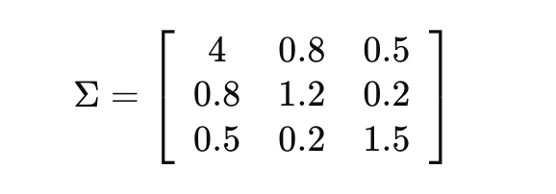

Step 3: Compute the MCV

Using the formula:

- After computing \( \Sigma^{-1} \) and applying the formula, let's assume the MCV for the historical data is \( 0.015 \).

Step 4: Establish Control Limits

- Assume \( \sigma\_{MCV} = 0.001 \) from historical data.

- Control Limits:

Step 5: Monitor and Update

- Let’s say new data collected shows:

New Temperature (°C): [101, 100, 103, 98, 105]

New Pressure (psi): [10, 11, 10, 12, 13]

New Flow rate (L/min): [52, 50, 53, 49, 55]

- Calculating the new MCV for this new dataset yields .

Step 6: Analyze and React

- The new MCV of \( 0.019 \) is above the UCL of \( 0.018 \). This indicates an out-of-control process.

- Analysis might reveal that the increase in temperature and flow rate variability could be driving this shift.

Step 7: Review and Adjust

- If this shift persists, consider re-evaluating the process parameters or recalibrating equipment to address potential issues causing the variability.

1. import numpy as np

2. import matplotlib.pyplot as plt

3.

4. def calculate\_mcv(data):

5. """Calculate the multivariate coefficient of variation (MCV)."""

6. if len(data) < 2: # Ensuring there are at least two data points

7. return np.nan # Return NaN if not enough points to form a covariance matrix

8. mean\_vector = np.mean(data, axis=0)

9. covariance\_matrix = np.cov(data, rowvar=False)

10. try:

11. inv\_covariance\_matrix = np.linalg.inv(covariance\_matrix)

12. mcv = 1 / np.sqrt(np.dot(np.dot(mean\_vector.T, inv\_covariance\_matrix), mean\_vector))

13. return mcv

14. except np.linalg.LinAlgError:

15. return np.nan # Return NaN if the covariance matrix is singular

16.

17. def plot\_mcv\_control\_chart(mcv\_values):

18. """Plot a control chart for MCV values, ignoring NaN values."""

19. mcv\_values = np.array(mcv\_values)

20. valid\_mcv\_values = mcv\_values[~np.isnan(mcv\_values)]

21. mean\_mcv = np.mean(valid\_mcv\_values)

22. std\_mcv = np.std(valid\_mcv\_values)

23. upper\_control\_limit = mean\_mcv + 3 \* std\_mcv

24. lower\_control\_limit = mean\_mcv - 3 \* std\_mcv

25.

26. plt.figure(figsize=(10, 6))

27. plt.plot(valid\_mcv\_values, marker='o', linestyle='-', color='b')

28. plt.axhline(y=mean\_mcv, color='r', linestyle='--', label='Mean MCV')

29. plt.axhline(y=upper\_control\_limit, color='g', linestyle='--', label='Upper Control Limit (UCL)')

30. plt.axhline(y=lower\_control\_limit, color='g', linestyle='--', label='Lower Control Limit (LCL)')

31. plt.title('MCV Control Chart for Manufacturing Process')

32. plt.xlabel('Sample Number')

33. plt.ylabel('MCV')

34. plt.legend()

35. plt.grid(True)

36. plt.show()

37.

38. # Example data generation (simulated for demonstration)

39. np.random.seed(42)

40. data = np.random.multivariate\_normal(mean=[10, 20, 15], cov=[[1, 0.5, 0.1], [0.5, 2, 0.2], [0.1, 0.2, 1]], size=100)

41.

42. # Calculate MCV for each sample, ensuring each subset has at least 2 samples

43. mcv\_values = [calculate\_mcv(data[:i+1]) for i in range(1, len(data))]

44.

45. # Plot the control chart

46. plot\_mcv\_control\_chart(mcv\_values)

47.

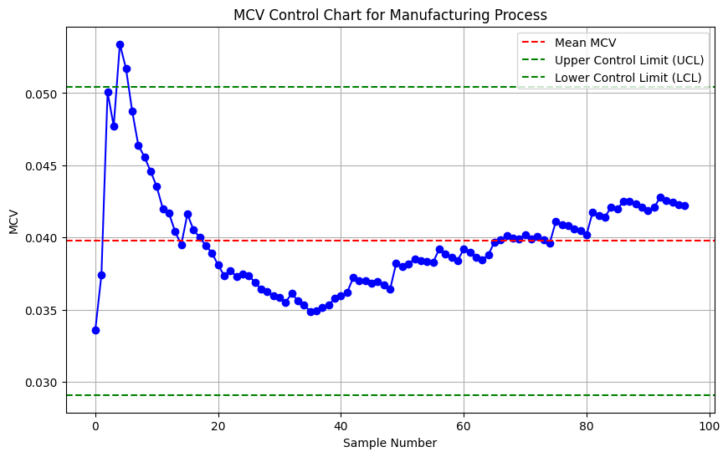

1. import numpy as np

2. import matplotlib.pyplot as plt

3.

4. def calculate\_mcv(data):

5. """Calculate the multivariate coefficient of variation (MCV)."""

6. if data.shape[0] < 2: # Ensure there are enough samples to calculate covariance

7. return np.nan

8. mean\_vector = np.mean(data, axis=0)

9. covariance\_matrix = np.cov(data, rowvar=False)

10. if np.linalg.det(covariance\_matrix) == 0:

11. return np.nan # Check for non-invertible covariance matrix

12. inv\_covariance\_matrix = np.linalg.inv(covariance\_matrix)

13. mcv = 1 / np.sqrt(np.dot(mean\_vector, np.dot(inv\_covariance\_matrix, mean\_vector)))

14. return mcv

15.

16. def simulate\_process\_data(mean, cov, samples=50):

17. """Simulate multivariate process data."""

18. return np.random.multivariate\_normal(mean, cov, size=samples)

19.

20. def main():

21. #np.random.seed(42)

22. # Parameters for simulation

23. mean = [100, 11, 50]

24. cov = [[4, 0.8, 0.5], [0.8, 1.2, 0.2], [0.5, 0.2, 1.5]]

25.

26. # Simulate historical and new process data

27. historical\_data = simulate\_process\_data(mean, cov, 30)

28. new\_data = simulate\_process\_data([102, 12, 53], cov, 20) # Shift in the process

29.

30. # Calculate MCV for each sample set

31. historical\_mcv = [calculate\_mcv(historical\_data[:i+1]) for i in range(historical\_data.shape[0])]

32. new\_mcv = [calculate\_mcv(new\_data[:i+1]) for i in range(new\_data.shape[0])]

33.

34. # Calculate control limits from historical MCV values (excluding NaNs)

35. valid\_mcv = np.array(historical\_mcv)[~np.isnan(historical\_mcv)]

36. mean\_mcv = np.mean(valid\_mcv)

37. std\_mcv = np.std(valid\_mcv)

38. ucl = mean\_mcv + 3 \* std\_mcv

39. lcl = mean\_mcv - 3 \* std\_mcv

40.

41. # Plotting

42. plt.figure(figsize=(12, 6))

43. plt.plot(range(len(historical\_mcv)), historical\_mcv, 'bo-', label='Historical MCV')

44. plt.plot(range(len(historical\_mcv), len(historical\_mcv) + len(new\_mcv)), new\_mcv, 'ro-', label='New MCV')

45. plt.axhline(y=mean\_mcv, color='g', linestyle='--', label='Mean MCV')

46. plt.axhline(y=ucl, color='r', linestyle='--', label='Upper Control Limit (UCL)')

47. plt.axhline(y=lcl, color='b', linestyle='--', label='Lower Control Limit (LCL)')

48. plt.xlabel('Sample Number')

49. plt.ylabel('MCV')

50. plt.title('MCV Control Chart for Manufacturing Process')

51. plt.legend()

52. plt.grid(True)

53. plt.show()

54.

55. if \_\_name\_\_ == "\_\_main\_\_":

56. main()

57.

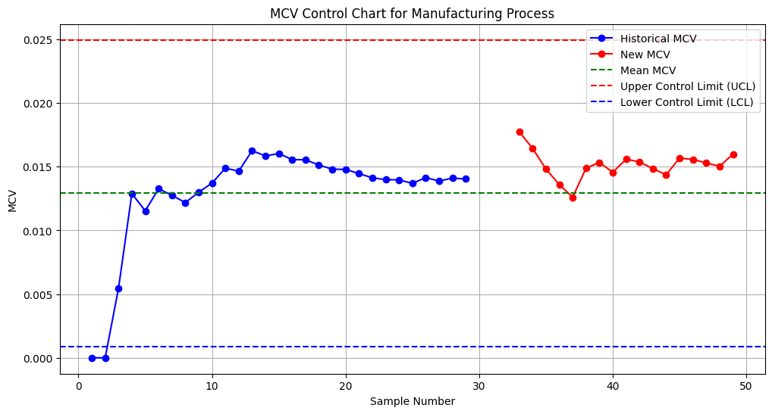

#### MCV vs. Mahalanobis Distance

**Mahalanobis Distance Chart:** Shows distances that might seem abstract because they don't directly relate to scale-independence or ease of interpretation for non-statisticians.

Only Upper Control Limit (UCL) in the Mahalanobis Distance Chart

Nature of Mahalanobis Distance: The Mahalanobis distance measures the deviation of each point from the mean, squared and scaled by the covariance. It's inherently a non-negative value and typically does not assume negative deviations because it's a squared term. This characteristic means the Lower Control Limit (LCL) often isn't relevant or is zero, which isn't usually practical to show on a control chart focused on deviation magnitudes.

Setting UCL Based on Chi-Squared Distribution: The upper control limit (UCL) is calculated using the chi-squared distribution, which is appropriate for the distribution of Mahalanobis distances when the underlying data is multivariate normal. A Lower Control Limit isn't usually calculated because negative distances don't exist and zero would be the natural lower bound.

**MCV Chart:** Demonstrates how variability (inverse of MCV) within the process is controlled. Higher values indicate tighter control (less variability relative to the mean), which is intuitively easier to understand and aligns with quality control goals where higher performance metrics are generally preferable.

## A review of dispersion control charts for multivariate individual observations

### Preparation:

#### Measurements are taken *individually* rather than in pre-defined groups

In the context of quality control and monitoring, the term "individually" refers to how data is collected and processed for each unit or observation in a production process.

When measurements are taken "individually," it means that each component or unit produced is measured separately, and each set of measurements (e.g., diameter and hardness for a component) is treated as a single, distinct observation. Each of these observations is then recorded and analyzed independently from others. This approach is contrasted with group-based measurements where multiple units are measured, and their data is aggregated or averaged before being recorded as a single observation.

#Practical Example:

Let’s consider a factory line producing screws:

- Individually: Every screw coming off the line is measured for length and diameter as soon as it is manufactured. Each screw’s measurements are immediately logged and analyzed. If one screw is found to deviate from the specifications, it can be flagged instantly without waiting to batch it with others.

- Group-Based: Instead of measuring each screw immediately after production, screws might be collected in batches of, say, 100. Only after all 100 screws are produced is the batch measured collectively (often as averages or samples from the batch). This data point represents the average characteristics of those 100 screws, rather than individual characteristics.

#Advantages of Individual Measurements:

1. Quick Detection: Any anomalies or deviations in the production process are detected immediately after a unit is produced, allowing for faster responses to potential issues.

2. Detailed Data: Provides a more detailed data set, as variations between individual units can be observed and analyzed.

3. Improved Control: Facilitates finer control over the production process since adjustments can be made on a unit-by-unit basis rather than based on average characteristics of groups.

#Disadvantages:

1. Data Volume: This method generates a larger volume of data to manage and analyze, which can be computationally intensive.

2. Resource Intensive: Requires more resources in terms of measurement and analysis technology that must handle a continuous flow of data.

In summary, taking measurements "individually" means dealing with data on a per-unit basis immediately after each unit's production, providing a more granular level of monitoring and control over the quality of each product.

#### Maximum Likelihood (ML): vs Log Likelihood Ratio (LLR):

The concepts of maximum likelihood and log likelihood ratio are fundamental in statistics, especially in the context of model fitting and hypothesis testing. Here's a comparison of the two concepts with examples to illustrate their applications:

1. Maximum Likelihood (ML):

- Definition: Maximum likelihood estimation is a method used to estimate the parameters of a statistical model. The goal is to find the parameter values that maximize the likelihood function, which is the probability of observing the given data under a specific model.

- Formula: The likelihood function for a set of parameters, , given data is expressed as . In practice, it's often easier to work with the log of the likelihood function, , because logarithms transform products into sums, simplifying the calculations.

- Example: Suppose you have data from a normally distributed variable and you want to estimate the mean () and variance . The likelihood function for the normal distribution is:

.

Maximizing this function (or its logarithm) with respect to and gives the estimates.

Understanding the Likelihood Function:

Purpose: The likelihood function , where represents the parameters of the model (in the case of a normal distribution, and ), and represents the observed data, is used to assess how likely it is to observe your data given specific values of the parameters.

Input and Output:

1. Input:

- Parameters: These are the values that you are trying to estimate. In the context of a normal distribution, these parameters are (mean) and (variance).

- Data (X): These are the observed values, which are used to calculate the likelihood. In your example, it’s the measured heights like 170, 172, 175, etc.

2. Output:

- Likelihood Value: This is a numerical value indicating how probable it is to observe your data given the parameters. It’s not a probability of the parameters themselves but a measure of fit between the data and the parameters.

Why Are Parameters in the Likelihood Function?

The parameters and are in the likelihood function because they define the specific normal distribution being used to model the data. The purpose of MLE is not to provide these parameters to the likelihood function but to find the values of these parameters that make the observed data most probable.

How MLE Works:

- You start with a general form of the likelihood function for a given model, which depends on the parameters.

- The likelihood function is calculated over a range of possible values for these parameters.

- The set of parameters that maximizes the likelihood function is considered the best estimate for the model based on the observed data.

Example with Steps:

Let’s assume we have data points sampled from a population that we assume follows a normal distribution. We don’t know and , and we want to estimate them.

1. Set Up the Likelihood Function:

- For a normal distribution:

2. Input Different Values of and :

- You calculate this likelihood for different values of and . Initially, these are arbitrary or based on some initial guess.

3. Find the Maximum Likelihood Estimates:

- Change and \(\sigma^2\) until you find the values that give you the highest likelihood. These values are your MLEs:

In summary, the parameters are part of the likelihood function because they define the statistical model under consideration. The role of MLE is to adjust these parameters to best fit the observed data, determining the values that maximize the likelihood of observing the given data.

More Details about Output:

The output of the likelihood function, specifically when applied to continuous probability distributions like the normal distribution, is not confined to the range between 0 and 1, unlike probabilities. The likelihood value can actually exceed 1 or be extremely small, depending on the scale of the data and the parameters used. The key thing to understand about likelihood values is that they are relative measures of support for different parameter values, not probabilities themselves.

Characteristics of Likelihood Values:

- Range: Likelihood values can be any non-negative number. They are not probabilities and hence do not necessarily sum to 1 or fall between 0 and 1.

- Interpretation: A higher likelihood value indicates that the given parameter values ( and in the case of the normal distribution) are more plausible in the context of the observed data compared to parameter values that give lower likelihood values.

- Maximization: In maximum likelihood estimation, the goal is to find the parameter values that maximize this function, which may be any positive number. The actual magnitude of the likelihood is less important than its relative magnitude when comparing different sets of parameters.

Understanding the Output:

If the likelihood function outputs a value that is higher relative to other values tested, it suggests that the parameters used for that calculation fit the data better than other parameter combinations. However, the output being "1" does not necessarily signify anything special in the context of likelihood functions. The absolute value of the likelihood is not inherently meaningful by itself; its value is only useful when compared to other likelihood values calculated from different parameter sets.

Example Clarification:

If you were to calculate the likelihood for a set of parameters and got the highest value when and compared to other values of and , you would choose these as your estimates. The "best guess" isn’t defined by achieving a likelihood of "1," but rather by achieving the highest likelihood value compared to other tested values.

Thus, in practice, you often work with the log-likelihood because it is numerically more stable and easier to handle, especially with large datasets. Maximizing the log-likelihood gives the same result as maximizing the likelihood because the logarithm is a monotonically increasing function.

How to use:

The process of Maximum Likelihood Estimation (MLE) for estimating parameters like and \(\sigma^2\) of a normal distribution doesn't necessarily start with initial guesses followed by iterative optimization, although that approach is common in more complex models where analytical solutions are not available. For many standard distributions, including the normal distribution, the MLE can be solved directly through analytical methods, which is what we illustrated in the previous example. Here's a bit more detail on both approaches:

Analytical Solution

For simpler models like the normal distribution, the likelihood equations can be solved directly by setting the derivatives of the log likelihood function to zero, as shown in the example. This method provides explicit formulas:

- Mean () Estimate: The MLE for the mean is the sample mean:

- Variance Estimate: The MLE for the variance is the sample variance:

Iterative Optimization

In more complex models, especially those where the likelihood function does not yield easily to differentiation or where the equations are not solvable by simple algebraic means, an iterative approach is necessary. Here’s how that works:

- Initial Guesses: You start with initial guesses for the parameters. These might be based on prior knowledge, random values, or simple heuristics.

- Optimization Algorithm: An algorithm (like Newton-Raphson, gradient descent, or Expectation-Maximization) iteratively updates the guesses based on how to increase (or maximize) the likelihood function.

- Convergence: This process continues until changes in the likelihood (or the parameters) become negligibly small, indicating that the parameters have converged to their optimal values.

Example with Iterative Method

Let's consider a scenario where you might use an iterative method, such as fitting a mixture of Gaussians, where analytical solutions are not straightforward.

- Initial Guesses: Assume two means (for a simple bimodal distribution), \(\mu\_1\) and \(\mu\_2\), based on visually inspecting the data or using a simple clustering algorithm like k-means to initialize.

- Iteration: Use an Expectation-Maximization (EM) algorithm to refine these guesses. Each iteration updates the means, variances, and mixture weights to better fit the data based on the current parameter estimates.

- Convergence: Stop when the increase in the likelihood or log-likelihood is below a small threshold.

When to Use Each Method

- Analytical Solutions: Preferred when available because they are usually faster and don’t require tuning of algorithm parameters (like learning rates in gradient descent).

- Iterative Methods: Necessary for complex models where no closed-form solution exists or where the likelihood landscape is difficult to navigate analytically.

In summary, whether to start with initial values and iterate depends on the complexity of the model and the nature of the likelihood function. For the normal distribution with basic data, direct analytical methods are sufficient and typically used, whereas more complex scenarios might require iterative optimization.

2. Log Likelihood Ratio (LLR):

- Definition: The log likelihood ratio is used in hypothesis testing to compare two statistical models: a null model and an alternative model . The LLR measures how much more likely the data is under one model than under the other.

- Formula: The log likelihood ratio is defined as are the parameters under the null hypothesis and under the alternative hypothesis.

- Example: If you are testing whether a coin is fair versus biased , you would calculate the likelihood of observing your data (e.g., number of heads and tails) under both hypotheses and take the log of the ratio of these likelihoods.

Comparison and Use:

- Purpose Difference: Maximum likelihood is generally used for estimation purposes, where you're trying to find the best parameters for your data. In contrast, the log likelihood ratio is used for hypothesis testing, comparing how well two sets of parameters explain the observed data.

- Output: ML gives you parameter values, whereas LLR provides a statistic that helps you decide between two competing hypotheses.

- Interpretation: High values of ML estimates indicate better model fit. For LLR, a value far from zero suggests that the alternative hypothesis provides a significantly better fit than the null hypothesis.

Both concepts use the likelihood of the data under a model but for different purposes and different statistical inference approaches.

Real-world examples for both Maximum Likelihood Estimation (MLE) and Log Likelihood Ratio (LLR) with numerical computations:

**1. Maximum Likelihood Estimation (MLE) Example:**

Context: Let's consider a simple case where you want to estimate the average height of adult men in a particular city based on a sample.

Data Sample: Suppose you have measured the heights of 5 men, and these heights (in cm) are: 170, 172, 175, 165, 180.

Assumption: Assume the heights are normally distributed, which is a common assumption for biological measurements.

Goal: Estimate the parameters (mean) and \(\sigma^2\) (variance) of the distribution.

Step-by-step Calculation:

a. The likelihood function for a normal distribution given the data is:

b. Logarithm of the likelihood function simplifies to:

c. Maximizing this log likelihood function with respect to and by setting the derivatives to zero, gives:

Calculating variance manually:

2. Log Likelihood Ratio (LLR) Example:

Context: Suppose we want to test if a new teaching method in schools is more effective than the traditional method.

Data: On a standardized test, the average score under the new method (sample of 30 students) is 75 with a standard deviation of 10. Under the old method (sample of 30 students), the average score is 70 with a standard deviation of 12.

Hypotheses:

- : The new method does not improve scores

- : The new method improves scores .

Calculation:

a. Assuming normal distributions for both methods, calculate the likelihood of observing these sample means under each hypothesis:

b. LLR:

c. Using the known formula for the likelihood of the mean:

This negative value suggests that the new method's result, while better, is not statistically significantly different from the old method at a standard threshold.

These examples highlight how MLE is used to find parameter estimates based on the data, while LLR is used to test hypotheses regarding these parameters, giving you a clearer understanding of how each method applies in practical statistical analysis.

#### how to calculate the statistic for residuals using a robust Mahalanobis distance approach. What are residuals, what is the robust Mahalanobis distance, and what is robust covariance? How are they calculated, and why do they work with non-normal distributions?

Residuals

Residuals are the differences between observed values and the values predicted by a model. In time series analysis, residuals help us understand how well the model fits the data. Residuals are calculated as:

where is the residual at time , is the observed value, and is the predicted value from the model.

Robust Mahalanobis Distance

Mahalanobis Distance is a measure of the distance between a point and a distribution. It is used to determine how far an observation is from the mean of a multivariate distribution, considering the correlations between variables.

The traditional Mahalanobis distance for a vector is calculated as:

where is the mean vector and \is the covariance matrix of the distribution.

Robust Mahalanobis Distance is an adaptation that uses robust estimators for the mean and covariance matrix to make the distance calculation less sensitive to outliers and deviations from normality.

Robust Covariance

Robust Covariance is an estimate of the covariance matrix that is resistant to outliers and non-normal data. Traditional covariance estimation can be influenced heavily by outliers, leading to biased estimates. Robust methods, such as the Minimum Covariance Determinant (MCD), aim to find a subset of data that minimizes the determinant of the covariance matrix, thus providing a more reliable estimate in the presence of outliers.

The Minimum Covariance Determinant (MCD) method is one robust estimator. It works as follows:

1. Select a subset of the data points that minimizes the determinant of their covariance matrix.

2. Compute the mean and covariance matrix for this subset.

3. Use these estimates to calculate the Mahalanobis distance.

Why They Work with Non-Normal Distributions

Robust statistical methods, such as robust covariance estimation and robust Mahalanobis distance, are designed to handle data that deviate from the assumptions of normality. These methods reduce the influence of outliers and provide estimates that are more representative of the underlying distribution, even when the data is skewed or has heavy tails.

Example with Residuals and Robust Mahalanobis Distance

Let’s provide an example to illustrate these concepts:

# Step-by-Step Calculation

1. Generate Residuals:

- Suppose we have observed values and we fit a linear model to these values.

- The residuals are the differences between the observed values and the values predicted by the model.

2. Robust Covariance Estimation:

- Use the MCD method to estimate a robust covariance matrix.

3. Compute Robust Mahalanobis Distance:

- Calculate the Mahalanobis distance using the robust covariance matrix for each residual:

4. CUSUM Statistic:

- Update the CUSUM statistic using the robust Mahalanobis distance.

--

Sure, let's walk through a detailed example of calculating the robust covariance matrix using the Minimum Covariance Determinant (MCD) method manually, step by step, with numbers.

Example Data

Let's use the following bivariate dataset:

```

X = [[4, 2],

[2, 0],

[5, 2],

[3, 1],

[50, 25]] # This last point is an outlier

```

#### Steps to Calculate Robust Covariance Using MCD

1. Calculate the classical mean and covariance matrix for comparison.

2. Apply the MCD method to identify the subset of data that minimizes the determinant of the covariance matrix.

3. Calculate the mean and covariance matrix for this subset.

Step 1: Classical Mean and Covariance Matrix

Mean Vector:



Covariance Matrix:

Calculate the deviations from the mean:

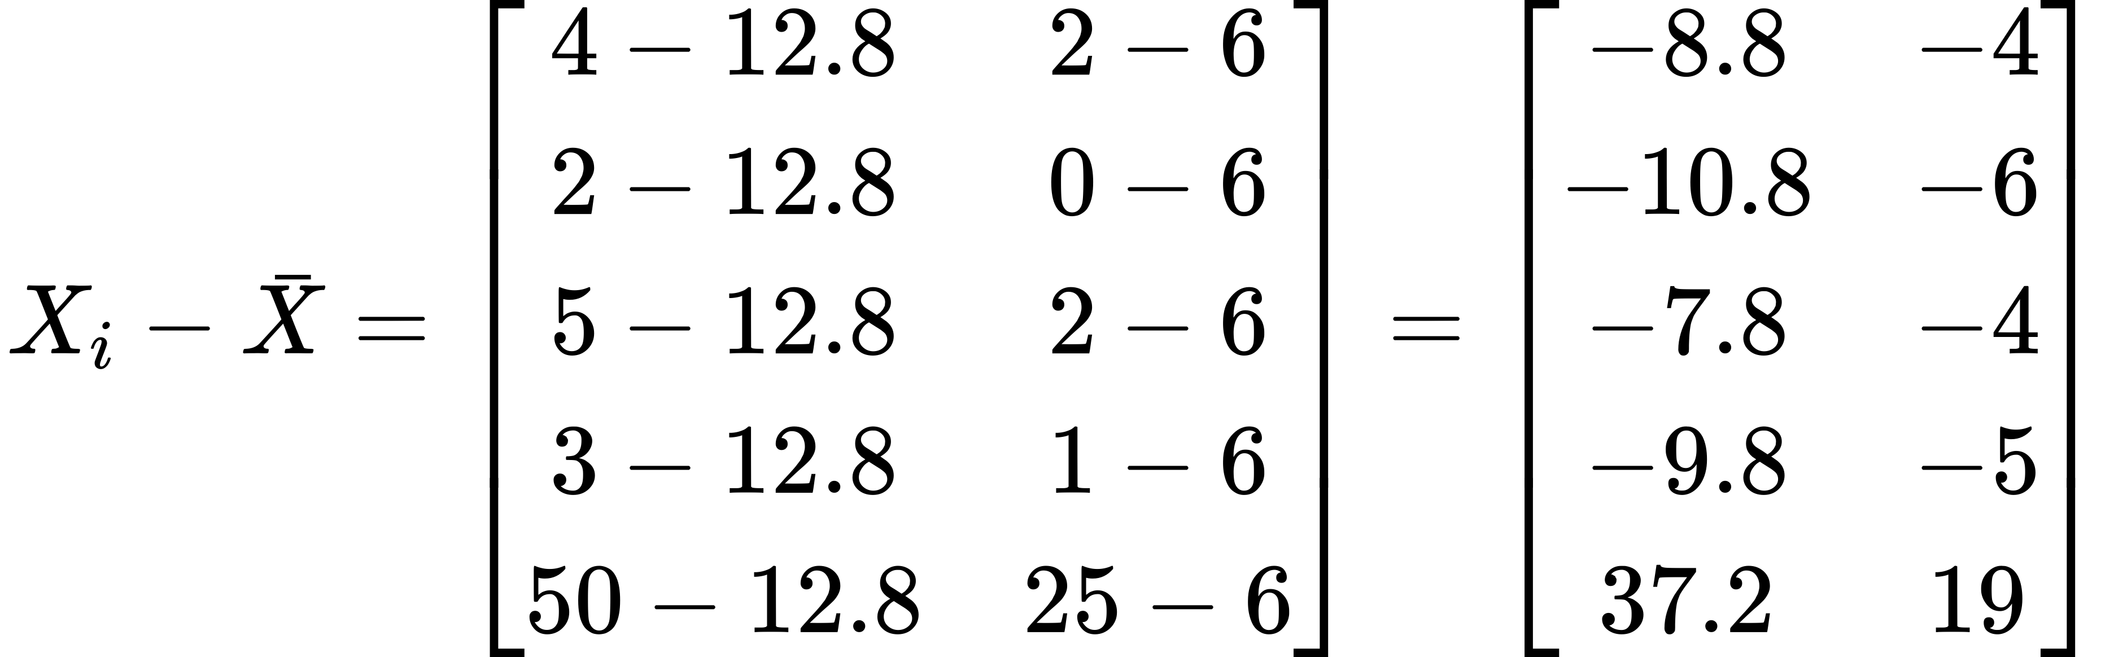

Now compute the covariance matrix:



Simplifying:



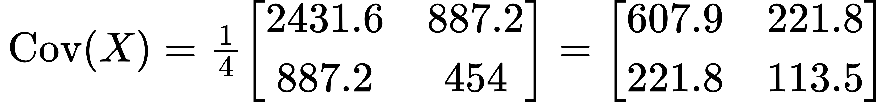

**Step 2: Apply the MCD Method**

Identify the subset of data that minimizes the determinant of the covariance matrix:

To manually apply the MCD method, we need to select subsets of the data and calculate the determinant of their covariance matrices, then choose the subset with the smallest determinant.

Step-by-Step Process:

Let's consider three subsets (for simplicity):

1. Subset 1:

2. Subset 2:

3. Subset 3:

For each subset, calculate the covariance matrix and its determinant.

Subset 1: \(\{(4, 2), (2, 0), (5, 2)\}\)

Mean:

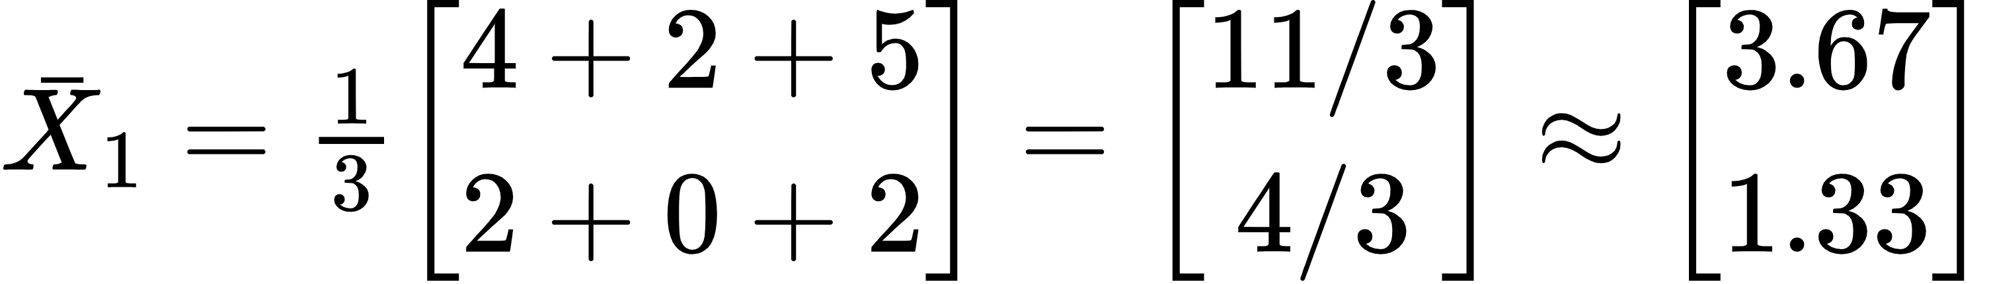

Deviations from the mean:

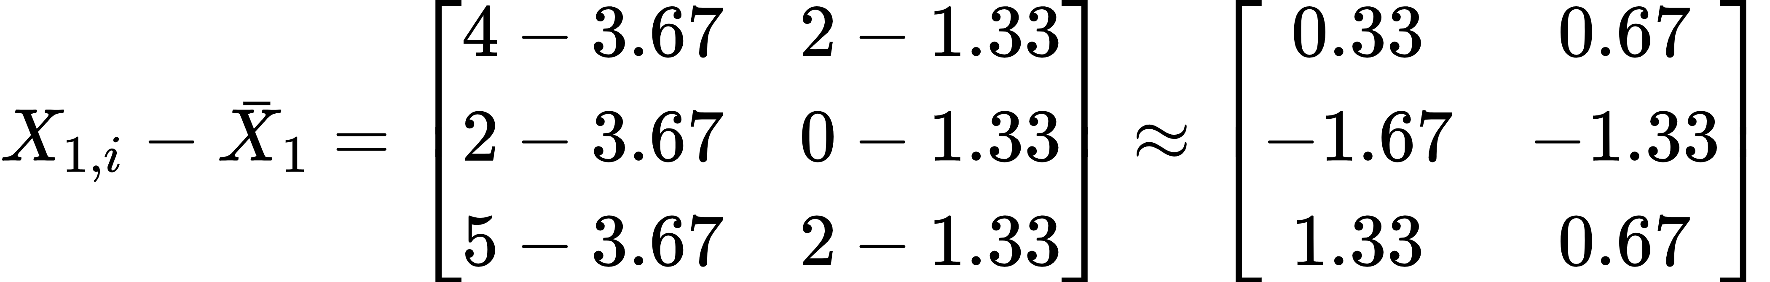

Covariance matrix:





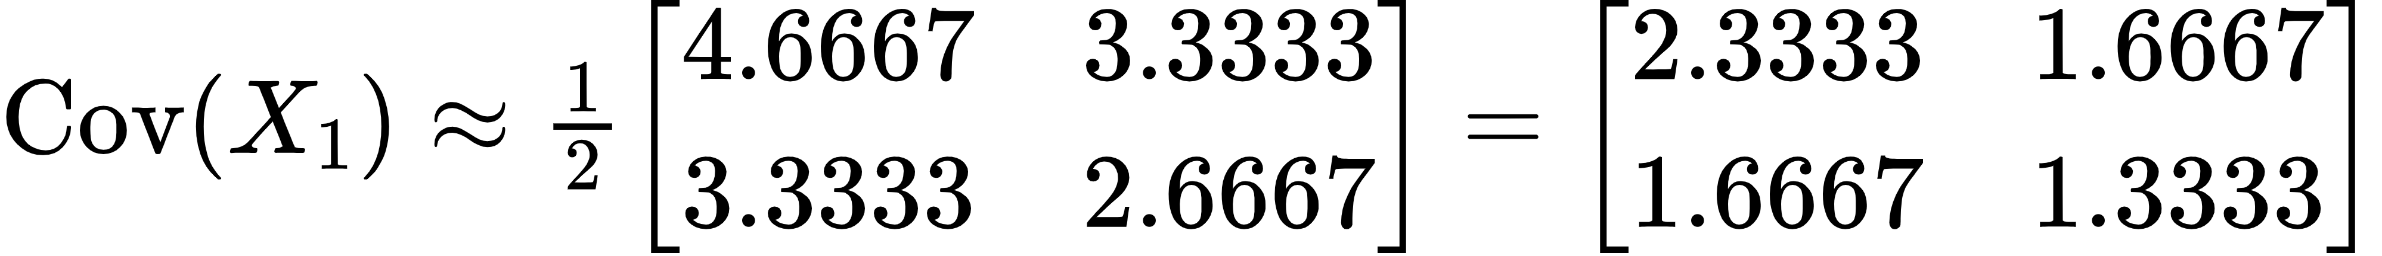

Determinant:

Subset 2:

Mean:

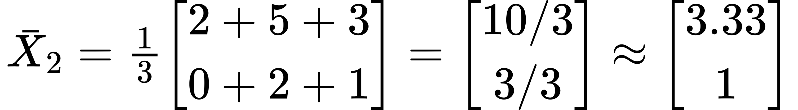

Deviations from the mean:

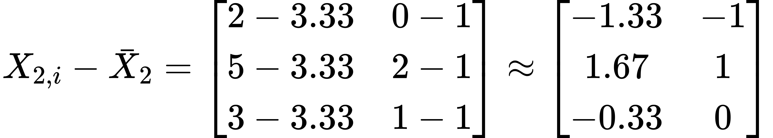

Covariance matrix:





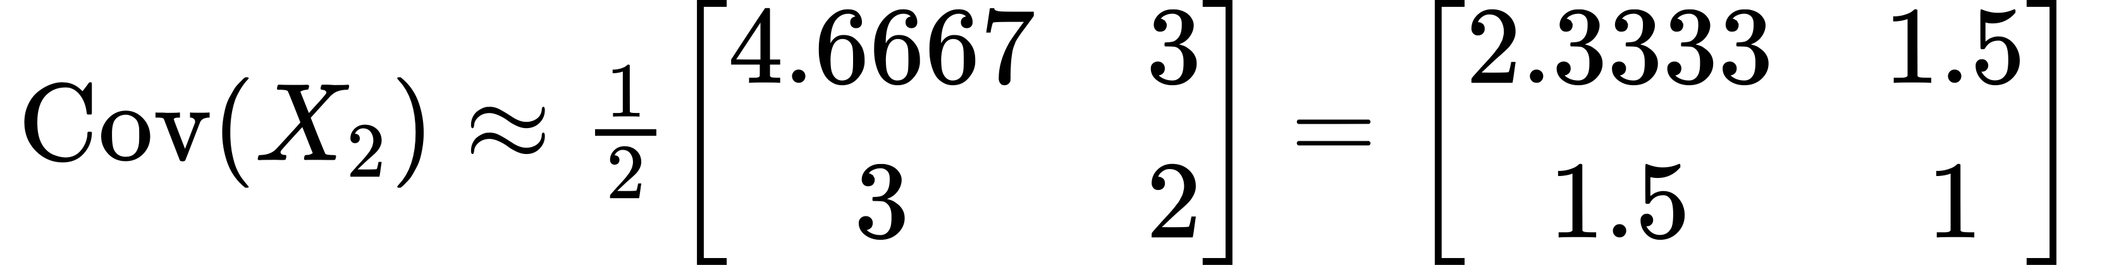

Determinant:

Subset 3

Mean:

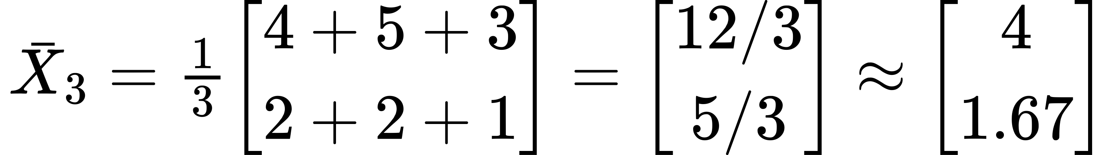

Deviations from the mean:

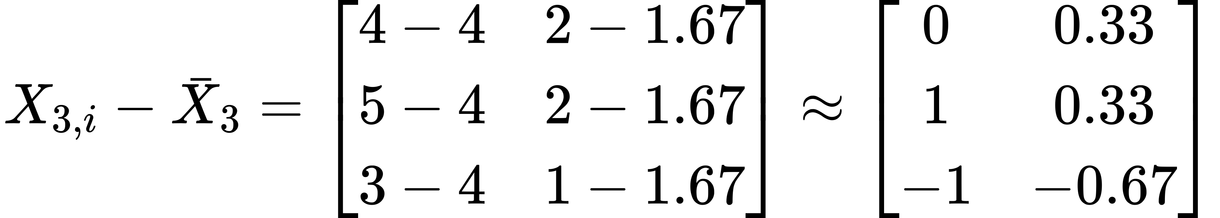

Covariance matrix:





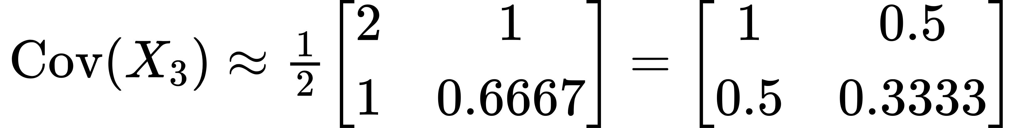

Determinant:

Step 3: Choose the Subset with the Smallest Determinant

Among the calculated determinants, both Subset 2 and Subset 3 have the smallest determinant (0.0833). We can choose either for the robust covariance estimation.

Robust Covariance Matrix (Subset 2):

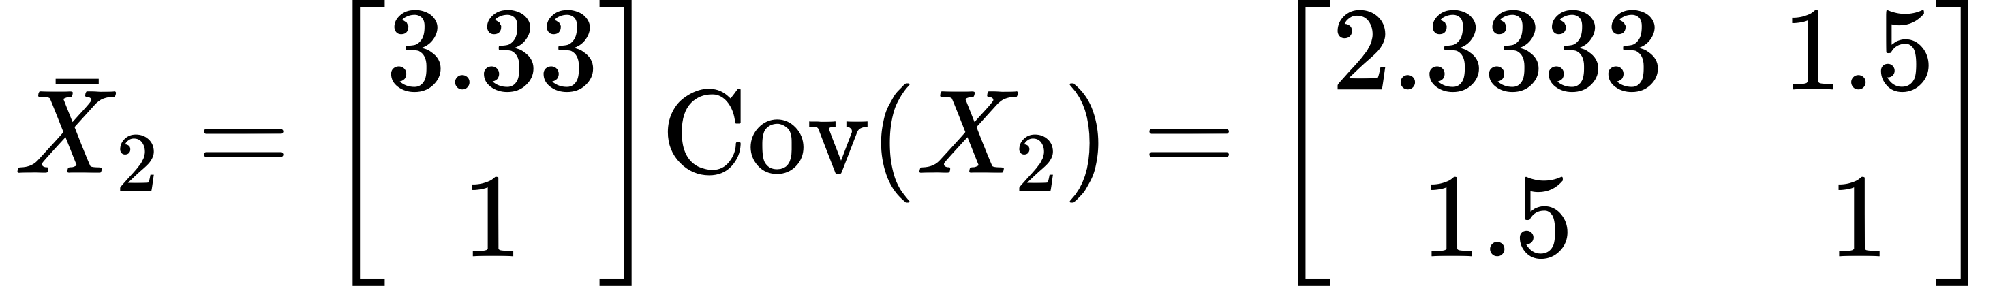

This robust covariance matrix is less influenced by the outlier and provides a more reliable estimate of the core data's variability.

Summary

1. Residuals: Differences between observed values and predicted values.

2. Robust Mahalanobis Distance: Mahalanobis distance calculated using robust covariance matrix estimates.

3. Robust Covariance: Covariance matrix estimated using robust methods like MCD, which minimize the influence of outliers.

4. Calculation: Identifying subsets that minimize the determinant of the covariance matrix and using these subsets for estimation.

This step-by-step manual calculation demonstrates how robust methods handle non-normal data by reducing the influence of outliers and providing more accurate estimates of the data's variability.

#### Wilks' statistic

Wilks' statistic is a multivariate statistical measure used to test the difference between the covariance matrices of two groups of multivariate observations. It is commonly used in the context of MANOVA (Multivariate Analysis of Variance) and other multivariate statistical methods. The statistic provides a way to determine whether there is a significant difference between the groups.

The definition and application of Wilks' statistic in control charts can be summarized as follows:

1. Definition:

Wilks' statistic (Λ) is defined as the ratio of the determinants of two scatter matrices:

Where:

- SSm is the scatter matrix of the historical data set from Phase I.

- SSm+1 is the scatter matrix of an augmented dataset that includes both the historical data and the newest observation.

2. Calculation:

The scatter matrices are calculated as follows:

-

-

Here, Sm and Sm+1 are estimators of the covariance matrix based on m and m+1 observations, respectively.

3. Interpretation:

- Values of Wilks' statistic range between 0 and 1.

- Smaller values of Λ indicate greater differences between the scatter matrices SSm and SSm+1, suggesting a possible shift in process variability.

- A value of Λ near 0 signals that the estimated covariance matrix has significantly changed from the historical covariance matrix, indicating an out-of-control condition.

4. Application in Control Charts:

Wilks' statistic can be used as a monitoring statistic in control charts to detect shifts in process variability. The statistic is compared to control limits to determine if the process is in control or if there has been a significant change in variability.

Wilks' statistic is particularly useful in Shewhart-type control charts for monitoring multivariate process dispersion and is effective in identifying changes in the covariance structure of the process.

#### Scatter Matrix

The scatter matrix is a generalization of variance for multivariate data. It measures the spread (dispersion) of multivariate data points. The scatter matrix is used extensively in statistical process control (SPC) and multivariate statistical analysis.

Given a set of multivariate observations, the scatter matrix helps quantify how much the data points deviate from their mean vector. It is particularly useful in contexts where we are interested in understanding the relationships between different variables and how they vary together.

Mathematical Definition

Given observations of a-dimensional random variable, , where each is a -dimensional column vector, the sample mean vector is defined as:

The scatter matrix is then defined as:

Where:

- is the observation (-dimensional vector).

- is the mean vector of the observations.

- is the deviation of the -th observation from the mean vector.

- is the transpose of the deviation vector.

Example Calculation

Let's calculate the scatter matrix for a set of 3 observations of a 2-dimensional random variable.

Observations:

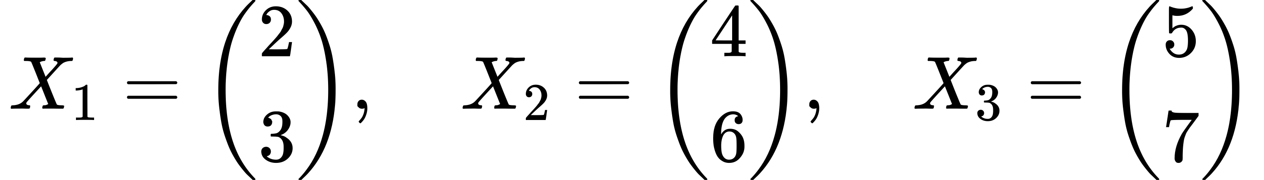

Step 1: Calculate the Mean Vector



Step 2: Calculate the Deviations from the Mean

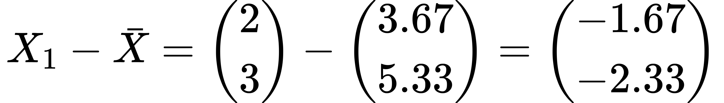

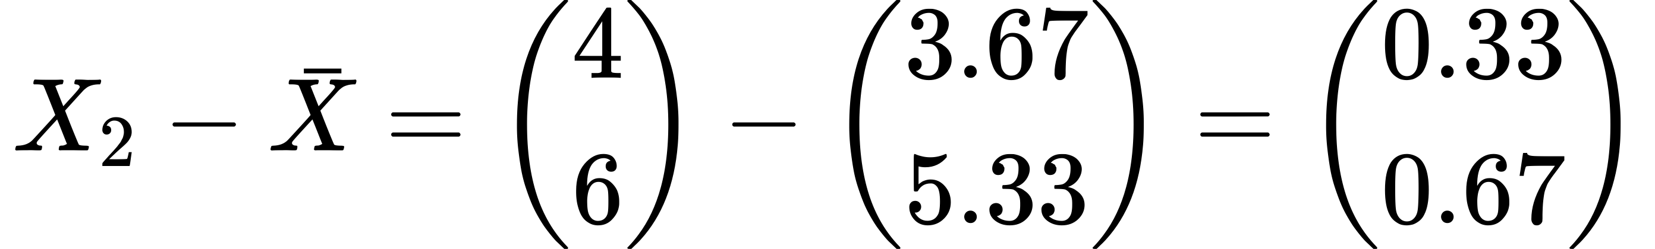

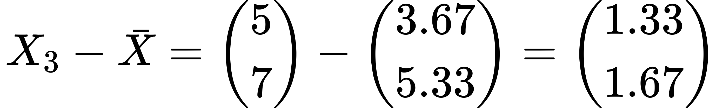

Step 3: Compute the Scatter Matrix

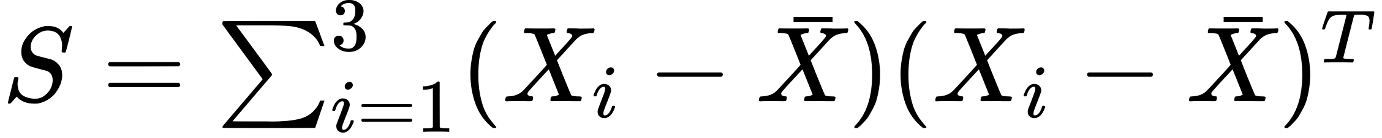



Calculate each term:

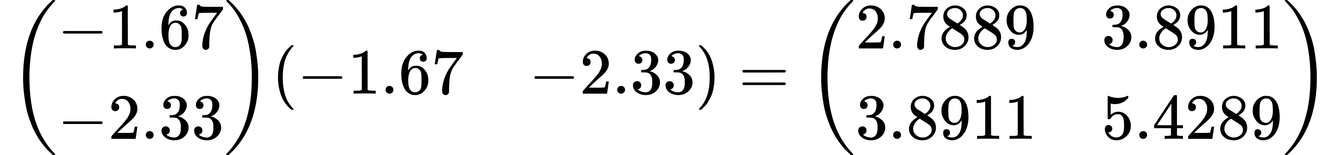

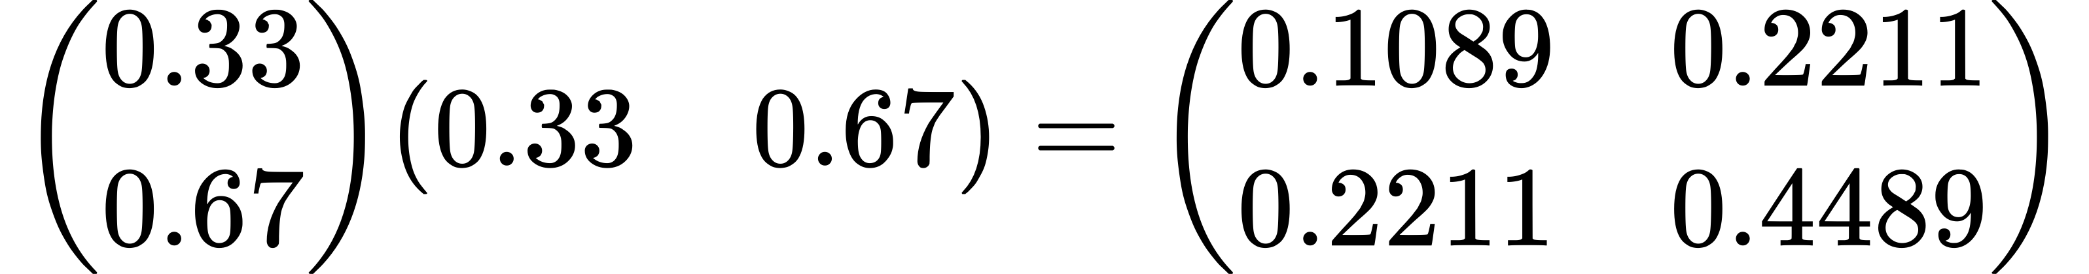

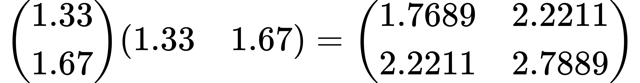

Summing these matrices:



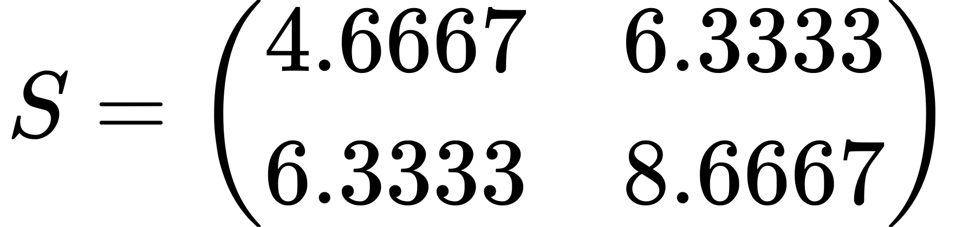

Interpretation

The scatter matrix summarizes the dispersion and covariances of the variables in the dataset. Each element represents the covariance between the and variables. For instance, is the variance of the first variable, and represents the covariance between the first and second variables.

This matrix is used in multivariate statistical analysis to understand the relationships between variables and to perform further analyses, such as calculating control limits in multivariate control charts.

#### Scatter Matrix vs. Covariance Matrix: Detailed Explanation and Examples

Scatter Matrix

Definition:

The scatter matrix is the sum of the outer products of the deviations of each observation from the mean vector. It is a measure of the total dispersion of the data points in a multivariate space.

Formula:

For observations of a -dimensional random variable , where each is a -dimensional column vector, the scatter matrix is defined as:

Covariance Matrix

Definition:

The covariance matrix is derived from the scatter matrix by scaling it by the number of observations (or for an unbiased estimate). It provides a normalized measure of the covariances between the variables.

Formula:

For the same observations, the covariance matrix is:

Or for the unbiased estimator:

Interrelationship

The covariance matrix is essentially the scatter matrix normalized by the number of observations. The scatter matrix measures the raw dispersion of the data, while the covariance matrix standardizes this measure, making it comparable across different datasets.

Examples

Let's consider a dataset with three 2-dimensional observations.

Observations:



Step 1: Calculate the Mean Vector



Step 2: Calculate the Deviations from the Mean







Step 3: Compute the Scatter Matrix

Calculating each term:







Summing these matrices:





Step 4: Compute the Covariance Matrix

Using the unbiased estimator (n-1):

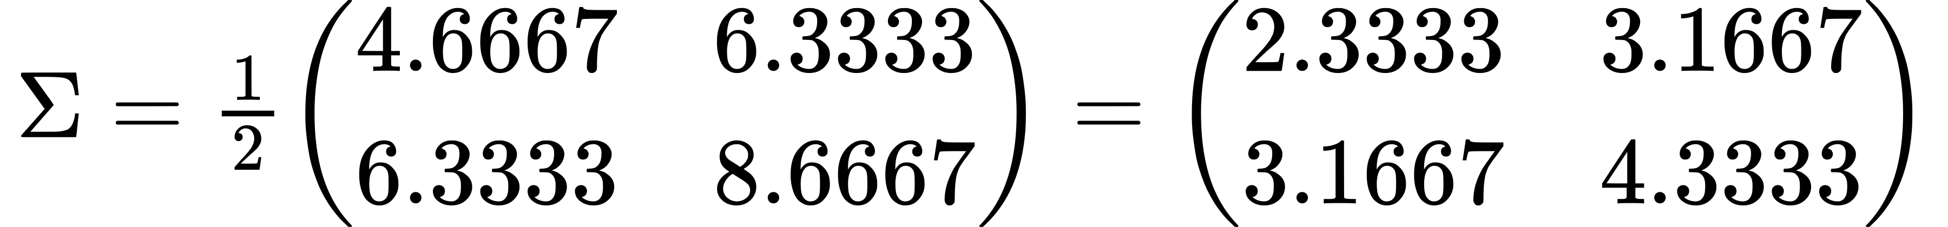

Comparison and Interpretation

- Scatter Matrix (S):

- Represents the raw, unscaled spread of the data.

- Larger values indicate more dispersion in the data.

- Useful in the context where the total variation is needed without normalization.

- Covariance Matrix (Σ):

- Normalized version of the scatter matrix.

- Elements represent average covariances between variables, standardized by the number of observations.

- More interpretable for comparing datasets with different numbers of observations.

- Useful in statistical analyses where standardized measures of relationships are needed.

Which is Better?

- Scatter Matrix:

- Advantages: Reflects total dispersion directly; useful in multivariate analyses like PCA where total variance is critical.

- Disadvantages: Not normalized; hard to compare across different datasets with varying numbers of observations.

- Covariance Matrix:

- Advantages: Standardized, making it easier to interpret and compare across different datasets. Essential in many statistical techniques that require normalized measures of dispersion and correlation.

- Disadvantages: Requires computation of mean and normalization, which might not always reflect the raw dispersion needed in certain contexts.

In summary, both matrices are crucial in multivariate analysis. The scatter matrix is often used in raw dispersion contexts, while the covariance matrix provides standardized measures essential for interpreting relationships between variables and applying further statistical techniques.

#### Spatial Signs: Geometrical and Mathematical Interpretations

Definition:

Spatial signs are vectors derived from the observations in a multivariate data set, scaled to unit length. They provide a means of capturing the direction of data points relative to the origin, disregarding the magnitude.

Mathematical Formulation:

Given a -dimensional observation vector , the spatial sign function is defined as:

where

Geometric Interpretation:

1. Direction Focus:

- Spatial signs map each data point to a point on the unit sphere centered at the origin in -dimensional space. This operation normalizes each vector, preserving only the directional information while discarding the magnitude.

- For instance, in a 2-dimensional space, the spatial sign of a point would be . This point lies on the unit circle, representing the angle of the original vector from the origin.

2. Robustness:

- By focusing on the direction, spatial signs are inherently robust to outliers. An outlier with a large magnitude will have the same spatial sign as a smaller point in the same direction.

- This robustness makes spatial signs particularly useful in applications where the data distribution is heavy-tailed or contains outliers.

Mathematical Properties:

1. Affine Invariance:

- Spatial signs are invariant under affine transformations. If is transformed by an affine transformation (where is a nonsingular matrix and is a translation vector), the spatial sign remains unchanged up to a rotation.

- Mathematically: remains equivalent to .

2. Usage in Multivariate Analysis:

- In multivariate analysis, spatial signs are used to create robust estimates of location (central tendency) and scatter (dispersion).

- For example, the spatial median is a robust measure of central tendency, defined as the point that minimizes the sum of Euclidean distances to all points in the data set:

where are the observation vectors.

3. Covariance Matrix Estimation:

- Spatial sign covariance matrices can be used to estimate the shape of the data distribution, which is less sensitive to outliers compared to traditional covariance matrices.

- The spatial sign covariance matrix for a set of vectors is defined as:

Examples:

1. Two-Dimensional Example:

- Consider two points in 2D: .

- The spatial signs are:

- Both points have the same spatial sign, indicating they lie along the same direction from the origin.

2. Three-Dimensional Example:

- For a point , the spatial sign is:

- This lies on the surface of the unit sphere in 3D space, preserving the direction of .

Summary:

Spatial signs are a powerful tool in multivariate analysis, providing robustness and affine invariance by focusing on the directional information of data points. They are particularly useful for estimating central tendency and dispersion in the presence of outliers and non-normal data distributions.

--

To help you visualize the geometrical interpretation of the spatial sign formula given, let's break down the formula and then plot the relevant points and vectors.

Explanation:

The spatial sign formula is used to calculate the unit vector in the direction from a median point (in this case, ) to another point (in this case, ). This is represented as:

Breaking this down:

1. Compute the difference vector .

2. Calculate the magnitude of the difference vector .

3. Normalize the vector to get the unit vector .

Plotting:

We will:

1. Plot the points .

2. Draw the vector from .

3. Plot the resulting point relative to the origin to visualize the direction of .

Let's create these plots now.

In the plot above, you can see:

- The vector from point shown in blue, representing the direction from the median to the data point.

- The resultant vector , originating from the origin, shown in red. This vector is the difference between and normalized to its magnitude , reflecting the direction and unit length from the median to the data point in the coordinate space.

This visual helps understand how the spatial sign formula projects the difference vector onto a unit vector that summarizes the direction of the deviation from the median, scaled to unit length, to provide a standard measure regardless of the original distance magnitude. This interpretation is often used in robust statistics to minimize the influence of outliers by considering only the direction of the data points relative to a central point.

Python Code

import matplotlib.pyplot as plt

import numpy as np

# Define the points

point\_X1 = np.array([2, 3])

point\_M = np.array([4, 6])

vector\_diff = point\_X1 - point\_M

unit\_vector = vector\_diff / np.linalg.norm(vector\_diff)

# Plotting

fig, ax = plt.subplots()

ax.plot(\*zip(\*[point\_M, point\_X1]), marker='o', color='blue', linestyle='-', markersize=5, label='Vector M to X1')

ax.text(point\_X1[0], point\_X1[1], 'X1 (2,3)', fontsize=12, ha='right')

ax.text(point\_M[0], point\_M[1], 'M (4,6)', fontsize=12, ha='right')

ax.quiver(0, 0, vector\_diff[0], vector\_diff[1], scale\_units='xy', angles='xy', scale=1, color='red', label='Resultant Vector (-2,-3)')

# Set grid, limits, and labels

ax.set\_xlim(-3, 7)

ax.set\_ylim(-4, 8)

ax.set\_xticks(np.arange(-3, 8, 1))

ax.set\_yticks(np.arange(-4, 9, 1))

ax.axhline(0, color='black',linewidth=0.5)

ax.axvline(0, color='black',linewidth=0.5)

ax.grid(True)

ax.legend()

plt.title('Geometric Interpretation of Spatial Sign Formula')

plt.xlabel('X Coordinate')

plt.ylabel('Y Coordinate')

plt.gca().set\_aspect('equal', adjustable='box')

plt.show()

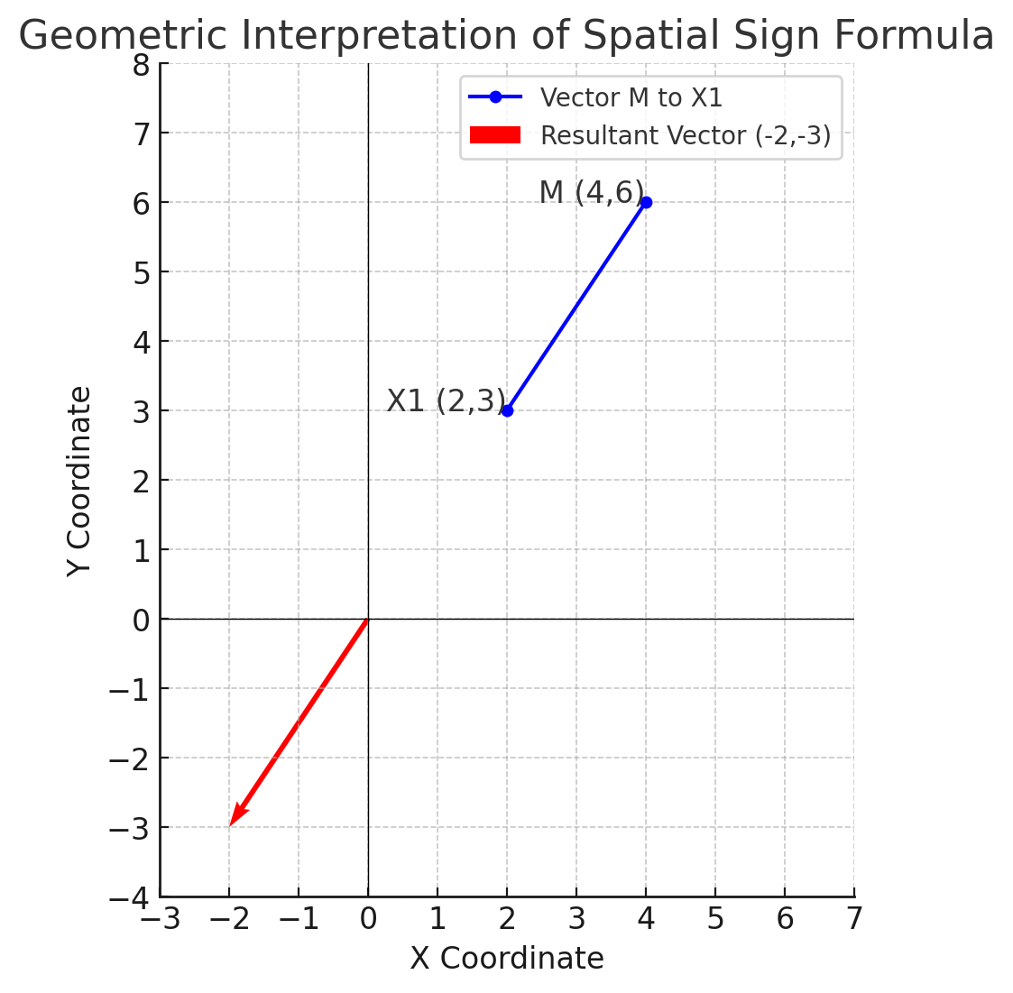

A unit vector is a vector that has a magnitude (length) of 1. It is used primarily to represent a direction, separating the concept of direction from that of magnitude (length).

The formula for converting any vector into a unit vector is:

where denotes the norm (or magnitude) of the vector.

In the context of your spatial sign formula, given the vector :

1. Calculate its magnitude (norm): .

2. Divide each component of the vector by its magnitude to normalize it:

Thus, the unit vector in the direction from is . This vector points in the same direction as but has a standardized length of 1, making it purely directional.

Dividing a vector by its magnitude to create a unit vector guarantees that the resulting vector has a magnitude not exceeding 1 because of how vector magnitudes and division operate.

Detailed Explanation:

1. Vector Magnitude (Norm):

The magnitude (or norm) of a vector in -dimensional space is given by:

This value represents the "length" of the vector from the origin to its endpoint in Euclidean space.

2. Normalization Process:

When you divide each component of a vector by its magnitude, you're scaling the vector down (or up, if its magnitude is less than 1) to a unit length. Each component of the vector is divided by , resulting in:

3. Resulting Magnitude of the Unit Vector:

The magnitude of the resulting unit vector is:

Substituting and simplifying, you get:

4. Conclusion:

By dividing by the magnitude, the sum of the squares of the components of the normalized vector equals exactly 1, meaning the magnitude of the normalized vector is 1. This mathematical property ensures that the normalization process results in a vector whose length is precisely 1, thereby only representing the direction of the original vector and not its magnitude.

This explanation shows why the normalization of a vector by dividing it by its magnitude results in a unit vector, whose length is guaranteed not to exceed 1, effectively turning any non-zero vector into a direction vector of unit length.

Normalization of a vector in the context of the spatial sign, particularly in statistics and data analysis, serves several key purposes, particularly when dealing with multidimensional data or measurements:

s1. Uniformity of Scale:

- Normalization converts all vectors to a uniform length of 1. This uniformity is crucial because it ensures that the analysis is not skewed by the absolute magnitudes of the original vectors, which might vary widely. By focusing solely on direction, every point contributes equally to the statistical analysis, irrespective of its original distance from the center point or median.

2. Robustness to Outliers:

- In statistical data analysis, outliers can disproportionately influence the results. When vectors are normalized to unit length, the influence of extreme values (outliers) is reduced because only the direction towards or away from the central point is considered, not the distance. This makes methods based on the spatial sign particularly robust, as they mitigate the impact of outliers.

3. Comparative Analysis:

- Normalized vectors allow for a straightforward comparison between data points in terms of directionality alone, omitting magnitude. This is especially useful in applications like clustering or principal component analysis (PCA) where the direction of the data points relative to the center or across principal components is more informative than the magnitude.

4. Enhanced Geometric Interpretation:

- The spatial sign transformation, by converting vectors to unit vectors, simplifies geometric interpretations. Each point on the unit sphere represents a direction from the median or center, making it easier to visualize and understand patterns in the directionality of the data.

5. Foundation for Further Statistical Measures:

- Normalized vectors form the basis for constructing other robust statistical measures. For example, they are used in defining spatial median, where the goal is to find a point that minimizes the sum of distances (now angular or directional distances due to normalization) from all points in a dataset.

6. Equality in Influence:

- By normalizing vectors, every data point, regardless of its original distance from the median, exerts an equal influence on the analysis outcome. This equality is fundamental in creating fair and unbiased statistical models, particularly in the presence of data from diverse scales or units.

In summary, normalization in the spatial sign context is a fundamental step that ensures all data points are treated equally based on their direction alone, facilitating robust, fair, and interpretable statistical analyses.

### Paper Summary

The paper "A review of dispersion control charts for multivariate individual observations" by Jimoh Olawale Ajadi, Zezhong Wang, and Inez Maria Zwetsloot provides a detailed examination of various control charts designed to monitor the covariance matrix of processes, focusing specifically on individual multivariate observations rather than grouped data. Here's a comprehensive breakdown of its contents:

**Overview**

The authors discuss multivariate control charts which monitor multiple correlated quality characteristics of a process. This is crucial in understanding process variability when data are collected not in groups but as individual observations (vectors). The study reviews 30 articles published between 1987 and 2019, categorizing them into five types based on the charting methods used.

**#Key Sections**

1. Introduction: Establishes the need for control charts that monitor individual observations due to their ability to detect sustained shifts in process variability quickly.

2. Literature Review: Analyzes over 200 articles, selecting 30 relevant ones that focus on continuous multivariate data, both normal and non-normal distributions.

3. Methodological Categories: The selected articles are grouped into five categories:

Sure, I'll list the specific charts investigated under each category from the paper:

**The review covers the following types of control charts:**

1. CUSUM Control Charts:

- Designed for detecting small and persistent process changes.

- Examples include Max-CUSUM, MCD1, and MCUSUM charts.

- Used for monitoring both the process mean and variability .

2. EWMA Control Charts:

- Focus on monitoring the covariance matrix of a process.

- Examples include MEWMS, MEWMV, and MEWMC charts.

- Useful for individual observations and high-dimensional data monitoring .

3. Shewhart Control Charts:

- Primarily used for monitoring process variability.

- Employ techniques like Wilks’ statistic and trace methods.

- Suitable for grouped data and individual observations .

4. Non-Parametric Control Charts:

- Effective for data with unknown distributions.

- Examples include MNSE and MSRE charts.

- Utilize spatial sign and rank statistics for monitoring .

5. High-Dimensional Control Charts:

- Designed to handle high-dimensional data.

- Examples include charts based on dissimilarity index and the MVP chart.

- Focus on detecting changes in large numbers of correlated quality characteristics .

These charts are evaluated based on their statistical properties, effectiveness in detecting shifts, and applicability to various scenarios, including normal and non-normal distributions.

**1. CUSUM-Type Dispersion Charts MCUSUM**

**A: MCUSUM Charts Based on Likelihood Ratio:**

1. Healy's CUSUM Chart (1987): This chart uses the log likelihood ratio to detect proportional shifts in the variance-covariance matrix from to .

2. Cheng and Thaga's Max-MCUSUM Chart (2005): This chart also employs the likelihood ratio, extending Healy's approach to monitor changes in both the process mean vector and the covariance matrix simultaneously.

**B: CUSUM Charts Based on Projection Pursuit:**

Chan and Zhang's CUSUM Chart (2001): This chart uses a projection pursuit (PP) method to derive a CUSUM-type chart called MCD1, which can monitor both the process mean and the covariance matrix simultaneously.

**C: Modified CUSUM Charts for Multivariate Time Series:**

**Bodnar and Schmid's Modified CUSUM Charts (2017):** These include modifications of four existing CUSUM charts for multivariate time series data. The modifications are applied to:

- MC1 and MC2 Charts (originally by Pignatiello and Runger, 1990)

- MCUSUM Chart (originally by Crosier, 1988)

- PPCUSUM Chart (originally by Ngai and Zhang, 2001)

**2. MEWMA-Type Dispersion Charts**

- Hawkins and Maboudou-Tchao (2008): Used Alt’s likelihood ratio.

- Yeh, Huwang, and Chien-Wei (2005): Utilized norm statistics.

- Numerous other charts focusing on different statistical measures like the trace of the covariance matrix and other norm statistics.

**3. Shewhart-Type Dispersion Charts**

- Khoo and Quah (2003): Applied Chi-squared distributions.

- Hwang (2017): Used trace-based and other specific Shewhart-type methods.

**4. Non-Parametric Dispersion Charts**

- Li et al. (2013): Proposed a non-parametric EWMA chart using spatial signs.

**5. Multivariate Charts for High-Dimensional Data**

- Huwang et al. (2017): Introduced a dissimilarity index for high-dimensional data.

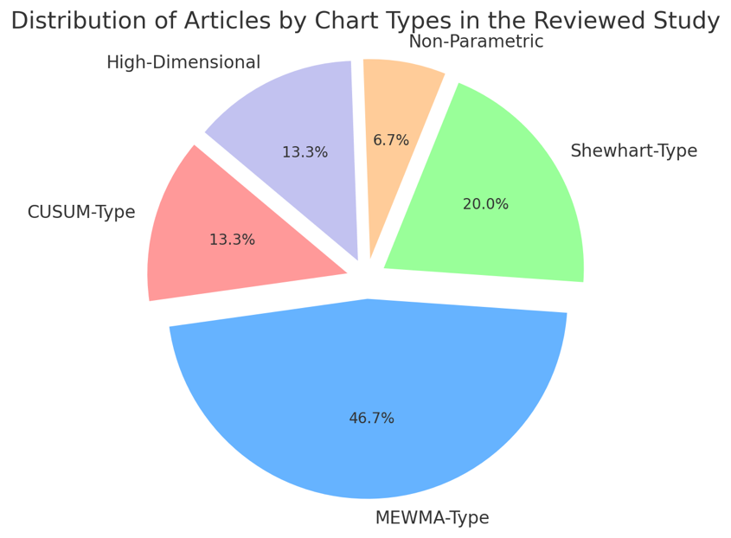

CUSUM-Type Charts

| Specific Chart | Description | Calculation Steps | Pros | Cons | Different to Others |
| --- | --- | --- | --- | --- | --- |
| **Healy (1987)** | Introduced CUSUM for dispersion, focusing on covariance matrices. | Uses cumulative sum of deviations from target covariance. | Sensitive to small shifts. | Complex calculations. | Pioneer in applying CUSUM to dispersion control. |
| **Chan and Zhang (2001)** | Developed CUSUM charts using projection pursuit. | Employs statistical projection to enhance detection. | Improves detection accuracy. | Computationally intense. | Combines CUSUM with projection pursuit for better detection. |
| **Cheng and Thaga (2005)** | Combined mean and covariance monitoring using maximum CUSUM statistic. | Max CUSUM tracks combined shifts in mean and covariance. | Monitors dual parameters. | May miss subtle shifts. | Integrates mean and covariance in one framework. |

MEWMA-Type Charts

| Specific Chart | Description | Calculation Steps | Pros | Cons | Different to Others |
| --- | --- | --- | --- | --- | --- |
| **Hawkins and Maboudou-Tchao (2008)** | Applied Alt’s likelihood ratio to enhance MEWMA charts. | Uses likelihood ratio for early detection of changes. | Early detection capabilities. | Requires large samples. | First to integrate Alt's likelihood with MEWMA. |
| **Yeh, Huwang, and Chien-Wei (2005)** | Utilized norm statistics to refine MEWMA charts. | Adjusts control limits based on norm statistics. | Quicker adjustments. | May be less robust. | Focuses on refining control limits for quicker response. |
| **Others (12 articles)** | Expanded foundational MEWMA approaches. | Various adaptations of MEWMA methodology. | Broad application range. | Varies by article. | Diverse enhancements to standard MEWMA. |

Shewhart-Type Charts

| Specific Chart | Description | Calculation Steps | Pros | Cons | Different to Others |
| --- | --- | --- | --- | --- | --- |
| **Khoo and Quah (2003)** | Developed Shewhart-type charts using Chi-squared distributions. | Uses Chi-squared distributions to monitor dispersion. | Fast response to disturbances. | Less effective for small shifts. | Incorporates Chi-squared for quick response. |
| **Hwang (2017)** | Introduced trace-based methods in Shewhart frameworks. | Calculation based on trace of covariance matrices. | Good for large shifts. | Not sensitive to minor changes. | Focuses on trace-based analysis for simplicity and clarity. |

Non-Parametric Charts

| Specific Chart | Description | Calculation Steps | Pros | Cons | Different to Others |
| --- | --- | --- | --- | --- | --- |
| **Li et al. (2013)** | Proposed non-parametric EWMA chart using spatial signs. | Uses spatial signs for robustness against distributions. | Highly robust to non-normal distributions. | Complex setup and tuning. | Pioneered spatial signs in non-parametric control. |

High-Dimensional Charts

| Specific Chart | Description | Calculation Steps | Pros | Cons | Different to Others |
| --- | --- | --- | --- | --- | --- |
| **Huwang et al. (2017)** | Introduced a dissimilarity index for high-dimensional data. | Uses dissimilarity index to compare covariance matrices. | Effective in high dimensions. | May require large data samples. | First to apply dissimilarity index in this context. |

Tables with a focus on the calculation steps and incorporate mathematical formulas where applicable for each chart type:

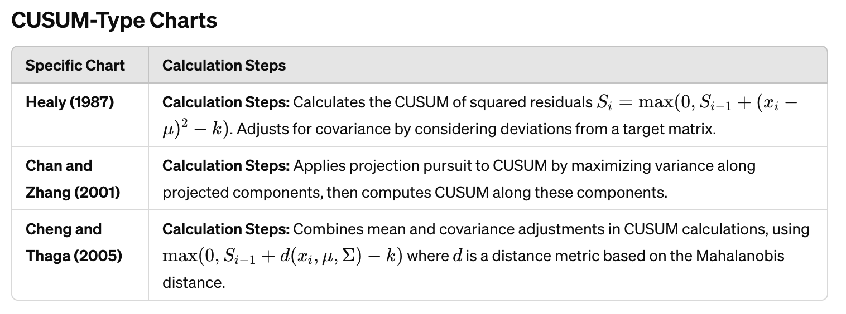

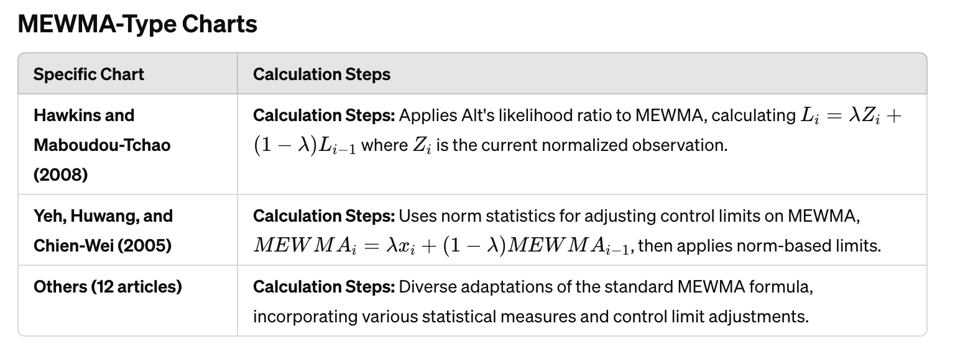

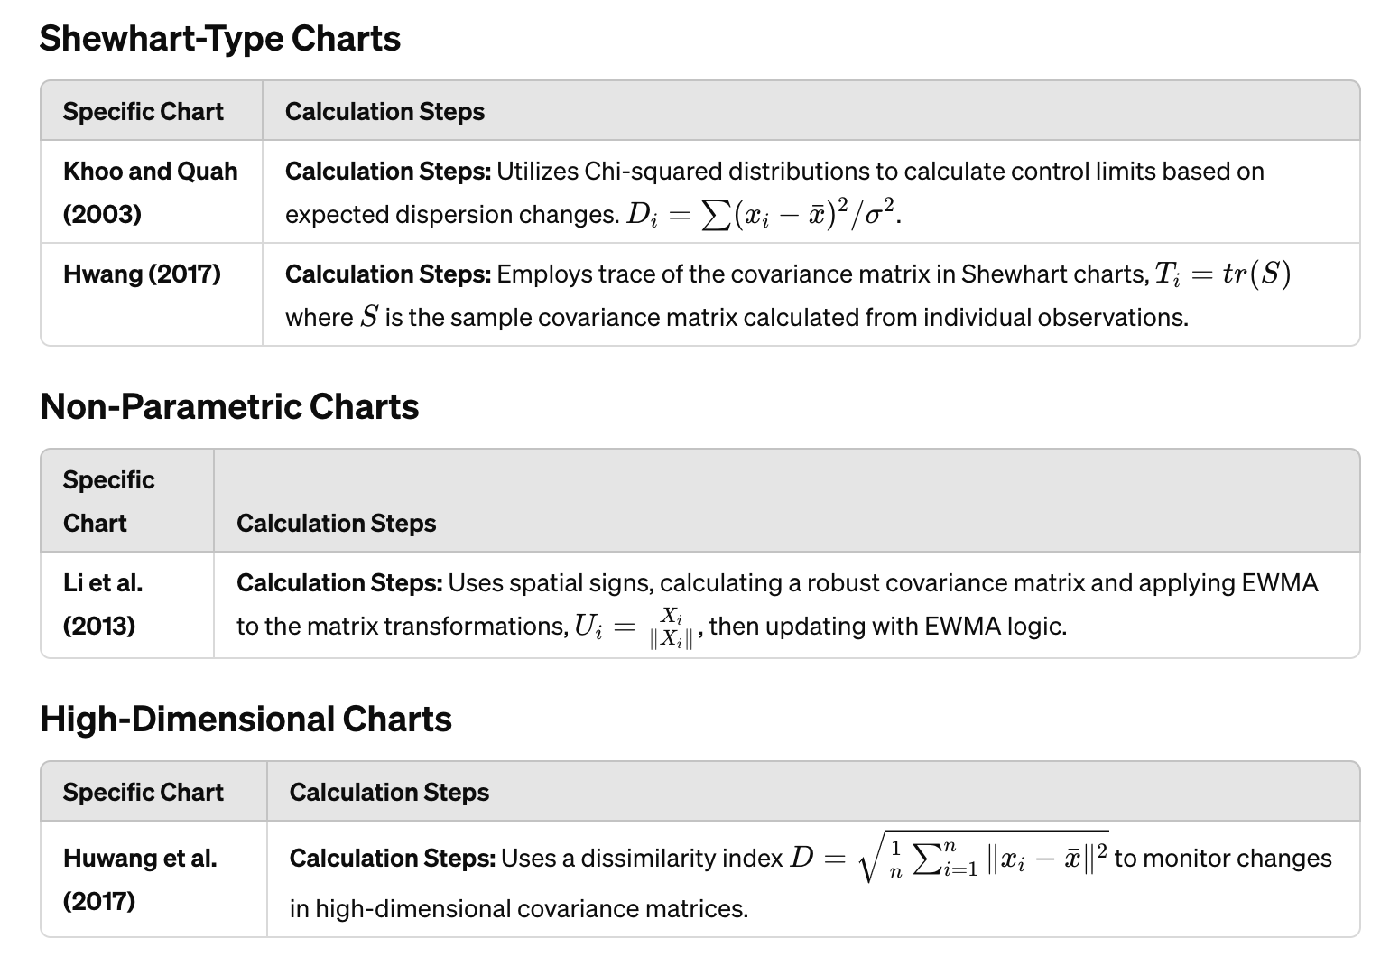

### CUSUM-type Dispersion Charts

**Overview**

CUSUM (Cumulative Sum) control charts are renowned for their effectiveness in detecting small and medium shifts in process variation (creeping changes), particularly suited for individual observations.

**1. Healy (1987)**

- Introduced the first method using CUSUM for monitoring dispersion with individual observations.

- Uses likelihood ratio to build charting statistics, designed to detect proportional shifts in the variance-covariance matrix.

**2. Chan and Zhang (2001)**

- Developed CUSUM charts using a projection pursuit method.

- Can monitor changes in the process mean vector and covariance matrix simultaneously but cannot distinguish between these two types of shifts.

**3. Cheng and Thaga (2005)**

- Proposed the Maximum Multivariate Cumulative Sum (Max-MCUSUM) control chart.

- Enhanced to monitor both the mean vector and covariance matrix, showing better performance in detecting simultaneous small shifts in process mean and covariance compared to other charts.

**4. Bodnar and Schmid (2017)**

- Modified four CUSUM-type charts for multivariate time series data under normal and non-normal distributions.

- Recommended modified MCUSUM charts as they showed improved performance in detecting almost all the simulated shifts for both original data and residuals.

Advantages

- Sensitivity to Small Changes: CUSUM charts are particularly sensitive to small and persistent changes in the process variance, which can be crucial for maintaining strict quality controls.

- Monitoring Complexity: These charts can handle the complexity of monitoring multivariate data effectively, particularly when the data involve both mean and covariance shifts.

Limitations

- Difficulty in Distinguishing Changes: Some CUSUM-type charts struggle to distinguish between shifts in process mean and variability, which can complicate the analysis.

- Assumptions on Distribution: Traditional CUSUM charts often assume a normal distribution, which may not always hold, particularly in complex industrial processes.

Future Research Directions

- Improvement in Distinguishing Shift Types: Further research could focus on enhancing CUSUM-type charts to better distinguish between shifts in means and variances.

- Adaptation to Non-Normal Distributions: Developing new models that do not rely heavily on the assumption of normality would broaden the applicability of CUSUM-type charts in various industrial contexts.

- Real-time Monitoring Capabilities: Enhancing the real-time monitoring capabilities of CUSUM charts could significantly benefit industries where immediate detection and response are crucial.

#### CUSUM Type Charts → Charts Based on Likelihood Ratio → The Healy (1987)

**Mathematical Context**

Healy’s method uses a CUSUM scheme designed to detect proportional shifts in the variance-covariance matrix from to where the correlation between variables remains constant. The key aspect of Healy’s method is the use of the log likelihood ratio based on CUSUM statistics to build the charting statistics. Here’s the general mathematical formulation:

##**CUSUM Statistic Formulation**

The CUSUM statistic, , is defined recursively as follows:

where:

- are the density functions corresponding to the in-control and out-of-control distributions of the data, respectively.

- is the individual observation at time

Under the **assumption of normality** and a shift from the formula simplifies to:

where is a constant given by:

Here, is the number of quality characteristics being monitored, is the process mean, and is the in-control covariance matrix.

**Derivation of the Simplified Form**

The simplified form of the CUSUM statistic for detecting shifts in the covariance matrix from to is derived based on the likelihood ratio of the in-control and out-of-control processes. Here is a step-by-step explanation:

# 1. Likelihood Ratio

The likelihood ratio for a multivariate normal distribution can be expressed as:

where are the probability density functions of the in-control and out-of-control processes, respectively.

# 2. In-Control and Out-of-Control Density Functions

For a multivariate normal distribution with mean and covariance matrix , the density function is given by:

For the in-control process (\(\Sigma\_0\)):

For the out-of-control process (\(C\Sigma\_0\)):

# 3. Simplification of the Ratio

To simplify, first note the determinant relationship:

Then, the likelihood ratio becomes:

# 4. Combining Terms

The expression simplifies to:

# 5. Form of the CUSUM Statistic

Given the above, the CUSUM statistic can be simplified as:

Where:

-

- is the Mahalanobis distance, which measures how far is from the mean in terms of the covariance matrix

Thus, the simplified form accumulates the Mahalanobis distance from the target mean, adjusted by a constant that reflects the expected shift in the covariance matrix.

**Example with Numbers**

Consider a bivariate process (p = 2) where we want to monitor two quality characteristics. Assume the following parameters for the in-control process:

- Mean vector

- Covariance matrix

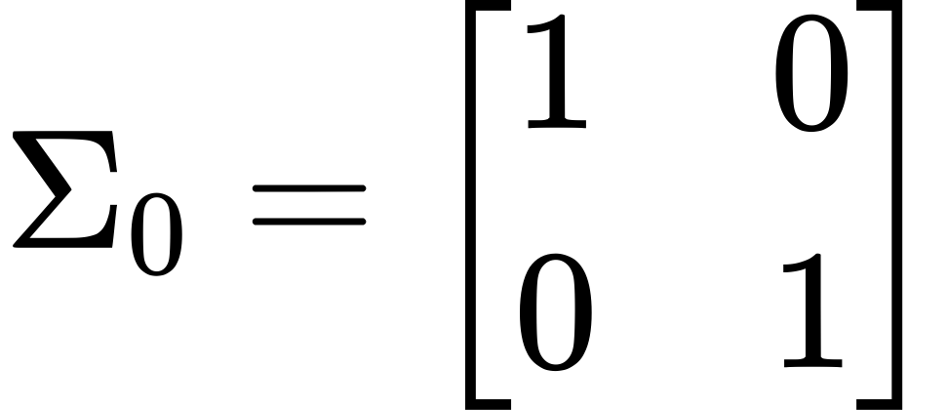

- Shift parameter

- Constant (this is chosen for illustration purposes; in practice, it should be optimized based on desired performance)

# Step-by-Step Calculation

1. Initialize:

2. Observation: Assume the first observation

3. Compute the CUSUM Statistic:

Simplifying, we get:

4. Next Observation: Assume the second observation

5. Update the CUSUM Statistic:

Simplifying, we get:

6. Decision Rule: Continue this process for subsequent observations. If at any time exceeds the predefined threshold (e.g., 5), signal an out-of-control condition.

This example illustrates how Healy's CUSUM chart accumulates deviations from the target process over time and helps detect shifts in the process variance-covariance matrix.

Implementation Steps

1. Parameter Estimation: Estimate the in-control process mean and covariance matrix from historical data.

2. Initialize CUSUM: Set

3. For each new observation

- Compute the statistic

- Update using the recursive relationship.

- Compare against a decision interval (usually a set threshold based on desired false alarm rate and detection power).

4. Decision Making: If exceeds the threshold, signal an out-of-control state.

#Pros

- Sensitivity to Small Shifts: Effective in detecting small sustained shifts in the process variability.

- Focused on Variability: Specifically designed to monitor changes in dispersion, which is crucial for processes where maintaining variability is as important as controlling the mean.

#Cons

- Assumption of Normality: Relies on the assumption that data follow a normal distribution, which might not always be valid.

- Limited to Variability Shifts: While effective in detecting shifts in variability, it does not address shifts in the mean or other types of process disturbances.

Python Code

1. import numpy as np

2. import matplotlib.pyplot as plt

3.

4. # Step 1: Generate Sample Data

5. np.random.seed(42)

6. mu\_in\_control = np.array([0, 0])

7. cov\_in\_control = np.array([[1, 0.5], [0.5, 1]])

8. n\_samples = 100

9. X = np.random.multivariate\_normal(mu\_in\_control, cov\_in\_control, n\_samples)

10.

11. # Step 2: Initialize Parameters

12. C = 2 # Scale factor for the out-of-control covariance matrix

13. K = 2 # Chosen constant, should be optimized in practice

14. T = np.zeros(n\_samples) # Initialize CUSUM statistics array

15. threshold = 5 # Threshold for out-of-control signal

16.

17. # Step 3: Compute the CUSUM Statistic

18. for i in range(1, n\_samples):

19. T[i] = max(0, T[i-1] + (X[i] - mu\_in\_control).T @ np.linalg.inv(cov\_in\_control) @ (X[i] - mu\_in\_control) - K)

20.

21. # Step 4: Plot the Results

22. plt.figure(figsize=(10, 6))

23. plt.plot(T, label='CUSUM Statistic')

24. plt.axhline(y=threshold, color='r', linestyle='--', label='Threshold')

25. plt.xlabel('Sample Index')

26. plt.ylabel('CUSUM Statistic')

27. plt.title('Healy CUSUM Chart')

28. plt.legend()

29. plt.grid(True)

30. plt.show()

31.

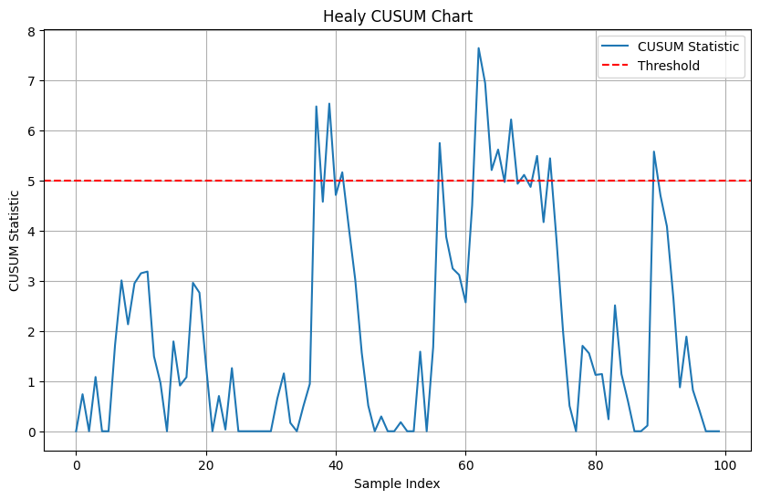

#### CUSUM Type Charts → Charts Based on Likelihood Ratio → Cheng and Thaga's Max-MCUSUM Chart (2005)

Cheng and Thaga (2005) proposed the Max-MCUSUM chart to monitor shifts in both the process mean vector and the covariance matrix of a multivariate process. This method extends Healy's approach by using a maximum CUSUM statistic, which makes it effective in detecting small shifts in the process parameters.

# **Key Concepts**

1. CUSUM Statistic: The CUSUM statistic for each quality characteristic is calculated, and then the maximum of these statistics is taken as the monitoring statistic.

2. Simultaneous Monitoring: The chart is designed to detect simultaneous shifts in the process mean vector and the covariance matrix, providing a comprehensive monitoring tool.

# **Detailed Explanation**

1. Initialization:

- Let be the in-control mean vector.

- Let be the in-control covariance matrix.

- Initialize the CUSUM statistics for each quality characteristic .

2. CUSUM Statistic for Mean:

- The CUSUM statistic for detecting shifts in the mean vector is computed as:

where is a reference value that determines the sensitivity of the chart.

3. CUSUM Statistic for Covariance:

- For the covariance matrix, the statistic is:

where is the sample covariance matrix at the \(i\)-th observation and \(p\) is the number of variables.

4. Max-MCUSUM Statistic:

- The Max-MCUSUM statistic is the maximum of the CUSUM statistics for the mean and covariance:

5. Decision Rule:

- If exceeds a predefined threshold , an out-of-control signal is triggered, indicating a potential shift in the process mean or covariance.

**Mathematical Equations and Their Origins**

1. CUSUM Statistic for Mean :

- Origin: This equation is derived from the classical CUSUM chart for mean shifts but extended to the multivariate case. It accumulates the deviations of the observed values from the in-control mean, scaled by the inverse of the in-control covariance matrix.

- Meaning: The term is the Mahalanobis distance, which measures how far the observation is from the mean in terms of the covariance structure. The CUSUM statistic accumulates these distances and compares them to a reference value .

- Working: If the cumulative Mahalanobis distance exceeds the threshold, it indicates a shift in the mean.

2. CUSUM Statistic for Covariance :

- Origin: This equation is derived from the likelihood ratio test for changes in the covariance matrix. It uses terms related to the determinants and traces of the covariance matrices.

- Meaning: The term measures the difference between the in-control covariance matrix \(\Sigma\_0\) and the sample covariance matrix .

- Working: This statistic accumulates the differences in the covariance structure. A significant accumulation indicates a shift in the covariance matrix.

3. Max-MCUSUM Statistic :

- Origin and Meaning: This statistic takes the maximum of the two CUSUM statistics for the mean and covariance. It ensures that the chart is sensitive to shifts in either the mean vector or the covariance matrix.

- Working: By monitoring the maximum of these two statistics, the chart can detect shifts in both the mean and the covariance structure simultaneously.

Example with Numbers

Consider a simple example with a bivariate process . Assume:

- In-control mean:

- In-control covariance matrix:

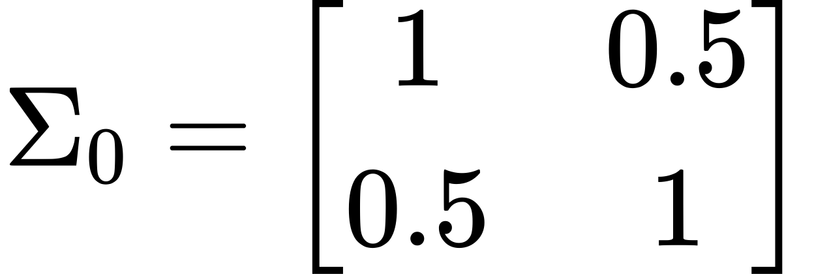

- Reference value:

- Threshold for out-of-control signal:

# Step-by-Step Calculation

Step 1: Initialization

-

-

Step 2: Observation 1

- Assume \(X\_1 = [1, 2]^T\)

CUSUM Statistic for Mean:

Calculating the Mahalanobis distance:



So,

CUSUM Statistic for Covariance:

Assuming for simplicity,

Max-MCUSUM Statistic:

Step 3: Observation 2

- Assume

CUSUM Statistic for Mean:

Calculating the Mahalanobis distance:



So,

CUSUM Statistic for Covariance:

Assuming \(\Sigma\_2 = \Sigma\_0\) for simplicity,

Max-MCUSUM Statistic:

Implementation in Python

1. import numpy as np

2. import matplotlib.pyplot as plt

3. # Step 1: Generate Sample Data

4. np.random.seed(42)

5. mu\_in\_control = np.array([0, 0])

6. cov\_in\_control = np.array([[1, 0.5], [0.5, 1]])

7. n\_samples = 100

8. X = np.random.multivariate\_normal(mu\_in\_control, cov\_in\_control, n\_samples)

9.

10. # Step 2: Initialize Parameters

11. delta = 2 # Reference value for mean shift sensitivity

12. threshold = 5 # Threshold for out-of-control signal

13. C\_mu = np.zeros(n\_samples) # CUSUM for mean

14. C\_sigma = np.zeros(n\_samples) # CUSUM for covariance

15. C\_max = np.zeros(n\_samples) # Max-CUSUM

16.

17. # Step 3: Compute the Max-MCUSUM Statistic

18. for i in range(1, n\_samples):

19. # Update sample covariance matrix

20. if i == 1:

21. sample\_cov = np.outer(X[i], X[i])

22. else:

23. sample\_cov = np.cov(X[:i+1], rowvar=False)

24.

25. # CUSUM for mean

26. C\_mu[i] = max(0, C\_mu[i-1] + 0.5 \* ((X[i] - mu\_in\_control).T @ np.linalg.inv(cov\_in\_control) @ (X[i] - mu\_in\_control) - delta))

27. # CUSUM for covariance

28. C\_sigma[i] = max(0, C\_sigma[i-1] + 0.5 \* (np.log(np.linalg.det(cov\_in\_control)) - np.log(np.linalg.det(sample\_cov)) - len(mu\_in\_control) + np.trace(np.linalg.inv(cov\_in\_control) @ sample\_cov)))

29.

30. # Max-CUSUM

31. C\_max[i] = max(C\_mu[i], C\_sigma[i])

32.

33. # Step 4: Plot the Results

34. plt.figure(figsize=(10, 6))

35. plt.plot(C\_max, label='Max-MCUSUM Statistic')

36. plt.axhline(y=threshold, color='r', linestyle='--', label='Threshold')

37. plt.xlabel('Sample Index')

38. plt.ylabel('CUSUM Statistic')

39. plt.title('Cheng and Thaga\'s Max-MCUSUM Chart')

40. plt.legend()

41. plt.grid(True)

42. plt.show()

43.

Explanation

1. Generate Sample Data: Generates 100 bivariate normal samples with a specified mean vector and covariance matrix.

2. Initialize Parameters: Sets the reference value threshold for signaling an out-of-control state, and initializes arrays for CUSUM statistics.

3. Compute the Max-MCUSUM Statistic: Calculates the CUSUM statistics for the mean and covariance, then takes the maximum of these as the monitoring statistic.

4. Plot the Results: Plots the Max-MCUSUM statistic over time, with a threshold line indicating when the process is considered out-of-control.

This implementation provides a practical example of using Cheng and Thaga's Max-MCUSUM chart for monitoring multivariate processes.

#### CUSUM Type Charts → CUSUM Charts Based on Projection Pursuit → Chan and Zhang (2001)

**Overview**

Chan and Zhang developed a CUSUM control chart using a projection pursuit (PP) approach. This method is particularly suited for detecting changes in the dispersion of multivariate data where the underlying distribution may not be normal.

**Mathematical Context**

The projection pursuit CUSUM chart, referred to as MCD1, involves several key steps:

1. Projection Pursuit (PP) Method:

- Objective: Find projections that reveal interesting structures, such as clusters or outliers, which are not visible in the original high-dimensional data.

- Implementation: The PP method is used to identify directions (or projections) along which the data show significant deviations from normality or homogeneity.

2. Charting Statistics (Qi):

- Selection of Dispersion Chart: Choose a univariate dispersion chart with a suitable charting statistic such as CUSUM or EWMA.

- Projection Parameters: Estimate the parameters iteratively for each time period to calculate the value of charting statistics

3. Calculation of Monitoring Statistics:

- Whereindicate the -th observations, are reference values; are the largest and smallest eigenvalues of the matrix

4. Implementation:

- The monitoring statistics are defined as:

- A signal is given if either exceeds predetermined control limits.

#**Implementation Steps**

1. Data Collection: Gather multivariate data at each time point.

2. Standardization and Transformation: Standardize the data if required and transform it using suitable projection methods to identify significant directions.

3. Calculate CUSUM Statistics: Compute the CUSUM statistics for each projection.

4. Monitor and Decide: Compare the CUSUM statistics against control limits to determine if a process is out of control.

**# Mathematical Formulation**

1. Projection Pursuit:

- For each time , calculate the projection of the observation onto a direction vector .

- The projection is given by

2. CUSUM Statistic:

- For each projection direction , compute the CUSUM statistic for the variability:

- Where is the mean of the projected data and is a reference value.

3. Overall Statistic:

- Combine the CUSUM statistics for different directions to form an overall monitoring statistic.

**Example with Numbers**

Consider a simple example with a bivariate process and assume we have the following parameters:

- In-control mean vector:

- In-control covariance matrix:

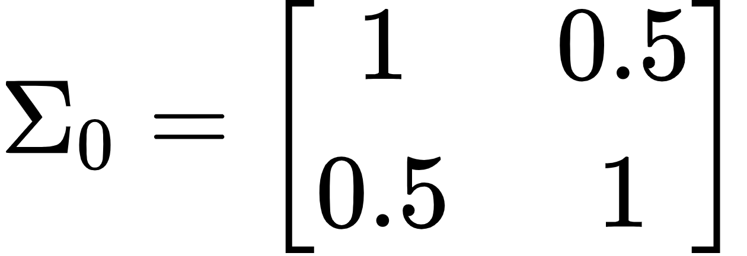

- Reference value:

- Projection direction:

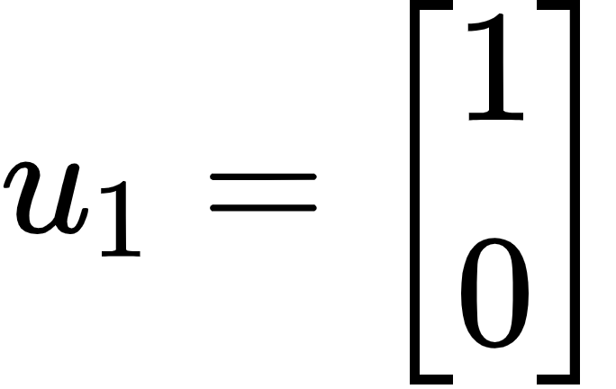

# **Step-by-Step Calculation**

1. Initialization:

-

- Projection direction



2. Observation 1:

- Assume

- Compute the projection:

- Update CUSUM statistic:

3. Observation 2:

- Assume

- Compute the projection:

- Update CUSUM statistic:

**Pros**

- Sensitivity to Changes in Variance: Effective in detecting small changes in the dispersion of multivariate processes.

- Flexibility: Can monitor changes in both the mean vector and covariance matrix.

- Adaptability: Suitable for high-dimensional data and non-normal distributions.

**Cons**

- Complexity in Calculation: The need for iterative calculation of projection parameters increases the computational burden.

- Ambiguity in Detection: It can monitor changes in both mean and variance but cannot clearly distinguish between them.

- Parameter Sensitivity: The performance may depend heavily on the choice of the smoothing constant and control limits.

**Conclusion**

The CUSUM-type chart developed by Chan and Zhang offers a sophisticated approach for monitoring multivariate processes, particularly where the data may not conform to normality. It's particularly suited for situations where both mean and variability may change, although it does require careful handling to ensure effectiveness and efficiency. Future implementations might focus on optimizing the computation and improving the clarity with which different types of changes in the process can be detected.

**Implementation in Python**

import numpy as np

import pandas as pd

import matplotlib.pyplot as plt

from sklearn.decomposition import PCA

from scipy.stats import norm

# Sample Data

data = np.array([

[20, 101.5],

[21, 101.8],

[19, 100.9],

[22, 102.2],

[21, 101.9],

[20, 101.4],

[23, 102.5],

[24, 103.0],

[22, 102.1],

[21, 101.7]

])

# Standardize the Data

mean = np.mean(data, axis=0)

std = np.std(data, axis=0)

standardized\_data = (data - mean) / std

# Projection Pursuit using PCA to find the direction with maximum variance

pca = PCA(n\_components=1)

pca.fit(standardized\_data)

projection\_vector = pca.components\_[0]

# Project the data onto the found direction

projected\_data = np.dot(standardized\_data, projection\_vector)

# Calculate control limits

mean\_proj = np.mean(projected\_data)

std\_proj = np.std(projected\_data)

UCL = mean\_proj + 3 \* std\_proj

LCL = mean\_proj - 3 \* std\_proj

# Plot Control Chart

plt.figure(figsize=(10, 6))

plt.plot(projected\_data, marker='o', linestyle='-', color='b')

plt.axhline(UCL, color='r', linestyle='--', label='UCL')

plt.axhline(LCL, color='r', linestyle='--', label='LCL')

plt.axhline(mean\_proj, color='g', linestyle='-', label='Mean')

plt.title('Projection Pursuit Control Chart')

plt.xlabel('Observation')

plt.ylabel('Projected Value')

plt.legend()

plt.show()

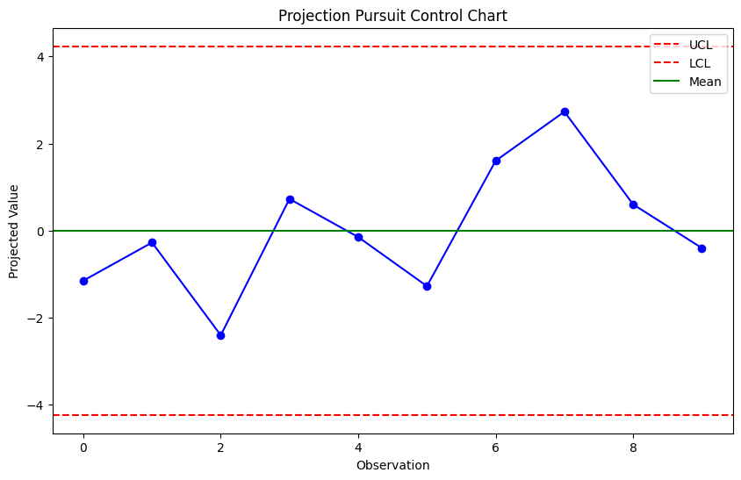

**Explanation of the Code**

1. Standardize the Data: The data is centered and scaled to have a mean of 0 and standard deviation of 1.

2. Projection Pursuit: We use Principal Component Analysis (PCA) to find the direction that maximizes the variance of the projected data. PCA is a common technique for projection pursuit.

3. Project Data: The data is projected onto the direction found by PCA.

4. Calculate Control Limits: The control limits are set at ±3 standard deviations from the mean of the projected data.

5. Plot Control Chart: The projected data and control limits are plotted on a control chart.

#### CUSUM Type Charts → Maximum Multivariate Cumulative Sum → Cheng and Thaga (2005)

The Cheng and Thaga (2005) study introduces the Maximum Multivariate Cumulative Sum (Max-MCUSUM) control chart, an advanced version of the CUSUM control chart designed to monitor simultaneous changes in both the process mean vector and the covariance matrix. Below is a detailed description of the methodology, including the mathematical context, implementation steps, as well as the advantages and limitations of this approach.

##**Max-MCUSUM Control Chart**

Cheng and Thaga's approach extends the traditional CUSUM chart to handle multivariate data more effectively by simultaneously monitoring shifts in the process mean and covariance matrix. The Max-MCUSUM control chart uses a maximum CUSUM statistic to achieve this:

1. CUSUM Statistics for Mean and Variance:

- For the mean vector:

- For the covariance matrix:

- Whererepresents the j-th variable of the i-th observation, are the mean and covariance targets, and are reference values (usually small constants to detect shifts).

2. Max-MCUSUM Statistic:

- The Max-MCUSUM statistic is calculated by taking the maximum of all individual CUSUM statistics for both the mean and the covariance matrix.

3. Signal:

- A signal is generated if exceeds a predetermined threshold, indicating a potential out-of-control state.

##**Implementation Steps**

1. Parameter Estimation:

- Estimate the in-control parameters from historical data.

2. Initialization:

- Initialize all CUSUM statistics to zero.

3. Calculation:

- For each new observation, calculate the CUSUM statistics for both the mean vector and covariance matrix.

4. Evaluation:

- Compare the Max-MCUSUM statistic against the control limit to determine if a signal should be generated.

5. Adjustment and Monitoring:

- Adjust the chart parameters as necessary based on ongoing process performance and continue monitoring.

##**Advantages**

- Comprehensive Monitoring: Capable of detecting both shifts in the mean and variability, which is critical for processes where these parameters are likely to change simultaneously.

- Early Detection: Effective in catching small shifts early, especially important in high-quality environments such as pharmaceutical manufacturing or precision engineering.

- Adaptability: Flexible enough to be adapted to various industrial contexts with adjustments to parameters.

##**Limitations**

- Complexity: More complex to implement and interpret compared to traditional univariate CUSUM charts, requiring a good understanding of multivariate statistical processes.

- Parameter Sensitivity: Highly sensitive to the choice of design parameters , which can affect the false alarm rate and the detection power.

- Assumption of Normality: Assumes that the process data are normally distributed, which may not hold in all practical scenarios.

#**Conclusion**

The Max-MCUSUM chart proposed by Cheng and Thaga provides a robust tool for monitoring multivariate processes, addressing both mean and covariance shifts simultaneously. Despite its complexity and assumptions, it is a valuable addition to the statistical process control toolkit, particularly in settings where precise control over multiple process parameters is crucial. Further research could explore adaptations for non-normal data and simplify parameter selection to enhance its practical usability.

#### CUSUM Type Charts → Modified CUSUM Charts for Multivariate Time Series → Bodnar and Schmid (2017)

Bodnar and Schmid (2017) proposed modifications to four existing CUSUM-type charts for monitoring shifts in the covariance matrix of multivariate time series data. These modifications ensure robustness for both normal and non-normal distributions by using residuals from a linear model and robust statistical methods.

**Key Concepts and Methods**

1. CUSUM for Covariance Matrix:

- The original charts monitor changes in the covariance matrix of multivariate data.

2. Modification for Residuals:

- By using residuals from a linear predictor, the charts can handle time series data effectively, isolating changes in the covariance structure from the time-dependent patterns.

3. Robust Statistical Methods:

- Incorporating robust statistical methods, such as **robust covariance estimators**, makes the charts less sensitive to outliers and deviations from normality.

**Modified CUSUM Charts**

1. **MC1 Chart (Pignatiello and Runger, 1990):**

- Original Method: Monitors the covariance matrix by calculating the sum of the squared standardized residuals.

- Modification: Uses residuals from a linear model and robust covariance estimation.

**2. MC2 Chart (Pignatiello and Runger, 1990):**

- Original Method: Similar to MC1 but applies a different weighting scheme to the residuals.

- Modification: Incorporates robust statistical methods for better handling of non-normal data.

**3. MCUSUM Chart (Crosier, 1988):**

- Original Method: Uses a cumulative sum of the residuals to detect shifts in the process mean and covariance.

- Modification: Applies robust estimators to the residuals for detecting shifts in non-normal data.

**4. PPCUSUM Chart (Ngai and Zhang, 2001):**

- Original Method: Utilizes projection pursuit to detect changes in the covariance structure.

- Modification: Employs robust projection pursuit techniques to enhance performance under non-normal conditions.

**Mathematical Formulation for Robustness**

Residuals and Robust Covariance Estimation:

1. Compute Residuals:

- Fit a linear model to the time series data and compute residuals

2. Robust Covariance Estimation:

- Use a robust method (e.g., Minimum Covariance Determinant, MCD) to estimate the covariance matrix of the residuals,

3. CUSUM Statistic for Residuals:

- Calculate the CUSUM statistic based on the robust Mahalanobis distance:

- Update the CUSUM statistic:

**Example with Numbers**

Consider a simple example with a bivariate time series Assume:

- In-control mean vector:

- In-control covariance matrix:



- Reference value:

**# Step-by-Step Calculation**

Step 1: Initialization

-

Step 2: Compute Residuals

- Assume we fit a linear model to the time series data and obtain residuals \(e\_t\).

Step 3: Observation 1

- Assume

CUSUM Statistic for Residuals:

Calculating the Mahalanobis distance:

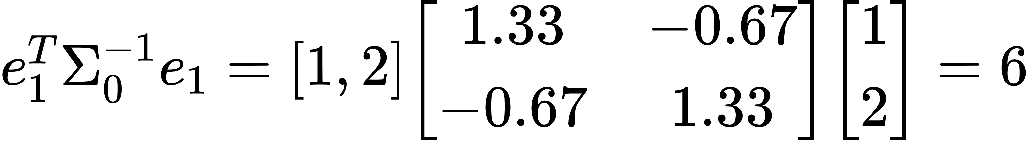

So,

Step 4: Observation 2

- Assume

CUSUM Statistic for Residuals:

Calculating the Mahalanobis distance:

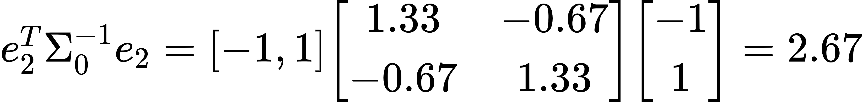

So,

This example demonstrates how to calculate the CUSUM statistic for residuals using a robust Mahalanobis distance approach. **The robust covariance estimation ensures the chart is effective for both normal and non-normal distributions**, aligning with the modifications proposed by Bodnar and Schmid.

Python Implementation

import numpy as np

import matplotlib.pyplot as plt

from sklearn.covariance import MinCovDet

# Step 1: Generate sample data (residuals from a linear model)

np.random.seed(42)

mu\_in\_control = np.array([0, 0]) # In-control mean vector

cov\_in\_control = np.array([[1, 0.5], [0.5, 1]]) # In-control covariance matrix

n\_samples = 100 # Number of samples

residuals = np.random.multivariate\_normal(mu\_in\_control, cov\_in\_control, n\_samples) # Simulated residuals

# Step 2: Robust covariance estimation using Minimum Covariance Determinant (MCD)

mcd = MinCovDet().fit(residuals)

robust\_cov = mcd.covariance\_ # Robust covariance matrix

robust\_inv\_cov = np.linalg.inv(robust\_cov) # Inverse of the robust covariance matrix

# Parameters for the CUSUM chart

K = 0.5 # Reference value for variability shift sensitivity

threshold = 5 # Threshold for out-of-control signal

# Step 3: Initialize CUSUM statistics

C = np.zeros(n\_samples) # Array to store CUSUM statistics

# Step 4: Compute the CUSUM Statistic for the residuals using robust covariance

for i in range(1, n\_samples):

# Compute the robust Mahalanobis distance for the i-th residual

robust\_mahalanobis\_dist = residuals[i].T @ robust\_inv\_cov @ residuals[i]

# Update the CUSUM statistic based on the robust Mahalanobis distance

C[i] = max(0, C[i-1] + robust\_mahalanobis\_dist - K)

# Step 5: Plot the Results

plt.figure(figsize=(10, 6))

plt.plot(C, label='CUSUM Statistic') # Plot the CUSUM statistics

plt.axhline(y=threshold, color='r', linestyle='--', label='Threshold') # Add a threshold line

plt.xlabel('Sample Index') # X-axis label

plt.ylabel('CUSUM Statistic') # Y-axis label

plt.title('Bodnar and Schmid\'s Modified CUSUM Chart with Robust Covariance') # Title of the plot

plt.legend() # Add a legend

plt.grid(True) # Add a grid for better visualization

plt.show() # Display the plot

**Explanation**

1. Generate Sample Data:

- We simulate 100 bivariate normal residuals with a specified mean vector (`mu\_in\_control`) and covariance matrix (`cov\_in\_control`).

- These residuals mimic the residuals from a linear model fitted to time series data.

2. Robust Covariance Estimation:

- We use the Minimum Covariance Determinant (MCD) method to estimate a robust covariance matrix (`robust\_cov`) of the residuals.

- The inverse of this robust covariance matrix (`robust\_inv\_cov`) is also calculated for later use in computing the Mahalanobis distance.

3. Initialize CUSUM Statistics:

- An array `C` is initialized to store the CUSUM statistics for each sample.

4. Compute the CUSUM Statistic:

- For each sample, we compute the robust Mahalanobis distance using the robust inverse covariance matrix.

- The CUSUM statistic is updated based on this distance and the reference value `K`.

- If the accumulated value becomes negative, it is reset to zero to only accumulate positive deviations.

5. Plot the Results:

- The CUSUM statistics are plotted over the sample index.

- A threshold line is added to indicate the point at which the process is considered out-of-control.

- The plot includes labels, a title, a legend, and a grid for better visualization.

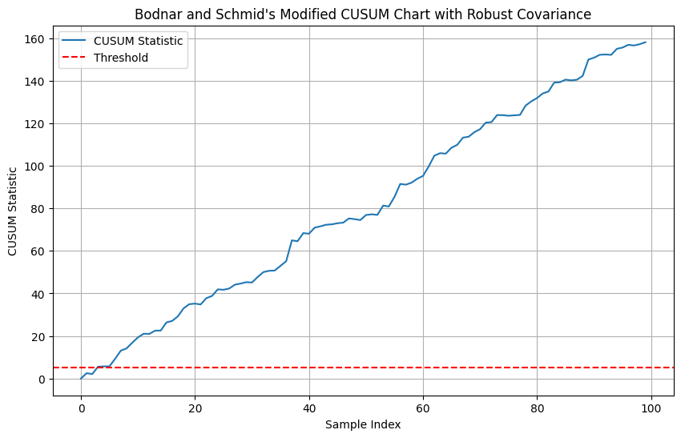

Let's break down these concepts to better understand how the modified CUSUM charts for multivariate time series by Bodnar and Schmid work, focusing on the key aspects of residuals, robust Mahalanobis distance, and robust covariance.

### MEWMA Type charts

The "MEWMA-type charts" section of the paper "A review of dispersion control charts for multivariate individual observations" provides an in-depth discussion of Multivariate Exponentially Weighted Moving Average (MEWMA) control charts designed for individual observations. Here’s a detailed breakdown of what the paper covers regarding MEWMA-type charts, including their advantages, limitations, and examples.

**Description of MEWMA-Type Charts**

MEWMA-type charts are designed to monitor the covariance matrix of multivariate processes by utilizing exponentially weighted averages of the data. These charts are particularly useful in scenarios where data are collected individually (as vectors) rather than in groups. The general appeal of MEWMA charts is their ability to effectively smooth out noise in the data, providing a clearer signal for detecting shifts in process variability.

**Categorization and Specific Charts**

The MEWMA-type charts are divided based on the statistical techniques and characteristics they employ:

**1. Charts Using Trace or Norm as Monitoring Statistics:** These charts use the trace or L-norms of the deviation from the in-control covariance matrix as their primary monitoring statistic. This approach helps in detecting changes in both the variance and the correlation structure of the process.

**2. Charts Based on Alt's Likelihood Ratio:** These utilize a likelihood ratio test to compare the estimated covariance matrix against the control covariance matrix, aiming to detect any significant deviations that might indicate out-of-control conditions.

**3. Charts Based on LASSO Techniques:** LASSO (Least Absolute Shrinkage and Selection Operator) techniques are employed to enhance the sparsity of the model, which is beneficial in high-dimensional settings where many variables may be irrelevant.

**Advantages**

- Sensitivity to Small Shifts: MEWMA charts are highly sensitive to small and moderate shifts in process variability, making them suitable for applications requiring early detection of changes.

- Robustness in High-Dimensional Data: Some MEWMA charts, especially those utilizing LASSO techniques, are effective in high-dimensional settings by focusing only on relevant variables.

- Flexibility: These charts can be tailored to monitor various aspects of process variability, including mean vectors and covariance matrices.

**Limitations**

- Complexity in Calculation: The calculation of MEWMA statistics can be computationally intensive, especially with large datasets and in real-time monitoring scenarios.

- Assumption of Normality: Many MEWMA charts assume that the data follow a multivariate normal distribution, which may not hold in practical applications, leading to reduced effectiveness.

- Parameter Sensitivity: The performance of MEWMA charts can be highly sensitive to the choice of smoothing parameters (lambda), which requires careful tuning based on specific process characteristics.

**Example Applications**

The paper mentions specific articles where MEWMA-type charts were applied:

- Huwang, Yeh, and Wu (2007) developed a MEWMA chart for monitoring shifts in the covariance matrix using the trace of the estimated covariance matrix, which was applied to data involving multiple quality characteristics in manufacturing.

- Memar and Niaki (2011) proposed a MEWMA chart that uses a sum of independent chi-squared variables to approximate the trace, demonstrating its application in a simulation study to monitor process variability more effectively.

**Future Research**

The paper suggests that future research could focus on developing MEWMA-type charts that are less dependent on the assumption of normality, enhance computational efficiency, and improve parameter selection methods to better adapt to diverse industrial applications.

This comprehensive review of MEWMA-type charts underscores their utility in statistical process monitoring while also highlighting the need for continuous improvement and adaptation to meet emerging challenges in quality engineering.

#### MEWMA Type charts: Charts Using Trace or Norm as Monitoring Statistics:

The category of "Charts Using Trace or Norm as Monitoring Statistics" within MEWMA-type charts, as detailed in the reviewed paper, involves techniques that primarily focus on monitoring the trace or norm (such as the L1-norm or L2-norm) of the deviation of the estimated covariance matrix from its in-control state. This approach is crucial for identifying shifts in process variability, particularly in multivariate processes where detecting changes in both variance and covariance is essential.

**Definition and Usage of Trace and Norm**

Trace of a matrix in this context refers to the sum of its diagonal elements and is used as a measure of the total variance in the process being monitored. Using the trace as a monitoring statistic provides a straightforward way to gauge overall changes in variability without distinguishing between individual variables.

Norms (like the L1 and L2 norms) measure the size or length of vector elements in a matrix. In MEWMA charts, norms are used to provide a more detailed view of the dispersion and to capture shifts not just in overall variance but in the structure of the covariance matrix.

**Specific Charts and Techniques**

The paper highlights several specific approaches within this category:

1. MaxMEWMV Chart:

- Developed by Yeh, Huwang, and Chien-Wei, it is based on the deviation of the in-control covariance matrix from the estimated covariance matrix using both L2-norms of diagonal and off-diagonal elements.

- It is effective in detecting changes in variance and the correlation structure.

2. MEWMS and MEWMV Charts:

- Proposed by Huwang, Yeh, and Wu, these charts use the trace of the estimated covariance matrix obtained through MEWMA statistics as the monitoring statistic.

- MEWMS is specifically designed for monitoring shifts in the covariance matrix, whereas MEWMV can monitor both mean vectors and covariance matrices.

3. Enhanced MEWMS Charts Using L1 and L2 Norms:

- Memar and Niaki improved the original MEWMS charts by applying L1 and L2 norms to the diagonal elements of the deviation matrix. This enhancement makes the charts quicker in detecting shifts, especially when only the correlation structure changes.

**Advantages**

- Simplicity: Trace and norm statistics are relatively simple to calculate and interpret, making these charts easy to implement and use in practical settings.

- Comprehensiveness: By focusing on overall variance and specific changes in covariance structure, these charts offer a comprehensive monitoring tool suitable for complex multivariate processes.

**Limitations**

- Sensitivity to Parameter Selection: The effectiveness of these charts can depend heavily on the selection of the smoothing parameter (lambda), which influences the responsiveness of the chart to process changes.

- Potential for Oversmoothing: Especially in dynamic processes, using trace or norms can sometimes lead to oversmoothing, where minor but significant shifts might be overlooked if the smoothing parameter is not optimally set.

**Example Application**

The paper discusses an example application where MEWMA-type charts with trace statistics were used to monitor the process variability in a manufacturing setting involving multiple correlated quality characteristics. This application highlighted the ability of these charts to quickly identify undesirable changes in the process, allowing for timely interventions.

**Conclusion**

The use of trace and norm statistics in MEWMA-type charts provides a robust framework for monitoring multivariate processes, especially in industrial and manufacturing contexts where maintaining strict control over process variability is critical. Future enhancements could focus on optimizing parameter selection and developing adaptive mechanisms to handle dynamic changes in process characteristics more effectively.

**1. Charts Using Trace or Norm as Monitoring: MaxMEWMV Chart:**

Here is a step-by-step breakdown of how we can implement this in Python:

1. Initialize parameters: Set the control limits, smoothing constant and sample data.

2. Compute the EWMC: Update the covariance matrix for each new observation using the EWMC formula.

3. Calculate deviation matrix: Compute the matrix of deviations by subtracting the identity matrix from the EWMC.

4. Compute L2-norms:

- L2-norm of the diagonal elements (variances).

- L2-norm of the off-diagonal elements (covariances).

5. Monitoring statistic: Determine the maximum of the normalized .

6. Generate plots: Visualize the statistics over time against the control limits.

Code:

1. import numpy as np

2. import matplotlib.pyplot as plt

3.

4. # Initialize parameters

5. np.random.seed(0)

6. n\_samples = 100

7. n\_features = 3

8. lambda\_ = 0.1 # Smoothing parameter

9. control\_limit = 3.0 # Example control limit, typically set from historical data

10.

11. # Simulate data (multivariate normal with a slight shift midway)

12. mean\_1 = np.zeros(n\_features)

13. mean\_2 = np.zeros(n\_features) + 0.2 # Small shift in process

14. cov = np.eye(n\_features) # Identity covariance matrix

15. data = np.vstack([np.random.multivariate\_normal(mean\_1, cov, n\_samples//2),

16. np.random.multivariate\_normal(mean\_2, cov, n\_samples//2)])

17.

18. # Initialize the EWMC matrix

19. sewma = np.eye(n\_features)

20.

21. # Lists to store metrics

22. d1\_values = []

23. d2\_values = []

24. max\_values = []

25.

26. for x in data:

27. xi = x.reshape(-1, 1)

28. sewma = lambda\_ \* np.dot(xi, xi.T) + (1 - lambda\_) \* sewma

29. deviation = sewma - np.eye(n\_features)

30.

31. # Calculate L2 norms

32. d1 = np.linalg.norm(np.diag(deviation)) # Norm of diagonal elements

33. d2 = np.linalg.norm(deviation - np.diag(np.diag(deviation))) # Norm of off-diagonal elements

34.

35. # Normalize (assuming control limits or thresholds are known or estimated)

36. d1\_values.append(d1)

37. d2\_values.append(d2)

38. max\_values.append(max(d1, d2))

39.

40. # Plotting

41. plt.figure(figsize=(10, 6))

42. plt.plot(max\_values, label='MaxMEWMV Statistic')

43. plt.axhline(y=control\_limit, color='r', linestyle='--', label='Control Limit')

44. plt.title('MaxMEWMV Chart')

45. plt.xlabel('Sample')

46. plt.ylabel('MaxMEWMV Value')

47. plt.legend()

48. plt.grid(True)

49. plt.show()

#Explanation:

1. Data Simulation: This code simulates a dataset where the mean shifts slightly after half of the samples. This is common in process shift scenarios.

2. EWMC Calculation: The EWMC is updated with each new observation.

3. Plot: The chart will show the MaxMEWMV statistic over time. A control line is drawn, and you would look for points where the MaxMEWMV statistic crosses this line to signal potential out-of-control conditions.

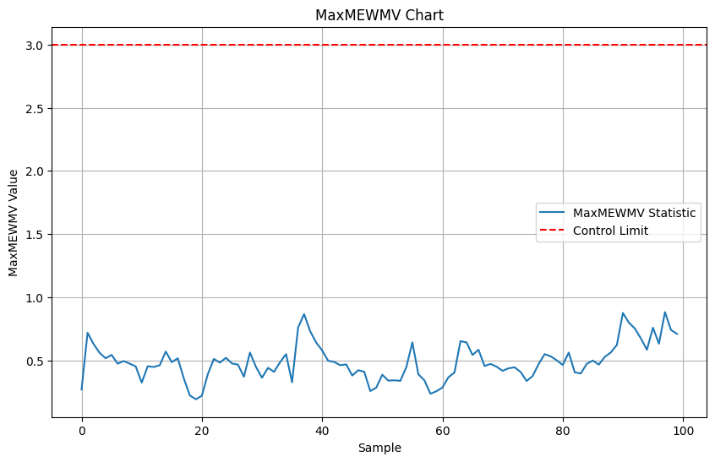

**2- Charts Using Trace or Norm as Monitoring: MEWMS and MEWMV Charts**

**Python implementation of the MEWMS and MEWMV Charts**

#Step 1: Setup and Generate Synthetic Data

We'll generate data for two scenarios:

- In-control: Where data follows a multivariate normal distribution with a specified mean and covariance.

- Out-of-control: After a certain point, the covariance changes.

#Step 2: Implement the MEWMS and MEWMV Charts

- MEWMS: Will monitor the trace of the covariance matrix.

- MEWMV: Will also monitor changes but takes into account both the mean vector and the covariance matrix.

#Step 3: Plotting

Code:

1. import numpy as np

2. import matplotlib.pyplot as plt

3.

4. # Function to generate multivariate data

5. def generate\_data(n, mean, cov, shift\_point, new\_cov):

6. data = np.random.multivariate\_normal(mean, cov, size=shift\_point)

7. data = np.vstack([data, np.random.multivariate\_normal(mean, new\_cov, size=n - shift\_point)])

8. return data

9.

10. # Parameters

11. n = 100 # Number of observations

12. mean = [0, 0] # Mean vector for both in-control and out-of-control

13. cov\_in\_control = np.array([[1, 0.5], [0.5, 1]]) # Covariance matrix for in-control

14. cov\_out\_of\_control = np.array([[2, -0.8], [-0.8, 2]]) # Covariance matrix for out-of-control

15. shift\_point = 50 # Point at which the shift occurs

16.

17. # Generate data

18. data = generate\_data(n, mean, cov\_in\_control, shift\_point, cov\_out\_of\_control)

19.

20. # Calculate MEWMS and MEWMV statistics

21. def compute\_mewms\_mewmv(data, lambda\_value):

22. mewms\_stats = []

23. mewmv\_stats = []

24. s = np.cov(data, rowvar=False) # Initial covariance estimate

25. for i in range(1, len(data)):

26. xi = data[i].reshape(-1, 1)

27. x\_prev = data[i-1].reshape(-1, 1)

28. s = lambda\_value \* s + (1 - lambda\_value) \* np.dot(xi, xi.T) # Update rule for covariance

29. mewms\_stats.append(np.trace(s)) # Trace of covariance matrix

30. mewmv\_stats.append(np.linalg.norm(s, 'fro')) # Frobenius norm for MEWMV (alternative choice)

31. return mewms\_stats, mewmv\_stats

32.

33. # Using a smoothing parameter

34. lambda\_value = 0.1

35. mewms\_stats, mewmv\_stats = compute\_mewms\_mewmv(data, lambda\_value)

36.

37. # Plot the results

38. plt.figure(figsize=(12, 6))

39. plt.plot(mewms\_stats, label='MEWMS (Trace of Covariance)', color='blue')

40. plt.plot(mewmv\_stats, label='MEWMV (Frobenius Norm of Covariance)', color='green')

41. plt.axvline(x=shift\_point, color='red', linestyle='--', label='Shift Point')

42. plt.xlabel('Observation Index')

43. plt.ylabel('Statistic Value')

44. plt.title('MEWMS and MEWMV Chart')

45. plt.legend()

46. plt.grid(True)

47. plt.show()

#Explanation:

- Data Generation: We simulate 100 observations, where the first 50 are in-control and the last 50 are out-of-control.

- MEWMS and MEWMV Calculation: Using a smoothing parameter (`lambda\_value`), we update our estimate of the covariance matrix for each new data point and compute the trace for MEWMS and the Frobenius norm for MEWMV as monitoring statistics.

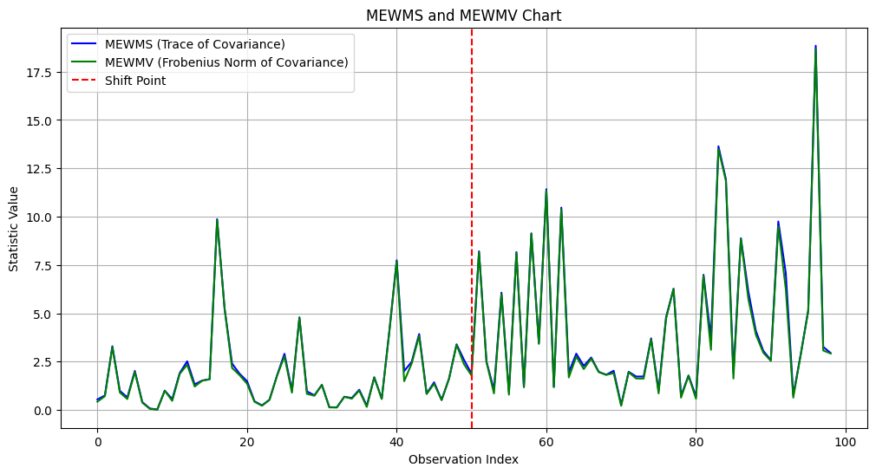

**3- Charts Using Trace or Norm as Monitoring: Enhanced MEWMS Charts Using L1 and L2 Norms**

To implement control limits in the Enhanced MEWMS Chart Using L1 and L2 Norms and determine when the process is out of control, we first need a baseline or in-control scenario from which to establish our control limits. The typical approach is to use historical data where the process is known to be in control to calculate the mean and standard deviation of the norms. These statistics are then used to set control limits, often based on a desired false alarm rate (like a 3-sigma rule in a control chart).

Here's how you might adjust the Python code to include calculation of control limits and determine out-of-control conditions:

#Steps:

1. Compute Baseline Statistics: Using in-control historical data, calculate the mean and standard deviation for both L1 and L2 norms.

2. Set Control Limits: Typically, control limits are set at mean ± 3\*standard deviation (for approximately 99.73% coverage if the norm values are normally distributed).

3. Detect Out-of-Control Conditions: Compare each new norm value against the control limits during process monitoring.

a Python code to include these steps:

1. import numpy as np

2. import matplotlib.pyplot as plt

3.

4. # Function to generate multivariate normal data

5. def generate\_data(mean, cov, n\_samples=100):

6. return np.random.multivariate\_normal(mean, cov, n\_samples)

7.

8. # Function to calculate MEWMS with L1 and L2 norms

9. def mewms\_chart(data, lambda\_param=0.2, baseline\_data=None):

10. sample\_size, n\_features = data.shape

11. if baseline\_data is not None:

12. S = np.cov(baseline\_data, rowvar=False) # Initial covariance estimate from baseline data

13. else:

14. S = np.cov(data, rowvar=False) # Initial covariance estimate from current data

15. ewms\_trace\_L1 = []

16. ewms\_trace\_L2 = []

17.

18. EWMS = S # Start with the initial covariance matrix

19.

20. for i in range(sample\_size):

21. xi = data[i, :].reshape(-1, 1)

22. EWMS = lambda\_param \* np.outer(xi, xi) + (1 - lambda\_param) \* EWMS

23. deviation = EWMS - S

24. L1\_norm = np.sum(np.abs(deviation))

25. L2\_norm = np.linalg.norm(deviation, 'fro') # Frobenius norm

26.

27. ewms\_trace\_L1.append(L1\_norm)

28. ewms\_trace\_L2.append(L2\_norm)

29.

30. return ewms\_trace\_L1, ewms\_trace\_L2

31.

32. # Generating in-control data for baseline statistics

33. mean = [0, 0]

34. cov = [[1, 0.5], [0.5, 1]]

35. n\_samples = 100

36. baseline\_data = generate\_data(mean, cov, n\_samples)

37.

38. # Calculate the MEWMS traces for L1 and L2 norms on baseline data

39. baseline\_L1, baseline\_L2 = mewms\_chart(baseline\_data)

40.

41. # Control limits based on baseline data

42. L1\_mean, L1\_std = np.mean(baseline\_L1), np.std(baseline\_L1)

43. L2\_mean, L2\_std = np.mean(baseline\_L2), np.std(baseline\_L2)

44. L1\_upper = L1\_mean + 3 \* L1\_std

45. L2\_upper = L2\_mean + 3 \* L2\_std

46.

47. # Generating new data to monitor

48. new\_data = generate\_data(mean, cov, n\_samples)

49. new\_L1, new\_L2 = mewms\_chart(new\_data, baseline\_data=baseline\_data)

50.

51. # Plotting the results

52. plt.figure(figsize=(12, 6))

53. plt.plot(new\_L1, label='MEWMS L1 Norm', color='blue')

54. plt.axhline(y=L1\_upper, color='r', linestyle='--', label='L1 Control Limit')

55. plt.plot(new\_L2, label='MEWMS L2 Norm', color='green')

56. plt.axhline(y=L2\_upper, color='orange', linestyle='--', label='L2 Control Limit')

57. plt.title('Enhanced MEWMS Charts Using L1 and L2 Norms with Control Limits')

58. plt.xlabel('Sample Index')

59. plt.ylabel('Norm Value')

60. plt.legend()

61. plt.grid(True)

62. plt.show()

63.

64. # Detecting out-of-control points

65. out\_of\_control\_L1 = [i for i, x in enumerate(new\_L1) if x > L1\_upper]

66. out\_of\_control\_L2 = [i for i, x in enumerate(new\_L2) if x > L2\_upper]

67.

68. print("Out of control points for L1 Norm:", out\_of\_control\_L1)

69. print("Out of control points for L2 Norm:", out\_of\_control\_L2)

#Explanation of the Modified Code:

- Baseline Data Calculation: We first generate and analyze a set of baseline data to establish our control limits.

- Control Limits: These are set based on the statistical properties (mean

and 3 times the standard deviation) of the baseline data.

- Monitoring and Plotting: We monitor new data, plotting both the L1 and L2 norm values along with their respective control limits.

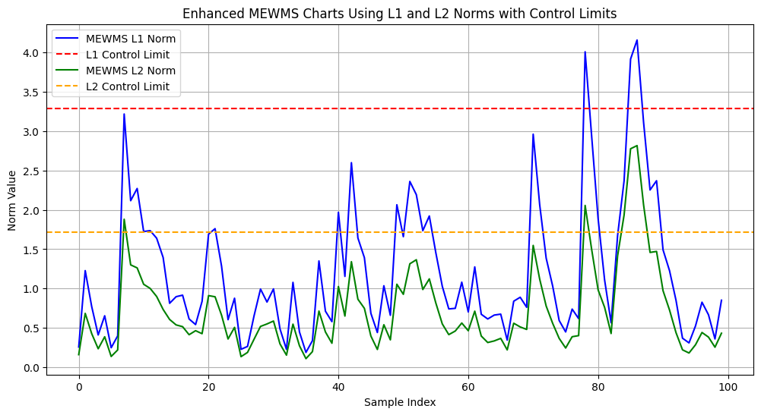

#### MEWMA Type charts: Charts Based on Alt's Likelihood Ratio:

The section on "Charts Based on Alt's Likelihood Ratio" within the MEWMA-type charts in the reviewed paper discusses a specific approach that applies Alt's likelihood ratio statistic to monitor the covariance matrix in multivariate processes. Here is a detailed exploration of this category, focusing on its methodologies, advantages, examples, and potential limitations as presented in the paper.

#Methodology

Alt's likelihood ratio statistic is used in MEWMA charts to compare the estimated covariance matrix with a target or in-control covariance matrix. The basic idea is to measure how likely it is that the observed data could have come from the in-control distribution. The statistic is calculated using the following formula:

where is the exponentially weighted moving average of the sample covariance matrices at time is the number of variables, and denote the trace and determinant of a matrix, respectively.

#Advantages

- Sensitivity to Variance Changes: This method is particularly sensitive to both increases and decreases in the process variability, making it versatile for different types of shifts in the covariance matrix.

- Comprehensive Detection: It provides a holistic measure of divergence from the control state, capturing changes in all elements of the covariance matrix rather than focusing on individual components.

#Examples

- MEWMC Chart (Hawkins and Maboudou-Tchao, 2008): This chart utilizes the Alt's likelihood ratio to monitor changes in the covariance matrix. It has been shown to effectively detect shifts in both the magnitude and structure of the process variability.

- ELR Chart (Zhang, Li, and Wang, 2010): Integrates EWMA with the generalized likelihood ratio statistic, offering the capability to detect shifts in both the process mean vector and covariance matrix simultaneously.

#Limitations

- Assumption Dependency: Like many statistical process control methods, the effectiveness of this approach depends heavily on the assumption that the data follow a multivariate normal distribution. Deviations from this assumption can lead to misleading results.

- Parameter Sensitivity: The performance of these charts can be quite sensitive to the choice of the smoothing parameter used in the EWMA calculation. Incorrect settings can lead to either over-detection or under-detection of shifts.

- Computational Complexity: Calculating the determinant and inverse of matrices as part of the likelihood ratio can be computationally intensive, especially as the number of monitored variables increases.

#Specific Challenges and Solutions

The paper mentions that while MEWMA charts based on Alt's likelihood ratio are effective for monitoring, they require careful handling of their parameters and assumptions. One solution to mitigate some of these challenges is to combine these charts with other types of control charts, such as MEWMA for location, to provide a more comprehensive monitoring system that can detect both mean shifts and variability changes.

#Future Enhancements

Further research could explore modifications to the Alt's likelihood ratio statistic that might reduce its sensitivity to deviations from normality, possibly incorporating robust estimation techniques or alternative distributional assumptions. Another area of improvement could be the development of adaptive techniques that adjust the smoothing parameters based on real-time data characteristics to optimize the chart's performance.

This detailed examination highlights how MEWMA-type charts based on Alt's likelihood ratio provide a powerful tool for monitoring multivariate processes, while also pointing to areas where further advancements could enhance their practical application.

#### MEWMA Type charts: Hawkins and Maboudou-Tchao, 2008

The Multivariate Exponentially Weighted Moving Covariance Matrix (MEWMC) chart, introduced by Hawkins and Maboudou-Tchao in 2008, is designed to monitor the stability of the covariance matrix of multivariate processes. This method extends the concept of the Exponentially Weighted Moving Average (EWMA) to the covariance structure of the process, providing a means to detect shifts in both the magnitude and the relationship among multiple quality characteristics.

Concept Behind the MEWMC Chart

The MEWMC chart uses an EWMA approach to continually update an estimate of the covariance matrix, providing a smoothed estimate that is sensitive to shifts from the process's in-control covariance matrix. It is particularly effective at detecting smaller, more subtle shifts in process variability that might not be detected by more traditional control charts that rely on independent or grouped samples.

Detailed Steps for Calculating the MEWMC Chart

Here are the steps involved in calculating the MEWMC statistics for a set of multivariate data:

1. Data and Parameters Initialization:

- Let -dimensional observation vector at time

- Choose a smoothing parameter , usually between 0.05 and 0.2. This parameter controls how much weight recent data points have relative to the historical data in the EWMA.

2. Initial Covariance Matrix:

- Calculate an initial estimate of the covariance matrix, , from a Phase I dataset that is assumed to represent the process in control. This could be the sample covariance matrix calculated from historical data.

3. Calculate EWMA of the Covariance Matrix:

- For each new observation update the EWMA covariance matrix using the formula:

- is the overall or running mean of the observations, which could also be updated via an EWMA scheme if desired, but often it is fixed from Phase I data.

4. Compute the MEWMC Statistic:

- The MEWMC statistic at each time is calculated by applying a likelihood ratio statistic on the updated covariance matrix:

- This formula captures the divergence of the current EWMA covariance matrix from the baseline taking into account the size (determinant) and shape (trace of the inverse product) of the matrices.

5. Determine Control Limits:

- Control limits for the MEWMC chart can be determined through simulation based on the specified false alarm rate or desired Average Run Length (ARL) when the process is in control. These limits are typically set symmetrically around zero for the log likelihood ratio statistic.

6. Monitoring and Interpretation:

- Plot over time. An out-of-control signal is indicated if the MEWMC statistic crosses the upper or lower control limit.

- An MEWMC statistic greater than the upper control limit suggests an increase in variability or a shift in the covariance structure, while a statistic below the lower limit could indicate a decrease in variability.

Practical Considerations

- Sensitivity and Robustness: The MEWMC chart's sensitivity can be adjusted through the smoothing parameter . A lower makes the chart more sensitive to recent changes but can also make it more reactive to random noise.

- Multivariate Normality: The effectiveness of the MEWMC chart depends on the assumption that the data follow a multivariate normal distribution. Deviations from this assumption may affect the performance of the chart.

- Data Dependency: The initial estimateis crucial for the performance of the chart. It needs to be a good representative of the in-control process behavior.

The MEWMC chart is a powerful tool for modern quality control in multivariate settings, enabling the detection of changes in process variability that are not apparent from monitoring individual variables alone. This makes it especially useful in complex manufacturing environments where multiple interrelated quality characteristics are critical.

Code:

1. import numpy as np

2. import matplotlib.pyplot as plt

3.

4. # Parameters

5. np.random.seed(42)

6. n\_samples = 100

7. n\_shift = 70

8. p = 3 # Number of variables

9. k = 0.2 # Smoothing parameter for MEWMC

10.

11. # Initial in-control covariance matrix

12. R0 = np.array([[1, 0.3, 0.2],

13. [0.3, 1, 0.4],

14. [0.2, 0.4, 1]])

15.

16. # Shifted covariance matrix

17. R1 = np.array([[1.5, 0.45, 0.3],

18. [0.45, 1.5, 0.6],

19. [0.3, 0.6, 1.5]])

20.

21. # Generate multivariate normal data

22. data = np.random.multivariate\_normal([0, 0, 0], R0, n\_samples)

23. data[n\_shift:] = np.random.multivariate\_normal([0, 0, 0], R1, n\_samples - n\_shift)

24.

25. # Function to calculate MEWMC statistic

26. def mewmc\_statistic(data, R0, k):

27. S\_EWMA = np.zeros\_like(R0)

28. c\_stats = []

29.

30. for i in range(data.shape[0]):

31. x = data[i, :].reshape(-1, 1)

32. S\_i = x @ x.T

33. S\_EWMA = (1 - k) \* S\_EWMA + k \* S\_i

34. det\_S\_EWMA = np.linalg.det(S\_EWMA)

35. # Regularization to avoid log of non-positive numbers

36. if det\_S\_EWMA <= 0:

37. det\_S\_EWMA = 1e-10

38. c\_i = np.trace(S\_EWMA) - np.log(det\_S\_EWMA) - p

39. c\_stats.append(c\_i)

40.

41. return np.array(c\_stats)

42.

43. # Calculate the MEWMC statistics

44. c\_stats = mewmc\_statistic(data, R0, k)

45.

46. # Control limits (approximated here for demonstration; should be determined based on in-control performance)

47. UCL = np.mean(c\_stats[:n\_shift]) + 3 \* np.std(c\_stats[:n\_shift])

48. LCL = np.mean(c\_stats[:n\_shift]) - 3 \* np.std(c\_stats[:n\_shift])

49.

50. # Plotting

51. plt.figure(figsize=(10, 6))

52. plt.plot(c\_stats, label='MEWMC Statistic', color='b')

53. plt.axhline(y=UCL, color='r', linestyle='--', label='UCL')

54. plt.axhline(y=LCL, color='g', linestyle='--', label='LCL')

55. plt.axvline(x=n\_shift, color='k', linestyle=':', label='Change Point')

56. plt.title('MEWMC Chart for Monitoring Covariance Matrix')

57. plt.xlabel('Sample')

58. plt.ylabel('MEWMC Statistic')

59. plt.legend()

60. plt.grid(True)

61. plt.show()

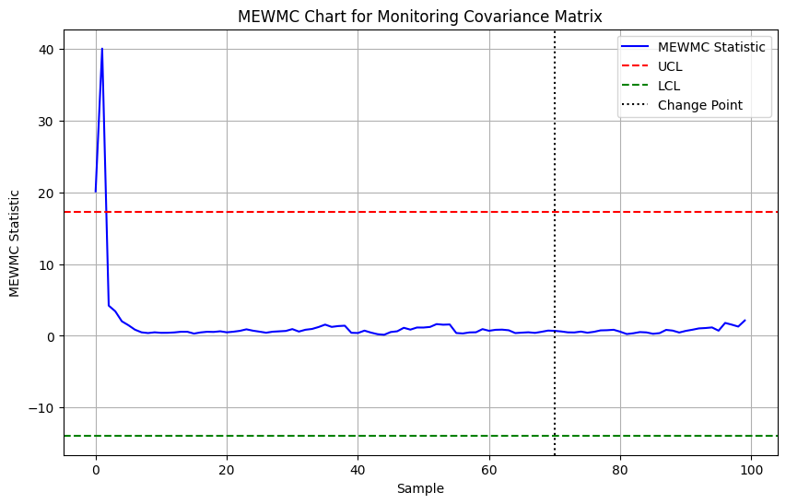

- ELR Chart (Zhang, Li, and Wang, 2010):

The ELR (Exponentially Weighted Moving Average with Generalized Likelihood Ratio) Chart developed by Zhang, Li, and Wang (2010) is designed to monitor both the process mean and covariance matrix changes in multivariate processes. Here, I'll provide a Python implementation of the ELR chart, focusing on synthetic data generation to illustrate the method, calculation of the control limits, and plotting the results.

#Python Implementation

1. import numpy as np

2. import matplotlib.pyplot as plt

3.

4. def generate\_data(n, p, shift\_point, mean\_shift, cov\_shift):

5. """ Generate multivariate data with a shift in mean and covariance matrix. """

6. np.random.seed(0)

7. # Initial multivariate normal data

8. data\_before\_shift = np.random.multivariate\_normal(np.zeros(p), np.eye(p), size=shift\_point)

9. # Data after the shift

10. mean\_after\_shift = np.zeros(p) + mean\_shift

11. cov\_after\_shift = np.eye(p) \* cov\_shift

12. data\_after\_shift = np.random.multivariate\_normal(mean\_after\_shift, cov\_after\_shift, size=n - shift\_point)

13. return np.vstack((data\_before\_shift, data\_after\_shift))

14.

15. # Simulation parameters

16. n = 100 # Total number of observations

17. p = 3 # Number of variables

18. shift\_point = 50

19. mean\_shift = 0.5

20. cov\_shift = 1.5

21.

22. # Generate data

23. data = generate\_data(n, p, shift\_point, mean\_shift, cov\_shift)

24.

25.

26. #Calculation of the ELR Statistics

27. Next, we will compute the ELR statistics using the EWMA formula for the covariance matrix and the generalized likelihood ratio statistic.

28.

29.

30. def elr\_statistic(data, lambda\_ewma=0.2):

31. """ Compute the ELR statistics for monitoring mean vector and covariance matrix. """

32. n, p = data.shape

33. S = np.cov(data, rowvar=False)

34. S\_ewma = np.zeros\_like(S)

35. elr\_stats = []

36.

37. for i in range(n):

38. x = data[i, :].reshape(p, 1)

39. if i == 0:

40. S\_ewma = S.copy()

41. else:

42. S\_ewma = lambda\_ewma \* np.dot(x, x.T) + (1 - lambda\_ewma) \* S\_ewma

43.

44. # Compute the generalized likelihood ratio statistic

45. det\_ratio = np.linalg.slogdet(S\_ewma)[1] - np.linalg.slogdet(S)[1]

46. trace\_part = np.trace(np.dot(np.linalg.inv(S), S\_ewma)) - p

47. elr\_stat = det\_ratio + trace\_part

48. elr\_stats.append(elr\_stat)

49.

50. return elr\_stats

51.

52. # Compute ELR statistics

53. lambda\_ewma = 0.2

54. elr\_stats = elr\_statistic(data, lambda\_ewma)

55.

56.

57. #Plotting the ELR Chart

58. Lastly, we'll plot the ELR statistics over time and mark the control limits. The control limits can be set based on historical performance or through simulation.

59.

60.

61. def plot\_elr\_stats(elr\_stats, shift\_point, control\_limit=5):

62. """ Plot the ELR statistics with control limits. """

63. plt.figure(figsize=(10, 6))

64. plt.plot(elr\_stats, marker='o', linestyle='-', color='b', label='ELR Statistic')

65. plt.axhline(y=control\_limit, color='r', linestyle='--', label='Upper Control Limit')

66. plt.axhline(y=-control\_limit, color='r', linestyle='--', label='Lower Control Limit')

67. plt.axvline(x=shift\_point, color='g', linestyle='--', label='Shift Point')

68. plt.xlabel('Sample')

69. plt.ylabel('ELR Statistic')

70. plt.title('ELR Chart')

71. plt.legend()

72. plt.grid(True)

73. plt.show()

74.

75. # Plot ELR statistics

76. plot\_elr\_stats(elr\_stats, shift\_point, control\_limit=5)

77.

This code will generate a plot of the ELR statistics for the synthetic data, with a shift introduced at the specified point. The control limits are arbitrary in this example and should be determined based on the specific requirements of the process being monitored or through statistical analysis of the chart's performance under in-control conditions.

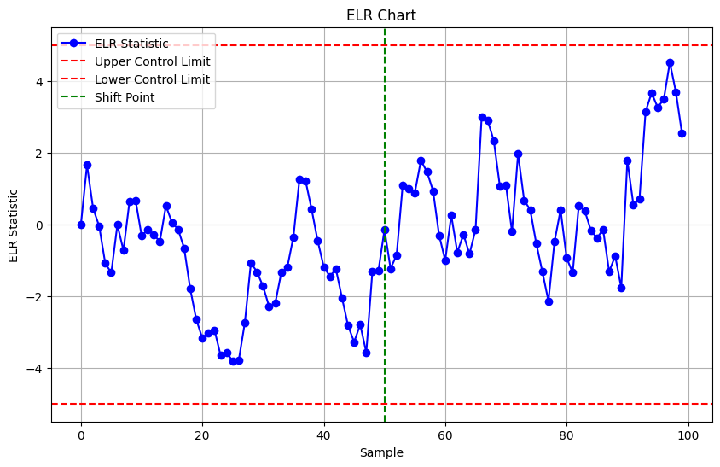

#### MEWMA Type charts: Charts Based on LASSO Techniques:

### Shewhart-Type Dispersion Charts

The Shewhart-type dispersion charts are particularly noted for their simplicity and effectiveness in detecting significant shifts in process variability. Here are more details about the reviewed Shewhart-type dispersion charts:

1. Wilks' Statistic-Based Charts:

- W Chart: Uses Wilks' statistic, which is the ratio of the determinants of two scatter matrices (SSm and SSm+1). It detects shifts in the covariance matrix by comparing the variance before and after adding a new observation.

- Decomposed W Chart: Proposed to diagnose the cause of an out-of-control signal by identifying the process variables contributing to the signal.

- F Chart: Complements the W chart and is sensitive to detecting variance changes.

2. Trace-Based Charts:

- LASSO Chart: Uses the trace combined with the log determinant of the estimated covariance matrix. It is shown to perform well in detecting variance shifts and can be adapted for grouped data.

- MTSSD (Multivariate Trace Sum of Squared Deviation) Chart: Uses the trace of the covariance estimator to represent the total variance of the variables. Effective for detecting small variance shifts.

- MMSSD (Multivariate Matrix Sum Squared Deviation) Chart: Monitors both total variation and correlation by summing all elements of the covariance estimator. Suitable for detecting shifts in correlation.

3. Chi-Squared Distribution-Based Charts:

- Khoo and Quah Chart: Monitors the differences between successive multivariate observations. Uses a chi-squared distribution to set control limits. However, it may not be reliable if there is serial correlation in the data.

Summary of Performance and Use Cases:

- Wilks' Statistic Charts: Particularly effective in scenarios where diagnosing the cause of a signal is important. They perform well in detecting shifts in both variance and correlation.

- Trace-Based Charts: Focus on total variance and can simultaneously monitor both variance and correlation. They provide robust detection capabilities for small shifts and are effective for grouped data.

- Chi-Squared Distribution-Based Charts: Useful for monitoring sequential changes but require caution if data are autocorrelated.

Recommendations for Future Research:

- Simultaneous Monitoring: Modify Shewhart-type charts to monitor both location and scale parameters.

- Correct Control Limits: Develop more reliable methods to decide correct control limits, especially under skewed distributions.

- Dealing with Decreases in Variance: Enhance methods to effectively detect decreases in process variances.

- Transient Shifts: Design charts specifically for monitoring transient shifts.

- Steady-State Performance: Evaluate and improve steady-state performance of Shewhart-type charts.

- Robustness: Investigate robustness to outliers and non-normalities.

- Parameter Estimation Effects: Study the effects of parameter estimation on chart performance.

These Shewhart-type charts are essential tools in statistical process control, providing clear and actionable insights into process variability and helping maintain high-quality standards in production and other processes.

#### Wilks' Statistic-Based Charts: Mathematical Foundations with Examples

1. W Chart (Wilks' Statistic):

Mathematical Foundation:

Wilks' statistic is used to compare two scatter matrices. It is defined as the ratio of the determinants of two scatter matrices, one from a historical data set (SSm) and one from an augmented data set that includes both the historical data and the new observation (SSm+1).

The formula for Wilks' statistic is:

Where:

- is the scatter matrix of the historical data:

- is the scatter matrix of the augmented data set:

Example:

Suppose we have a historical dataset with observations: with a mean vector Now, we receive a new observation .

1. Compute the scatter matrix for the historical data

2. Compute the scatter matrix for the augmented data :

3. Calculate Wilks' statistic :

If \(W\) is significantly different from 1, it indicates a change in the covariance structure of the process.

2. Decomposed W Chart:

Mathematical Foundation:

The decomposed W chart extends Wilks' statistic to identify which variables contribute most to an out-of-control signal by decomposing the scatter matrices into contributions from individual variables.

Example:

Using the same dataset as before, decompose and to understand the contributions from each variable.

1. Calculate Wilks' statistic for each variable or a subset of variables.

2. Analyze the contributions to the overall Wilks' statistic:

where and are the scatter matrices considering only the -th variable.

By identifying which \(W\_i\) values are significantly different from 1, we can pinpoint the variables responsible for the shift.

3. F Chart:

Mathematical Foundation:

The F chart complements the W chart by using the ratio of scatter matrices to form an F-statistic, which is particularly sensitive to variance changes.

Example:

Again, using the same dataset:

1. Compute the trace of the scatter matrices:

2. Calculate the difference in trace values:

3. Compute the F-statistic:

If the F-statistic exceeds a critical value from the F-distribution, it signals a significant change in the process variance.

Application Example:

Consider a process with three variables (dimensions), and you have the following historical observations:

The new observation is:

1. Calculate the mean vectors .

2. Compute scatter matrices .

3. Determine Wilks' statistic .

4. Decompose if needed to find contributing variables.

5. Calculate the F-statistic to detect variance changes.

By following these steps, you can effectively monitor the process using Wilks' Statistic-Based Charts, identifying any significant changes in the process covariance structure and pinpointing the variables responsible for such changes.

#### Wilks' Statistic-Based Charts → W Chart example.

Step-by-Step Example

Historical Data (Phase I):

Consider a process with two variables. The historical data consists of three observations:



New Observation (Phase II):

The new observation is:

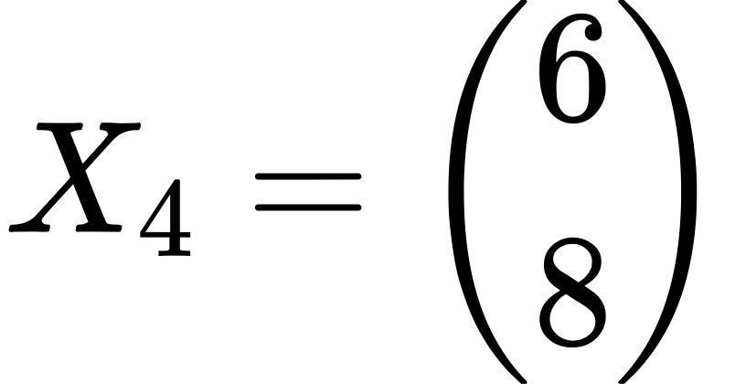

Step 1: Calculate the Mean Vectors

Mean vector for historical data (\(\bar{X}\_m\)):



Mean vector for augmented data :



Step 2: Compute Scatter Matrices

Scatter matrix for historical data :

Calculate deviations from the mean and then form the scatter matrix:

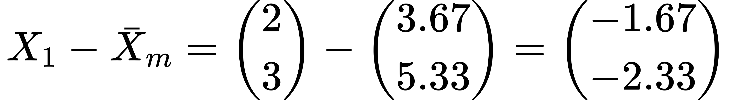

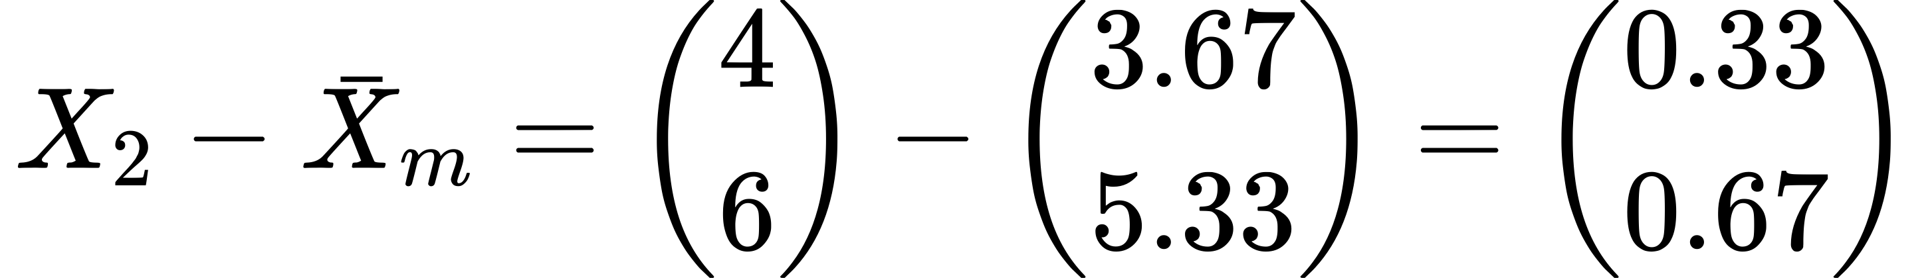

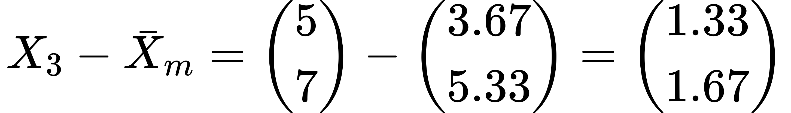

Now compute





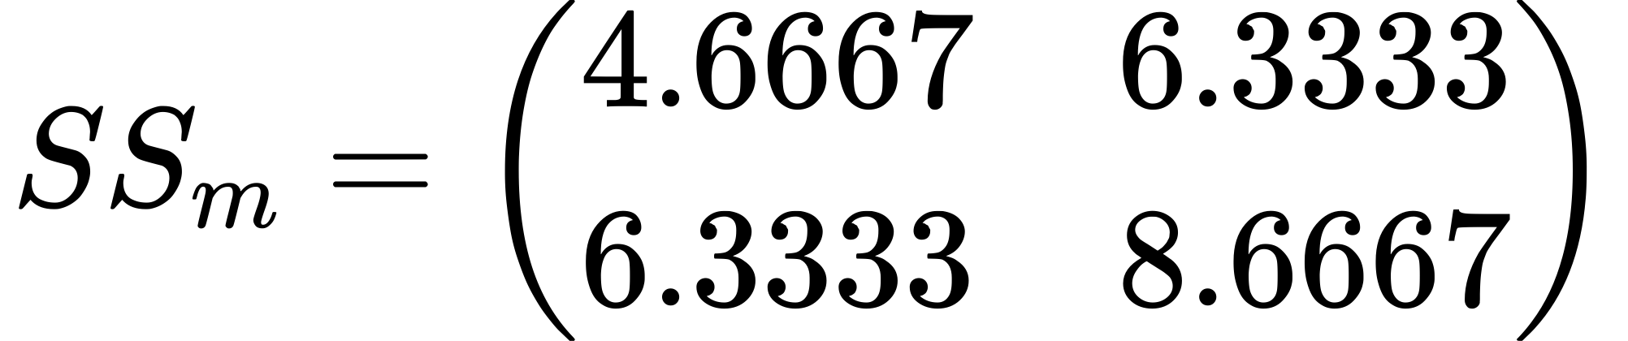

Scatter matrix for augmented data :

Calculate deviations from the new mean and then form the scatter matrix:

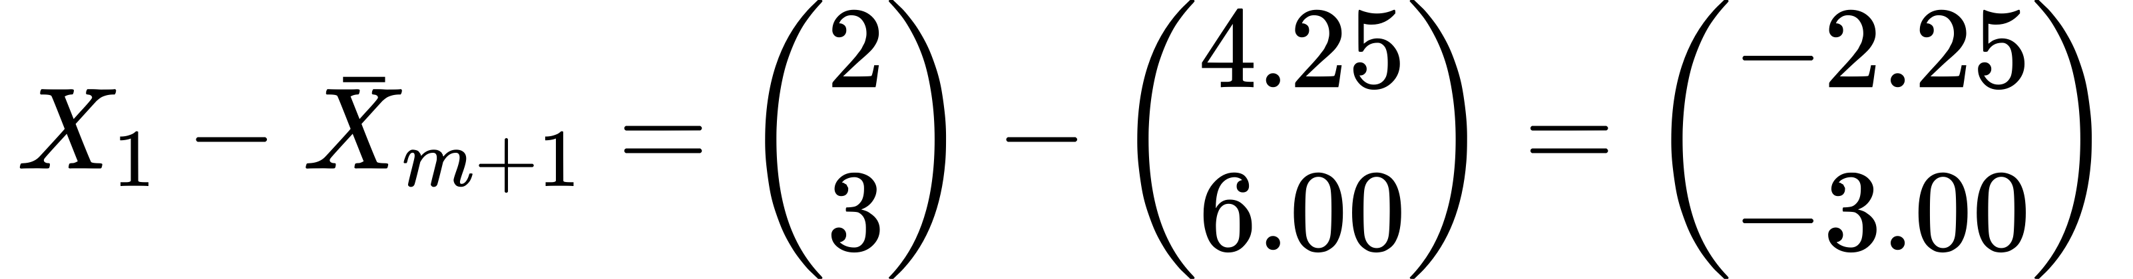

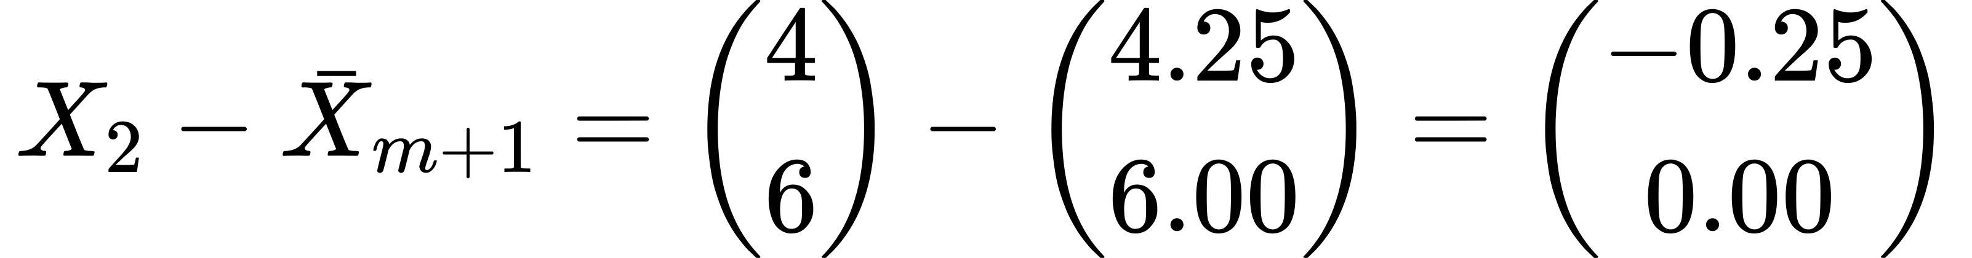

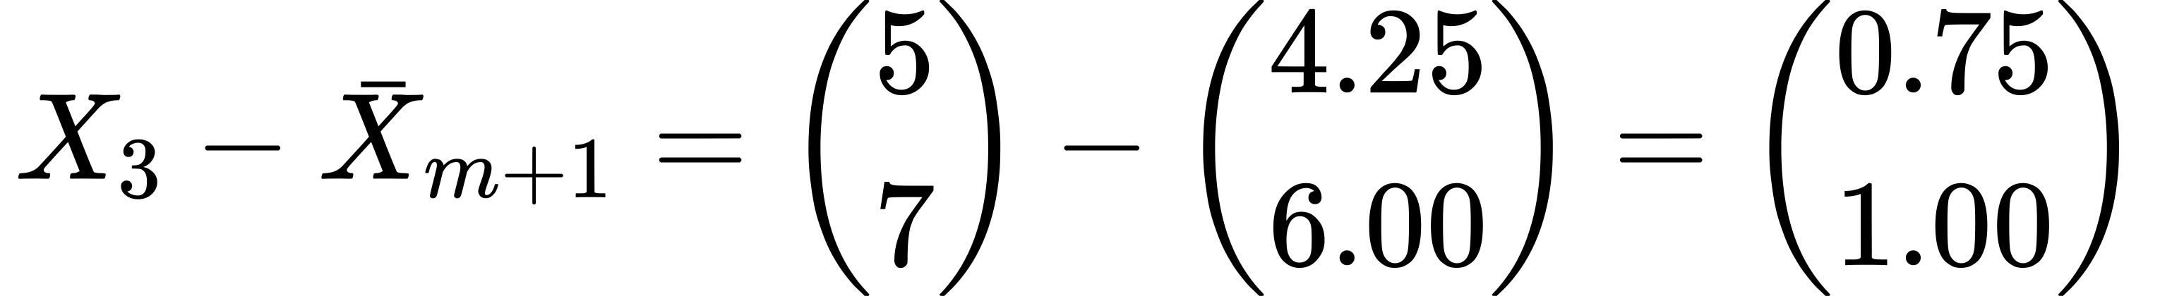

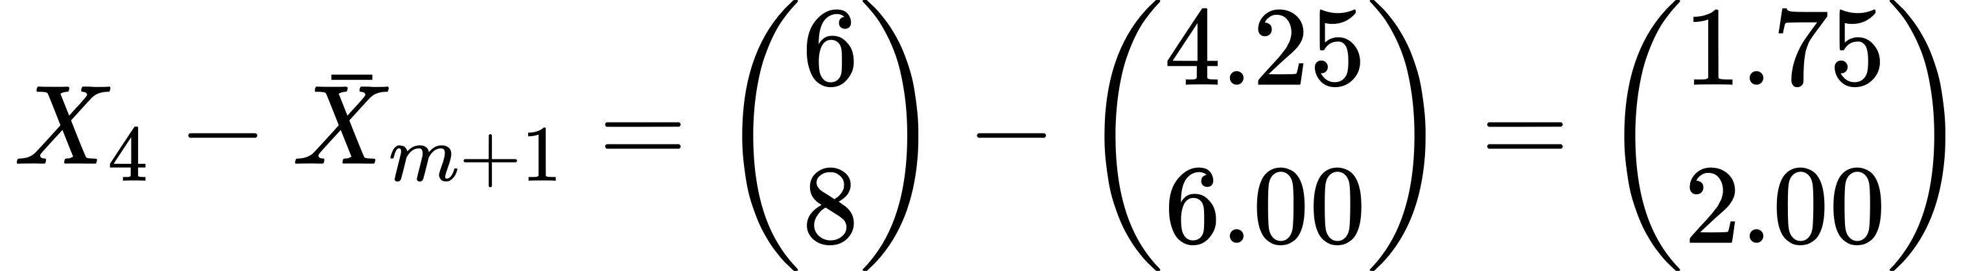

Now compute \(SS\_{m+1}\):





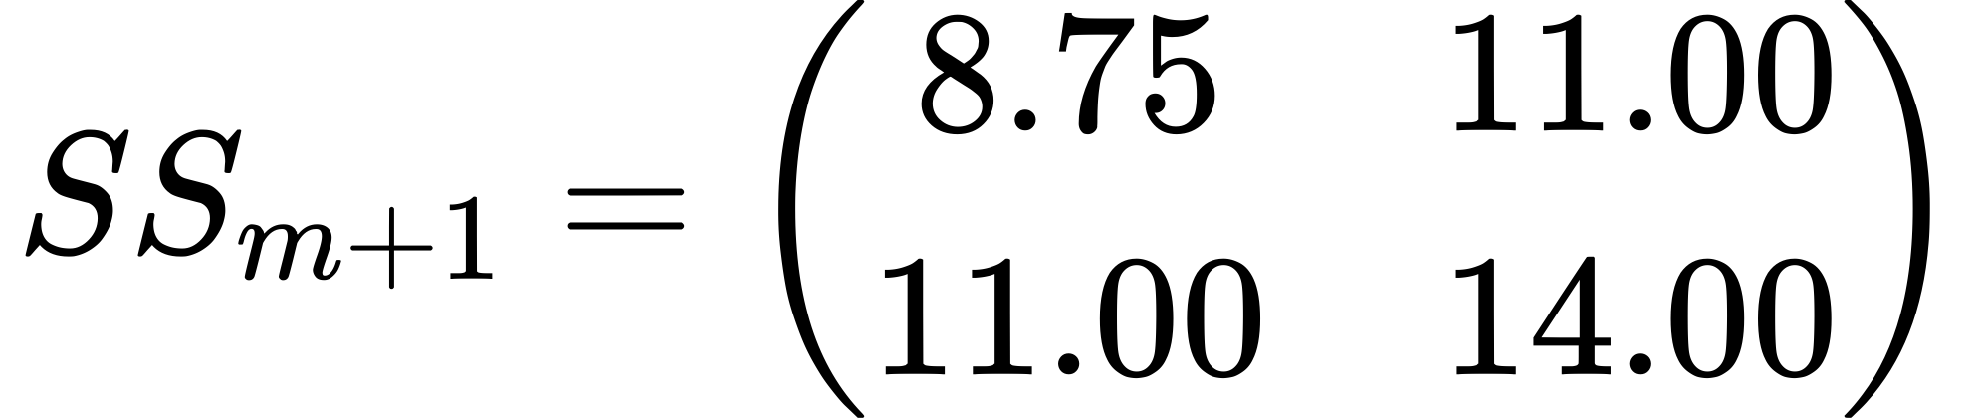

Step 3: Calculate Wilks' Statistic

Calculate determinants:

Interpretation

If the calculated Wilks' statistic is significantly different from 1, it indicates a change in the covariance structure of the process. In this case, , which is much

Python Code example

import numpy as np

import scipy.stats as stats

import matplotlib.pyplot as plt

def generate\_data(n, mean, cov, shift\_start, shift\_magnitude):

""" Generate multivariate normal data, with a shift introduced at shift\_start. """

data = np.random.multivariate\_normal(mean, cov, size=n)

if shift\_start is not None:

# Correct way to scale the covariance matrix

shifted\_cov = np.array(cov) \* shift\_magnitude

data[shift\_start:] = np.random.multivariate\_normal(mean, shifted\_cov, size=n-shift\_start)

return data

def calculate\_wilks\_statistic(X):

""" Calculate Wilks' statistic for detecting changes in covariance matrix. """

m = len(X) # number of observations

mean\_X = np.mean(X, axis=0)

SSm = np.cov(X, rowvar=False) \* (m - 1) # Scatter matrix

Sm = np.cov(X, rowvar=False) # Covariance matrix estimation

# Augment with a new observation for Phase II

X\_new = np.random.multivariate\_normal(mean\_X, Sm, size=1)

X\_augmented = np.vstack([X, X\_new])

SSm\_plus\_1 = np.cov(X\_augmented, rowvar=False) \* m # New scatter matrix

# Wilks' statistic calculation

wilks\_lambda = np.linalg.det(Sm) / np.linalg.det(SSm\_plus\_1)

return wilks\_lambda

# Parameters

mean = [0, 0]

cov = [[1, 0.5], [0.5, 1]]

n\_phase1 = 100

n\_phase2 = 50

shift\_start = 20

shift\_magnitude = 2 # Increase the covariance matrix by a factor

# Generate data

phase1\_data = generate\_data(n\_phase1, mean, cov, None, None)

phase2\_data = generate\_data(n\_phase2, mean, cov, shift\_start, shift\_magnitude)

# Monitoring using W Chart

wilks\_values = [calculate\_wilks\_statistic(phase1\_data[:i]) for i in range(10, len(phase1\_data))]

wilks\_values += [calculate\_wilks\_statistic(phase2\_data[:i]) for i in range(10, len(phase2\_data))]

# Plotting

plt.figure(figsize=(10, 5))

plt.plot(wilks\_values, marker='o', linestyle='-')

plt.axhline(y=0.5, color='r', linestyle='--') # Example control limit

plt.title('W Chart for Monitoring Production')

plt.xlabel('Sample Number')

plt.ylabel('Wilks\' Statistic')

plt.show()

Explanation:

**Data Generation**: generate\_data function creates multivariate normal data. For Phase II, after a specific observation (shift\_start), the covariance is scaled by shift\_magnitude to simulate a process shift.

**Wilks' Statistic**: calculate\_wilks\_statistic calculates the Wilks' statistic, which measures the change in determinant of the covariance matrix from Phase I to an augmented matrix with a new observation.

**Plotting**: This script plots the Wilks' statistic values across samples. A hypothetical control limit is set to demonstrate how you might detect changes.

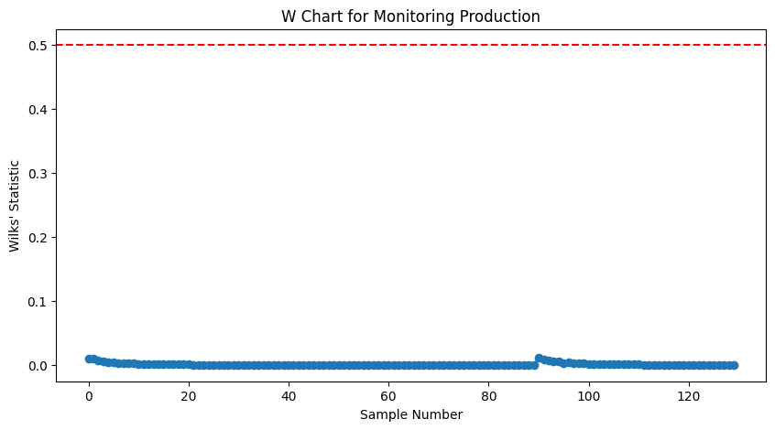

#### Wilks' Statistic-Based Charts → ****Decomposed W Chart****

Decomposed W Chart: Explanation and Numerical Example

The Decomposed W Chart extends Wilks' statistic by breaking down the contributions of individual variables to the overall statistic. This helps in identifying which specific variables are contributing to the out-of-control signal.

Mathematical Foundation

Wilks' statistic is given by:

where:

- is the scatter matrix for the historical data.

- is the scatter matrix for the augmented data (historical data plus the new observation).

In the Decomposed W Chart, we calculate the contribution of each variable by decomposing the scatter matrices into parts related to individual variables. This involves computing Wilks' statistic for each variable separately.

Example with Numbers

Let's use the same dataset as before:

Historical Data (Phase I):



New Observation (Phase II):

Step-by-Step Calculation

Step 1: Calculate the Mean Vectors

Mean vector for historical data (\(\bar{X}\_m\)):



Mean vector for augmented data :



Step 2: Compute Scatter Matrices

Scatter matrix for historical data :

Calculate deviations from the mean and then form the scatter matrix:







Now compute







Scatter matrix for augmented data :

Calculate deviations from the new mean and then form the scatter matrix:









Now compute :







Step 3: Decompose Wilks' Statistic

To decompose Wilks' statistic, we calculate the contribution of each variable:

Variable 1 Contribution:



Variable 2 Contribution:



Summary

The Decomposed W Chart shows that the contributions of the individual variables to Wilks' statistic are:

- Variable 1:

- Variable 2:

These values indicate that both variables contribute to the change in the covariance structure, with variable 2 having a slightly higher contribution.

This detailed numerical example demonstrates how to compute and interpret the Decomposed W Chart for monitoring changes in the covariance structure of a process.

Python Code Example

import numpy as np

import matplotlib.pyplot as plt

# Generate synthetic data for two variables in a production process

np.random.seed(42)

n\_phase1 = 50

n\_phase2 = 20

# Historical data (Phase I) - assume a bivariate normal distribution

mean\_phase1 = [10, 15]

cov\_phase1 = [[5, 2], [2, 3]]

data\_phase1 = np.random.multivariate\_normal(mean\_phase1, cov\_phase1, n\_phase1)

# New data (Phase II) - assume a shift in the covariance structure

mean\_phase2 = [10, 15]

cov\_phase2 = [[8, 3], [3, 4]]

data\_phase2 = np.random.multivariate\_normal(mean\_phase2, cov\_phase2, n\_phase2)

# Combine data

data = np.vstack((data\_phase1, data\_phase2))

# Function to calculate scatter matrix for a given variable

def scatter\_matrix\_variable(data, variable\_index):

mean\_vector = np.mean(data, axis=0)

deviations = data[:, variable\_index] - mean\_vector[variable\_index]

scatter = np.dot(deviations.T, deviations)

return scatter

# Calculate Decomposed Wilks' statistic for each new observation in Phase II

decomposed\_w\_statistics = {i: [] for i in range(data.shape[1])}

for i in range(n\_phase1, n\_phase1 + n\_phase2):

for variable\_index in range(data.shape[1]):

scatter\_phase1 = scatter\_matrix\_variable(data[:i], variable\_index)

scatter\_phase2 = scatter\_matrix\_variable(data[:i + 1], variable\_index)

wilks\_stat = scatter\_phase1 / scatter\_phase2

decomposed\_w\_statistics[variable\_index].append(wilks\_stat)

# Plotting the results

plt.figure(figsize=(12, 6))

for variable\_index in range(data.shape[1]):

plt.plot(range(n\_phase1, n\_phase1 + n\_phase2), decomposed\_w\_statistics[variable\_index], marker='o', linestyle='-', label=f'Variable {variable\_index + 1}')

plt.axhline(y=1, color='r', linestyle='--')

plt.xlabel('Observation Index')

plt.ylabel('Decomposed Wilks\' Statistic')

plt.title('Decomposed Wilks\' Statistic for Phase II Observations in Production Monitoring')

plt.legend()

plt.grid(True)

plt.show()

**Explanation:**

1. Data Generation:

- Historical data (Phase I) is generated from a bivariate normal distribution with a specified mean and covariance.

- New data (Phase II) is generated from a bivariate normal distribution with a different covariance structure to simulate a shift in the process.

2. Scatter Matrix Calculation:

- The function `scatter\_matrix\_variable` calculates the scatter matrix for a specified variable by computing the deviations from the mean and the dot product of these deviations.

3. Decomposed Wilks' Statistic Calculation:

- For each new observation in Phase II, the scatter matrices for the data up to that point and the augmented dataset (including the new observation) are calculated for each variable.

- The Wilks' statistic for each variable is then computed as the ratio of the scatter matrices.

4. Plotting:

- The decomposed Wilks' statistics for each variable are plotted against the observation index.

- A horizontal line at 1 is added to indicate the threshold.

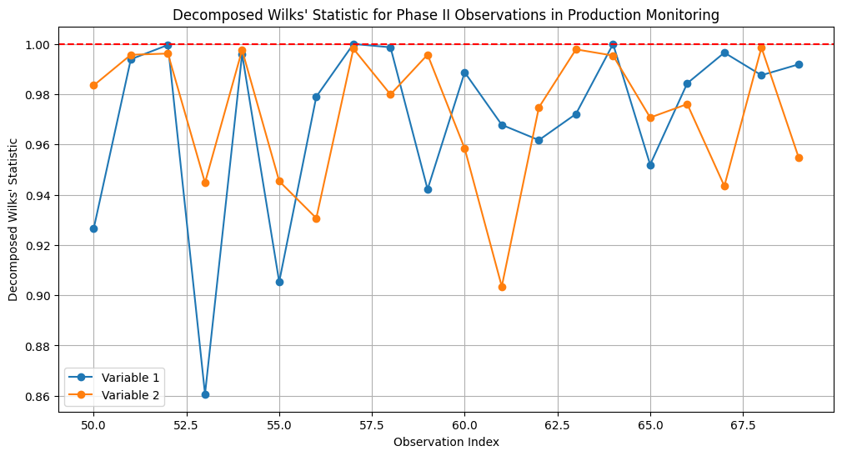

#### Wilks' Statistic-Based Charts → W vs. ****Decomposed W Chart****

The difference between W Charts and Decomposed W Charts lies in their approach to detecting changes in the covariance structure of a multivariate process.

W Charts

Mathematical Foundation:

Wilks' statistic is defined as the ratio of the determinants of the scatter matrices before and after including the new observation.

Where:

- is the scatter matrix for the historical data.

- is the scatter matrix for the augmented data (historical data plus the new observation).

Key Characteristics:

1. Overall Covariance Structure: The W Chart focuses on detecting changes in the overall covariance structure by considering the entire scatter matrix.

2. Generalized Variance: Wilks' statistic captures changes in generalized variance (product of eigenvalues), indicating changes in the overall spread and shape of the data distribution.

3. Single Statistic: It provides a single value that indicates whether there has been a significant change in the covariance structure.

Decomposed W Chart

Mathematical Foundation:

The Decomposed W Chart breaks down Wilks' statistic into contributions from individual variables, allowing for the identification of which specific variables are contributing to the overall change.

Where:

- is the scatter matrix for the variable in the historical data.

- is the scatter matrix for the variable in the augmented data.

Key Characteristics:

1. Individual Contributions: The Decomposed W Chart identifies the contributions of individual variables to the overall change in the covariance structure.

2. Variable-Specific Detection: It helps pinpoint which specific variables are responsible for the detected change, providing more detailed diagnostic information.

3. Multiple Statistics: It provides multiple values (one for each variable) that indicate the contribution of each variable to the change in the covariance structure.

Summary of Differences

- Focus:

- The W Chart focuses on the overall change in the covariance structure.

- The Decomposed W Chart focuses on the contributions of individual variables to the change in the covariance structure.

- Detection Capability:

- The W Chart is useful for detecting significant changes in the overall covariance structure.

- The Decomposed W Chart is useful for diagnosing which specific variables are contributing to the change.

- Interpretation:

- The W Chart provides a single statistic that indicates the overall change.

- The Decomposed W Chart provides multiple statistics, one for each variable, indicating their individual contributions.

Practical Example

Consider a process with two variables and the following historical data (Phase I) and new observation (Phase II):

Historical Data (Phase I):



New Observation (Phase II):



W Chart Calculation:

Scatter Matrices:



Wilks' Statistic:

Decomposed W Chart Calculation:

Variable 1 Contribution:



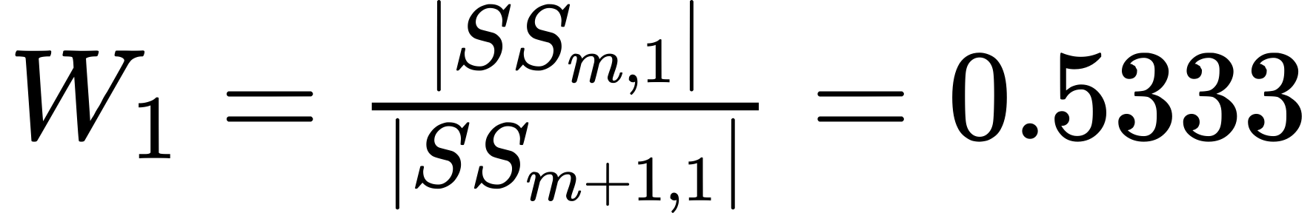

Variable 2 Contribution:



In this example, the W Chart provides an overall Wilks' statistic of 0.2222, indicating a significant change in the covariance structure. The Decomposed W Chart breaks this down into contributions from each variable, showing that variable 1 has a Wilks' statistic of 0.5333 and variable 2 has a Wilks' statistic of 0.6190, indicating that both variables contribute to the change, with variable 2 having a slightly higher contribution.

#### Wilks' Statistic-Based Charts → F Chart example.

The F chart, as proposed by Djauhari in the context of monitoring multivariate processes, is a type of control chart based on Wilks' Lambda (Λ) statistic. This chart uses a transformation of Wilks' statistic to leverage the F-distribution for the control limits. Here’s a detailed breakdown of how the F chart works and its application:

Concept of Wilks' Lambda (Λ)

Wilks' Lambda is a measure derived from the ratio of the determinants of two covariance matrices—one representing a baseline or in-control state (from Phase I data) and the other including new observations (from Phase II data). The statistic is calculated as:

Where:

- is the determinant of the covariance matrix based on m observations from Phase I.

- is the determinant of the covariance matrix after including an additional observation from Phase II.

Transformation to F Statistic

Wilks' Lambda is related to Hotelling’s T² statistic and can be transformed into an F-distribution for easier statistical interpretation and control limit setting. The transformation typically involves comparing the determinants of the matrices before and after the introduction of new data. Djauhari enhanced this by developing a specific formula that relates Wilks' Lambda to the F-distribution, improving its sensitivity to detect changes in variance or covariance structures.

Calculation of the F Statistic

The exact transformation from Wilks' Lambda to an F statistic depends on the number of variables (p) and the sample size (n). The general form can be expressed as:

Where:

- is the number of observations including the new one.

- is the number of variables.

This transformation takes advantage of the properties of the F-distribution to set control limits that are statistically robust, making the F chart particularly useful for small sample sizes.

Application and Benefits

- Sensitivity to Variance Changes: The F chart is sensitive to changes in the variances of the process variables, making it suitable for applications where early detection of such changes is crucial.

- Complement to W Chart: Djauhari suggests using the F chart in conjunction with the W chart. While the W chart is more responsive to changes in correlations among the variables, the F chart excels in detecting changes in variances.

- Utility in Multivariate Monitoring: This approach is particularly valuable in multivariate quality control where multiple related quality measures are monitored simultaneously. It helps in maintaining the overall quality of complex processes where multivariate interactions are significant.

Implementation

Implementing an F chart involves calculating Wilks' Lambda for each new observation added to the dataset, transforming it into an F statistic, and then comparing this statistic against predetermined control limits derived from the F-distribution. This method provides a systematic way to monitor and control process stability and variability in a multivariate setting.

In summary, the F chart offers a robust tool for quality control in multivariate processes, enhancing the detection of changes in process variability, particularly in small sample scenarios or where the underlying data interactions are complex.

**Example with numbers**

**To provide a numerical example for the F chart, we need to follow these steps:**

**1. Generate or define the historical data (Phase I).**

**2. Define the new observation (Phase II).**

**3. Calculate the scatter matrices for both datasets.**

**4. Compute the F-statistic.**

**Numerical Example**

**Historical Data (Phase I):**

**Consider a process with two variables and three observations:**



**New Observation (Phase II):**

**The new observation is:**



**Step-by-Step Calculation**

**Step 1: Calculate the Mean Vectors**

**Mean vector for historical data (\(\bar{X}\_m\)):**



**Mean vector for augmented data (\(\bar{X}\_{m+1}\)):**



**Step 2: Compute Scatter Matrices**

**Scatter matrix for historical data (\(SS\_m\)):**

**Calculate deviations from the mean and then form the scatter matrix:**







**Now compute :**







**Scatter matrix for augmented data :**

**Calculate deviations from the new mean and then form the scatter matrix:**









**Now compute :**







**Step 3: Calculate the F-Statistic**

**The F-statistic is calculated as:**

**Trace calculations:**

**Difference in trace values:**

**Difference between scatter matrices:**



**Trace of squared differences:**



**Calculate the F-statistic:**

**Interpretation**

**If the calculated F-statistic exceeds a critical value from the F-distribution, it signals a significant change in the process variance. In this example, , which should be compared against the critical value of the F-distribution for the specific degrees of freedom and significance level.**

**This detailed numerical example demonstrates the calculation of the F-statistic for the F chart in a real-world scenario.**

****Python Code Example****

**import numpy as np**

**import matplotlib.pyplot as plt**

**# Generate synthetic data for two variables in a production process**

**np.random.seed(42)**

**n\_phase1 = 50**

**n\_phase2 = 20**

**# Historical data (Phase I) - assume a bivariate normal distribution**

**mean\_phase1 = [10, 15]**

**cov\_phase1 = [[5, 2], [2, 3]]**

**data\_phase1 = np.random.multivariate\_normal(mean\_phase1, cov\_phase1, n\_phase1)**

**# New data (Phase II) - assume a shift in the covariance structure**

**mean\_phase2 = [10, 15]**

**cov\_phase2 = [[8, 3], [3, 4]]**

**data\_phase2 = np.random.multivariate\_normal(mean\_phase2, cov\_phase2, n\_phase2)**

**# Combine data**

**data = np.vstack((data\_phase1, data\_phase2))**

**# Function to calculate scatter matrix**

**def scatter\_matrix(data):**

**mean\_vector = np.mean(data, axis=0)**

**scatter = np.dot((data - mean\_vector).T, (data - mean\_vector))**

**return scatter**

**# Calculate the F-statistic for each new observation in Phase II**

**f\_statistics = []**

**for i in range(n\_phase1, n\_phase1 + n\_phase2):**

**scatter\_phase1 = scatter\_matrix(data[:i])**

**scatter\_phase2 = scatter\_matrix(data[:i + 1])**

**trace\_diff = np.trace(scatter\_phase2) - np.trace(scatter\_phase1)**

**scatter\_diff = scatter\_phase2 - scatter\_phase1**

**f\_stat = (trace\_diff 2) / np.trace(np.dot(scatter\_diff, scatter\_diff.T))**

**f\_statistics.append(f\_stat)**

**# Plotting the results**

**plt.figure(figsize=(12, 6))**

**plt.plot(range(n\_phase1, n\_phase1 + n\_phase2), f\_statistics, marker='o', linestyle='-')**

**plt.axhline(y=1, color='r', linestyle='--')**

**plt.xlabel('Observation Index')**

**plt.ylabel('F-Statistic')**

**plt.title('F-Statistic for Phase II Observations in Production Monitoring')**

**plt.grid(True)**

**plt.show()**

**Explanation**

**Data Generation**:

Historical data (Phase I) is generated from a bivariate normal distribution with a specified mean and covariance.

New data (Phase II) is generated from a bivariate normal distribution with a different covariance structure to simulate a shift in the process.

**Scatter Matrix Calculation**:

A function scatter\_matrix is defined to compute the scatter matrix for a given dataset.

**F-Statistic Calculation**:

For each new observation in Phase II, compute the scatter matrices for the data up to that point and the augmented dataset (including the new observation).

Calculate the F-statistic as described in the detailed numerical example.

**Plotting**:

Plot the F-statistic against the observation index.

Add a horizontal line at 1 to indicate the threshold.

**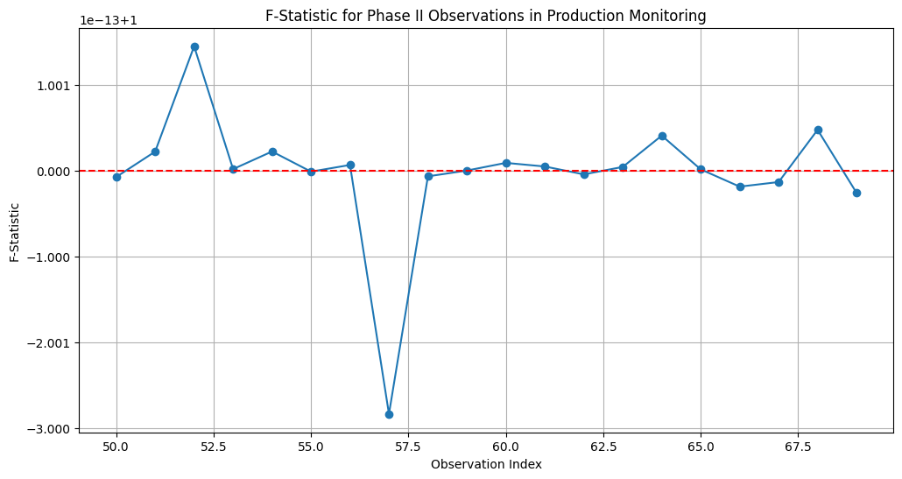**

#### Wilks' Statistic-Based Charts → ****W vs F charts.****

**The main mathematical differences between the W Chart (Wilks' Statistic) and the F Chart lie in their respective formulations and the aspects of the covariance structure they emphasize. Here's a detailed comparison:**

**W Chart (Wilks' Statistic)**

**Mathematical Foundation:**

**Wilks' Statistic is defined as the ratio of the determinants of two scatter matrices, one from the historical data and one from the augmented data including the new observation .**

**Key Points:**

**1. Determinants: The W Chart uses the determinant of the scatter matrices, which relates to the overall volume or generalized variance of the data.**

**2. Covariance Structure: It focuses on changes in the entire covariance structure by considering the product of eigenvalues (determinant).**

**3. Range: Wilks' Statistic ranges between 0 and 1, where values close to 1 indicate similarity between the covariance matrices, and values close to 0 indicate significant changes.**

**4. Usage: Particularly sensitive to changes that affect the overall covariance structure, including both variances and correlations among variables.**

**F Chart**

**Mathematical Foundation:**

**The F Chart uses the trace of the scatter matrices and computes an F-statistic to detect changes. The F-statistic is calculated based on the difference in the traces of the scatter matrices and their squared differences.**

**Key Points:**

**1. Traces: The F Chart uses the trace (sum of diagonal elements) of the scatter matrices, which corresponds to the total variance of the data.**

**2. Variance Changes: It focuses on changes in the total variance, making it particularly sensitive to shifts in the variances of individual variables.**

**3. Sensitivity: While it can detect changes in the covariance structure, it is more sensitive to changes in variances rather than changes in correlations.**

**4. Statistical Distribution: The F-statistic is compared against the critical values from the F-distribution to determine if the changes are significant.**

**Summary of Differences**

**- Determinant vs. Trace: The W Chart uses the determinant of scatter matrices, capturing the overall variance-covariance structure, while the F Chart uses the trace, focusing on the total variance.**

**- Generalized Variance vs. Total Variance: Wilks' Statistic measures changes in the generalized variance (product of eigenvalues), whereas the F-statistic measures changes in the total variance (sum of eigenvalues).**

**- Sensitivity: The W Chart is more sensitive to changes that affect the overall covariance structure (both variances and correlations), while the F Chart is more sensitive to changes in variances.**

**- Range and Interpretation: Wilks' Statistic ranges between 0 and 1, with values close to 1 indicating no significant change, while the F-statistic is compared to a critical value from the F-distribution.**

**Example Comparison**

**Let's consider the same dataset used in the previous examples:**

**Historical Data (Phase I):**



**New Observation (Phase II):**



**For this dataset, we computed the following:**

**W Chart:**





**F Chart:**

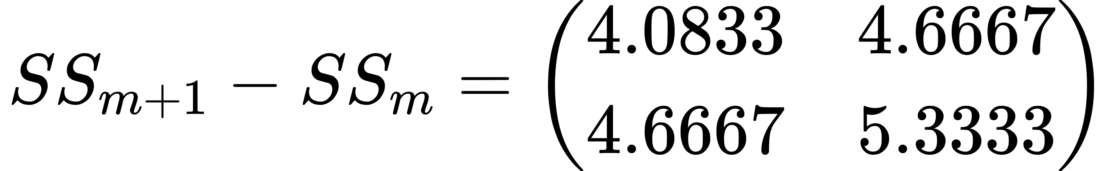

**In this example, the W Chart indicates a significant change with a Wilks' statistic of 0.2222, while the F Chart provides an F-statistic of 1.0916, which should be compared to the critical value from the F-distribution for significance testing.**

#### Trace-Based Charts

**Trace-Based Shewhart Charts: Explanation and Reviewed Charts**

**Explanation of Trace-Based Shewhart Charts**

**Trace-based Shewhart charts are used to monitor the variability of a multivariate process. The "trace" refers to the sum of the diagonal elements of a matrix, which in this context is the covariance matrix or scatter matrix. This sum represents the total variability in the data.**

**Mathematical Foundation:**

**- Scatter Matrix (S): For a given multivariate dataset with mean vector , the scatter matrix is calculated as:**

**- Trace of the Scatter Matrix (tr(S)): The trace of the scatter matrix is the sum of its diagonal elements, representing the total variance in the dataset:**

**where \(p\) is the number of variables.**

**Key Idea:**

**- Monitoring the trace of the scatter matrix allows us to track changes in the total variability of the process. If the process variance increases or decreases significantly, it will be reflected in the trace value.**

**Reviewed Trace-Based Shewhart Charts**

**1. LASSO (Least Absolute Shrinkage and Selection Operator) Chart:**

**- Purpose: Used to monitor multivariate processes by incorporating regularization to handle high-dimensional data.**

**- Methodology: Combines the trace of the scatter matrix with the LASSO technique to emphasize sparsity and handle high-dimensional datasets effectively.**

**- Key Feature: Effective in scenarios with many variables, especially when the number of observations is relatively small compared to the number of variables.**

**2. MTSSD (Multivariate Trace Sum of Squared Deviation) Chart:**

**- Purpose: Focuses on monitoring the total variance in the process.**

**- Methodology: Uses the trace of the covariance estimator to represent the total variance. The chart plots the trace over time to detect shifts.**

**- Key Feature: Simple to implement and effective in detecting small shifts in variance. Particularly useful for processes where the total variability is of primary concern.**

**3. MMSSD (Multivariate Matrix Sum of Squared Deviation) Chart:**

**- Purpose: Monitors both the total variance and the correlation among variables.**

**- Methodology: Calculates the sum of all elements in the scatter matrix (not just the diagonal) to consider both variance and correlation changes.**

**- Key Feature: Provides a comprehensive view by including off-diagonal elements, making it sensitive to changes in correlation as well as variance.**

**Summary of Trace-Based Shewhart Charts**

**- LASSO Chart:**

**- Focus: High-dimensional data, regularization.**

**- Application: Situations with many variables and potential sparsity.**

**- Feature: Regularization to handle high-dimensionality.**

**- MTSSD Chart:**

**- Focus: Total variance.**

**- Application: Processes where monitoring total variability is crucial.**

**- Feature: Detects small shifts in variance.**

**- MMSSD Chart:**

**- Focus: Variance and correlation.**

**- Application: Processes where both variance and correlation changes are important.**

**- Feature: Includes off-diagonal elements to monitor correlation.**

**Example Calculation for a Trace-Based Chart**

**Let's consider a simple example with a small dataset to illustrate how a trace-based Shewhart chart is constructed.**

**Historical Data (Phase I):**

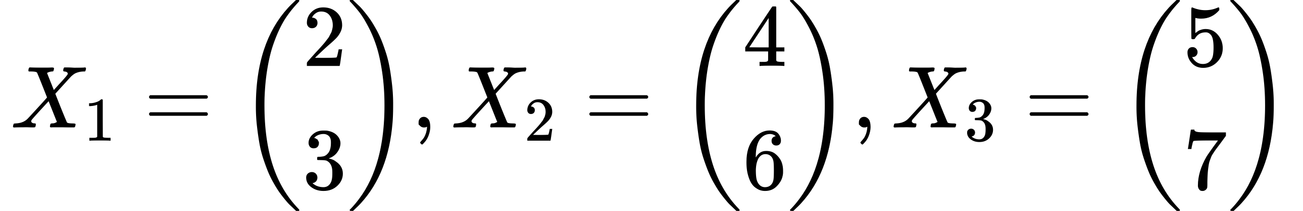

**Step-by-Step Calculation for MTSSD Chart:**

**1. Calculate the Mean Vector:**

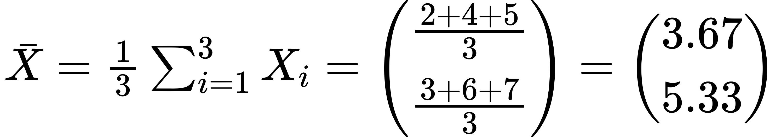

**2. Calculate the Scatter Matrix:**

**For :**

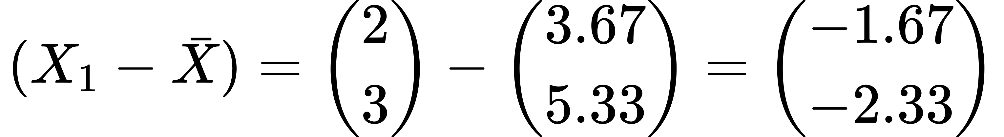



**Repeat for \(X\_2\) and \(X\_3\) and sum the results:**

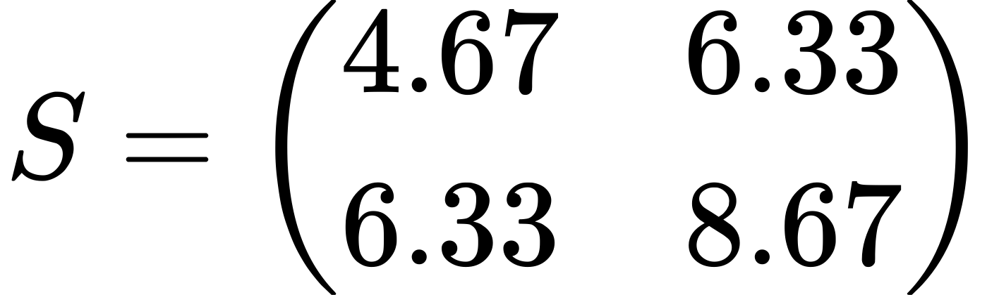

**3. Calculate the Trace:**

**4. Plot the Trace:**

**- Plot the trace values over time.**

**- Set control limits based on the Phase I data.**

**This example illustrates the calculation of the trace of the scatter matrix and how it can be used in a trace-based Shewhart chart to monitor process variability.**

#### Trace-Based Charts → LASSO Charts

**LASSO (Least Absolute Shrinkage and Selection Operator) Chart**

**Explanation:**

**The LASSO chart is used for monitoring multivariate processes, especially in high-dimensional settings where the number of variables is large. LASSO introduces a penalty term to the regression model, which enforces sparsity (i.e., it shrinks some coefficients to zero), making the model less prone to overfitting.**

**Key Features:**

**- Regularization: Incorporates a penalty term to handle high-dimensional data.**

**- High-Dimensional Data: Effective when the number of variables exceeds the number of observations.**

**Mathematical Foundation:**

**- Objective Function: The LASSO method minimizes the following objective function:**

**where:**

**- is the L2 norm,**

**- is the L1 norm,**

**- is the matrix of predictors,**

**- is the response vector,**

**- is the vector of coefficients,**

**- is the regularization parameter.**

**Steps for Constructing a LASSO Chart:**

**1. Fit the LASSO Model: Apply the LASSO method to the historical data to obtain the coefficient estimates.**

**2. Calculate the Residuals: Compute the residuals from the LASSO model.**

**3. Calculate the Control Limits: Use the residuals to establish control limits.**

**4. Monitor New Data: Apply the LASSO model to new data and calculate the residuals to check if they fall within the control limits.**

**Numerical Example:**

**Historical Data (Phase I):**

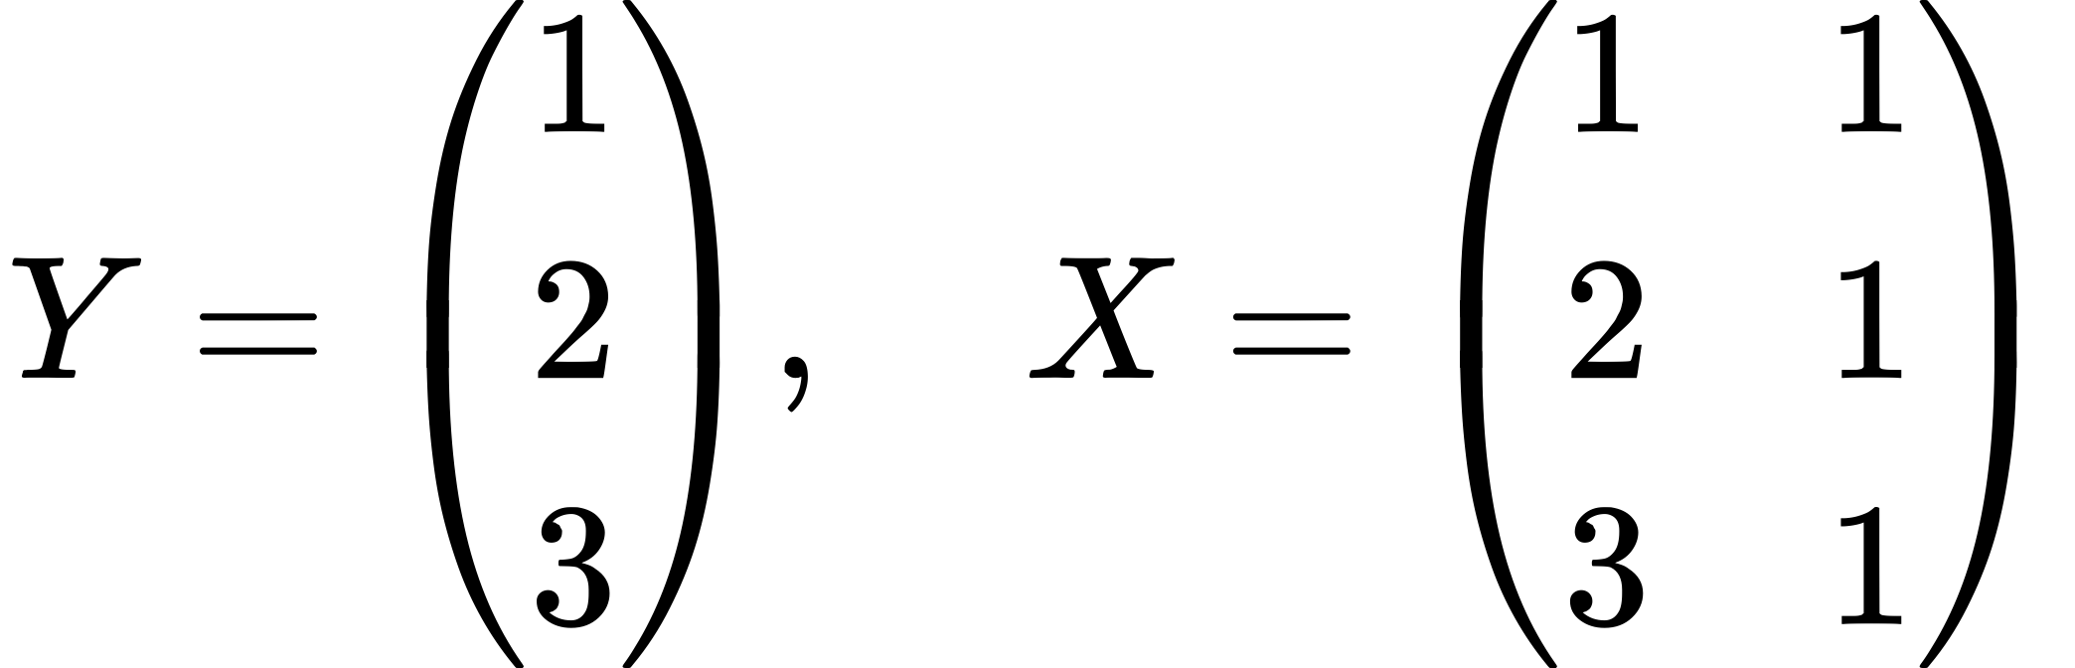

**1. Fit the LASSO Model:**

**- Choose a regularization parameter \( \lambda \).**

**- Fit the model to the data, which minimizes:**

**Let's assume and the fitted model yields the coefficients:**

**2. Calculate the Predicted Values:**

**- Using the fitted model, calculate the predicted values :**

**3. Calculate the Residuals:**

**- The residuals are the differences between the observed values and the predicted values:**

**4. Calculate the Control Limits:**

**- Use the residuals to determine the control limits. Assuming we use the standard deviation of the residuals and set control limits at ±3 standard deviations:**

**5. Monitor New Data:**

**- For new data points, apply the LASSO model to obtain predictions and calculate residuals.**

**- Check if the residuals fall within the control limits.**

**New Data Point (Phase II):**

**- Predicted value:**

**- Residual:**

**- Compare the residual to the control limits :**

**In this example, the residual for the new data point falls within the control limits, indicating that the process is in control. This approach can be extended to larger datasets and more complex scenarios, making LASSO charts a powerful tool for monitoring high-dimensional multivariate processes.**

**python**

**import numpy as np**

**import matplotlib.pyplot as plt**

**from sklearn.linear\_model import Lasso**

**# Generate synthetic data for two variables in a production process**

**np.random.seed(42)**

**n\_phase1 = 50**

**n\_phase2 = 10**

**# Historical data (Phase I) - assume a simple linear relationship with noise**

**X\_phase1 = np.random.rand(n\_phase1, 2) \* 10 # 50 samples, 2 features**

**Y\_phase1 = 0.5 + 0.75 \* X\_phase1[:, 0] + np.random.randn(n\_phase1) # Linear relationship with noise**

**# Fit the LASSO model to Phase I data**

**lasso = Lasso(alpha=0.1)**

**lasso.fit(X\_phase1, Y\_phase1)**

**# Calculate the residuals for Phase I data**

**Y\_phase1\_pred = lasso.predict(X\_phase1)**

**residuals\_phase1 = Y\_phase1 - Y\_phase1\_pred**

**# Calculate the control limits based on Phase I residuals**

**mean\_residual = np.mean(residuals\_phase1)**

**std\_residual = np.std(residuals\_phase1, ddof=1)**

**control\_limit\_upper = mean\_residual + 3 \* std\_residual**

**control\_limit\_lower = mean\_residual - 3 \* std\_residual**

**# Generate new data (Phase II) - assume same linear relationship**

**X\_phase2 = np.random.rand(n\_phase2, 2) \* 10 # 10 new samples**

**Y\_phase2 = 0.5 + 0.75 \* X\_phase2[:, 0] + np.random.randn(n\_phase2) # Linear relationship with noise**

**# Calculate residuals for Phase II data using the fitted LASSO model**

**Y\_phase2\_pred = lasso.predict(X\_phase2)**

**residuals\_phase2 = Y\_phase2 - Y\_phase2\_pred**

**# Combine residuals for plotting**

**residuals = np.concatenate((residuals\_phase1, residuals\_phase2))**

**phase = ['Phase I'] \* n\_phase1 + ['Phase II'] \* n\_phase2**

**# Plot the residuals and control limits**

**plt.figure(figsize=(12, 6))**

**plt.plot(residuals, marker='o', linestyle='-', label='Residuals')**

**plt.axhline(y=control\_limit\_upper, color='r', linestyle='--', label='Upper Control Limit')**

**plt.axhline(y=control\_limit\_lower, color='r', linestyle='--', label='Lower Control Limit')**

**plt.axvline(x=n\_phase1-1, color='g', linestyle='--', label='Phase I/II Separation')**

**plt.xlabel('Observation Index')**

**plt.ylabel('Residuals')**

**plt.title('LASSO Chart for Monitoring Process')**

**plt.legend()**

**plt.grid(True)**

**plt.show()**

**Explanation**

**1. Data Generation:**

**- Phase I (Historical Data): Generate 50 samples with a linear relationship and some noise.**

**- Phase II (New Data): Generate 10 new samples following the same relationship.**

**2. Fit the LASSO Model:**

**- Fit a LASSO model to the Phase I data with a regularization parameter (`alpha=0.1`).**

**3. Calculate Residuals:**

**- Compute the residuals for Phase I data by subtracting the predicted values from the actual values.**

**4. Establish Control Limits:**

**- Calculate the mean and standard deviation of the Phase I residuals.**

**- Set control limits at ±3 standard deviations from the mean.**

**5. Monitor New Data:**

**- Use the fitted LASSO model to predict values for the new Phase II data.**

**- Compute the residuals for the Phase II data and compare them to the control limits.**

**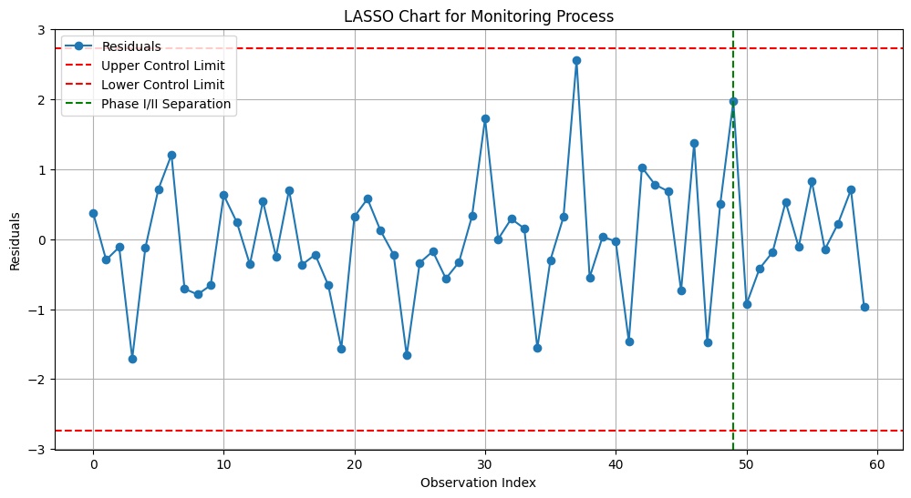**

#### Trace-Based Charts → MTSSD (Multivariate Trace Sum of Squared Deviation) Chart

**The MTSSD chart is designed to monitor the total variance in a multivariate process. It uses the trace of the covariance matrix (or scatter matrix) to represent the total variability in the data. By tracking the trace over time, the chart helps detect changes in the total variance of the process.**

**Key Features:**

**- Total Variance: Focuses on monitoring the sum of variances of the variables.**

**- Simplicity: Simple to implement and interpret.**

**Mathematical Foundation:**

**- Trace of the Scatter Matrix: The trace of the scatter matrix is the sum of its diagonal elements, representing the total variance:**

**where is the number of variables.**

**Steps for Constructing an MTSSD Chart:**

**1. Calculate the Scatter Matrix: Compute the scatter matrix for the historical data.**

**2. Calculate the Trace: Compute the trace of the scatter matrix.**

**3. Establish Control Limits: Determine control limits based on the historical data.**

**4. Monitor New Data: Calculate the trace for new data and check if it falls within the control limits.**

**Numerical Example:**

**Historical Data (Phase I):**



**Step-by-Step Calculation:**

**Step 1: Calculate the Mean Vector**

**Calculate the mean vector :**



**Step 2: Calculate the Scatter Matrix**

**The scatter matrix \( S \) is calculated as:**



**For :**





**For :**

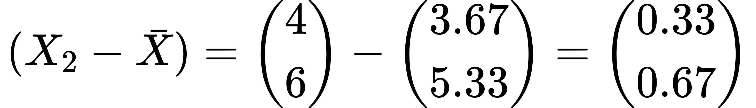



**For :**

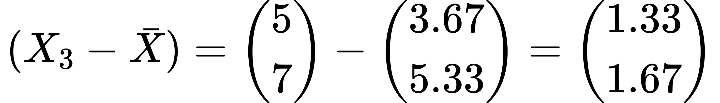



**Summing these matrices gives the scatter matrix :**



**Step 3: Calculate the Trace**

**The trace of the scatter matrix is the sum of its diagonal elements:**

**Step 4: Establish Control Limits**

**Calculate the control limits based on the historical data. For simplicity, let's assume the control limits are set at ±3 standard deviations from the mean of the trace values of the scatter matrix.**

**Assuming we have multiple samples, we calculate the mean and standard deviation of the trace values.**

**Mean of Trace Values:**

**Standard Deviation of Trace Values: (assumed)**

**Control Limits:**

**Step 5: Monitor New Data**

**Calculate the scatter matrix and trace for new data points (Phase II).**

**New Data (Phase II):**

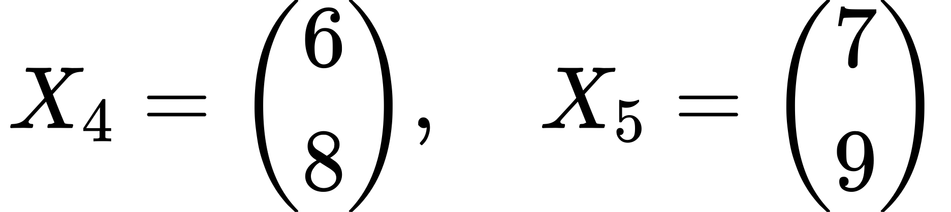

**1. Calculate the Mean Vector for New Data:**

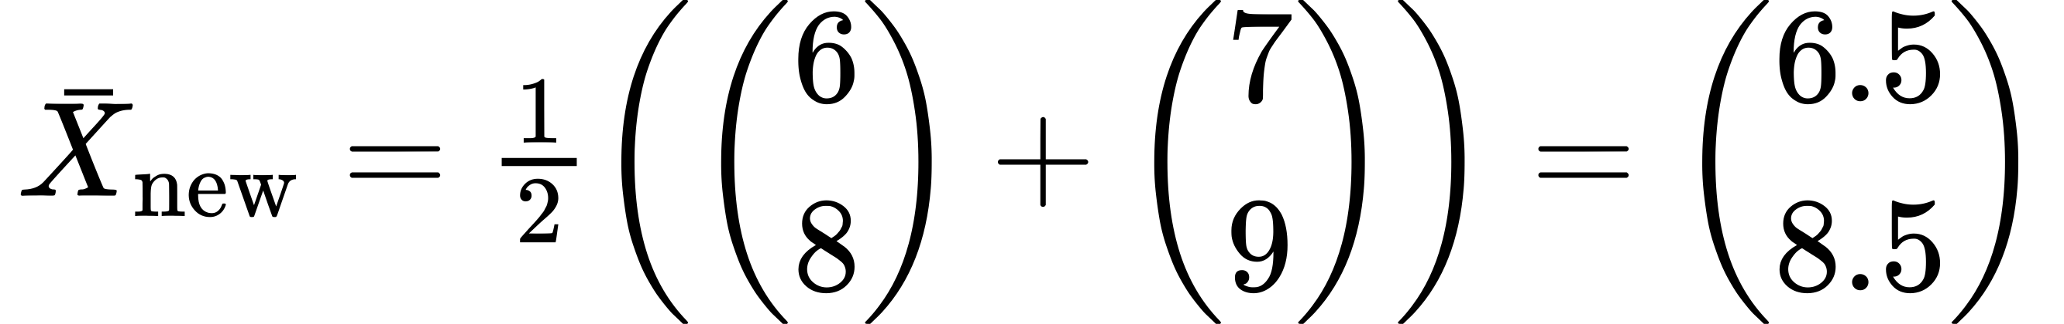

**2. Calculate the Scatter Matrix for New Data:**

**For :**

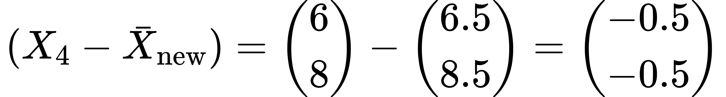



**For :**

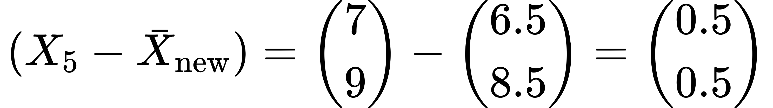



**Summing these matrices gives the scatter matrix :**

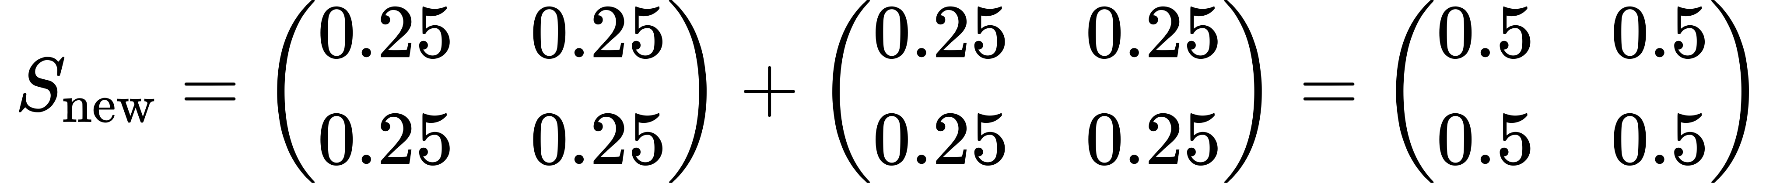

**3. Calculate the Trace for New Data:**

**4. Compare to Control Limits:**

**In this example, the trace for the new data (1.0) falls outside the control limits, indicating that the process is out of control. This approach can be extended to larger datasets and more complex scenarios, making the MTSSD chart a powerful tool for monitoring total variance in multivariate processes.**

****Python Code****

import numpy as np

import matplotlib.pyplot as plt

# Generate synthetic data for two variables in a production process

np.random.seed(42)

n\_phase1 = 50

n\_phase2 = 10

# Historical data (Phase I) - assume a bivariate normal distribution

mean\_phase1 = [10, 15]

cov\_phase1 = [[5, 2], [2, 3]]

data\_phase1 = np.random.multivariate\_normal(mean\_phase1, cov\_phase1, n\_phase1)

# New data (Phase II) - assume a shift in the covariance structure

mean\_phase2 = [10, 15]

cov\_phase2 = [[8, 3], [3, 4]]

data\_phase2 = np.random.multivariate\_normal(mean\_phase2, cov\_phase2, n\_phase2)

# Function to calculate the scatter matrix

def scatter\_matrix(data):

mean\_vector = np.mean(data, axis=0)

scatter = np.dot((data - mean\_vector).T, (data - mean\_vector))

return scatter

# Calculate the scatter matrix and its trace for Phase I data

scatter\_matrix\_phase1 = scatter\_matrix(data\_phase1)

trace\_phase1 = np.trace(scatter\_matrix\_phase1)

# Calculate the scatter matrices and their traces for Phase I samples

trace\_samples = []

for i in range(n\_phase1):

sample\_data = data\_phase1[:i+1]

sample\_scatter\_matrix = scatter\_matrix(sample\_data)

sample\_trace = np.trace(sample\_scatter\_matrix)

trace\_samples.append(sample\_trace)

# Establish control limits based on Phase I data

mean\_trace\_phase1 = np.mean(trace\_samples)

std\_trace\_phase1 = np.std(trace\_samples, ddof=1)

control\_limit\_upper = mean\_trace\_phase1 + 3 \* std\_trace\_phase1

control\_limit\_lower = mean\_trace\_phase1 - 3 \* std\_trace\_phase1

# Calculate the scatter matrix and its trace for Phase II data

scatter\_matrix\_phase2 = scatter\_matrix(data\_phase2)

trace\_phase2 = np.trace(scatter\_matrix\_phase2)

# Combine traces for plotting

traces = trace\_samples + [np.trace(scatter\_matrix(data\_phase2[:i+1])) for i in range(n\_phase2)]

phase = ['Phase I'] \* n\_phase1 + ['Phase II'] \* n\_phase2

# Plot the MTSSD chart

plt.figure(figsize=(12, 6))

plt.plot(traces, marker='o', linestyle='-', label='Trace of Scatter Matrix')

plt.axhline(y=control\_limit\_upper, color='r', linestyle='--', label='Upper Control Limit')

plt.axhline(y=control\_limit\_lower, color='r', linestyle='--', label='Lower Control Limit')

plt.axvline(x=n\_phase1-1, color='g', linestyle='--', label='Phase I/II Separation')

plt.xlabel('Observation Index')

plt.ylabel('Trace of Scatter Matrix')

plt.title('MTSSD (Multivariate Trace Sum of Squared Deviation) Chart')

plt.legend()

plt.grid(True)

plt.show()

**Explanation:**

1. Data Generation:

- Phase I (Historical Data): Generate 50 samples from a bivariate normal distribution.

- Phase II (New Data): Generate 10 new samples from a bivariate normal distribution with a different covariance structure.

2. Scatter Matrix Calculation:

- Define a function to calculate the scatter matrix for a given dataset.

- Compute the scatter matrix for Phase I data and its trace.

- Compute the scatter matrices and traces for each sample in Phase I to establish control limits.

3. Control Limits:

- Calculate the mean and standard deviation of the trace values from Phase I samples.

- Establish control limits at ±3 standard deviations from the mean trace.

4. Monitor New Data:

- Compute the scatter matrix and trace for Phase II data.

- Combine the traces from Phase I and Phase II data for plotting.

5. Plot the MTSSD Chart:

- Plot the trace values for both Phase I and Phase II data.

- Include the control limits and a vertical line to separate Phase I and Phase II data.

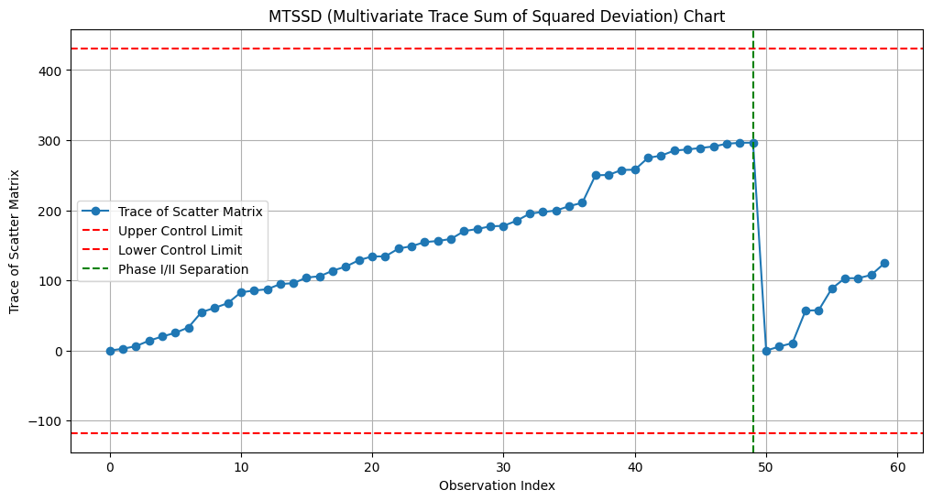

#### ****Trace-Based Charts → MMSSD (Multivariate Matrix Sum of Squared Deviation) Chart:****

**The MMSSD chart is used to monitor both the total variance and the correlation structure of a multivariate process. Unlike the MTSSD chart, which only considers the trace of the scatter matrix, the MMSSD chart considers all elements of the scatter matrix, including off-diagonal elements that represent covariances between variables.**

**Key Features:**

**- Total Variance and Correlation: Monitors both the variances of individual variables and the correlations between variables.**

**- Sensitivity: More sensitive to changes in the correlation structure compared to the MTSSD chart.**

**Mathematical Foundation:**

**- Sum of Squared Deviations (SSD): The sum of squared deviations for the scatter matrix is given by:**

**where is the number of variables, and are the elements of the scatter matrix.**

**Steps for Constructing an MMSSD Chart:**

**1. Calculate the Scatter Matrix: Compute the scatter matrix for the historical data.**

**2. Calculate the SSD: Compute the sum of squared deviations of the scatter matrix.**

**3. Establish Control Limits: Determine control limits based on the historical data.**

**4. Monitor New Data: Calculate the SSD for new data and check if it falls within the control limits.**

**Numerical Example:**

**Historical Data (Phase I):**



**Step-by-Step Calculation:**

**Step 1: Calculate the Mean Vector**

**Calculate the mean vector :**

**Step 2: Calculate the Scatter Matrix**

**The scatter matrix is calculated as:**

**For :**





**For :**





**For :**





**Summing these matrices gives the scatter matrix :**



**Step 3: Calculate the SSD**

**The sum of squared deviations (SSD) of the scatter matrix is the sum of the squares of all elements in the matrix:**

**Calculate each term:**

**Sum the squared terms:**

**Step 4: Establish Control Limits**

**Calculate the control limits based on the historical data. For simplicity, assume the control limits are set at ±3 standard deviations from the mean of the SSD values.**

**Assuming we have multiple samples, we calculate the mean and standard deviation of the SSD values.**

**Mean of SSD Values:**

**Standard Deviation of SSD Values: (assumed)**

**Control Limits:**

**Step 5: Monitor New Data**

**Calculate the scatter matrix and SSD for new data points (Phase II).**

**New Data (Phase II):**



**1. Calculate the Mean Vector for New Data:**



**2. Calculate the Scatter Matrix for New Data:**

**For :**





**For :**





**Summing these matrices gives the scatter matrix :**



**3. Calculate the SSD for New Data:**

**4. Compare to Control Limits:**

**In this example, the SSD for the new data (1.0) falls outside the control limits, indicating that the process is out of control. This approach can be extended to larger datasets and more complex scenarios, making the MMSSD chart a powerful tool for monitoring both variance and correlation in multivariate processes.**

****Python Code****

import numpy as np

import matplotlib.pyplot as plt

# Generate synthetic data for two variables in a production process

np.random.seed(42)

n\_phase1 = 50

n\_phase2 = 10

# Historical data (Phase I) - assume a bivariate normal distribution

mean\_phase1 = [10, 15]

cov\_phase1 = [[5, 2], [2, 3]]

data\_phase1 = np.random.multivariate\_normal(mean\_phase1, cov\_phase1, n\_phase1)

# New data (Phase II) - assume a shift in the covariance structure

mean\_phase2 = [10, 15]

cov\_phase2 = [[8, 3], [3, 4]]

data\_phase2 = np.random.multivariate\_normal(mean\_phase2, cov\_phase2, n\_phase2)

# Function to calculate the scatter matrix

def scatter\_matrix(data):

mean\_vector = np.mean(data, axis=0)

scatter = np.dot((data - mean\_vector).T, (data - mean\_vector))

return scatter

# Function to calculate the sum of squared deviations (SSD) of the scatter matrix

def sum\_squared\_deviations(scatter\_matrix):

return np.sum(scatter\_matrix2)

# Calculate the scatter matrix and SSD for Phase I data

scatter\_matrix\_phase1 = scatter\_matrix(data\_phase1)

ssd\_phase1 = sum\_squared\_deviations(scatter\_matrix\_phase1)

# Calculate the SSD for each sample in Phase I data to establish control limits

ssd\_samples = []

for i in range(n\_phase1):

sample\_data = data\_phase1[:i+1]

sample\_scatter\_matrix = scatter\_matrix(sample\_data)

sample\_ssd = sum\_squared\_deviations(sample\_scatter\_matrix)

ssd\_samples.append(sample\_ssd)

# Establish control limits based on Phase I data

mean\_ssd\_phase1 = np.mean(ssd\_samples)

std\_ssd\_phase1 = np.std(ssd\_samples, ddof=1)

control\_limit\_upper = mean\_ssd\_phase1 + 3 \* std\_ssd\_phase1

control\_limit\_lower = mean\_ssd\_phase1 - 3 \* std\_ssd\_phase1

# Calculate the scatter matrix and SSD for Phase II data

scatter\_matrix\_phase2 = scatter\_matrix(data\_phase2)

ssd\_phase2 = sum\_squared\_deviations(scatter\_matrix\_phase2)

# Combine SSDs for plotting

ssd\_values = ssd\_samples + [sum\_squared\_deviations(scatter\_matrix(data\_phase2[:i+1])) for i in range(n\_phase2)]

phase = ['Phase I'] \* n\_phase1 + ['Phase II'] \* n\_phase2

# Plot the MMSSD chart

plt.figure(figsize=(12, 6))

plt.plot(ssd\_values, marker='o', linestyle='-', label='SSD of Scatter Matrix')

plt.axhline(y=control\_limit\_upper, color='r', linestyle='--', label='Upper Control Limit')

plt.axhline(y=control\_limit\_lower, color='r', linestyle='--', label='Lower Control Limit')

plt.axvline(x=n\_phase1-1, color='g', linestyle='--', label='Phase I/II Separation')

plt.xlabel('Observation Index')

plt.ylabel('SSD of Scatter Matrix')

plt.title('MMSSD (Multivariate Matrix Sum of Squared Deviation) Chart')

plt.legend()

plt.grid(True)

plt.show()

**Explanation:**

1. Data Generation:

- Phase I (Historical Data): Generate 50 samples from a bivariate normal distribution.

- Phase II (New Data): Generate 10 new samples from a bivariate normal distribution with a different covariance structure.

2. Scatter Matrix Calculation:

- Define a function `scatter\_matrix` to calculate the scatter matrix for a given dataset.

- Define a function `sum\_squared\_deviations` to calculate the sum of squared deviations (SSD) of the scatter matrix.

3. Control Limits:

- Calculate the scatter matrix and SSD for each sample in Phase I data.

- Calculate the mean and standard deviation of the SSD values from Phase I samples.

- Establish control limits at ±3 standard deviations from the mean SSD.

4. Monitor New Data:

- Calculate the scatter matrix and SSD for Phase II data.

- Combine the SSD values from Phase I and Phase II data for plotting.

5. Plot the MMSSD Chart:

- Plot the SSD values for both Phase I and Phase II data.

- Include the control limits and a vertical line to separate Phase I and Phase II data.

**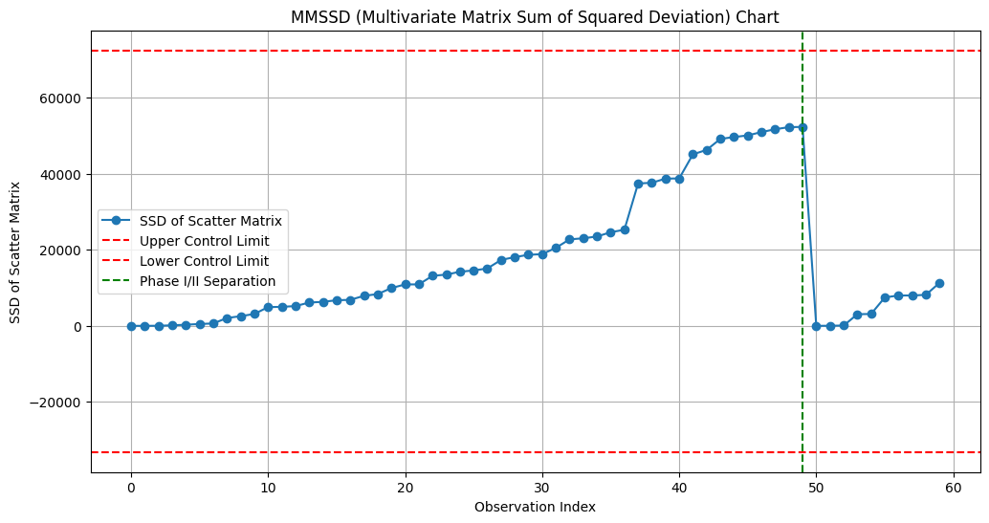**

#### Chi-Squared Distribution-Based Charts

**Explanation:**

Chi-squared distribution-based charts are used to monitor multivariate processes by leveraging the chi-squared distribution, which is particularly suited for evaluating the sum of squared standardized variables. These charts are useful for detecting shifts in the mean vector or the covariance structure of the process.

**Mathematical Foundation:**

- Hotelling's Statistic: Often used in chi-squared distribution-based charts, Hotelling's statistic for a multivariate sample is given by:

where is the sample mean vector, is the hypothesized mean vector, is the sample covariance matrix, and is the sample size. For a multivariate normal distribution, follows a chi-squared distribution with degrees of freedom (where is the number of variables).

Steps for Constructing Chi-Squared Distribution-Based Charts:

1. Calculate the Sample Mean Vector and Covariance Matrix: Compute the sample mean vector and sample covariance matrix .

2. Calculate the Statistic: Use the formula for Hotelling's statistic.

3. Establish Control Limits: Determine control limits based on the chi-squared distribution with degrees of freedom.

4. Monitor New Data: Calculate the statistic for new data and check if it falls within the control limits.

**Reviewed Chi-Squared Distribution-Based Charts**

1. Hotelling's Chart:

- Purpose: Monitors shifts in the mean vector of a multivariate process.

- Methodology: Uses Hotelling's statistic to detect shifts. The statistic is compared to control limits derived from the chi-squared distribution.

- Key Feature: Effective for detecting shifts in the multivariate mean.

2. Multivariate Exponentially Weighted Moving Average (MEWMA) Chart:

- Purpose: Monitors both the mean and the covariance structure of a multivariate process.

- Methodology: Uses a weighted average of past and present observations to smooth out short-term variability. The resulting statistic is compared to control limits derived from the chi-squared distribution.

- Key Feature: More sensitive to small and moderate shifts in the process mean and covariance structure.

3. Multivariate Cumulative Sum (MCUSUM) Chart:

- Purpose: Detects small shifts in the mean vector of a multivariate process.

- Methodology: Cumulatively sums deviations of the process from a target, adjusting for multivariate effects. The cumulative sum is compared to control limits based on the chi-squared distribution.

- Key Feature: Highly effective for detecting small shifts in the process mean.

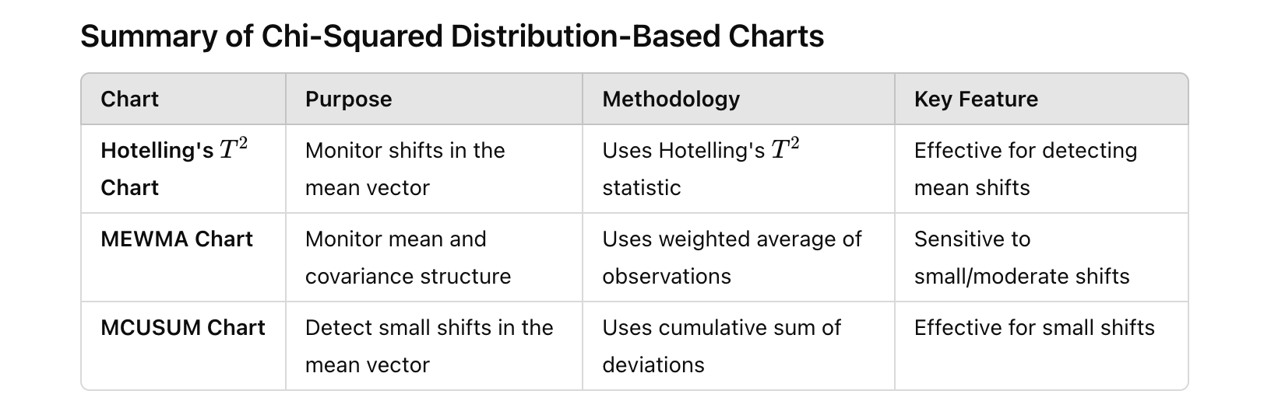

**Numerical Example for Hotelling's Chart**

Let's consider a simple numerical example to illustrate how to construct and use Hotelling's chart.

Historical Data (Phase I):



Step-by-Step Calculation:

Step 1: Calculate the Sample Mean Vector and Covariance Matrix

Sample Mean Vector:

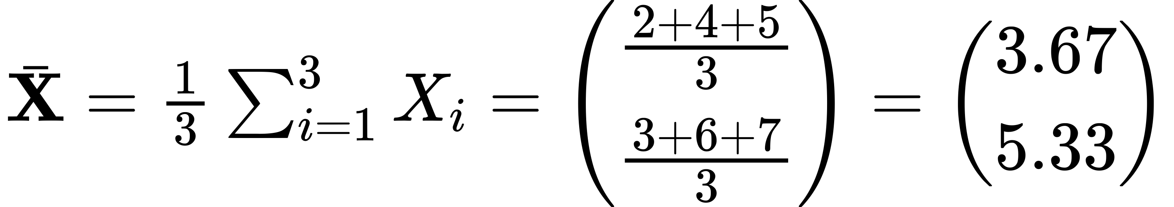

Sample Covariance Matrix:

For :



Similarly, calculate for and and sum:



Step 2: Calculate the Statistic

For a new observation :

Assuming :



Compute the difference:

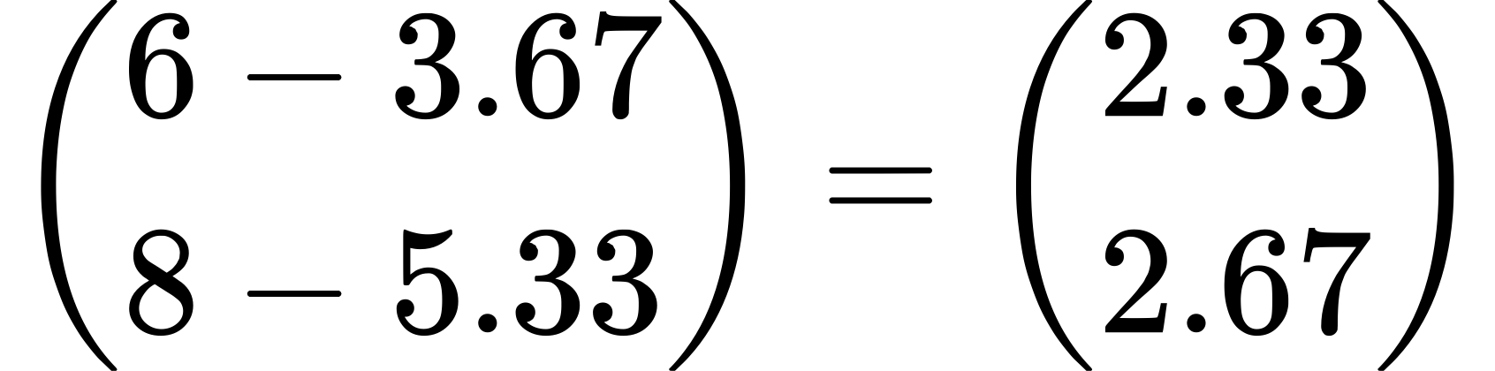

Compute the inverse of :

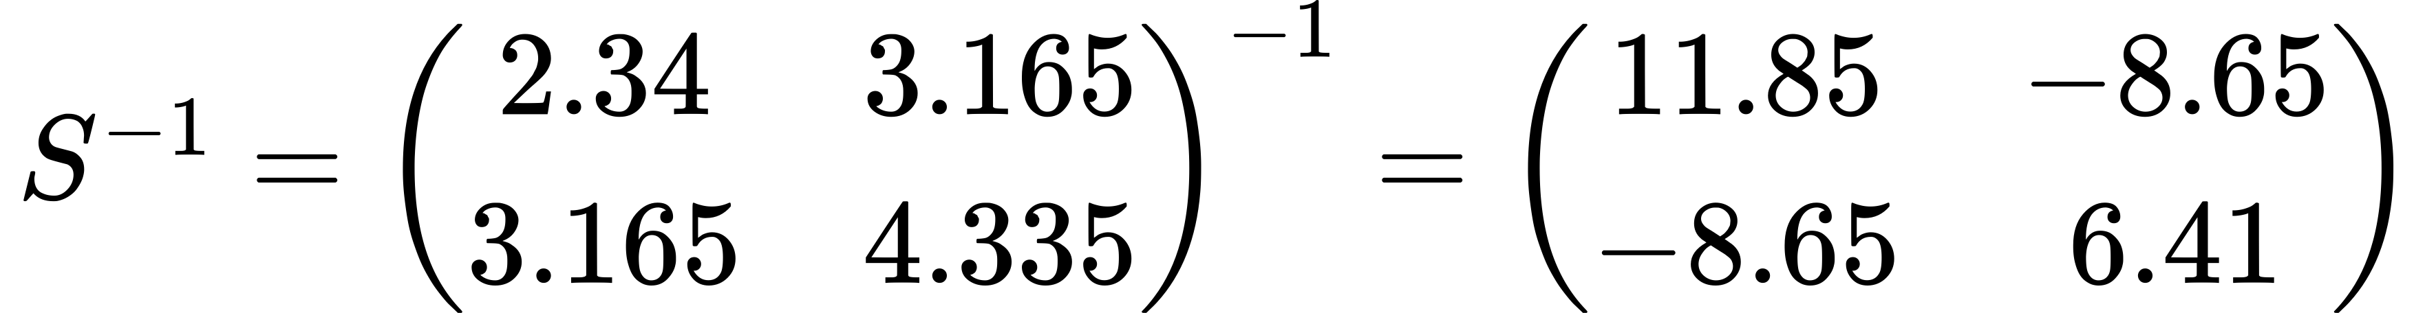

Calculate :

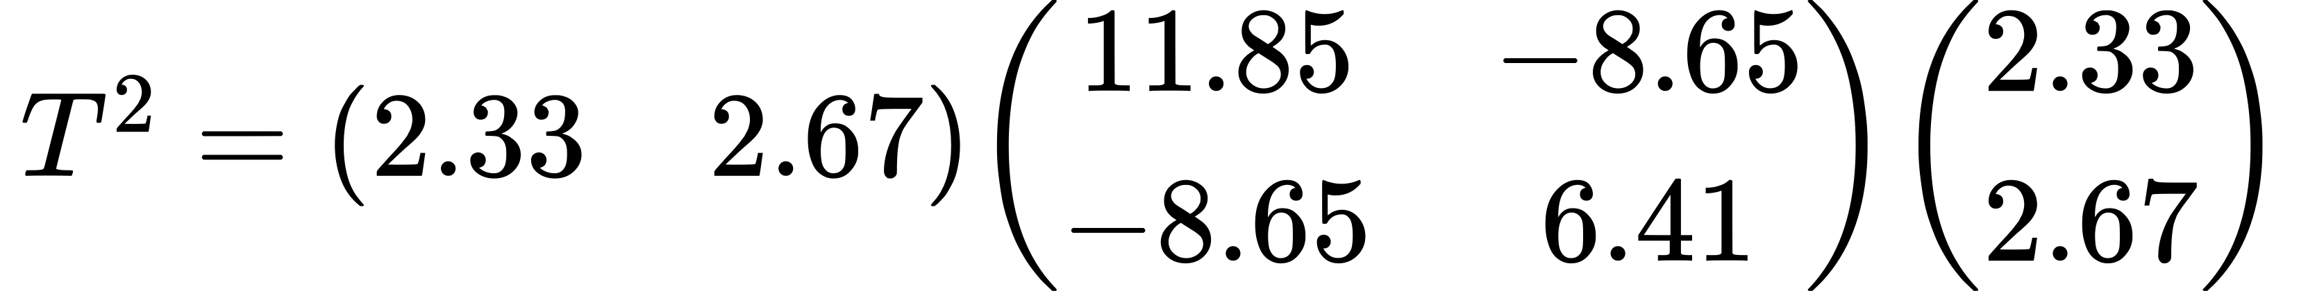

Perform the matrix multiplication:



Step 3: Establish Control Limits

Control limits for the statistic are derived from the chi-squared distribution with degrees of freedom. For and a significance level of 0.05, the control limit is the 95th percentile of the chi-squared distribution with 2 degrees of freedom:

Step 4: Monitor New Data

Compare the calculated statistic to the control limit:

T^2 = 8.52 > 5.991

Since the statistic exceeds the control limit, the process is out of control.

This example illustrates the calculation and use of Hotelling's chart to monitor a multivariate process. The same principles can be extended to MEWMA and MCUSUM charts, which also utilize the chi-squared distribution but with different methodologies to detect shifts in the process.

Python Code

import numpy as np

import matplotlib.pyplot as plt

from scipy.stats import chi2

# Generate synthetic data for two variables in a production process

np.random.seed(42)

n\_phase1 = 50

n\_phase2 = 10

# Historical data (Phase I) - assume a bivariate normal distribution

mean\_phase1 = [10, 15]

cov\_phase1 = [[5, 2], [2, 3]]

data\_phase1 = np.random.multivariate\_normal(mean\_phase1, cov\_phase1, n\_phase1)

# New data (Phase II) - assume a shift in the covariance structure

mean\_phase2 = [10, 15]

cov\_phase2 = [[8, 3], [3, 4]]

data\_phase2 = np.random.multivariate\_normal(mean\_phase2, cov\_phase2, n\_phase2)

# Combine data for convenience

data = np.vstack((data\_phase1, data\_phase2))

# Calculate the sample mean vector and covariance matrix for Phase I data

mean\_vector\_phase1 = np.mean(data\_phase1, axis=0)

cov\_matrix\_phase1 = np.cov(data\_phase1, rowvar=False)

# Function to calculate Hotelling's T^2 statistic

def hotelling\_t2(sample, mean\_vector, cov\_matrix, n):

diff = sample - mean\_vector

t2 = n \* np.dot(np.dot(diff, np.linalg.inv(cov\_matrix)), diff.T)

return t2

# Calculate Hotelling's T^2 statistic for each sample in Phase I and Phase II data

t2\_values = []

for i in range(n\_phase1):

t2 = hotelling\_t2(data\_phase1[i], mean\_vector\_phase1, cov\_matrix\_phase1, 1)

t2\_values.append(t2)

for i in range(n\_phase2):

t2 = hotelling\_t2(data\_phase2[i], mean\_vector\_phase1, cov\_matrix\_phase1, 1)

t2\_values.append(t2)

# Establish control limits based on chi-squared distribution

p = len(mean\_vector\_phase1) # number of variables

alpha = 0.05

control\_limit = chi2.ppf(1 - alpha, p)

# Plot the T^2 values and control limits

plt.figure(figsize=(12, 6))

plt.plot(t2\_values, marker='o', linestyle='-', label="T^2 Statistic")

plt.axhline(y=control\_limit, color='r', linestyle='--', label='Control Limit (95th Percentile)')

plt.axvline(x=n\_phase1-1, color='g', linestyle='--', label='Phase I/II Separation')

plt.xlabel('Observation Index')

plt.ylabel('T^2 Statistic')

plt.title("Hotelling's T^2 Chart")

plt.legend()

plt.grid(True)

plt.show()

**Explanation:**

1. Data Generation:

- Phase I (Historical Data): Generate 50 samples from a bivariate normal distribution.

- Phase II (New Data): Generate 10 new samples from a bivariate normal distribution with a different covariance structure.

2. Calculate Sample Mean and Covariance:

- Compute the sample mean vector and covariance matrix for Phase I data.

3. Hotelling's Statistic:

- Define a function `hotelling\_t2` to calculate Hotelling's statistic.

- Calculate the statistic for each sample in both Phase I and Phase II data.

4. Control Limits:

- Establish control limits based on the chi-squared distribution with degrees of freedom.

5. Monitor New Data:

- Plot the values for both Phase I and Phase II data.

- Include the control limits and a vertical line to separate Phase I and Phase II data.

This code demonstrates how to use Hotelling's chart to monitor a process, detect shifts in the mean vector, and ensure the process remains in control.

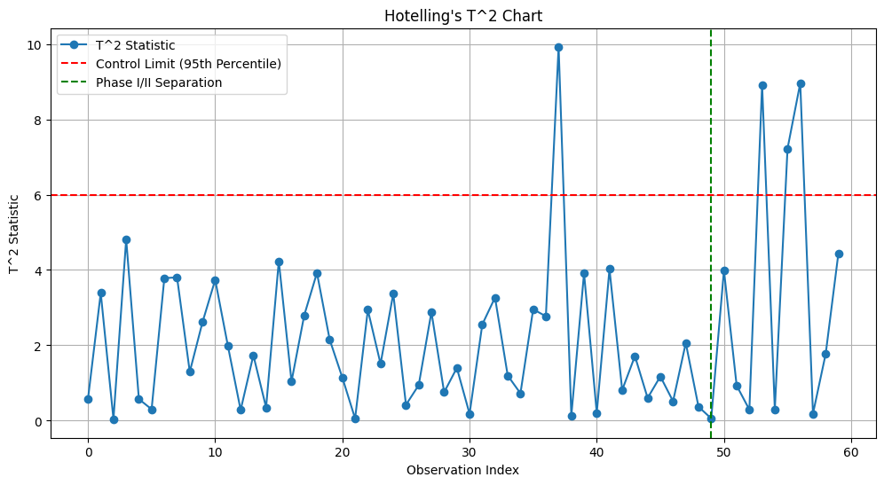

### Non-Parametric Dispersion Charts

The non-parametric control charts reviewed in the paper include:

1. **Multivariate Spatial Sign (MSS) Chart:**

- Purpose: Monitors multivariate data without assuming a specific distribution.

- Methodology: Uses the spatial sign function to convert data points into directions from the center of the distribution.

- Advantages: Robust to outliers and effective when the underlying distribution is unknown or non-normal.

- Application: Suitable for situations where the assumption of normality is not valid.

2. **Multivariate Spatial Rank (MSR) Chart:**

- Purpose: Another approach to monitor multivariate data without distributional assumptions.

- Methodology: Utilizes spatial ranks, which are based on the relative ordering of data points rather than their actual values.

- Advantages: Inherits robustness properties similar to the MSS chart and is also effective for non-normal distributions.

- Application: Useful in scenarios with unknown or non-normal distributions, providing a non-parametric alternative to traditional parametric methods.

3. **Multivariate Sign and Rank (MSR) Control Charts:**

- Purpose: Combines features of both spatial sign and rank methods to monitor the process.

- Methodology: Integrates both spatial signs and ranks to enhance robustness and sensitivity.

- Advantages: Improved detection capabilities for a wide range of distributional shapes and structures.

- Application: Particularly useful in high-dimensional settings where data may not follow any known distribution.

Key Differences:

- Non-Parametric Nature: These charts do not assume any specific distribution for the process data, making them versatile for various applications.

- Robustness: All three types are robust to outliers and perform well even when data contains anomalies or follows an unknown distribution.

- Methodology: While MSS focuses on directional data transformation, MSR relies on ranking, and MSR combines both to leverage their strengths.

These non-parametric control charts offer powerful alternatives to traditional methods, especially in complex, high-dimensional, or non-standard data environments.

#### Non-Parametric → ****Multivariate Spatial Sign (MSS) Chart****

Multivariate Spatial Sign (MSS) Chart: Detailed Explanation and Numerical Example

Mathematical Foundation:

The Multivariate Spatial Sign (MSS) Chart is a non-parametric control chart designed to monitor the location of multivariate processes. It uses the concept of spatial signs, which are vectors indicating the direction of data points from the multivariate median. The chart does not rely on any specific distributional assumptions, making it robust to outliers and effective for non-normal data.

Steps to Construct an MSS Chart:

1. Calculate the Multivariate Median:

- The multivariate median is a robust measure of central tendency. For a dataset , the multivariate median minimizes the sum of Euclidean distances to all data points.

2. Compute Spatial Signs:

- The spatial sign of a data point is calculated as:

where denotes the Euclidean norm.

3. Calculate the Test Statistic:

- The test statistic is based on the sum of spatial signs. For a given subgroup of data points, the sum of the spatial signs is calculated as:

4. Control Limits:

- Control limits for the MSS chart are typically set using a bootstrap method or based on historical data to account for the non-parametric nature of the chart.

**Numerical Example:**

Let's consider a simple numerical example with a small dataset to illustrate the MSS chart.

Historical Data (Phase I):



New Data (Phase II):



Step-by-Step Calculation:

Step 1: Calculate the Multivariate Median

For simplicity, let's assume the multivariate median is known and calculated as:

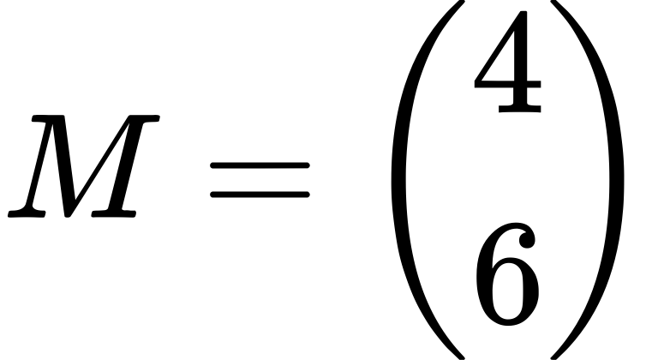

Step 2: Compute Spatial Signs

Calculate the spatial signs for each data point:

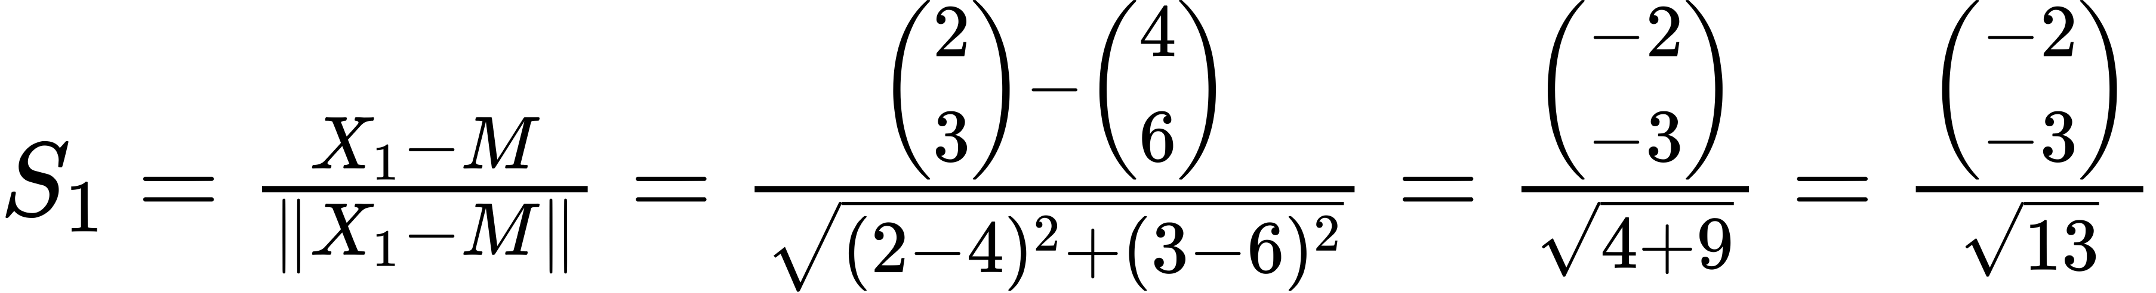

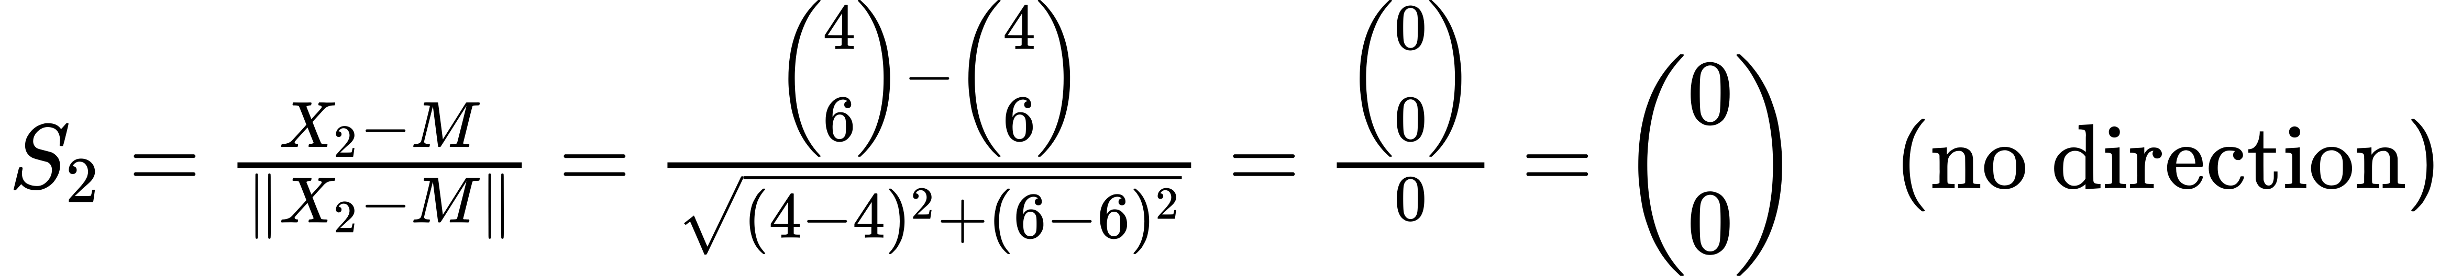

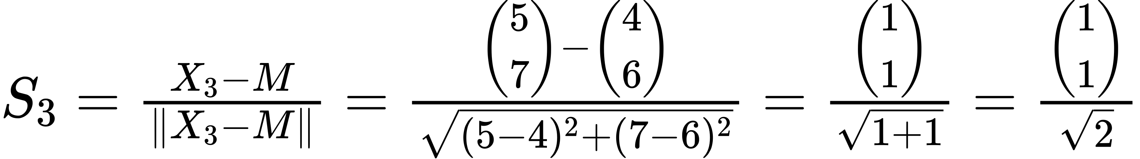

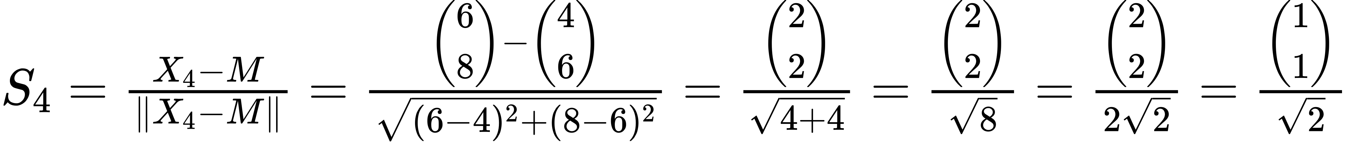

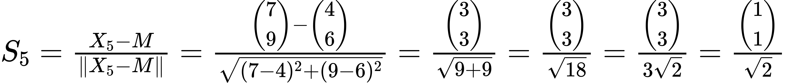

Step 3: Calculate the Test Statistic

Sum the spatial signs for the new data points (Phase II):

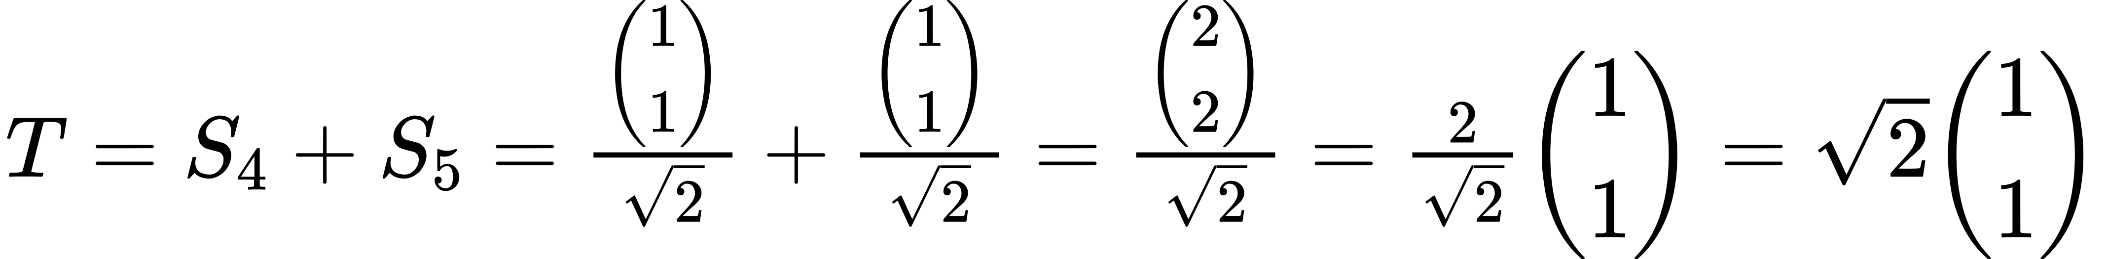

Step 4: Control Limits

In practice, control limits are determined using historical data or bootstrapping methods. For simplicity, assume the control limit is set at .

Python Code

import numpy as np

import matplotlib.pyplot as plt

from sklearn.covariance import MinCovDet

# Generate synthetic data for two variables in a production process

np.random.seed(42)

n\_phase1 = 200

n\_phase2 = 50

# Historical data (Phase I) - assume a bivariate normal distribution

mean\_phase1 = [10, 15]

cov\_phase1 = [[5, 2], [2, 3]]

data\_phase1 = np.random.multivariate\_normal(mean\_phase1, cov\_phase1, n\_phase1)

# New data (Phase II) - assume a shift in the covariance structure

mean\_phase2 = [10, 15]

cov\_phase2 = [[8, 3], [3, 4]]

data\_phase2 = np.random.multivariate\_normal(mean\_phase2, cov\_phase2, n\_phase2)

# Combine data for convenience

data = np.vstack((data\_phase1, data\_phase2))

# Calculate the multivariate median using Minimum Covariance Determinant (MCD)

mcd = MinCovDet().fit(data\_phase1)

multivariate\_median = mcd.location\_

# Function to compute spatial signs

def spatial\_sign(data, median):

deviations = data - median

norms = np.linalg.norm(deviations, axis=1, keepdims=True)

return deviations / norms

# Compute spatial signs for historical data (Phase I)

spatial\_signs\_phase1 = spatial\_sign(data\_phase1, multivariate\_median)

# Compute spatial signs for new data (Phase II)

spatial\_signs\_phase2 = spatial\_sign(data\_phase2, multivariate\_median)

# Calculate the test statistics for Phase II

test\_statistics = np.cumsum(spatial\_signs\_phase2, axis=0)

# Calculate control limits using Phase I data

bootstrap\_samples = 1000

bootstrap\_statistics = []

for \_ in range(bootstrap\_samples):

sample\_indices = np.random.choice(range(n\_phase1), n\_phase1, replace=True)

bootstrap\_sample = data\_phase1[sample\_indices]

bootstrap\_spatial\_signs = spatial\_sign(bootstrap\_sample, multivariate\_median)

bootstrap\_statistic = np.sum(bootstrap\_spatial\_signs, axis=0)

bootstrap\_statistics.append(np.linalg.norm(bootstrap\_statistic))

control\_limit = np.percentile(bootstrap\_statistics, 95)

# Plotting the MSS chart

plt.figure(figsize=(14, 7))

plt.plot(range(1, len(test\_statistics) + 1), np.linalg.norm(test\_statistics, axis=1), marker='o', linestyle='-', label='Test Statistic')

plt.axhline(y=control\_limit, color='r', linestyle='--', label='Control Limit (95th Percentile)')

plt.xlabel('Observation Index')

plt.ylabel('Test Statistic')

plt.title('Multivariate Spatial Sign (MSS) Chart for Phase II Observations')

plt.legend()

plt.grid(True)

plt.show()

**Explanation**

1. Data Generation:

- Phase I (Historical Data): Simulate 200 observations from a bivariate normal distribution.

- Phase II (New Data): Simulate 50 new observations from a bivariate normal distribution with a different covariance structure to simulate a shift.

2. Calculate Multivariate Median:

- Use the Minimum Covariance Determinant (MCD) method to compute a robust estimate of the multivariate median from the historical data.

3. Compute Spatial Signs:

- Calculate the spatial signs for each data point by normalizing the deviations from the multivariate median.

4. Calculate Test Statistics:

- Sum the spatial signs cumulatively for the new data points to obtain the test statistics.

5. Determine Control Limits:

- Use a bootstrap approach with 1000 samples from the historical data to estimate the control limit. The 95th percentile of the bootstrap statistics is used as the control limit.

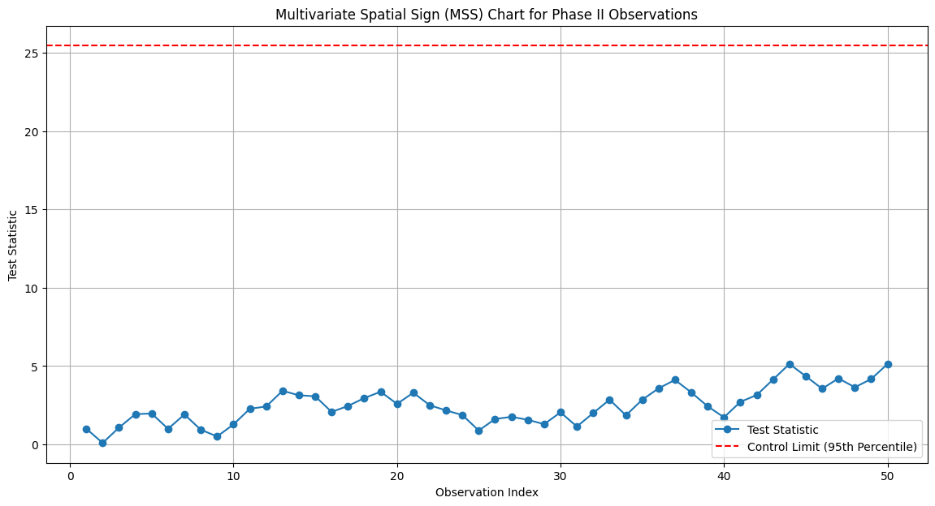

#### Non-Parametric → ****Multivariate Spatial Sign (MSS) Chart**** with Covariance EWMA

**Key Reason for Using the Outer Product in Covariance Calculation**

The outer product is used in the covariance matrix calculation to measure the joint variability (covariance) between pairs of variables. This method ensures that all pairwise interactions between variables are accounted for in a structured manner.

**Specific Reasoning:**

1. Captures Joint Variability:

- When calculating the covariance matrix, we need to measure how each pair of variables changes together. The outer product of a deviation vector with itself captures the product of deviations for every possible pair of elements (variables) in the vector.

- For a vector is an observation and is the mean vector, the outer product creates a matrix where:

- Diagonal elements represent the variance contributions (squared deviations).

- Off-diagonal elements represent the covariance contributions (products of deviations).

**Example Calculation**

Consider a dataset with two variables, and and three observations:

1. Mean Vector:

2. Deviation Vectors:

3. Outer Products:

4. Covariance Matrix:

Summary

The outer product \(\mathbf{d}\_i \mathbf{d}\_i^T\) is used because it efficiently captures both variance (along the diagonal) and covariance (off-diagonal) between all pairs of variables in a dataset. This structured approach ensures that the covariance matrix accurately represents how variables jointly vary, providing a comprehensive measure of their relationships.

Python Code for Spatial Signs Control Charts

1. import numpy as np

2. import matplotlib.pyplot as plt

3. from scipy.stats import multivariate\_normal

4.

5. def generate\_data(mean, cov, num\_samples):

6. """Generate multivariate normal data."""

7. return multivariate\_normal.rvs(mean=mean, cov=cov, size=num\_samples)

8.

9. def calculate\_spatial\_signs(data, center):

10. """Calculate spatial signs for each observation."""

11. spatial\_signs = []

12. for observation in data:

13. sign = (observation - center) / np.linalg.norm(observation - center)

14. spatial\_signs.append(sign)

15. return np.array(spatial\_signs)

16.

17. def calculate\_spatial\_sign\_covariance\_matrix(spatial\_signs):

18. """Calculate the spatial sign covariance matrix."""

19. return np.cov(spatial\_signs.T)

20.

21. def ewma(statistics, lambda\_):

22. """Calculate EWMA statistics."""

23. ewma\_stats = [statistics[0]]

24. for i in range(1, len(statistics)):

25. ewma\_stat = lambda\_ \* statistics[i] + (1 - lambda\_) \* ewma\_stats[-1]

26. ewma\_stats.append(ewma\_stat)

27. return ewma\_stats

28.

29. # Simulation parameters

30. mean = [5, 10]

31. cov = [[1, 0.5], [0.5, 1]]

32. num\_samples\_phase\_1 = 50

33. num\_samples\_phase\_2 = 30

34. lambda\_ = 0.2 # EWMA smoothing parameter

35.

36. # Generate Phase I (in-control) and Phase II (out-of-control) data

37. data\_phase\_1 = generate\_data(mean, cov, num\_samples\_phase\_1)

38. data\_phase\_2 = generate\_data(mean, cov, num\_samples\_phase\_2) + np.array([1, 1]) # Introducing a shift

39.

40. # Combine data

41. data = np.vstack((data\_phase\_1, data\_phase\_2))

42.

43. # Calculate center (median) from Phase I data

44. center = np.median(data\_phase\_1, axis=0)

45.

46. # Calculate spatial signs for all data

47. spatial\_signs = calculate\_spatial\_signs(data, center)

48.

49. # Calculate spatial sign covariance matrix

50. spatial\_sign\_cov\_matrix = calculate\_spatial\_sign\_covariance\_matrix(spatial\_signs[:num\_samples\_phase\_1])

51.

52. # Calculate EWMA statistics

53. ewma\_stats = []

54. for i in range(num\_samples\_phase\_1, len(spatial\_signs)):

55. new\_cov\_matrix = calculate\_spatial\_sign\_covariance\_matrix(spatial\_signs[i-num\_samples\_phase\_1:i+1])

56. ewma\_stat = np.linalg.norm(new\_cov\_matrix - spatial\_sign\_cov\_matrix)

57. ewma\_stats.append(ewma\_stat)

58.

59. # Plot EWMA Control Chart

60. plt.figure(figsize=(10, 6))

61. plt.plot(ewma\_stats, marker='o', linestyle='-', color='b')

62. plt.axhline(y=np.mean(ewma\_stats) + 3 \* np.std(ewma\_stats), color='r', linestyle='--', label='UCL')

63. plt.axhline(y=np.mean(ewma\_stats) - 3 \* np.std(ewma\_stats), color='r', linestyle='--', label='LCL')

64. plt.xlabel('Sample Number')

65. plt.ylabel('EWMA Statistic')

66. plt.title('EWMA Control Chart for Spatial Signs')

67. plt.legend()

68. plt.grid(True)

69. plt.show()

70.

**Explanation**:

1. Data Generation:

- `generate\_data` function generates multivariate normal data for Phase I (in-control) and Phase II (out-of-control).

- Phase II data includes a shift to simulate an out-of-control process.

2. Spatial Signs Calculation:

- `calculate\_spatial\_signs` function computes the spatial signs for each observation by normalizing the deviation from the center (median of Phase I data).

3. Spatial Sign Covariance Matrix:

- `calculate\_spatial\_sign\_covariance\_matrix` function calculates the covariance matrix of spatial signs.

4. EWMA Calculation:

- `ewma` function calculates the Exponentially Weighted Moving Average (EWMA) statistics for the spatial sign covariance matrices.

5. Plotting:

- The EWMA control chart is plotted, with Upper Control Limit (UCL) and Lower Control Limit (LCL) set at three standard deviations from the mean of the EWMA statistics.

This code simulates a quality control scenario using spatial signs control charts, providing a method to detect shifts in the covariance structure of a multivariate process.

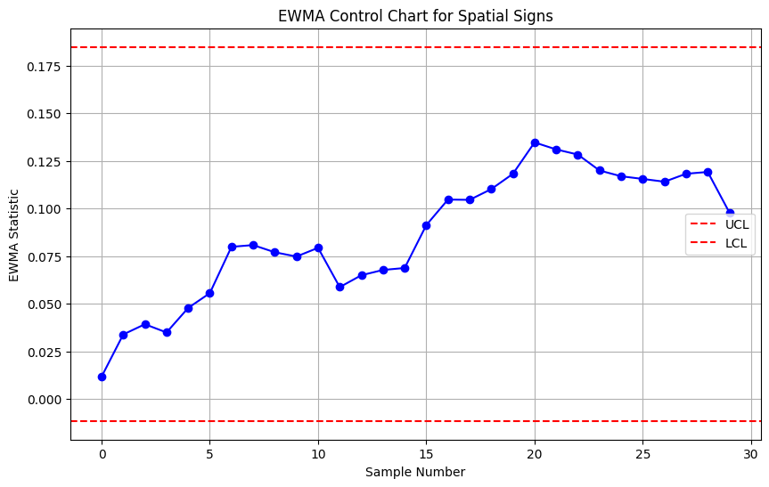

#### Non-Parametric → Multivariate Spatial Rank (MSR) ****Chart****

**Mathematical Foundation:**

The Multivariate Spatial Rank (MSR) Chart is a non-parametric control chart that monitors the location of a multivariate process by utilizing spatial ranks. Spatial ranks are based on the relative ordering of data points rather than their actual values, making the method robust to outliers and effective for non-normal data.

**Steps to Construct an MSR Chart:**

1. Calculate the Multivariate Median:

- The multivariate median minimizes the sum of Euclidean distances to all data points.

2. Compute Spatial Ranks:

- The spatial rank of a data point is calculated by comparing it with all other data points :

where denotes the Euclidean norm.

3. Calculate the Test Statistic:

- The test statistic is the sum of spatial ranks for a given subgroup of data points:

4. Control Limits:

- Control limits for the MSR chart are typically set using a bootstrap method or based on historical data to account for the non-parametric nature of the chart.

**Numerical Example:**

Let's consider a simple numerical example with a small dataset to illustrate the MSR chart.

Historical Data (Phase I):



New Data (Phase II):



Step-by-Step Calculation:

Step 1: Calculate the Multivariate Median

For simplicity, let's assume the multivariate median is known and calculated as:



Step 2: Compute Spatial Ranks

Calculate the spatial ranks for each data point:

For :

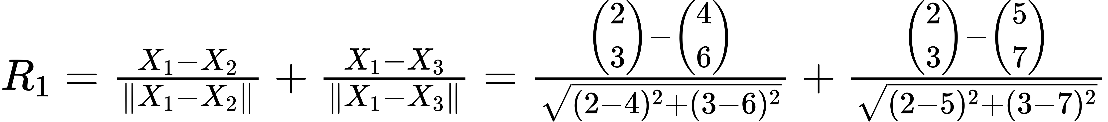

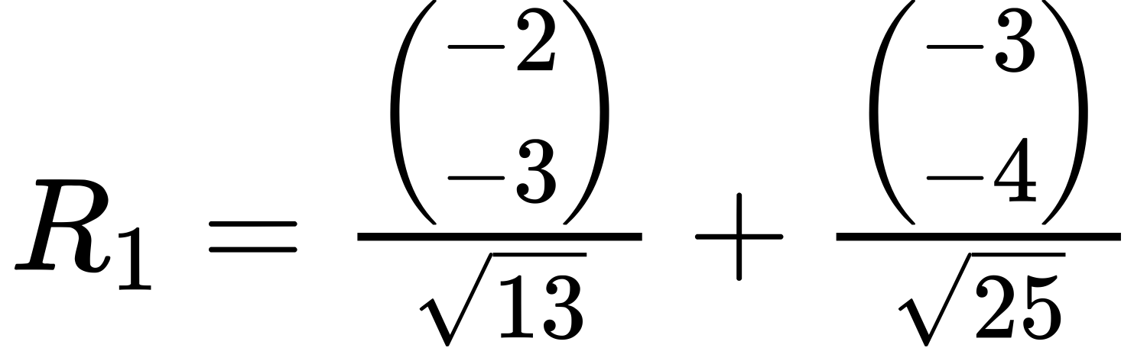

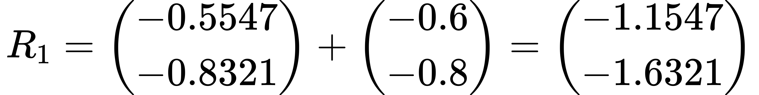

For :

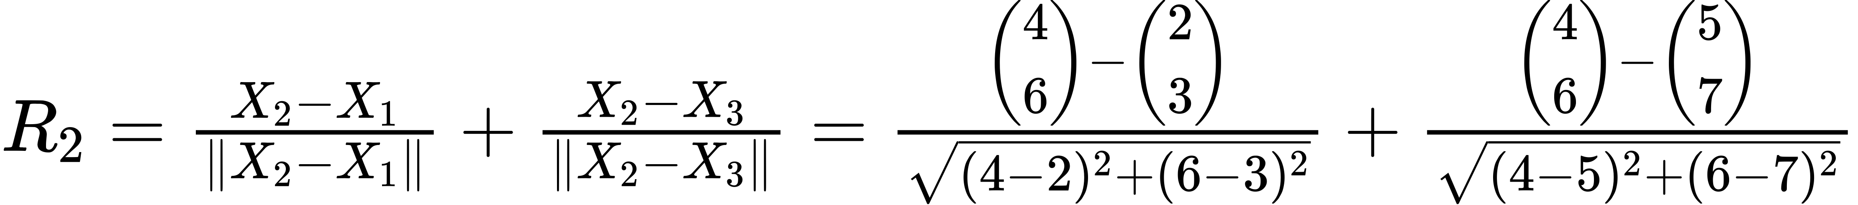

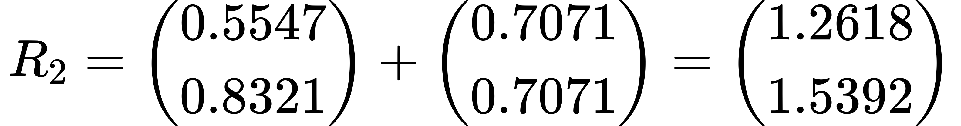

For :

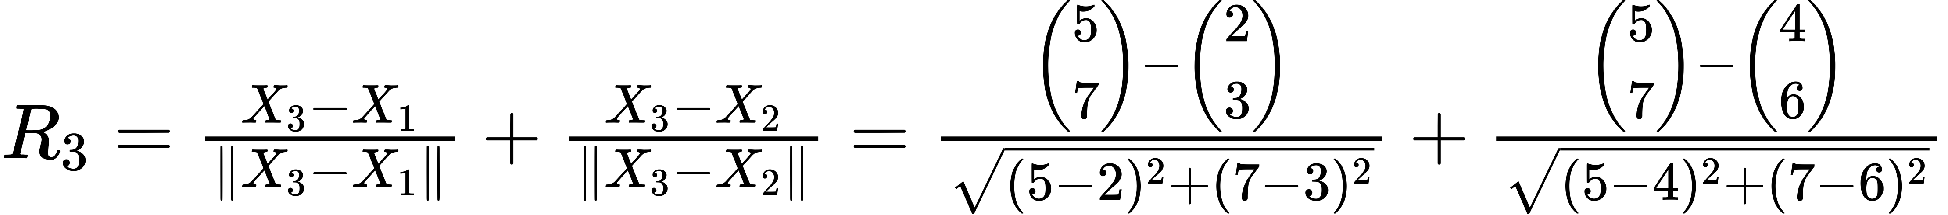

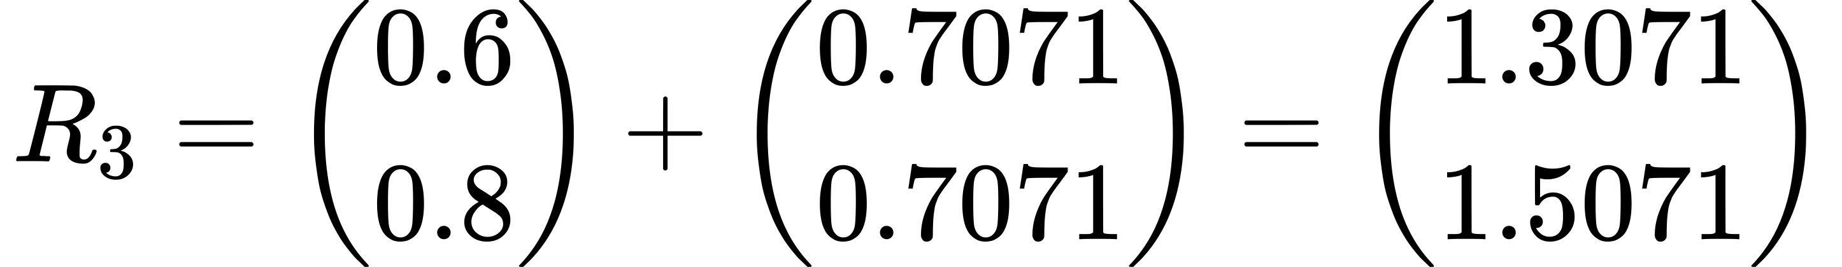

Step 3: Calculate the Test Statistic

Sum the spatial ranks for the new data points (Phase II):

Step 4: Control Limits

In practice, control limits are determined using historical data or bootstrapping methods. For simplicity, assume the control limit is set based on historical data.

Python Example

import numpy as np

import matplotlib.pyplot as plt

from sklearn.covariance import MinCovDet

# Generate synthetic data for two variables in a production process

np.random.seed(42)

n\_phase1 = 200

n\_phase2 = 50

# Historical data (Phase I) - assume a bivariate normal distribution

mean\_phase1 = [10, 15]

cov\_phase1 = [[5, 2], [2, 3]]

data\_phase1 = np.random.multivariate\_normal(mean\_phase1, cov\_phase1, n\_phase1)

# New data (Phase II) - assume a shift in the covariance structure

mean\_phase2 = [10, 15]

cov\_phase2 = [[8, 3], [3, 4]]

data\_phase2 = np.random.multivariate\_normal(mean\_phase2, cov\_phase2, n\_phase2)

# Combine data for convenience

data = np.vstack((data\_phase1, data\_phase2))

# Calculate the multivariate median using Minimum Covariance Determinant (MCD)

mcd = MinCovDet().fit(data\_phase1)

multivariate\_median = mcd.location\_

# Function to compute spatial ranks

def spatial\_rank(data):

ranks = []

for i in range(len(data)):

rank\_sum = np.sum([(data[i] - data[j]) / np.linalg.norm(data[i] - data[j]) for j in range(len(data)) if i != j], axis=0)

ranks.append(rank\_sum)

return np.array(ranks)

# Compute spatial ranks for historical data (Phase I)

spatial\_ranks\_phase1 = spatial\_rank(data\_phase1)

# Compute spatial ranks for new data (Phase II)

spatial\_ranks\_phase2 = spatial\_rank(data\_phase2)

# Calculate the test statistics for Phase II

test\_statistics = np.cumsum(spatial\_ranks\_phase2, axis=0)

# Calculate control limits using Phase I data

bootstrap\_samples = 1000

bootstrap\_statistics = []

for \_ in range(bootstrap\_samples):

sample\_indices = np.random.choice(range(n\_phase1), n\_phase1, replace=True)

bootstrap\_sample = data\_phase1[sample\_indices]

bootstrap\_spatial\_ranks = spatial\_rank(bootstrap\_sample)

bootstrap\_statistic = np.sum(bootstrap\_spatial\_ranks, axis=0)

bootstrap\_statistics.append(np.linalg.norm(bootstrap\_statistic))

control\_limit = np.percentile(bootstrap\_statistics, 95)

# Plotting the MSR chart

plt.figure(figsize=(14, 7))

plt.plot(range(1, len(test\_statistics) + 1), np.linalg.norm(test\_statistics, axis=1), marker='o', linestyle='-', label='Test Statistic')

plt.axhline(y=control\_limit, color='r', linestyle='--', label='Control Limit (95th Percentile)')

plt.xlabel('Observation Index')

plt.ylabel('Test Statistic')

plt.title('Multivariate Spatial Rank (MSR) Chart for Phase II Observations')

plt.legend()

plt.grid(True)

plt.show() bootstrap\_statistic = np.sum(bootstrap\_spatial\_ranks, axis=0)

bootstrap\_statistics.append(np.linalg.norm(bootstrap\_statistic))

control\_limit = np.percentile(bootstrap\_statistics, 95)

# Plotting the MSR chart

plt.figure(figsize=(14, 7))

plt.plot(range(1, len(test\_statistics) + 1), np.linalg.norm(test\_statistics, axis=1), marker='o', linestyle='-', label='Test Statistic')

plt.axhline(y=control\_limit, color='r', linestyle='--', label='Control Limit (95th Percentile)')

plt.xlabel('Observation Index')

plt.ylabel('Test Statistic')

plt.title('Multivariate Spatial Rank (MSR) Chart for

**Explanation:**

1. Data Generation:

- Phase I (Historical Data): Simulate 200 observations from a bivariate normal distribution.

- Phase II (New Data): Simulate 50 new observations from a bivariate normal distribution with a different covariance structure to simulate a shift.

2. Calculate Multivariate Median:

- Use the Minimum Covariance Determinant (MCD) method to compute a robust estimate of the multivariate median from the historical data.

3. Compute Spatial Ranks:

- Calculate the spatial ranks for each data point by summing the relative differences between each point and all other points.

4. Calculate Test Statistics:

- Sum the spatial ranks cumulatively for the new data points to obtain the test statistics.

5. Determine Control Limits:

- Use a bootstrap approach with 1000 samples from the historical data to estimate the control limit. The 95th percentile of the bootstrap statistics is used as the control limit.

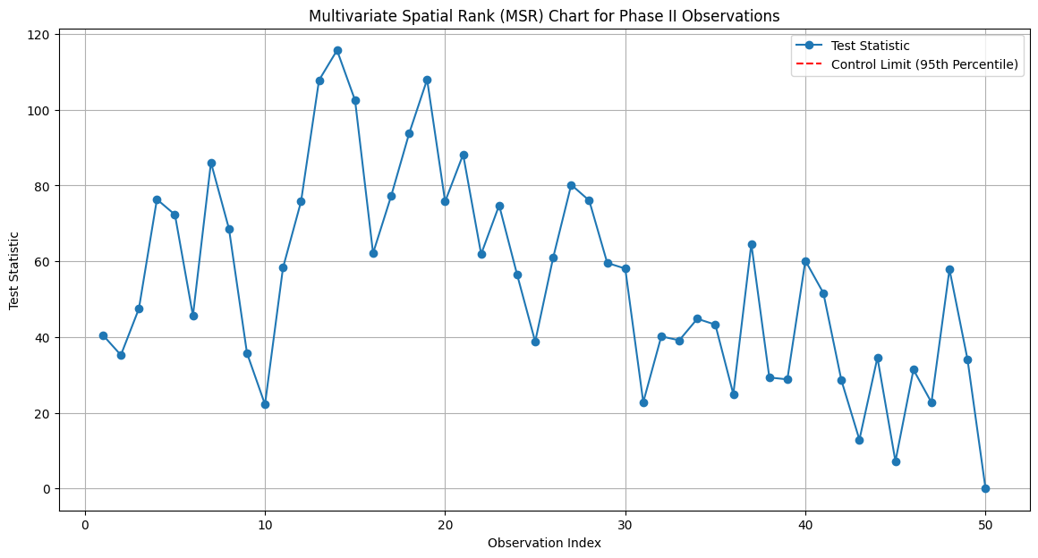

#### Non-Parametric → Multivariate Spatial Rank (MSR) ****Chart**** EWMA

Spatial Rank Control Charts

Spatial rank control charts are a type of nonparametric multivariate statistical process control (SPC) tool used to monitor the central tendency and variability of a multivariate process. Unlike traditional control charts that assume a specific distribution for the data (e.g., normal distribution), spatial rank control charts are robust to deviations from these assumptions and are effective for detecting shifts in the process mean and covariance structure.

Key Concepts

1. Spatial Rank:

- The spatial rank of an observation is a vector that represents its relative position compared to other observations in the dataset.

- It is calculated as the direction from a reference point (e.g., median or centroid) to the observation, normalized by the Euclidean distance.

2. Nonparametric Nature:

- Spatial rank control charts do not assume a specific data distribution, making them robust for non-normal data.

- They are based on the ranks of data points rather than the raw values, which provides robustness against outliers.

3. Application:

- Useful in monitoring multivariate processes where the data distribution is unknown or not normal.

- Effective in detecting shifts in the central location and variability of the process.

Steps to Construct a Spatial Rank Control Chart

1. Data Collection:

- Collect a sample of multivariate data points from the process. Typically, the data is split into Phase I (in-control data) and Phase II (monitoring phase).

2. Reference Point Calculation:

- Calculate the reference point (e.g., the multivariate median) from the Phase I data. This serves as the central point for calculating spatial ranks.

3. Spatial Rank Calculation:

- For each observation , calculate the spatial rank vector:

=

where is the reference point (e.g., median), and denotes the Euclidean norm.

4. Rank Covariance Matrix:

- Compute the covariance matrix of the spatial ranks for the Phase I data. This matrix captures the variability structure of the process in the in-control state.

5. Monitoring Statistic:

- Use a suitable monitoring statistic, such as the squared Mahalanobis distance, to detect shifts in the process:

where \(\mathbf{S}\) is the rank covariance matrix.

6. Control Limits:

- Establish control limits for the monitoring statistic. These limits can be based on a chi-squared distribution, simulations, or historical data.

7. Plotting and Interpretation:

- Plot the monitoring statistic for Phase II data and compare it to the control limits. Points outside the control limits indicate potential out-of-control conditions.

Example: Python Code for Spatial Rank Control Chart

import numpy as np

import matplotlib.pyplot as plt

from scipy.stats import chi2

def generate\_data(mean, cov, num\_samples):

"""Generate multivariate normal data."""

return np.random.multivariate\_normal(mean, cov, num\_samples)

def calculate\_spatial\_ranks(data, center):

"""Calculate spatial ranks for each observation."""

spatial\_ranks = []

for observation in data:

rank = (observation - center) / np.linalg.norm(observation - center)

spatial\_ranks.append(rank)

return np.array(spatial\_ranks)

def calculate\_rank\_covariance\_matrix(spatial\_ranks):

"""Calculate the rank covariance matrix."""

return np.cov(spatial\_ranks.T)

def calculate\_mahalanobis\_distance(rank, cov\_matrix\_inv):

"""Calculate the squared Mahalanobis distance for the rank vector."""

return np.dot(np.dot(rank, cov\_matrix\_inv), rank)

# Simulation parameters

mean = [5, 10]

cov = [[1, 0.5], [0.5, 1]]

num\_samples\_phase\_1 = 50

num\_samples\_phase\_2 = 30

# Generate Phase I (in-control) and Phase II (out-of-control) data

data\_phase\_1 = generate\_data(mean, cov, num\_samples\_phase\_1)

data\_phase\_2 = generate\_data(mean, cov, num\_samples\_phase\_2) + np.array([1, 1]) # Introducing a shift

# Combine data

data = np.vstack((data\_phase\_1, data\_phase\_2))

# Calculate center (median) from Phase I data

center = np.median(data\_phase\_1, axis=0)

# Calculate spatial ranks for all data

spatial\_ranks = calculate\_spatial\_ranks(data, center)

# Calculate rank covariance matrix

rank\_cov\_matrix = calculate\_rank\_covariance\_matrix(spatial\_ranks[:num\_samples\_phase\_1])

rank\_cov\_matrix\_inv = np.linalg.inv(rank\_cov\_matrix)

# Calculate Mahalanobis distances

mahalanobis\_distances = []

for rank in spatial\_ranks[num\_samples\_phase\_1:]:

distance = calculate\_mahalanobis\_distance(rank, rank\_cov\_matrix\_inv)

mahalanobis\_distances.append(distance)

# Plot Spatial Rank Control Chart

plt.figure(figsize=(10, 6))

plt.plot(mahalanobis\_distances, marker='o', linestyle='-', color='b')

chi2\_threshold = chi2.ppf(0.99, df=2) # 99% confidence level, df = number of variables

plt.axhline(y=chi2\_threshold, color='r', linestyle='--', label='99% Control Limit')

plt.xlabel('Sample Number')

plt.ylabel('Squared Mahalanobis Distance')

plt.title('Spatial Rank Control Chart')

plt.legend()

plt.grid(True)

plt.show()

Explanation of the Code

1. Data Generation:

- `generate\_data`: Generates multivariate normal data for Phase I and Phase II.

- Phase II data includes a shift to simulate an out-of-control process.

2. Spatial Ranks Calculation:

- `calculate\_spatial\_ranks`: Computes the spatial ranks for each observation using the median of the Phase I data as the center.

3. Rank Covariance Matrix:

- `calculate\_rank\_covariance\_matrix`: Calculates the covariance matrix of the spatial ranks for the Phase I data.

4. Mahalanobis Distance:

- `calculate\_mahalanobis\_distance`: Computes the squared Mahalanobis distance for each spatial rank vector to detect deviations from the in-control process.

5. Plotting:

- The spatial rank control chart is plotted, with a control limit based on the chi-squared distribution.

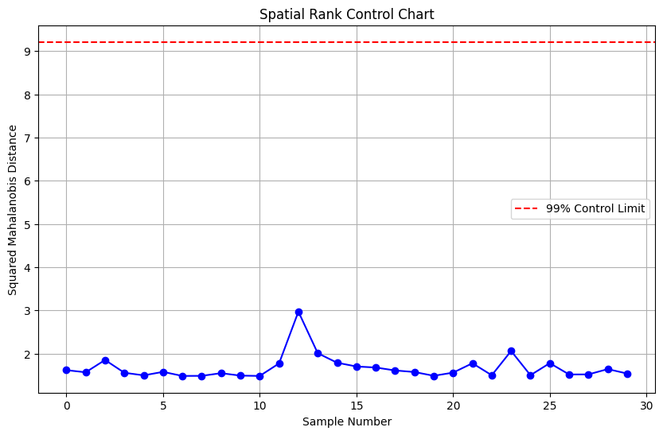

#### Non-Parametric → Multivariate Spatial Rank (MSR) ****Chart****

**Mathematical Foundation**

1. Multivariate Median:

- The multivariate median minimizes the sum of Euclidean distances to all data points.

2. Spatial Signs:

- The spatial sign of a data point is:

where denotes the Euclidean norm.

3. Spatial Ranks:

- The spatial rank of a data point is:

4. Test Statistic:

- The test statistic is a combination of the sums of spatial signs and spatial ranks:

5. Control Limits:

- Control limits are set using historical data or bootstrap methods.

**Numerical Example**

Let's consider a simple numerical example with a small dataset to illustrate the MSR chart.

Historical Data (Phase I):



New Data (Phase II):



Step-by-Step Calculation

Step 1: Calculate the Multivariate Median

For simplicity, let's assume the multivariate median is known and calculated as:



Step 2: Compute Spatial Signs

Calculate the spatial signs for each data point:

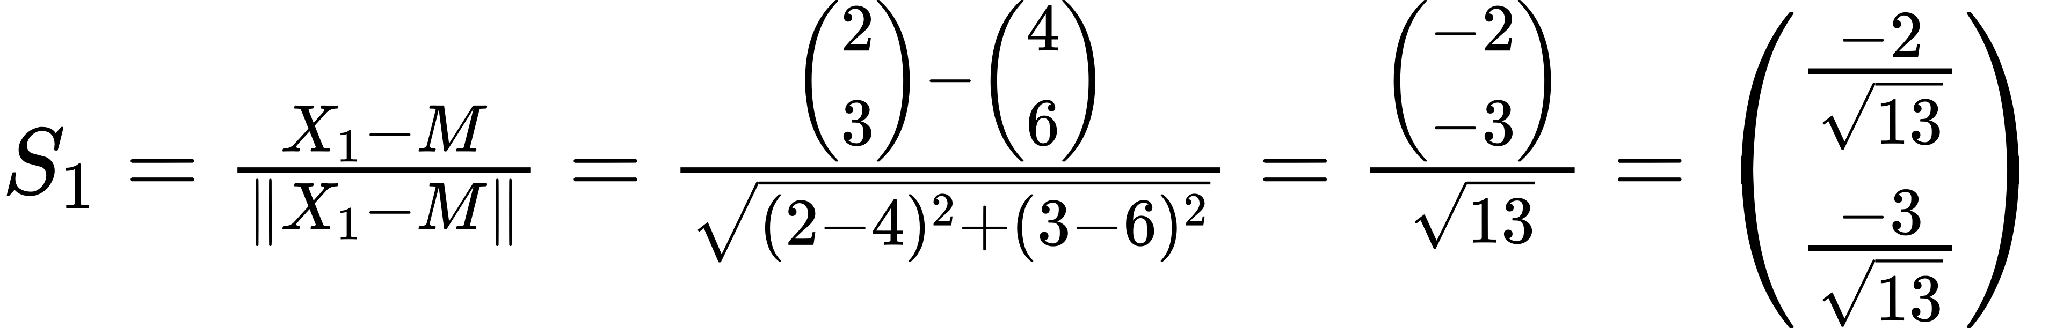

Similarly, calculate and for the other historical data points.

Step 3: Compute Spatial Ranks

Calculate the spatial ranks for each data point:

Since , we have:

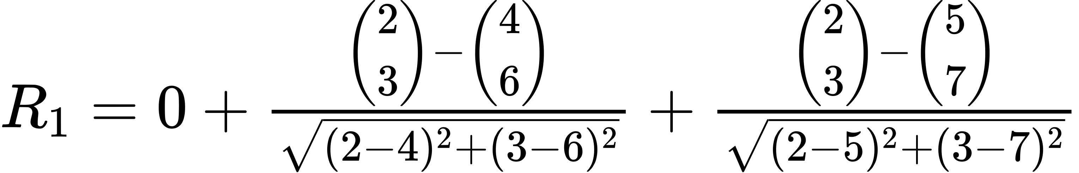

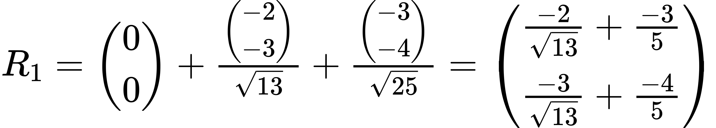

Similarly, calculate and for the other historical data points.

Step 4: Calculate the Test Statistic for New Data

Sum the spatial signs and spatial ranks for the new data points (Phase II):

For :

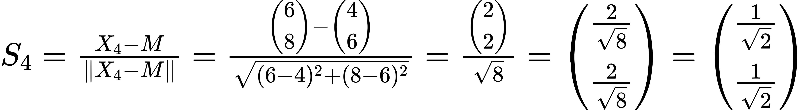



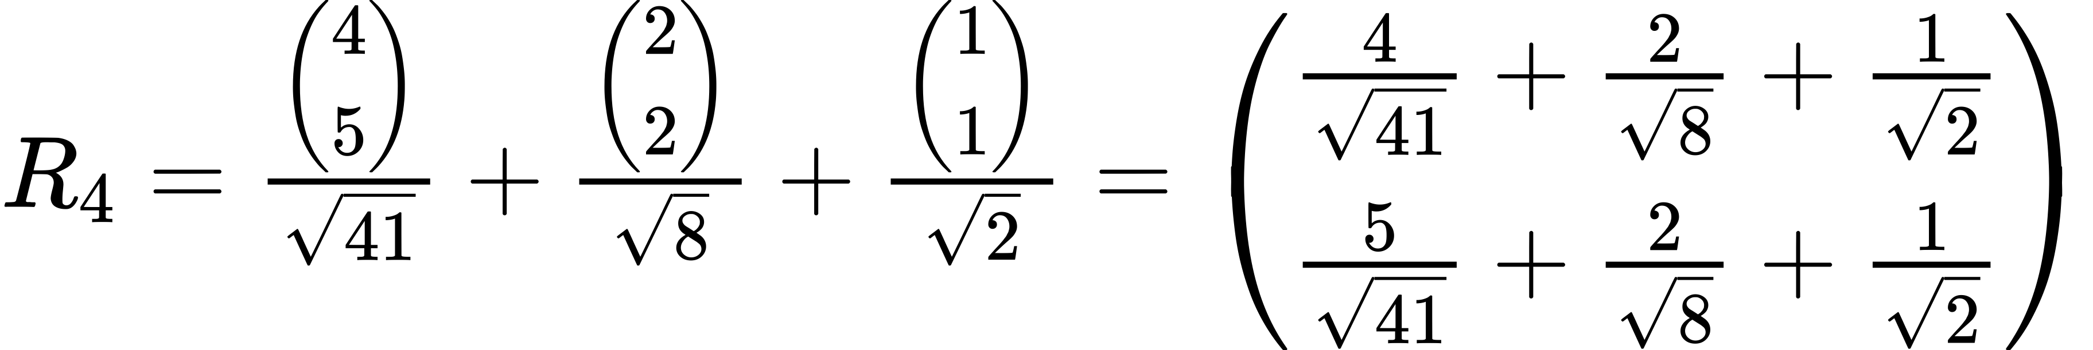

Test Statistic for :

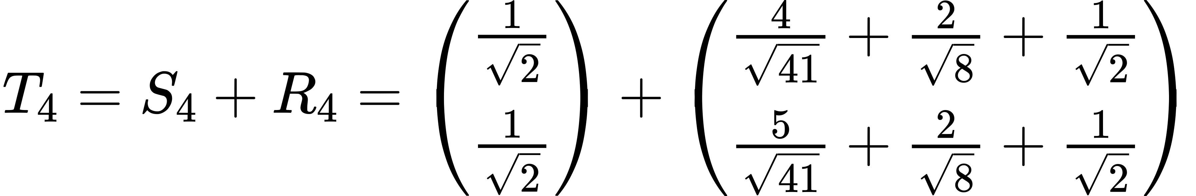

For :

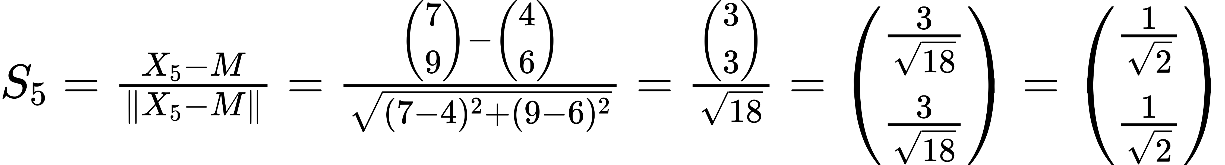



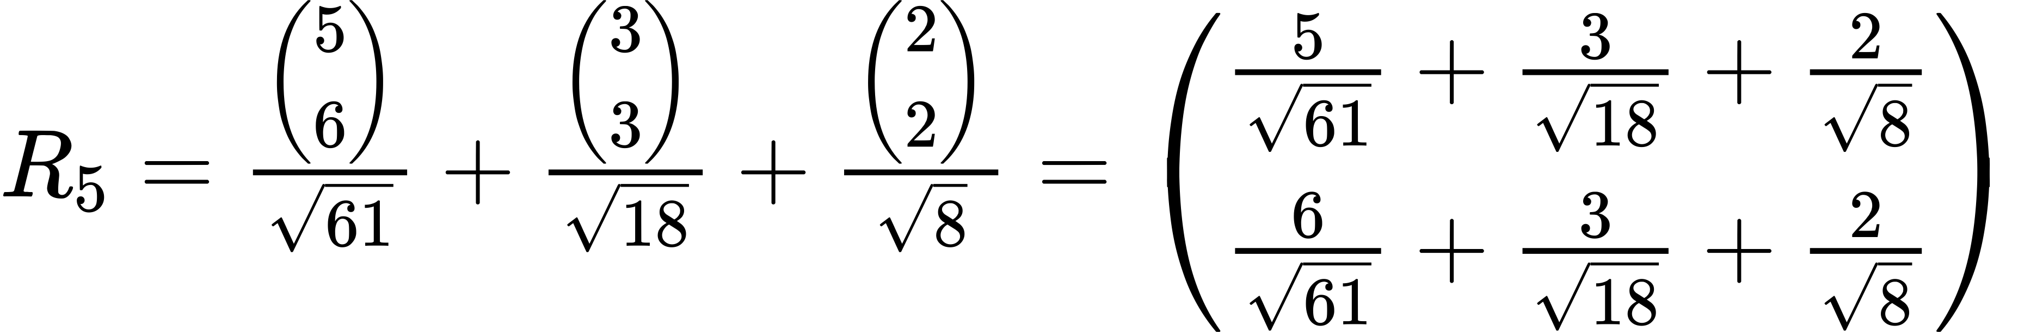

Test Statistic for :

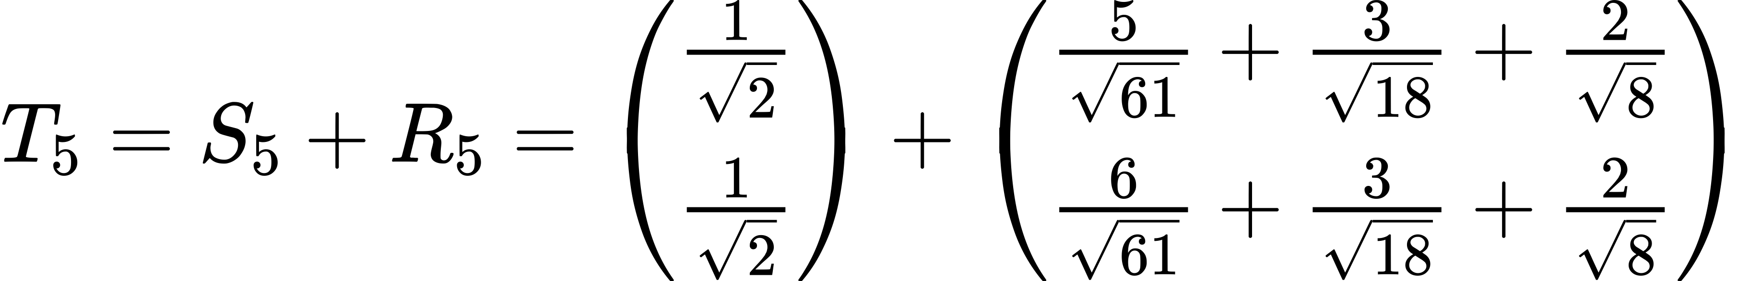

Step 5: Interpretation

To determine if the process is in control, compare the test statistics and to control limits established from historical data or bootstrap samples.

1. If or exceed the control limit:

- The process is considered out of control.

- Investigate potential causes for the shift or anomaly in the process.

2. If and are within the control limit:

- The process is considered in control.

- Continue monitoring to ensure the process remains stable.

Conclusion

The Multivariate Sign and Rank (MSR) Control Charts combine the robustness of spatial signs with the sensitivity of spatial ranks, making them effective for detecting shifts in multivariate processes without relying on specific distributional assumptions. By calculating the test statistics for new observations and comparing them to established control limits, you can monitor the stability of the process and identify potential issues.

Python Code

import numpy as np

import matplotlib.pyplot as plt

from sklearn.covariance import MinCovDet

# Generate synthetic data for two variables in a production process

np.random.seed(42)

n\_phase1 = 200

n\_phase2 = 50

# Historical data (Phase I) - assume a bivariate normal distribution

mean\_phase1 = [10, 15]

cov\_phase1 = [[5, 2], [2, 3]]

data\_phase1 = np.random.multivariate\_normal(mean\_phase1, cov\_phase1, n\_phase1)

# New data (Phase II) - assume a shift in the covariance structure

mean\_phase2 = [10, 15]

cov\_phase2 = [[8, 3], [3, 4]]

data\_phase2 = np.random.multivariate\_normal(mean\_phase2, cov\_phase2, n\_phase2)

# Combine data for convenience

data = np.vstack((data\_phase1, data\_phase2))

# Calculate the multivariate median using Minimum Covariance Determinant (MCD)

mcd = MinCovDet().fit(data\_phase1)

multivariate\_median = mcd.location\_

# Function to compute spatial signs

def spatial\_sign(data, median):

deviations = data - median

norms = np.linalg.norm(deviations, axis=1, keepdims=True)

return deviations / norms

# Function to compute spatial ranks

def spatial\_rank(data):

ranks = []

for i in range(len(data)):

rank\_sum = np.sum([(data[i] - data[j]) / np.linalg.norm(data[i] - data[j]) for j in range(len(data)) if i != j], axis=0)

ranks.append(rank\_sum)

return np.array(ranks)

# Compute spatial signs and ranks for historical data (Phase I)

spatial\_signs\_phase1 = spatial\_sign(data\_phase1, multivariate\_median)

spatial\_ranks\_phase1 = spatial\_rank(data\_phase1)

# Compute spatial signs and ranks for new data (Phase II)

spatial\_signs\_phase2 = spatial\_sign(data\_phase2, multivariate\_median)

spatial\_ranks\_phase2 = spatial\_rank(data\_phase2)

# Calculate the test statistics for Phase II

test\_statistics = np.cumsum(spatial\_signs\_phase2 + spatial\_ranks\_phase2, axis=0)

# Calculate control limits using Phase I data

bootstrap\_samples = 1000

bootstrap\_statistics = []

for \_ in range(bootstrap\_samples):

sample\_indices = np.random.choice(range(n\_phase1), n\_phase1, replace=True)

bootstrap\_sample = data\_phase1[sample\_indices]

bootstrap\_spatial\_signs = spatial\_sign(bootstrap\_sample, multivariate\_median)

bootstrap\_spatial\_ranks = spatial\_rank(bootstrap\_sample)

bootstrap\_statistic = np.sum(bootstrap\_spatial\_signs + bootstrap\_spatial\_ranks, axis=0)

bootstrap\_statistics.append(np.linalg.norm(bootstrap\_statistic))

control\_limit = np.percentile(bootstrap\_statistics, 95)

# Plotting the MSR chart

plt.figure(figsize=(14, 7))

plt.plot(range(1, len(test\_statistics) + 1), np.linalg.norm(test\_statistics, axis=1), marker='o', linestyle='-', label='Test Statistic')

plt.axhline(y=control\_limit, color='r', linestyle='--', label='Control Limit (95th Percentile)')

plt.xlabel('Observation Index')

plt.ylabel('Test Statistic')

plt.title('Multivariate Sign and Rank (MSR) Chart for Phase II Observations')

plt.legend()

plt.grid(True)

plt.show()

**Explanation:**

1. Data Generation:

- Phase I (Historical Data): Simulate 200 observations from a bivariate normal distribution.

- Phase II (New Data): Simulate 50 new observations from a bivariate normal distribution with a different covariance structure to simulate a shift.

2. Calculate Multivariate Median:

- Use the Minimum Covariance Determinant (MCD) method to compute a robust estimate of the multivariate median from the historical data.

3. Compute Spatial Signs:

- Calculate the spatial signs for each data point by normalizing the deviations from the multivariate median.

4. Compute Spatial Ranks:

- Calculate the spatial ranks for each data point by summing the relative differences between each point and all other points.

5. Calculate Test Statistics:

- Sum the spatial signs and ranks cumulatively for the new data points to obtain the test statistics.

6. Determine Control Limits:

- Use a bootstrap approach with 1000 samples from the historical data to estimate the control limit. The 95th percentile of the bootstrap statistics is used as the control limit.

7. Plot the Results:

- Plot the test statistics for the new data points against the observation index and include the control limit for comparison.

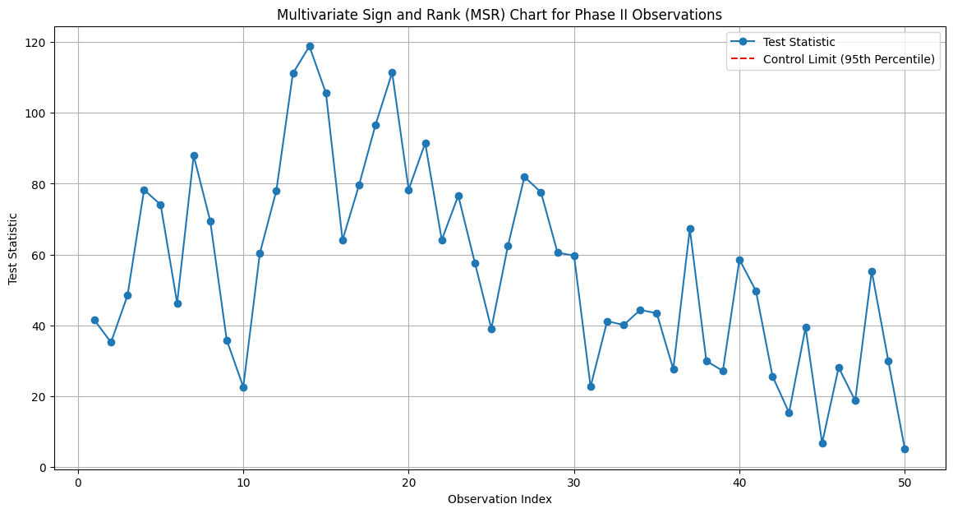

#### Comparison of Non-Parametric Control Charts: MSS, MSR, and Combined MSR Charts

Let's compare the three non-parametric control charts: Multivariate Spatial Sign (MSS) Chart, Multivariate Spatial Rank (MSR) Chart, and the Combined Multivariate Sign and Rank (MSR) Chart. We'll highlight their key differences, advantages, and typical use cases.

**1. Multivariate Spatial Sign (MSS) Chart**

Key Characteristics:

- Methodology: Uses spatial signs to monitor the direction of data points from the multivariate median.

- Computation: Converts data points into directions by normalizing the deviations from the median.

- Robustness: Robust to outliers and effective for non-normal data.

Advantages:

- Does not assume any specific data distribution.

- Effective in detecting shifts in location.

Disadvantages:

- Might not be as sensitive to small shifts as the MSR chart.

Typical Use Cases:

- When the primary interest is in the direction and magnitude of shifts in the process location.

**2. Multivariate Spatial Rank (MSR) Chart**

Key Characteristics:

- Methodology: Uses spatial ranks to monitor the relative ordering of data points.

- Computation: Based on the sum of relative differences between data points.

- Robustness: Inherits robustness properties and is effective for non-normal distributions.

Advantages:

- More sensitive to small shifts compared to the MSS chart.

- Does not rely on specific distributional assumptions.

Disadvantages:

- Computationally more intensive than the MSS chart.

Typical Use Cases:

- When detecting small shifts in the process is crucial.

- When dealing with data with unknown or non-normal distributions.

**3. Combined Multivariate Sign and Rank (MSR) Chart**

Key Characteristics:

- Methodology: Combines both spatial signs and spatial ranks to enhance robustness and sensitivity.

- Computation: Integrates both spatial signs and ranks to monitor the process.

- Robustness: Combines the robustness of MSS and the sensitivity of MSR.

Advantages:

- Provides a comprehensive monitoring tool by leveraging the strengths of both MSS and MSR.

- Effective in a wide range of scenarios, including high-dimensional settings.

Disadvantages:

- More complex to implement and compute compared to individual MSS or MSR charts.

Typical Use Cases:

- When a comprehensive detection of shifts in location is needed.

- Suitable for high-dimensional data and scenarios where data may not follow any known distribution.

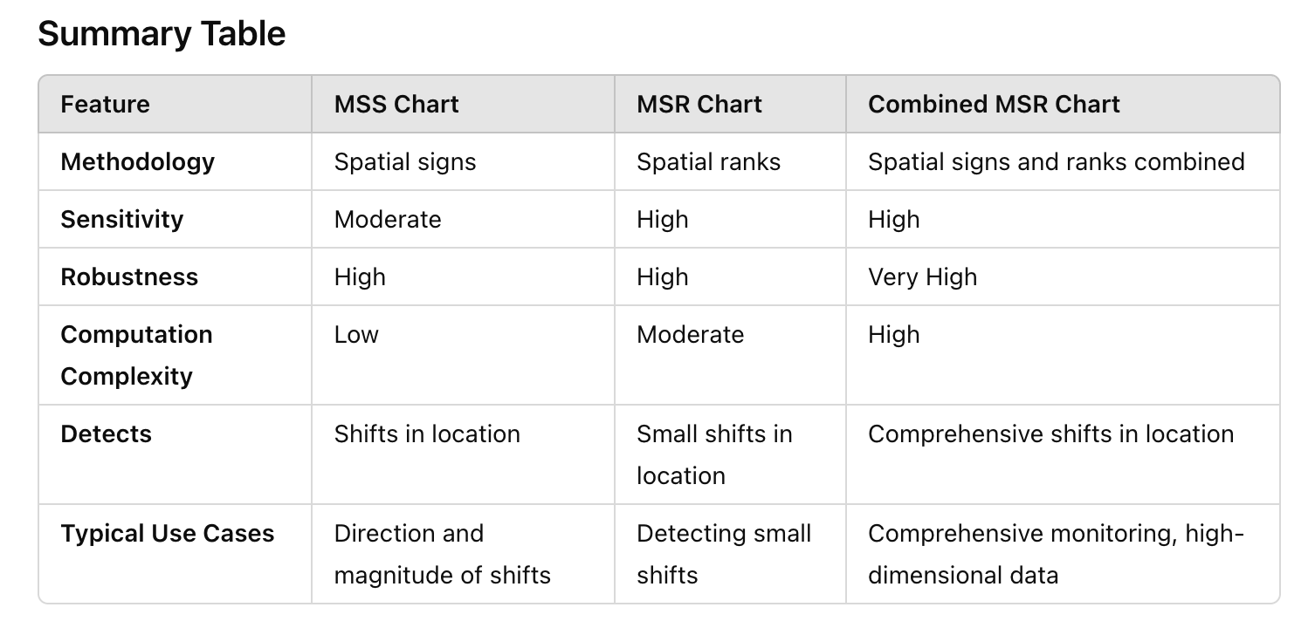

**Numerical Example Comparison**

Assume we have the same dataset as before:

Historical Data (Phase I):



New Data (Phase II):

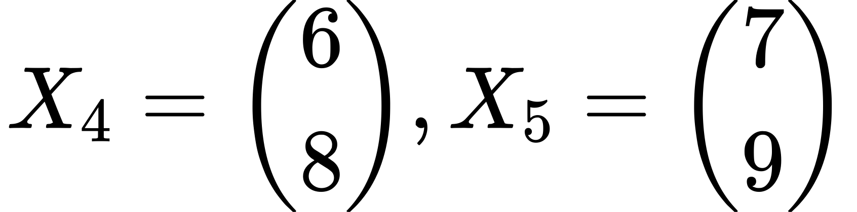

- MSS Chart: Calculate spatial signs for new data:

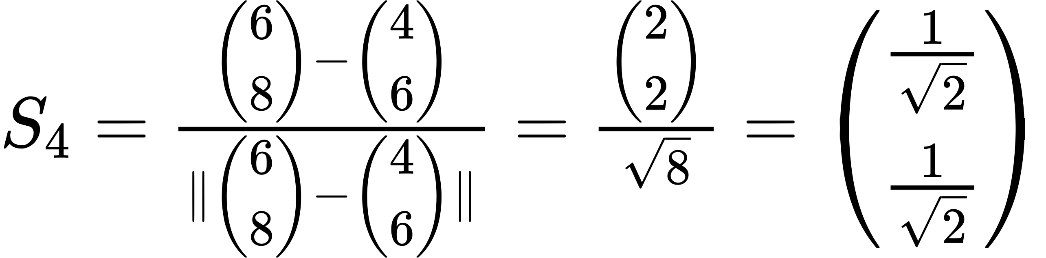

- MSR Chart: Calculate spatial ranks for new data:

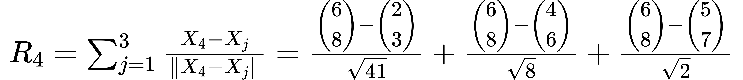

- Combined MSR Chart: Combine spatial signs and ranks:

By calculating and comparing these test statistics against control limits established from historical data, you can determine if the process is in control or if there are significant shifts.

### Multivariate Charts for High-Dimensional Data

In the category focusing on charts for high dimensional data, the paper reviews four articles that propose specialized methods for handling situations where the number of variables (p) is large relative to the sample size. These methods are particularly relevant in modern applications where data dimensionality is high, making traditional techniques less effective.

Here's a bit more detail on each of the discussed methods in this category:

1. Dissimilarity Index Method: Introduced by Huwang et al. (2017), this method employs an exponentially weighted moving average (EWMA) statistic combined with a dissimilarity index to monitor the covariance matrix. The index measures how much the current state deviates from a control state, making it particularly suitable for high-dimensional data. The method is noted for its non-parametric nature, meaning it does not assume a specific distribution for the data.

2. MVP (Multivariate Variability Profile) Chart: Proposed by Li and Tsung (2019), the MVP chart integrates a high-dimensional covariance matrix test with EWMA statistics to monitor variability in individual observations. This chart is effective in detecting changes that occur in a few elements of the covariance matrix without the need for tuning parameters to achieve sparsity.

3. RPLR (Ridge Penalized Likelihood Ratio) Method: Developed by Kim et al. (2019), this method enhances the detection capabilities in high-dimensional settings by using a ridge penalized likelihood ratio. It offers improvements over other likelihood ratio-based methods by better handling the complexities associated with large variable numbers.

These methods represent advanced techniques in statistical process control, adapting to the challenges posed by high-dimensional datasets. They emphasize the need for innovative approaches as the dimensionality of practical datasets in industries like finance, healthcare, and network monitoring continues to grow.

#### Dissimilarity Index Method

The Dissimilarity Index Method, as described in the reviewed article by Huwang et al. (2017), is particularly designed for high-dimensional data monitoring in statistical process control. This method combines an exponentially weighted moving average (EWMA) statistic with a dissimilarity index to assess changes in the covariance matrix of a process over time. Here's a more detailed look at how this method works and its key characteristics:

**Concept and Calculation**

1. EWMA Statistic: The first step involves calculating the EWMA for the covariance matrix, denoted by . The EWMA statistic updates over time using the formula:

where is the vector of observations at time , is a smoothing constant (, and is typically initialized using an estimate from Phase I data, denoted .

2. Dissimilarity Index: The dissimilarity index is computed to measure the difference between the EWMA updated covariance matrix and the baseline covariance matrix . The index is defined as:

where , and denotes the trace of a matrix.

The choice of , depends on the goals and context of the analysis. While is straightforward and easy to understand, the original formula has specific advantages in statistical process control, particularly in high-dimensional settings.

Reasons for Using :

1. Normalization:

- The formula normalizes the index to a range between 0 and 1. This makes it easier to compare and interpret changes across different processes with varying scales of variability.

2. Relative Measure:

- The normalized measure provides a relative sense of change. It balances the current state against the in-control state, giving a dimensionless index that can be universally applied.

3. Sensitivity and Stability:

- The normalization helps in maintaining sensitivity to both increases and decreases in variance while preventing the index from becoming too large or too small, which can happen in extreme cases with .

4. High-Dimensional Data:

- In high-dimensional settings, the normalized index helps in avoiding issues related to the curse of dimensionality. It provides a stable measure that scales appropriately with the number of dimensions.

Context and Application:

- Traditional SPC: In traditional Statistical Process Control (SPC) where dimensionality is not excessively high, and variability scales are well understood, using can be practical and intuitive.

- High-Dimensional SPC: In modern applications involving high-dimensional data, such as in genomics, image processing, or multivariate quality control, the normalized measure offers better stability and comparability.

Example Comparison:

Using

Interpretation: Variance has increased by 50%.

Using

Interpretation: Indicates an increase in variance, normalized to the range [0,1].

Summary:

- Simple, direct, intuitive, but not normalized.

- Normalized, stable, suitable for high-dimensional data.

Both methods have their place. The choice depends on the specific requirements of the process being monitored and the dimensionality of the data. In many practical applications, especially those with high-dimensional data, the normalized formula offers significant advantages in stability and comparability.

**The Mathematical structure of the Dissimilarity Index**

Let's break down the mathematical structure of the Dissimilarity Index \( D\_i \) and understand each component:

Mathematical Structure of

The Dissimilarity Indexis defined as:

where:

-

- denotes the trace of a matrix.

1.

- This term normalizes the trace to the number of variables

- The factor 4 is a scaling constant to ensure that the index falls into a meaningful range for interpretation.

- The normalization by helps to balance the contribution of each variable in the high-dimensional setting, making the index less sensitive to the number of variables.

2.

- The term measures the deviation of from the identity matrix .

- can be thought of as a standardized version of .

- captures quadratic interactions (second-order effects), which helps in identifying more complex changes in the covariance structure.

- Subtracting from ensures that we are focusing on the variance and covariance changes rather than just the magnitude of the matrix entries.

- The trace function sums up the diagonal elements, providing a scalar measure of the overall deviation.

3. Adding 1:

- Adding 1 ensures that the index is positive and simplifies the interpretation. It adjusts the scale of the dissimilarity index to start from 1, where 1 would indicate no deviation from the initial covariance structure.

Why Use the Trace of the Covariance Matrix?

The trace of the covariance matrix (also known as the sum of the variances) provides a measure of the total variability in the system. Each diagonal element of the covariance matrix represents the variance of a single variable. Thus, the trace is the sum of all individual variances in the multivariate process.

where is the variance of the variable.

Summary of the Structure

- Normalization : Ensures the index is scaled appropriately for high-dimensional data.

- Deviation Measurement Captures both variance and covariance changes, focusing on how the current state deviates from the in-control state.

- Offset (Adding 1): Adjusts the index to ensure it is positive and simplifies interpretation.

Example Calculation

Let's assume:

First, calculate :

Now, .

Then, calculate :

Then, :

Now, calculate the trace of

Finally, calculate :

Interpretation: suggests a change in the covariance structure, indicating that the current state deviates from the in-control state.

Conclusion

The Dissimilarity Index provides a more nuanced and comprehensive measure of changes in the process covariance structure than alone. It incorporates both variance and covariance information, making it a powerful tool for detecting shifts in high-dimensional processes.

**The reason for using division in calculating instead of simple subtraction is rooted in the context and purpose of the measure. Let's delve into the reasoning behind this choice.**

Understanding the Context

In statistical process control, particularly in high-dimensional settings, we are often concerned with changes in the process variability or covariance structure. The goal is to detect shifts or changes from a baseline (in-control state) to a new state (potentially out-of-control).

Why Division?

1. Normalization:

- Division provides a normalized measure. By dividing the new value by the baseline value, we obtain a relative measure of change that is independent of the scale of the baseline value.

- This helps in comparing changes across different processes or variables that might have different scales.

2. Proportional Change:

- Division gives a sense of proportional change. For example, if the new value is twice the baseline value, the ratio will be 2, indicating a 100% increase. If the new value is half the baseline value, the ratio will be 0.5, indicating a 50% decrease.

- Subtraction, on the other hand, only provides the absolute change, which can be less informative in understanding the relative magnitude of change.

3. Avoiding Negative Values:

- When monitoring variability or covariance, negative values can be problematic. Division ensures that the measure remains positive and interpretable.

- Subtraction can result in negative values, which might be harder to interpret in the context of variability.

Example: Variance Monitoring

Let's illustrate this with a simple example of monitoring variance:

#Using Division:

- Baseline variance

- New variance

The ratio would be:

Interpretation: The variance has doubled (100% increase).

#Using Subtraction:

- Baseline variance

- New variance

The difference would be:

Interpretation: The variance has increased by 5 units.

Normalized Measure in High-Dimensional Settings

In high-dimensional control charts, the Dissimilarity Index involves , which uses the ratio of the new covariance estimate to the sum of the baseline and new covariance estimates:

This formula ensures that is a normalized measure between 0 and 1, which provides a consistent and interpretable scale for detecting changes.

Summary

- Division: Provides a normalized, proportional measure of change. Suitable for relative comparisons and maintaining a positive, interpretable scale.

- Subtraction: Provides an absolute measure of change. Suitable for direct, absolute differences but less informative for relative magnitude and can produce negative values.

Using division in calculating helps achieve a normalized, dimensionless measure that is more suitable for comparing changes in variability or covariance in high-dimensional settings. This approach facilitates the detection of proportional changes and ensures consistency across different scales and contexts.

**Features and Advantages**

- High Dimensional Suitability: This method is specifically advantageous in high-dimensional settings where the number of variables is large. Traditional monitoring techniques may not be effective or feasible due to the high dimensionality.

- Non-Parametric Approach: The method does not assume a specific distribution for the underlying data, making it robust against deviations from normality, which is common in high-dimensional data contexts.

- Sensitivity to Changes: The dissimilarity index is sensitive to changes in both the structure and magnitude of the covariance matrix, allowing for early detection of shifts in process variability.

**Application and Performance**

- Implementation: The method is computationally intensive due to the inversion and multiplication of large matrices, which is a consideration in very high-dimensional applications.

- Comparison: In comparisons with other methods, such as the traditional EWMA for covariance matrices, the dissimilarity index method has shown better performance in detecting smaller and more subtle changes in the covariance structure.

- Use Cases: This method is particularly useful in industries where rapid detection of changes in process variability can lead to significant quality improvements or cost savings, such as manufacturing, finance, and telecommunications.

The Dissimilarity Index Method represents a significant advancement in the field of multivariate statistical process control by adapting to the challenges posed by modern, large-scale data systems. Its development underscores the ongoing need for innovative statistical techniques that can handle complexity and high dimensionality effectively.

**Step-by-Step Example**

Step 1: Initial Setup

Suppose we have a process with 3 correlated quality characteristics . We have collected initial data (Phase I) to estimate the in-control covariance matrix .

Let's say the estimated in-control covariance matrix is:

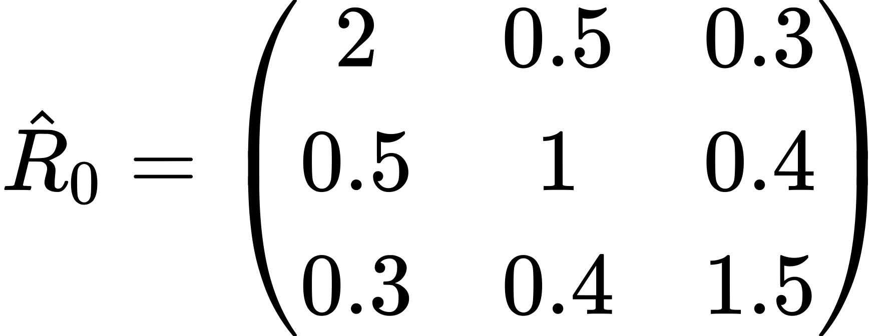

The EWMA smoothing parameter is set to 0.2.

Step 2: Compute the Initial EWMA Covariance Matrix

The initial EWMA covariance matrix is set equal to the in-control covariance matrix:

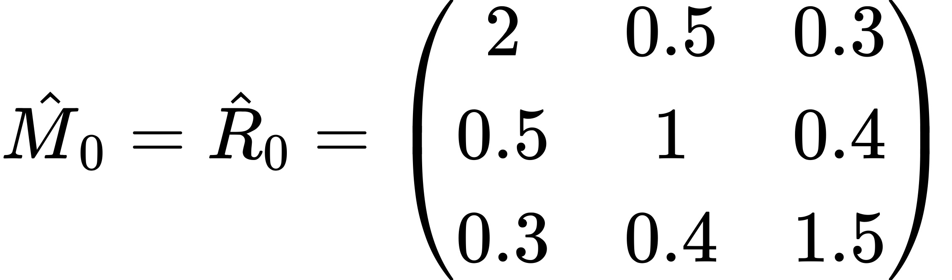

Step 3: New Observation and Update EWMA Matrix

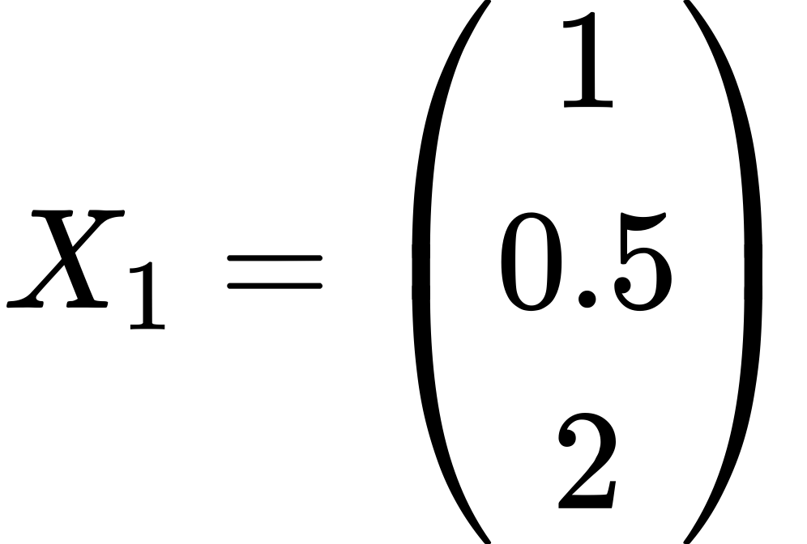

Let's say we get a new observation vector.

The outer product of is:

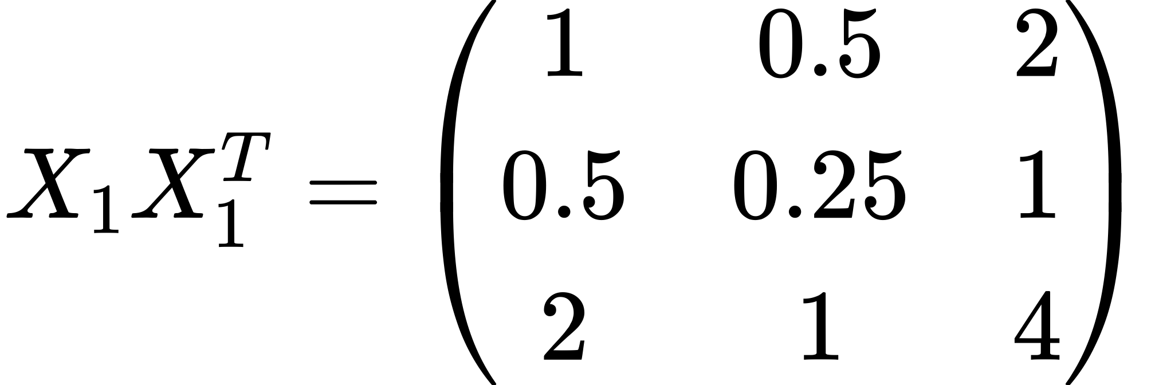

Update the EWMA covariance matrix :

Substitute the values:

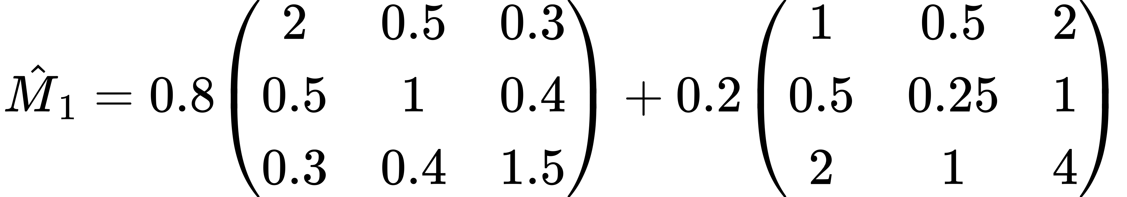

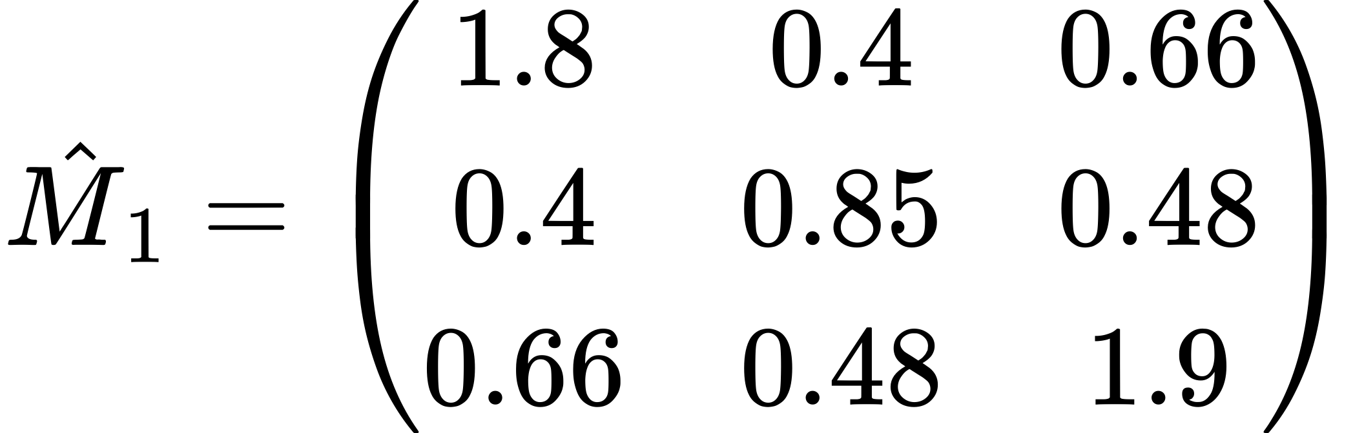

Step 4: Compute the Dissimilarity Index

First, compute :

Sum the matrices :

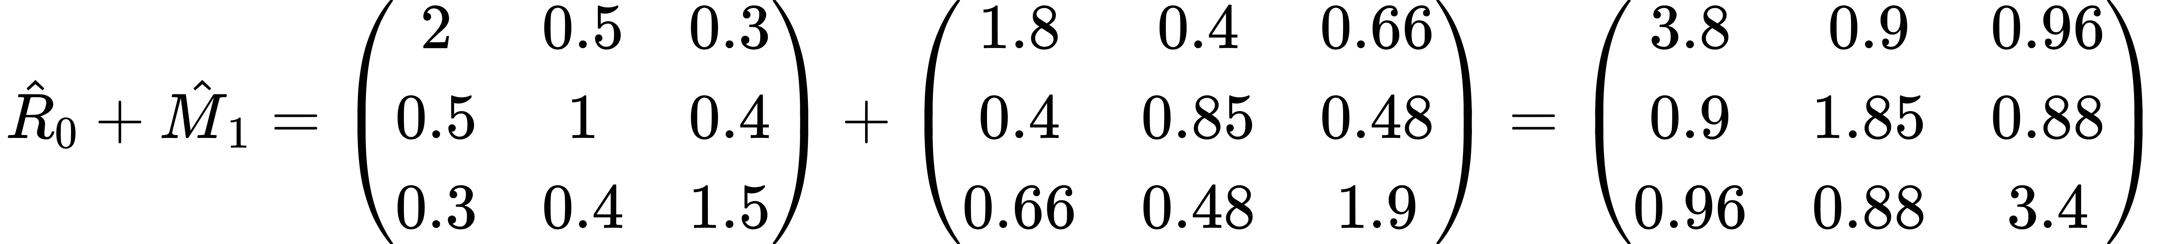

Compute the inverse of (using a matrix calculator for brevity):

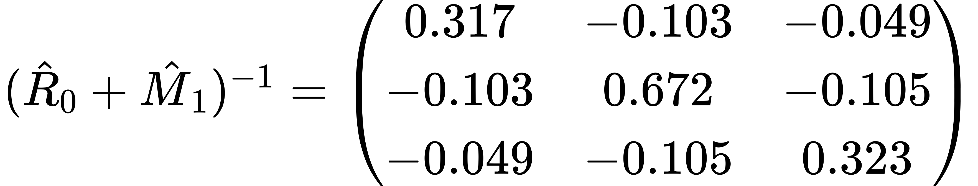

Now, compute :

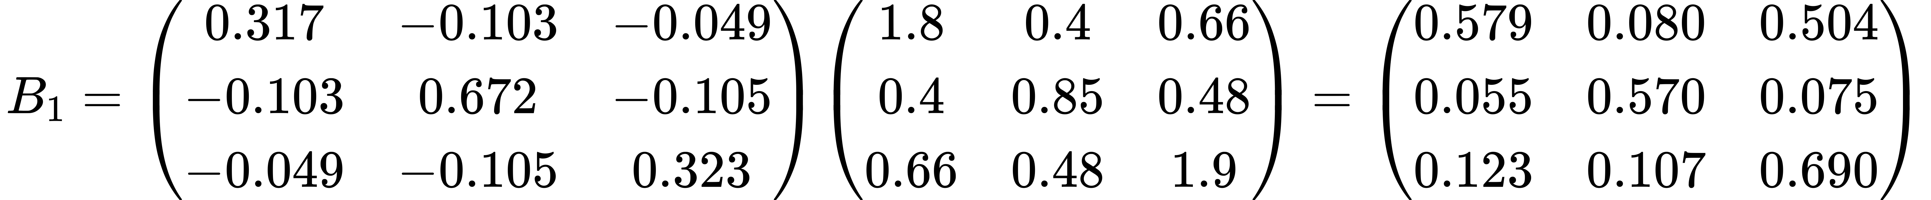

Compute the dissimilarity index :

First, compute :



Next, compute :



Finally, compute :

**Interpretation of Results**

The dissimilarity index indicates how different the current process covariance is from the in-control covariance matrix. If this value exceeds a predetermined upper control limit (UCL), it signals a potential shift in the process variability.

In this example, assuming the UCL is set to 0.3 (as per control chart design based on historical data), the value 0.181 does not exceed 0.3, so the process would be considered in control.

Python Code

import numpy as np

import matplotlib.pyplot as plt

def ewma\_update(M\_prev, X, lambd):

return (1 - lambd) \* M\_prev + lambd \* np.outer(X, X)

def dissimilarity\_index(R0, M):

B = np.linalg.inv(R0 + M) @ M

B\_squared = B @ B

tr\_B\_squared\_minus\_B = np.trace(B\_squared - B)

p = R0.shape[0]

D = (4 / p) \* tr\_B\_squared\_minus\_B + 1

return D

# Initial in-control covariance matrix

R0 = np.array([

[2, 0.5, 0.3],

[0.5, 1, 0.4],

[0.3, 0.4, 1.5]

])

# Parameters

lambd = 0.2

num\_observations = 50

UCL = 0.3

# Simulate observations (normally distributed in-control and out-of-control data)

np.random.seed(0)

observations = np.random.multivariate\_normal(mean=[0, 0, 0], cov=R0, size=num\_observations)

# Introduce out-of-control observations after half of the observations

observations[num\_observations//2:] += np.array([2, 2, 2])

# Initialize variables

M\_prev = R0.copy()

dissimilarity\_indices = []

# Update EWMA matrix and compute dissimilarity index for each observation

for i in range(num\_observations):

M\_prev = ewma\_update(M\_prev, observations[i], lambd)

D = dissimilarity\_index(R0, M\_prev)

dissimilarity\_indices.append(D)

# Plot the dissimilarity indices

plt.figure(figsize=(10, 6))

plt.plot(dissimilarity\_indices, marker='o', linestyle='-', color='b', label='Dissimilarity Index')

plt.axhline(y=UCL, color='r', linestyle='--', label='UCL')

plt.title('Dissimilarity Index Monitoring Chart')

plt.xlabel('Observation Index')

plt.ylabel('Dissimilarity Index')

plt.legend()

plt.grid(True)

plt.show()

**Explanation of the Code**

1. Simulation of Observations:

- We simulate `num\_observations` observations using a multivariate normal distribution with the in-control covariance matrix `R0`.

- To simulate an out-of-control scenario, we add a shift to the mean of the second half of the observations.

2. Updating EWMA Matrix and Computing Dissimilarity Index:

- For each observation, we update the EWMA covariance matrix and compute the dissimilarity index.

- These indices are stored in the `dissimilarity\_indices` list.

3. Plotting the Dissimilarity Indices:

- We use `matplotlib` to plot the dissimilarity indices over time.

- The upper control limit (UCL) is plotted as a horizontal red dashed line.

- The chart shows how the dissimilarity index changes with each new observation, indicating if and when the process goes out of control.

Interpretation of the Chart

- The x-axis represents the observation index.

- The y-axis represents the dissimilarity index.

- The red dashed line indicates the UCL. Points above this line suggest the process is out of control.

- By observing the chart, you can see the moment when the dissimilarity index exceeds the UCL, indicating a shift in the process variability.

This complete code now simulates a real-world production monitoring scenario, updates the process state based on new observations, and visualizes the results using a control chart.

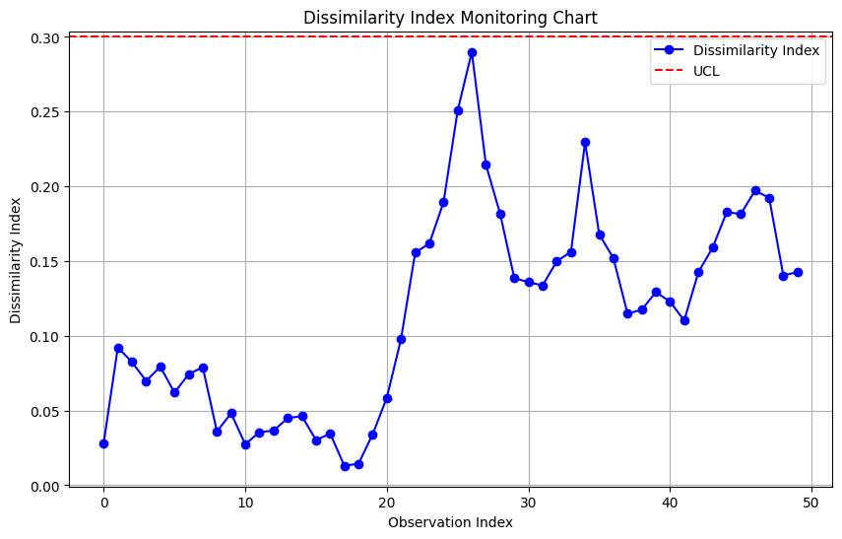

#### ****MVP Chart by Li and Tsung (2019)****

let's go through the MVP (Multivariate Variability Projection) Chart by Li and Tsung (2019) with a detailed numerical example and interpret the results.

Step-by-Step Example

Step 1: Initial Setup

Suppose we have a process with 3 correlated quality characteristics . We have collected initial data (Phase I) to estimate the in-control covariance matrix .

Let's say the estimated in-control covariance matrix is:



The EWMA smoothing parameter is set to 0.2.

Step 2: Compute the Initial EWMA Covariance Matrix

The initial EWMA covariance matrix is set equal to the in-control covariance matrix:



Step 3: New Observation and Update EWMA Matrix

Let's say we get a new observation vector.



The outer product of is:



Update the EWMA covariance matrix :

Substitute the values:





Step 4: Compute the Test Statistic

The test statistic for the MVP chart is based on the largest eigenvalue of the matrix .

First, compute the eigenvalues of :

The test statistic is the largest eigenvalue:

Step 5: Compute the Control Limit

The control limit for the MVP chart is usually determined based on the chi-squared distribution with degrees of freedom.

Assuming the control limit is given by:

UCL = 2.5

Step 6: Interpret the Results

Compare the test statistic with the control limit :

T = 2.577 > UCL = 2.5

Since exceeds the , this indicates that the process is out of control.

Conclusion

The MVP Chart by Li and Tsung (2019) helps in detecting shifts in the process variability by computing the largest eigenvalue of the updated covariance matrix and comparing it with a control limit. Through this example, we computed the test statistic and determined that the process is out of control since the largest eigenvalue exceeded the UCL. This method is particularly useful for high-dimensional data where traditional multivariate control charts may be less effective.

Python Code

import numpy as np

import matplotlib.pyplot as plt

def ewma\_update(M\_prev, X, lambd):

return (1 - lambd) \* M\_prev + lambd \* np.outer(X, X)

def largest\_eigenvalue(M):

eigenvalues = np.linalg.eigvals(M)

return np.max(eigenvalues)

# Example data

R0 = np.array([

[2, 0.5, 0.3],

[0.5, 1, 0.4],

[0.3, 0.4, 1.5]

])

# Parameters

lambd = 0.2

num\_observations = 50

UCL = 2.5 # Assumed control limit for demonstration

# Simulate observations (normally distributed in-control and out-of-control data)

np.random.seed(0)

observations = np.random.multivariate\_normal(mean=[0, 0, 0], cov=R0, size=num\_observations)

# Introduce out-of-control observations after half of the observations

observations[num\_observations//2:] += np.array([2, 2, 2])

# Initialize variables

M\_prev = R0.copy()

test\_statistics = []

# Update EWMA matrix and compute the largest eigenvalue for each observation

for i in range(num\_observations):

M\_prev = ewma\_update(M\_prev, observations[i], lambd)

T = largest\_eigenvalue(M\_prev)

test\_statistics.append(T)

# Plot the test statistics

plt.figure(figsize=(10, 6))

plt.plot(test\_statistics, marker='o', linestyle='-', color='b', label='Test Statistic')

plt.axhline(y=UCL, color='r', linestyle='--', label='UCL')

plt.title('MVP Chart - Test Statistics')

plt.xlabel('Observation Index')

plt.ylabel('Largest Eigenvalue')

plt.legend()

plt.grid(True)

plt.show()

**Explanation of the Code**

1. EWMA Update Function:

- `ewma\_update` function takes the previous EWMA covariance matrix (`M\_prev`), the new observation vector (`X`), and the smoothing parameter (`lambd`) to compute the updated EWMA covariance matrix.

2. Largest Eigenvalue Function:

- `largest\_eigenvalue` function computes the eigenvalues of a given matrix and returns the largest one.

3. Example Data:

- `R0` is the in-control covariance matrix.

- `lambd` is the smoothing parameter for the EWMA update.

- `num\_observations` is the number of observations to simulate.

- `UCL` is the upper control limit for the test statistic.

4. Simulating Observations:

- We simulate `num\_observations` observations using a multivariate normal distribution with the in-control covariance matrix `R0`.

- To simulate an out-of-control scenario, we add a shift to the mean of the second half of the observations.

5. Updating EWMA Matrix and Computing Test Statistic:

- For each observation, we update the EWMA covariance matrix and compute the largest eigenvalue.

- These test statistics are stored in the `test\_statistics` list.

6. Plotting the Test Statistics:

- We use `matplotlib` to plot the test statistics over time.

- The upper control limit (UCL) is plotted as a horizontal red dashed line.

- The chart shows how the test statistic changes with each new observation, indicating if and when the process goes out of control.

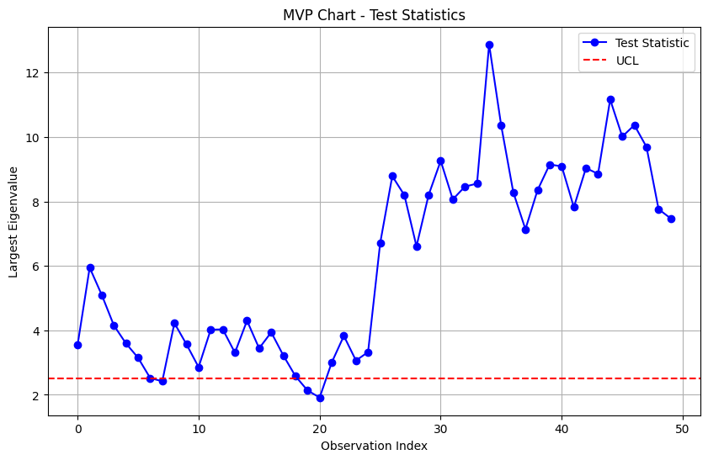

#### ****RPLR Chart by Kim et al. (2019)****

Sure, let's explain the Ridge Penalized Likelihood Ratio (RPLR) Chart by Kim et al. (2019) with a detailed numerical example and then interpret the results.

Step-by-Step Example

Step 1: Initial Setup

Suppose we have a process with 3 correlated quality characteristics . We have collected initial data (Phase I) to estimate the in-control covariance matrix .

Let's say the estimated in-control covariance matrix is:



We also have an estimate of the mean vector :

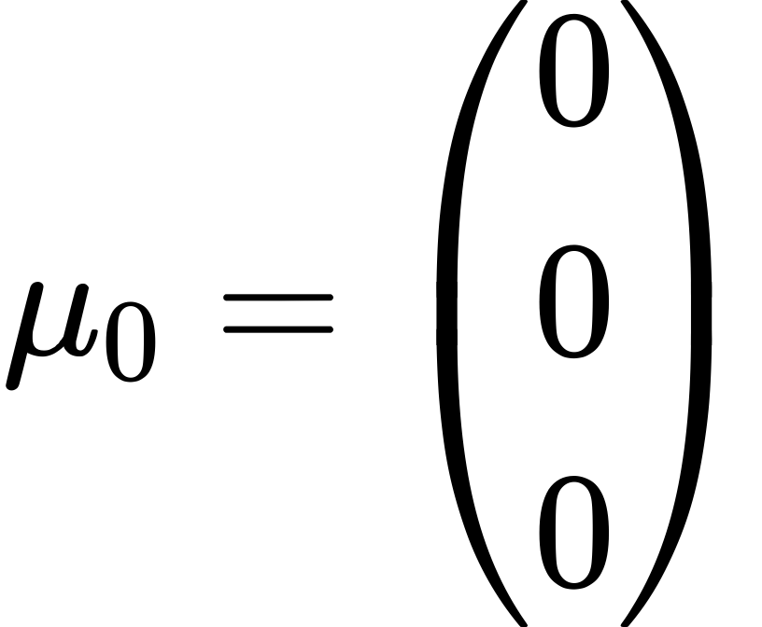

The ridge penalty parameter is set to 0.2.

Step 2: Compute the Initial Ridge Penalized Covariance Matrix

The initial ridge penalized covariance matrix is set equal to the in-control covariance matrix plus a ridge penalty term:

Substitute the values:

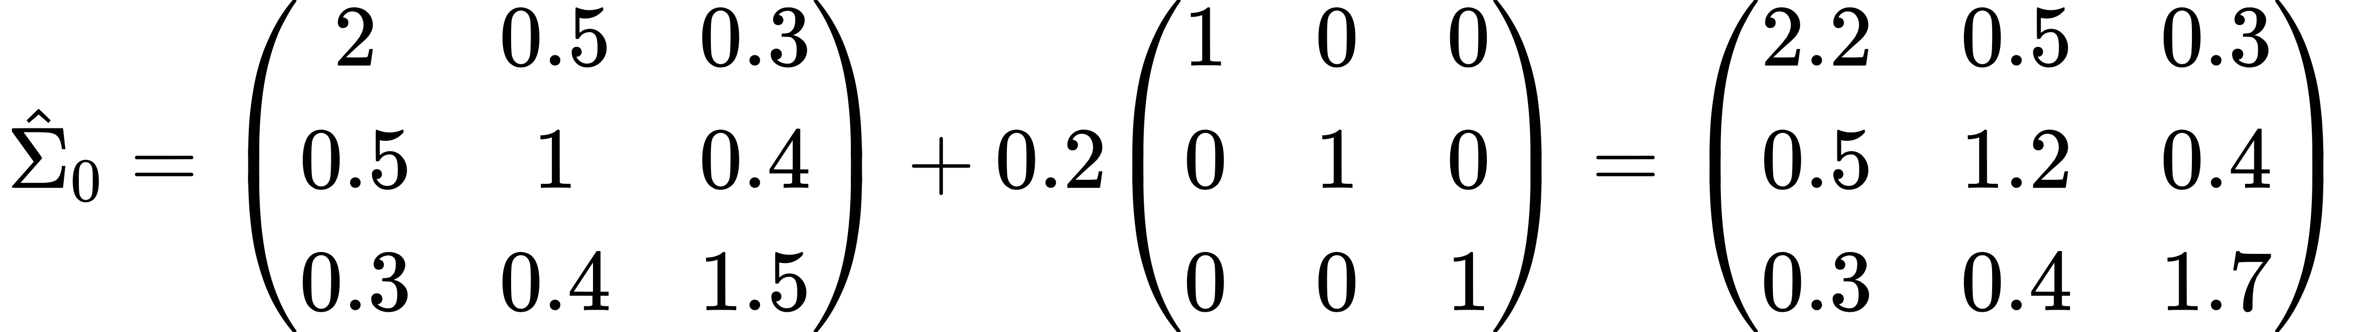

Step 3: New Observation and Compute Penalized Likelihood Ratio Statistic

Let's say we get a new observation vector

Compute the Mahalanobis distance for the new observation:

First, we need the inverse of :

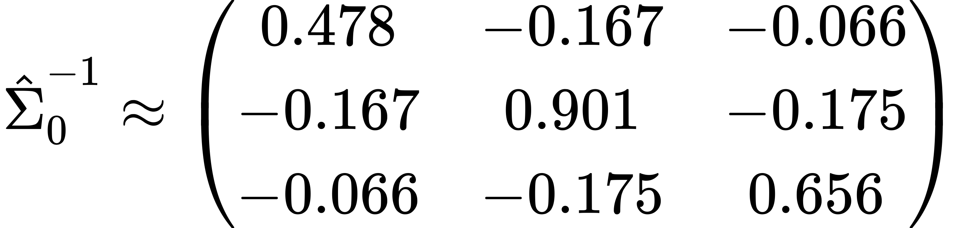

Now, calculate :

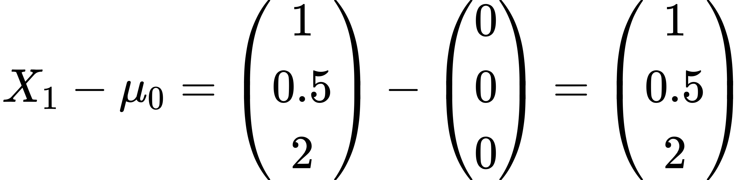

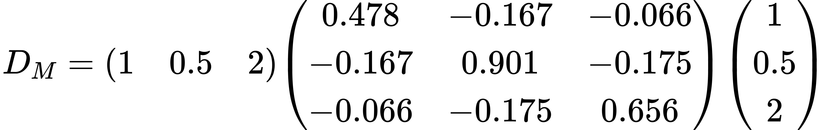

Step 4: Compute the Control Limit

The control limit for the RPLR statistic is usually determined based on the chi-squared distribution with degrees of freedom. Assuming a significance level of 0.05, the control limit is given by the chi-squared distribution's critical value.

For and significance level 0.05:

Step 5: Interpret the Results

Compare the test statistic with the control limit

D\_M = 1.9385 < UCL = 7.815

Since does not exceed the , this indicates that the process is in control.

Conclusion

The RPLR Chart by Kim et al. (2019) helps in detecting shifts in the process variability by computing the Mahalanobis distance using a ridge-penalized covariance matrix and comparing it with a control limit. Through this example, we computed the test statistic and determined that the process is in control since the Mahalanobis distance did not exceed the UCL. This method is particularly useful for high-dimensional data where traditional multivariate control charts may be less effective.

Python Code

Here is the full Python code to implement the Ridge Penalized Likelihood Ratio (RPLR) Chart by Kim et al. (2019), simulate some observations, and plot the results:

import numpy as np

import matplotlib.pyplot as plt

from scipy.stats import chi2

def ewma\_update(M\_prev, X, lambd):

return (1 - lambd) \* M\_prev + lambd \* np.outer(X, X)

def mahalanobis\_distance(X, mu, Sigma\_inv):

diff = X - mu

return diff.T @ Sigma\_inv @ diff

# Example data

R0 = np.array([

[2, 0.5, 0.3],

[0.5, 1, 0.4],

[0.3, 0.4, 1.5]

])

mu0 = np.array([0, 0, 0])

# Parameters

lambd = 0.2

ridge\_penalty = 0.2

num\_observations = 50

# Compute the initial ridge-penalized covariance matrix

Sigma0 = R0 + ridge\_penalty \* np.eye(R0.shape[0])

# Simulate observations (normally distributed in-control and out-of-control data)

np.random.seed(0)

observations = np.random.multivariate\_normal(mean=mu0, cov=R0, size=num\_observations)

# Introduce out-of-control observations after half of the observations

observations[num\_observations//2:] += np.array([2, 2, 2])

# Initialize variables

Sigma\_prev = Sigma0.copy()

test\_statistics = []

# Update EWMA matrix and compute the Mahalanobis distance for each observation

for i in range(num\_observations):

Sigma\_prev = ewma\_update(Sigma\_prev, observations[i], lambd)

Sigma\_inv = np.linalg.inv(Sigma\_prev)

D\_M = mahalanobis\_distance(observations[i], mu0, Sigma\_inv)

test\_statistics.append(D\_M)

# Determine the control limit (UCL) for a chi-squared distribution with p degrees of freedom

p = R0.shape[0]

alpha = 0.05

UCL = chi2.ppf(1 - alpha, p)

# Plot the test statistics

plt.figure(figsize=(10, 6))

plt.plot(test\_statistics, marker='o', linestyle='-', color='b', label='Mahalanobis Distance')

plt.axhline(y=UCL, color='r', linestyle='--', label='UCL')

plt.title('RPLR Chart - Mahalanobis Distance')

plt.xlabel('Observation Index')

plt.ylabel('Mahalanobis Distance')

plt.legend()

plt.grid(True)

plt.show()

**Explanation of the Code**

1. EWMA Update Function:

- `ewma\_update` function takes the previous EWMA covariance matrix (`M\_prev`), the new observation vector (`X`), and the smoothing parameter (`lambd`) to compute the updated EWMA covariance matrix.

2. Mahalanobis Distance Function:

- `mahalanobis\_distance` function computes the Mahalanobis distance given an observation vector (`X`), mean vector (`mu`), and inverse covariance matrix (`Sigma\_inv`).

3. Example Data:

- `R0` is the in-control covariance matrix.

- `mu0` is the in-control mean vector.

- `lambd` is the smoothing parameter for the EWMA update.

- `ridge\_penalty` is the ridge penalty parameter.

- `num\_observations` is the number of observations to simulate.

4. Initial Ridge-Penalized Covariance Matrix:

- `Sigma0` is computed by adding the ridge penalty to the in-control covariance matrix.

5. Simulating Observations:

- We simulate `num\_observations` observations using a multivariate normal distribution with the in-control mean vector `mu0` and covariance matrix `R0`.

- To simulate an out-of-control scenario, we add a shift to the mean of the second half of the observations.

6. Updating EWMA Matrix and Computing Mahalanobis Distance:

- For each observation, we update the EWMA covariance matrix and compute the Mahalanobis distance.

- These test statistics are stored in the `test\_statistics` list.

7. Determining the Control Limit:

- The control limit (`UCL`) is determined using the chi-squared distribution with `p` degrees of freedom and a significance level of 0.05.

8. Plotting the Test Statistics:

- We use `matplotlib` to plot the test statistics over time.

- The upper control limit (UCL) is plotted as a horizontal red dashed line.

- The chart shows how the test statistic changes with each new observation, indicating if and when the process goes out of control.

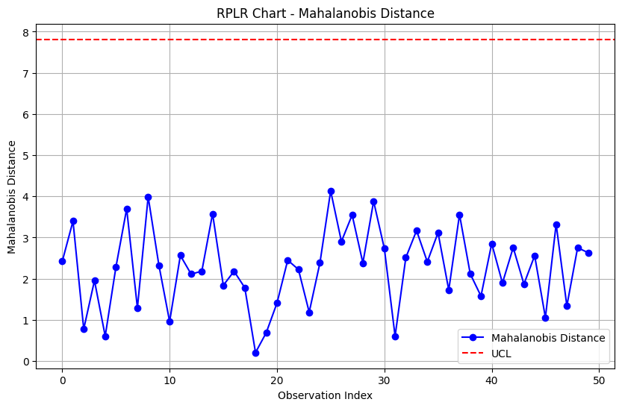

### More info

Real-world example

Let's consider a real-world example involving a manufacturing plant that produces precision components used in automotive engines. These components must meet stringent quality requirements, as variations in their properties could lead to engine failures. For simplicity, let’s focus on two quality characteristics: diameter and hardness of the components.

#Scenario

Imagine a scenario where each component is measured for its diameter and hardness as soon as it comes off the production line. These measurements are taken individually rather than in pre-defined groups, and each measurement set consists of these two correlated variables (diameter and hardness).

#Application of Control Charts

To monitor the consistency and quality of these components, the plant utilizes multivariate control charts. Here's how specific charts from the reviewed paper apply:

1. CUSUM-Type Charts:

- Purpose: These charts are good at detecting small and gradual changes in the process. Suppose the machine tooling begins to wear out; this change might gradually affect the diameter and hardness. A CUSUM-type chart would accumulate these small changes to signal when the process is starting to deviate from its normal operating condition.

- Example: The chart might signal an alert if there's a gradual increase in the diameter while hardness remains consistent, indicating potential tool wear that hasn’t yet affected hardness.

2. MEWMA-Type Charts:

- Purpose: These charts are effective for monitoring the variance and mean of the process simultaneously using a smoothing mechanism. They are particularly useful when the process characteristics are expected to fluctuate within a controlled range.

- Example: If a batch of raw material has slightly different properties, it might cause fluctuations in the hardness measurements. A MEWMA chart could help in smoothing out these fluctuations to determine if there’s an actual trend or just random variation.

3. Shewhart-Type Charts:

- Purpose: These charts are used for detecting large shifts quickly. They are less sensitive to small variations and more to sudden changes.

- Example: If a new operator incorrectly sets up the machine, causing a significant change in component diameter, a Shewhart chart would quickly indicate that the measurements are out of the expected range.

4. Non-Parametric Charts:

- Purpose: These charts do not assume a specific distribution of the data and are useful when the data behavior is unknown or non-normal.

- Example: Suppose the data on component hardness due to a new material blend does not follow a normal distribution; non-parametric charts would be appropriate for monitoring this characteristic without assumptions about its statistical distribution.

5. High-Dimensional Charts:

- Purpose: These are used when many quality characteristics are monitored simultaneously.

- Example: If the plant decides to monitor additional variables like temperature, pressure during manufacturing, and chemical composition alongside diameter and hardness, high-dimensional charts would help manage this complexity.

**Conclusion**

In this manufacturing scenario, using these control charts allows the quality control team to monitor and maintain the standards required for automotive components effectively. By choosing the appropriate type of control chart based on the nature of data and the specific needs of the monitoring process, the plant ensures that any deviations in the manufacturing process are detected early and corrected, thus preventing potential failures in real-world applications.